Topic: Option #1- Mutually Conflicting Requirements

Tripti Vishwakarma
Colorado State University Global
Course Code: CSC 505-1
Jonathan Vanover
May 26 2024

Mutually conflicting requirements refer to a situation where two or more requirements in a system or project are in direct conflict with each other, such that satisfying one requirement would make it impossible or very difficult to satisfy another. These conflicts can arise in various contexts, such as software development, product design, engineering, business processes, and project management.

For example, in software development, one requirement might be to create a highly secure system (which often requires complex authentication procedures), while another requirement might be to ensure that the system is extremely user-friendly (which usually means minimizing barriers to access, like authentication procedures). These two requirements conflict because improving security often comes at the cost of user convenience, and vice versa.

Identifying and resolving mutually conflicting requirements is an important part of the design process. It often involves negotiation, compromise, and prioritization to determine which requirements are more critical or to find a balance that can satisfy all stakeholders to an acceptable degree.

Resolution strategies might include:

1. Prioritization: Deciding which requirement is more important for the project's success and prioritizing it over the other.
2. Trade-offs: Making concessions on both sides to reach a satisfactory compromise that partially meets both requirements.
3. Refinement: Clarifying or redefining the requirements to eliminate or reduce the conflict.
4. Innovation: Finding a creative solution that allows both requirements to be met without significant compromise.
5. Stakeholder Engagement: Involving stakeholders to understand the underlying needs that the requirements represent, which can sometimes lead to alternative solutions that resolve the conflict.

When dealing with multiple stakeholders and conflicting requirements, the process becomes more complex, as it involves negotiation, prioritization, and conflict resolution activities. Here's how you might model this situation in a UML Communication Diagram:

UML Communication Diagram: Handling Conflicting Requirements with Multiple Stakeholders

Participants/Objects:
1. Stakeholder1, Stakeholder2, ...: Actors representing various users or clients, each with their own set of requirements.
2. ConflictResolutionSystem: A system or subsystem specifically designed to handle and resolve conflicts in requirements.
3. RequirementsDatabase: A storage system or database that holds all the requirements and their status.
4. NegotiationInterface: A user interface that facilitates negotiation and discussion among stakeholders.

Interactions:
1. Each Stakeholder sends their requirements to the ConflictResolutionSystem. For example, Stakeholder1 sends `inputRequirements(requirements1)` and `Stakeholder2` sends `inputRequirements(requirements2)`.
2. The ConflictResolutionSystem stores these requirements in the RequirementsDatabase.
3. The ConflictResolutionSystem analyzes the requirements for potential conflicts.
4. If conflicts are detected, the ConflictResolutionSystem notifies all involved stakeholders via the NegotiationInterface.
5. The stakeholders use the NegotiationInterface to discuss and negotiate a resolution.
6. Agreed resolutions are sent back to the ConflictResolutionSystem.
7. The ConflictResolutionSystem updates the RequirementsDatabase with the resolved requirements.
8. Finally, the ConflictResolutionSystem informs stakeholders of the updated status via the NegotiationInterface.

Communication Pathways:
- Multiple stakeholders send their requirements to the conflict resolution system.
- The system checks for conflicts and engages stakeholders in negotiation if necessary.
- Stakeholders and the system interact to resolve conflicts.
- The system updates requirements and notifies stakeholders of the outcomes.

Below is the UML diagram crafted using Gliffy –

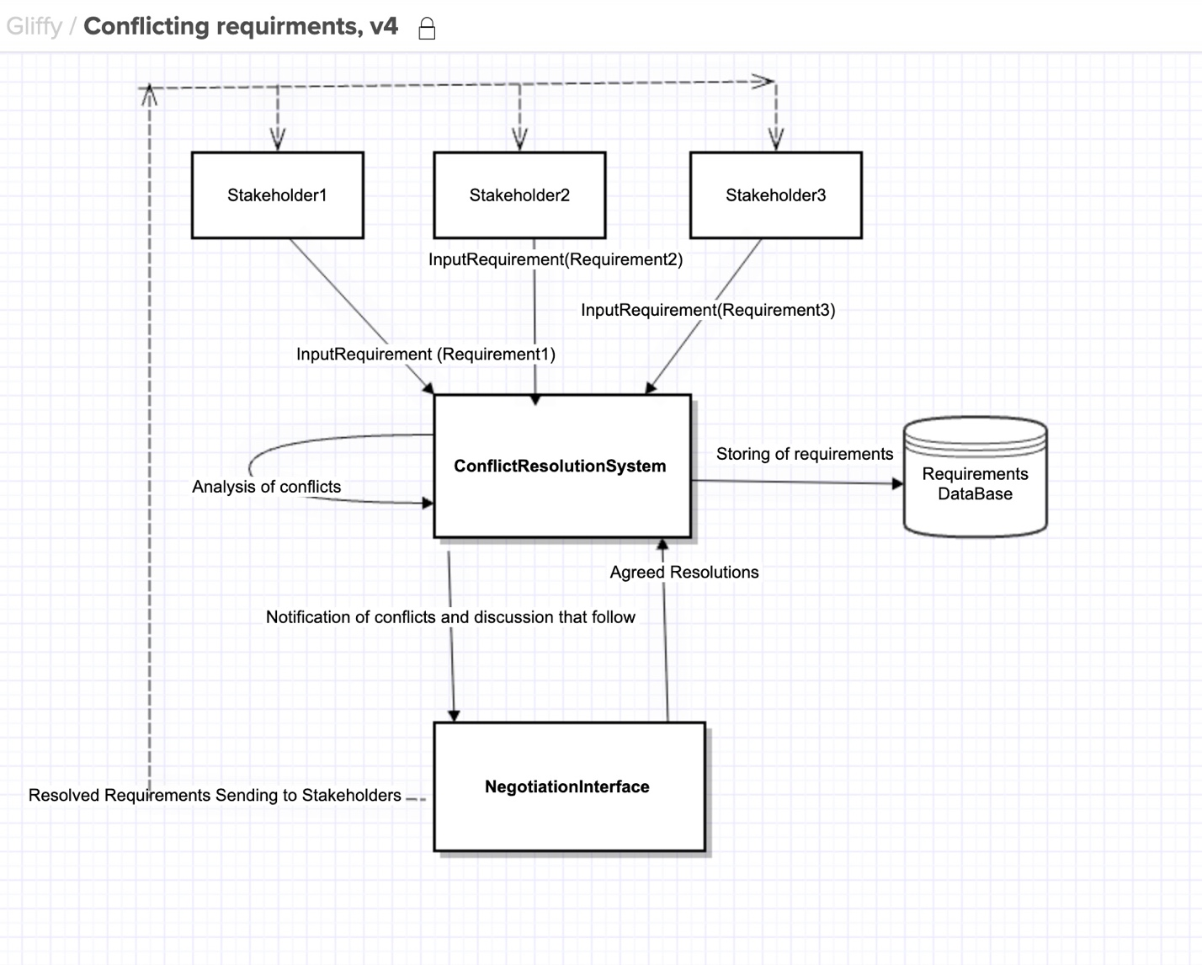

References:
- Sommerville, I. (2016). Software Engineering (10th ed.). Pearson Education Limited.
- Pressman, R. S., & Maxim, B. R. (2015). Software Engineering: A Practitioner's Approach (8th ed.). McGraw-Hill Education.
- IEEE Computer Society. (2014). Guide to the Software Engineering Body of Knowledge (SWEBOK V3.0). IEEE Computer Society.
- Fowler, M. (2004). UML Distilled: A Brief Guide to the Standard Object Modeling Language (3rd ed.). Addison-Wesley Professional.
- Ambler, S. W., & Constantine, L. L. (1999). The Unified Process Inception Phase: Best Practices for Completing the Inception Phase of the Unified Process. Cambridge University Press.
- Booch, G., Rumbaugh, J., & Jacobson, I. (2005). The Unified Modeling Language User Guide (2nd ed.). Addison-Wesley Professional.
Online Resources:
- IBM Developer. (n.d.). UML Activity Diagram Overview. https://www.ibm.com/cloud/learn/uml-activity-diagrams
- Visual Paradigm. (n.d.). Activity Diagram Tutorial. https://www.visual-paradigm.com/guide/uml-unified-modeling-language/what-is-activity-diagram/

Simple Python Script-

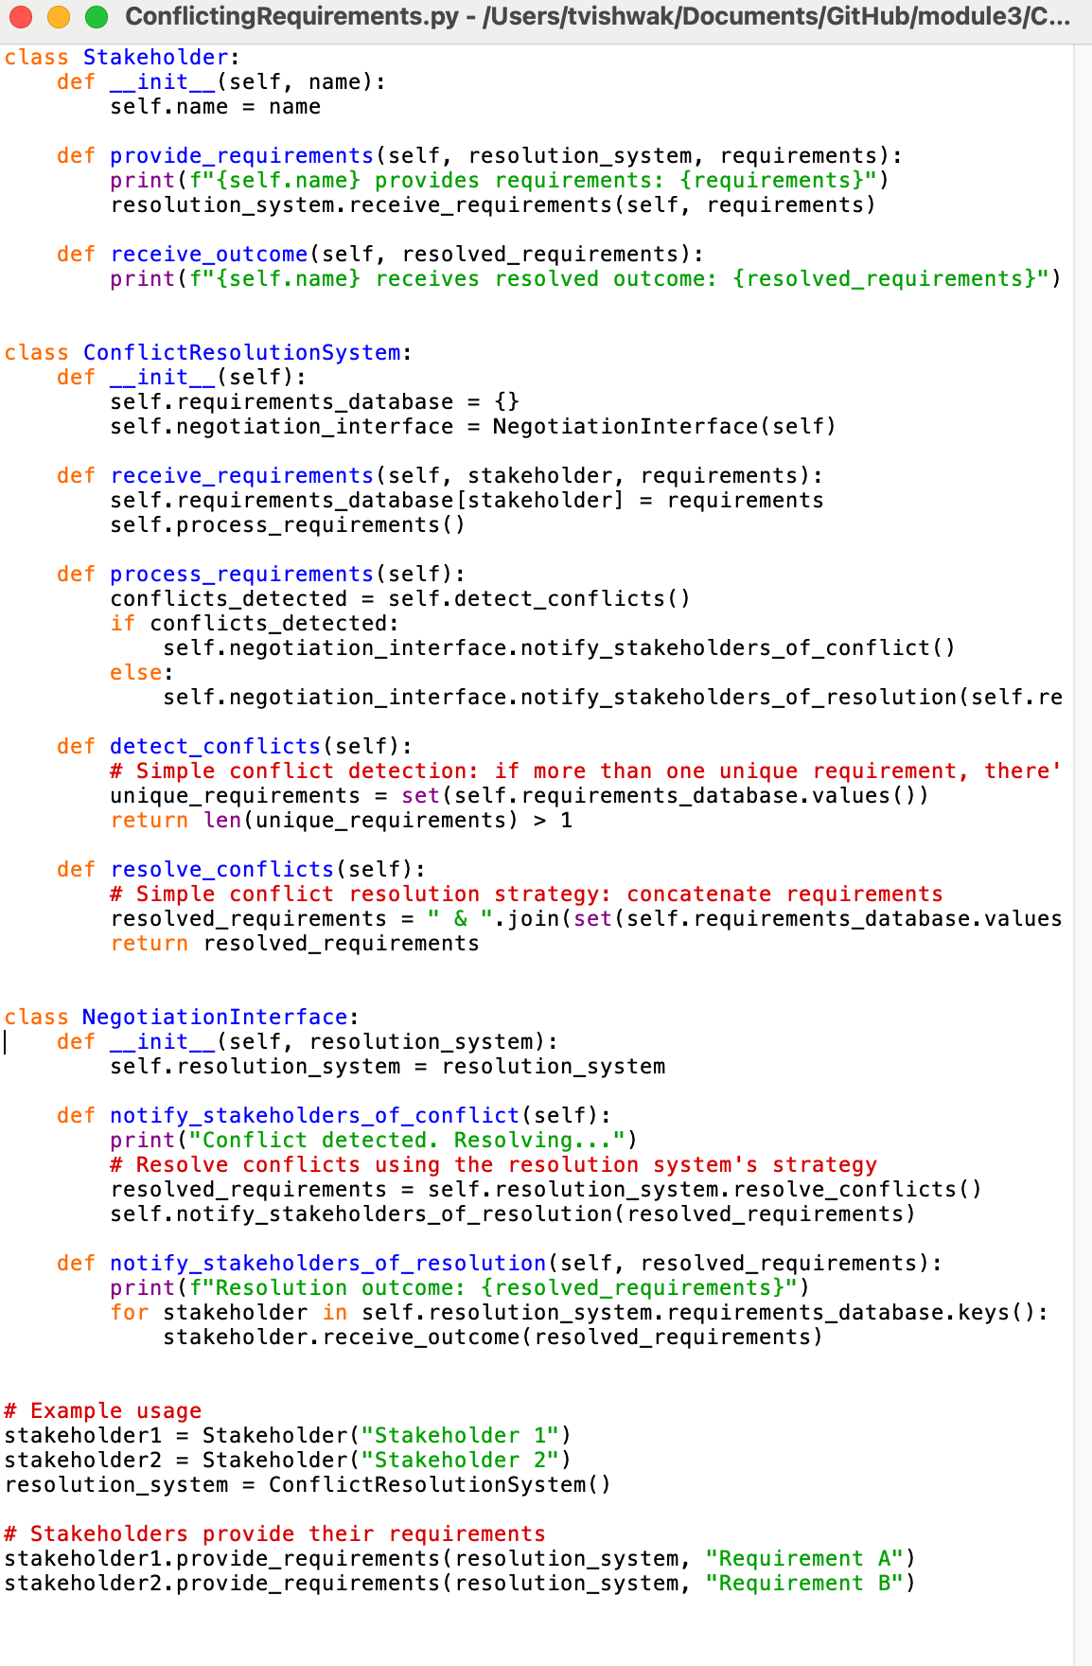

Execution:

