Topic: Informed Search Heuristics
Tripti Vishwakarma
Colorado State University Global
Course Code CSC510 1
Dr. Isaac Gang
April 13, 2025

Title: Interactive Pathfinding Using A* Search Algorithm: An Informed Search Heuristics
Abstract
This paper explores the implementation of the A* search algorithm within an interactive Python script designed for pathfinding in a grid environment. The script allows users to input various parameters, such as grid size, start and goal positions, and obstacle placements, while ensuring input validation and user feedback. The A* algorithm is examined for its efficiency, optimality, and usability in practical applications.

Introduction
Pathfinding algorithms are critical in various fields, such as robotics, game development, and navigation systems. Among these, the A* search algorithm is renowned for its optimal and complete pathfinding capabilities, provided the heuristic used is admissible. This paper presents an interactive Python script utilizing the A* algorithm to solve grid-based pathfinding problems, emphasizing user interaction and input validation.
Methodology
The A* algorithm was implemented in Python, leveraging a priority queue to manage nodes during the search process. The algorithm combines the actual cost from the start node and a heuristic estimate to the goal, ensuring efficient pathfinding. The script prompts users for grid dimensions, start and goal positions, and obstacles, incorporating checks to validate inputs and guide users toward correct data entry.
Algorithm Implementation 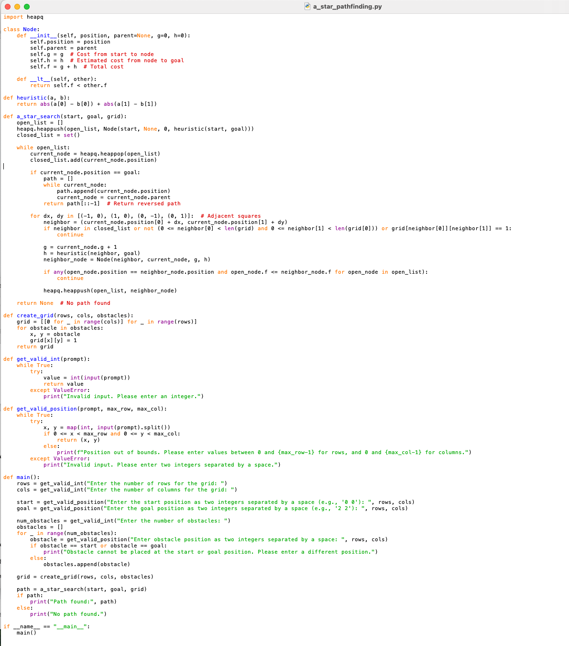

Instructions for Testing the Code
- Saved the provided code as a Python file named a_star_pathfinding.py.
- Run the Script (using python a_star_pathfinding.py in terminal or command prompt).
- Provide User Input by following the prompts to enter:
  - The number of rows and columns for the grid.
  - The start position (two integers separated by space).
  - The goal position (two integers separated by space).
  - The number of obstacles (integers).
  - Their positions (two integers separated by space).
- Observe the Output: The script will display the path found, if any, or indicate if no path is possible.

Execution 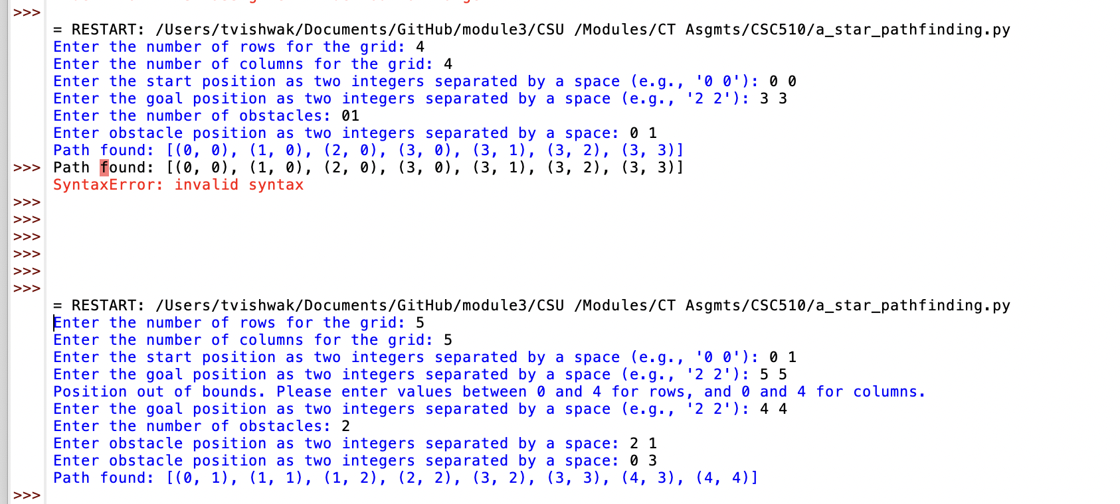

Results
The interactive script successfully calculates optimal paths in various grid configurations, demonstrating the robustness and flexibility of the A* algorithm in handling dynamic user inputs. User feedback mechanisms were effective in guiding users through the input process, reducing errors and enhancing the overall experience.

Discussion

Completeness and Admissibility
The A* search algorithm is both complete and admissible. Completeness ensures that if there is a path from the start node to the goal node, the algorithm will find it. Admissibility is achieved when the heuristic used in the algorithm does not overestimate the actual cost to reach the goal, guaranteeing that A* finds the shortest path. This makes A* a reliable choice for scenarios where finding an optimal solution is critical.

Evaluation Function
A* uses an evaluation function defined as f(n)=g(n)+h(n)f(n)=g(n)+h(n). Here, g(n)g(n) represents the actual cost from the start node to the current node nn, and h(n)h(n) is the heuristic estimate of the cost from nn to the goal. This evaluation function helps prioritize nodes that are likely to lead to the shortest path, balancing actual costs with estimated future costs.

Space Efficiency
The A* algorithm is not particularly space-efficient because it retains all generated nodes in memory. This can lead to significant memory usage, especially in large search spaces, as it requires storage for both open and closed lists. However, this is a trade-off for its completeness and optimality, as keeping track of nodes is essential to ensure the best path is found.

Advantages and Disadvantages

Advantages:
- Optimality: A* guarantees finding the shortest path if the heuristic is admissible.
- Flexibility: It can be adapted to various problems by modifying the heuristic.
- Dynamic Pathfinding: Effective in dynamic environments where obstacles and paths may change.

Disadvantages:
- Memory Usage: High memory consumption due to the storage of nodes can be a limitation in large grids or complex environments.
- Computational Cost: The algorithm can be computationally intensive, especially with complex heuristics or large graphs.

Fit for Intended Function
For the intended function of pathfinding in a grid environment, A* is well-suited due to its ability to consistently find optimal paths. The interactive nature of the script benefits from A*'s reliability in dynamically adjusting to user-defined parameters, such as grid size and obstacles. While memory consumption is a potential concern, it is manageable within typical grid sizes used in this context, making A* a practical choice for this application.

Conclusion
This paper presented an interactive implementation of the A* search algorithm, highlighting its practical application in grid-based pathfinding. The script's ability to handle user inputs dynamically and provide feedback ensures a robust and user-friendly experience, demonstrating the algorithm's versatility and effectiveness.

References

Hart, P. E., Nilsson, N. J., & Raphael, B. (1968). A formal basis for the heuristic determination of minimum cost paths. IEEE Transactions on Systems Science and Cybernetics, 4(2), 100-107.
Russell, S., & Norvig, P. (2016). Artificial Intelligence: A Modern Approach (3rd ed.). Pearson Education.
Business Intelligence, Analytics, Data Science, and AI, by Ramesh Sharda; Dursun Delen; Efraim Turban

