Topic: AI Driven Recruiting Optimization
Tripti Vishwakarma
Colorado State University Global
Course Code CSC 510 -1
Dr. Isaac Gang
May 10, 2025

Title- Final Portfolio Project: AI Driven Recruitment Optimization

Introduction

Recruiting top talent is a time-intensive process requiring significant human effort to evaluate resumes, compare candidates, and assess their suitability for specific roles. To streamline this process, the AI-based Recruiting Optimization Program was designed to assist recruiters in automating and optimizing candidate evaluation. By leveraging natural language processing (NLP) and machine learning (ML) techniques, this program scores and ranks candidates based on their resumes and a provided job description. The program provides detailed outputs, including key skills match, years of experience, certifications, and education, enabling recruiters to make data-driven hiring decisions efficiently.

This paper describes the tools and methods used in developing the program, including expert system concepts and symbolic planning techniques. The program represents a practical application of AI in solving real-world problems, reducing the workload of recruiters while improving the accuracy and fairness of candidate evaluation.

Tools, Libraries, and APIs Utilized
The program was implemented in Python using a combination of open-source libraries to achieve its functionality. Below are the key tools and their roles:

- PyPDF2: Used for extracting text from PDF resumes. This library enables the parsing of multi-page PDF documents, allowing the program to process candidate resumes in their most common format.
- spaCy: A robust Natural Language Processing (NLP) library used to preprocess text, including tokenization, lemmatization, and removal of stopwords and punctuation. SpaCy ensures that the program can handle unstructured text in both resumes and job descriptions effectively.
- pandas: A data manipulation library used to structure and analyze candidate data. It organizes extracted text into a DataFrame, which is then used for ranking candidates.
- scikit-learn: Provides the TF-IDF Vectorizer (Term Frequency-Inverse Document Frequency) for feature extraction and Cosine Similarity for comparing resumes to the job description. These methods allow the program to compute similarity scores and rank candidates.
- re (Regular Expressions): Used for extracting numerical data, such as years of experience, from unstructured text in resumes.
These libraries collectively enabled efficient implementation of text extraction, preprocessing, and candidate ranking.

Search Methods and Their Contribution
The program uses TF-IDF Vectorization and Cosine Similarity as its primary search and ranking methods. Here’s how these methods contributed to achieving the program’s goals:
- TF-IDF Vectorization:
  - Converts unstructured text (e.g., resumes and job descriptions) into numerical feature vectors by calculating the importance of each word relative to the corpus.
  - This method ensures that frequently occurring but less meaningful words (e.g., "the," "and") are assigned low weights, while domain-specific terms (e.g., "Python," "SQL") are emphasized.
- Cosine Similarity:
  - A mathematical measure used to calculate the similarity between the job description vector and each resume vector.
  - The program ranks resumes based on their similarity score, with higher scores indicating better alignment with the job description.
These search methods are crucial for evaluating candidates in a quantitative manner, enabling the program to provide accurate and fair rankings.

Inclusion of Deep Learning Models
Although the program does not currently use deep learning models, it can be extended to include them. For example:
- Transformer-based models such as BERT or Sentence-BERT could be used to enhance semantic understanding between resumes and job descriptions.
- These models would allow the program to understand the context of words in resumes and job descriptions, resulting in more accurate similarity scores.
While deep learning models were not included in this iteration to maintain simplicity and interpretability, they remain a future enhancement for the program.

Expert System Concepts
The program incorporates aspects of expert systems by combining rule-based logic with machine learning techniques. These rules emulate the decision-making process of a human recruiter. Examples include:
Skills Match-The program identifies specific keywords (e.g., "Python," "SQL") in resumes and calculates a match percentage based on the required skills in the job description.
Experience Validation-Using regular expressions, the program extracts years of experience from resumes and compares them to the job description’s requirements.
Certification Matching- Checks for certifications (e.g., "AWS Certified," "Azure Certified") in resumes and evaluates whether they meet the requirements specified in the job description.
These rule-based elements, combined with NLP and search methods, form the foundation of the program’s expert system, making it both interpretable and actionable for recruiters.
Knowledge Representation
The program represents knowledge in both structured and unstructured formats:
Structured Representation-
After processing the resumes and job description, the program organizes extracted data (e.g., skills, experience, certifications) into a tabular format using pandas. This structured representation allows for efficient analysis and comparison.
Unstructured Representation-
Raw text from resumes and the job description is stored and preprocessed using SpaCy. This unstructured representation is transformed into numerical vectors using TF-IDF for similarity calculations.

Symbolic Planning
Symbolic planning refers to breaking down a complex task into smaller, logical steps to achieve a goal. In the context of this program, symbolic planning is used as follows:
Task Decomposition: The program divides the candidate evaluation process into independent, sequential steps, such as:
Extracting text from resumes.
Preprocessing text (e.g., tokenization, lemmatization).
Computing similarity scores.
Extracting and evaluating skills, experience, and certifications.
Ranking candidates based on combined criteria.
Logical Decision-Making:
Rule-based logic is applied at each step to emulate the decision-making process of a recruiter. For example: If a resume contains fewer matched skills than required, the candidate is ranked lower. If a candidate’s years of experience meet or exceed the requirement, they are given preference.
Symbolic planning ensures that the program operates systematically and produces outputs that are easy to interpret and justify.

Code 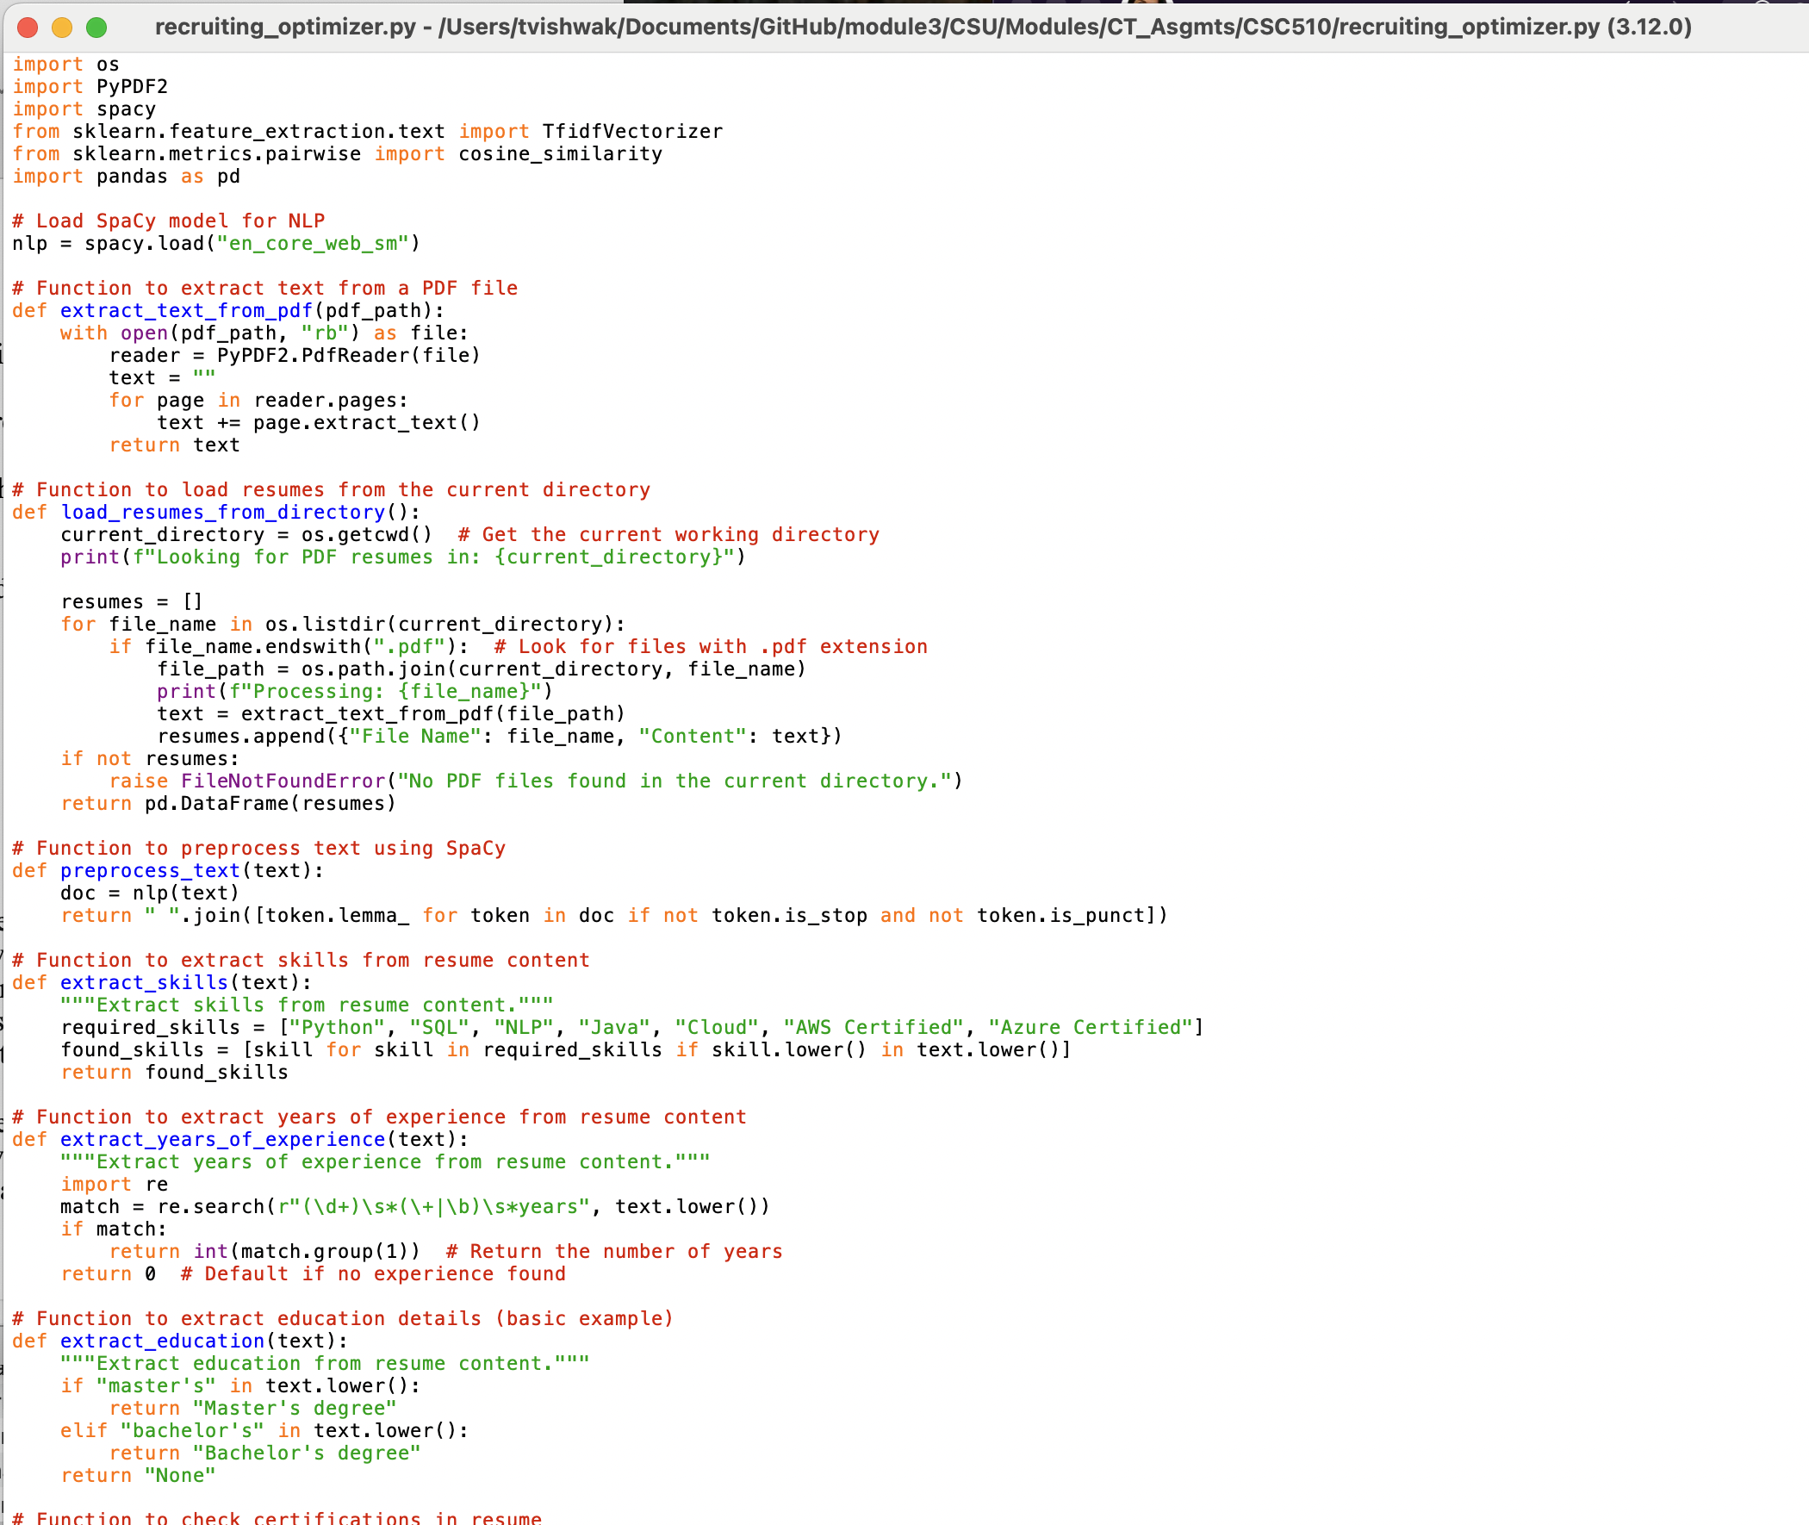

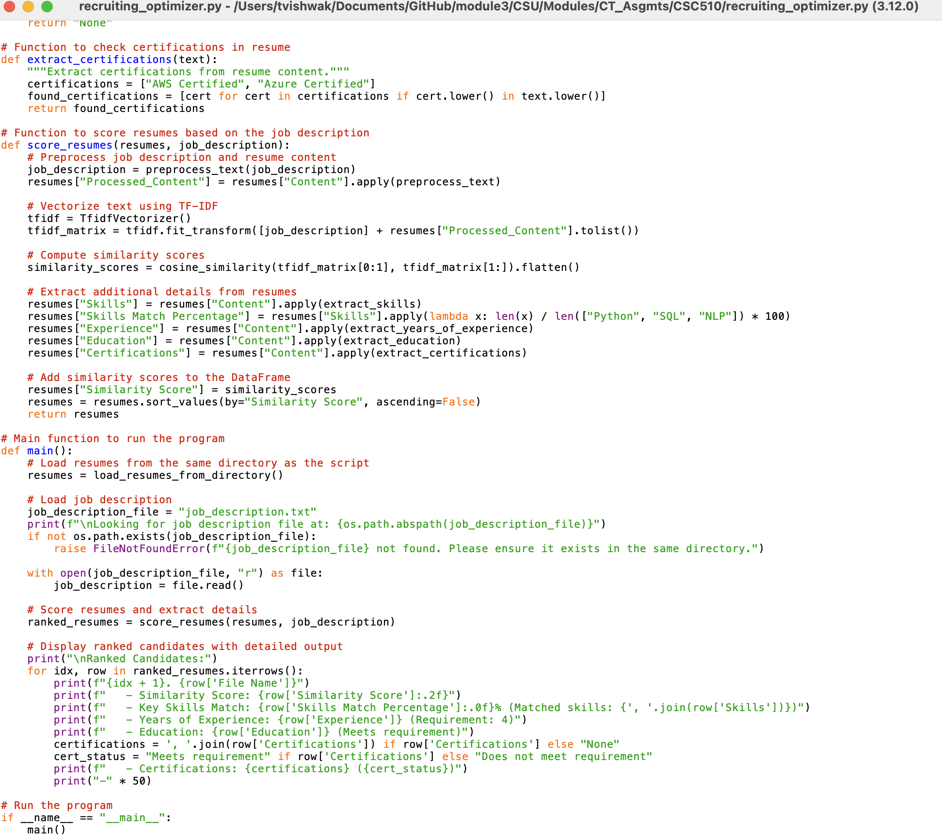

Output- 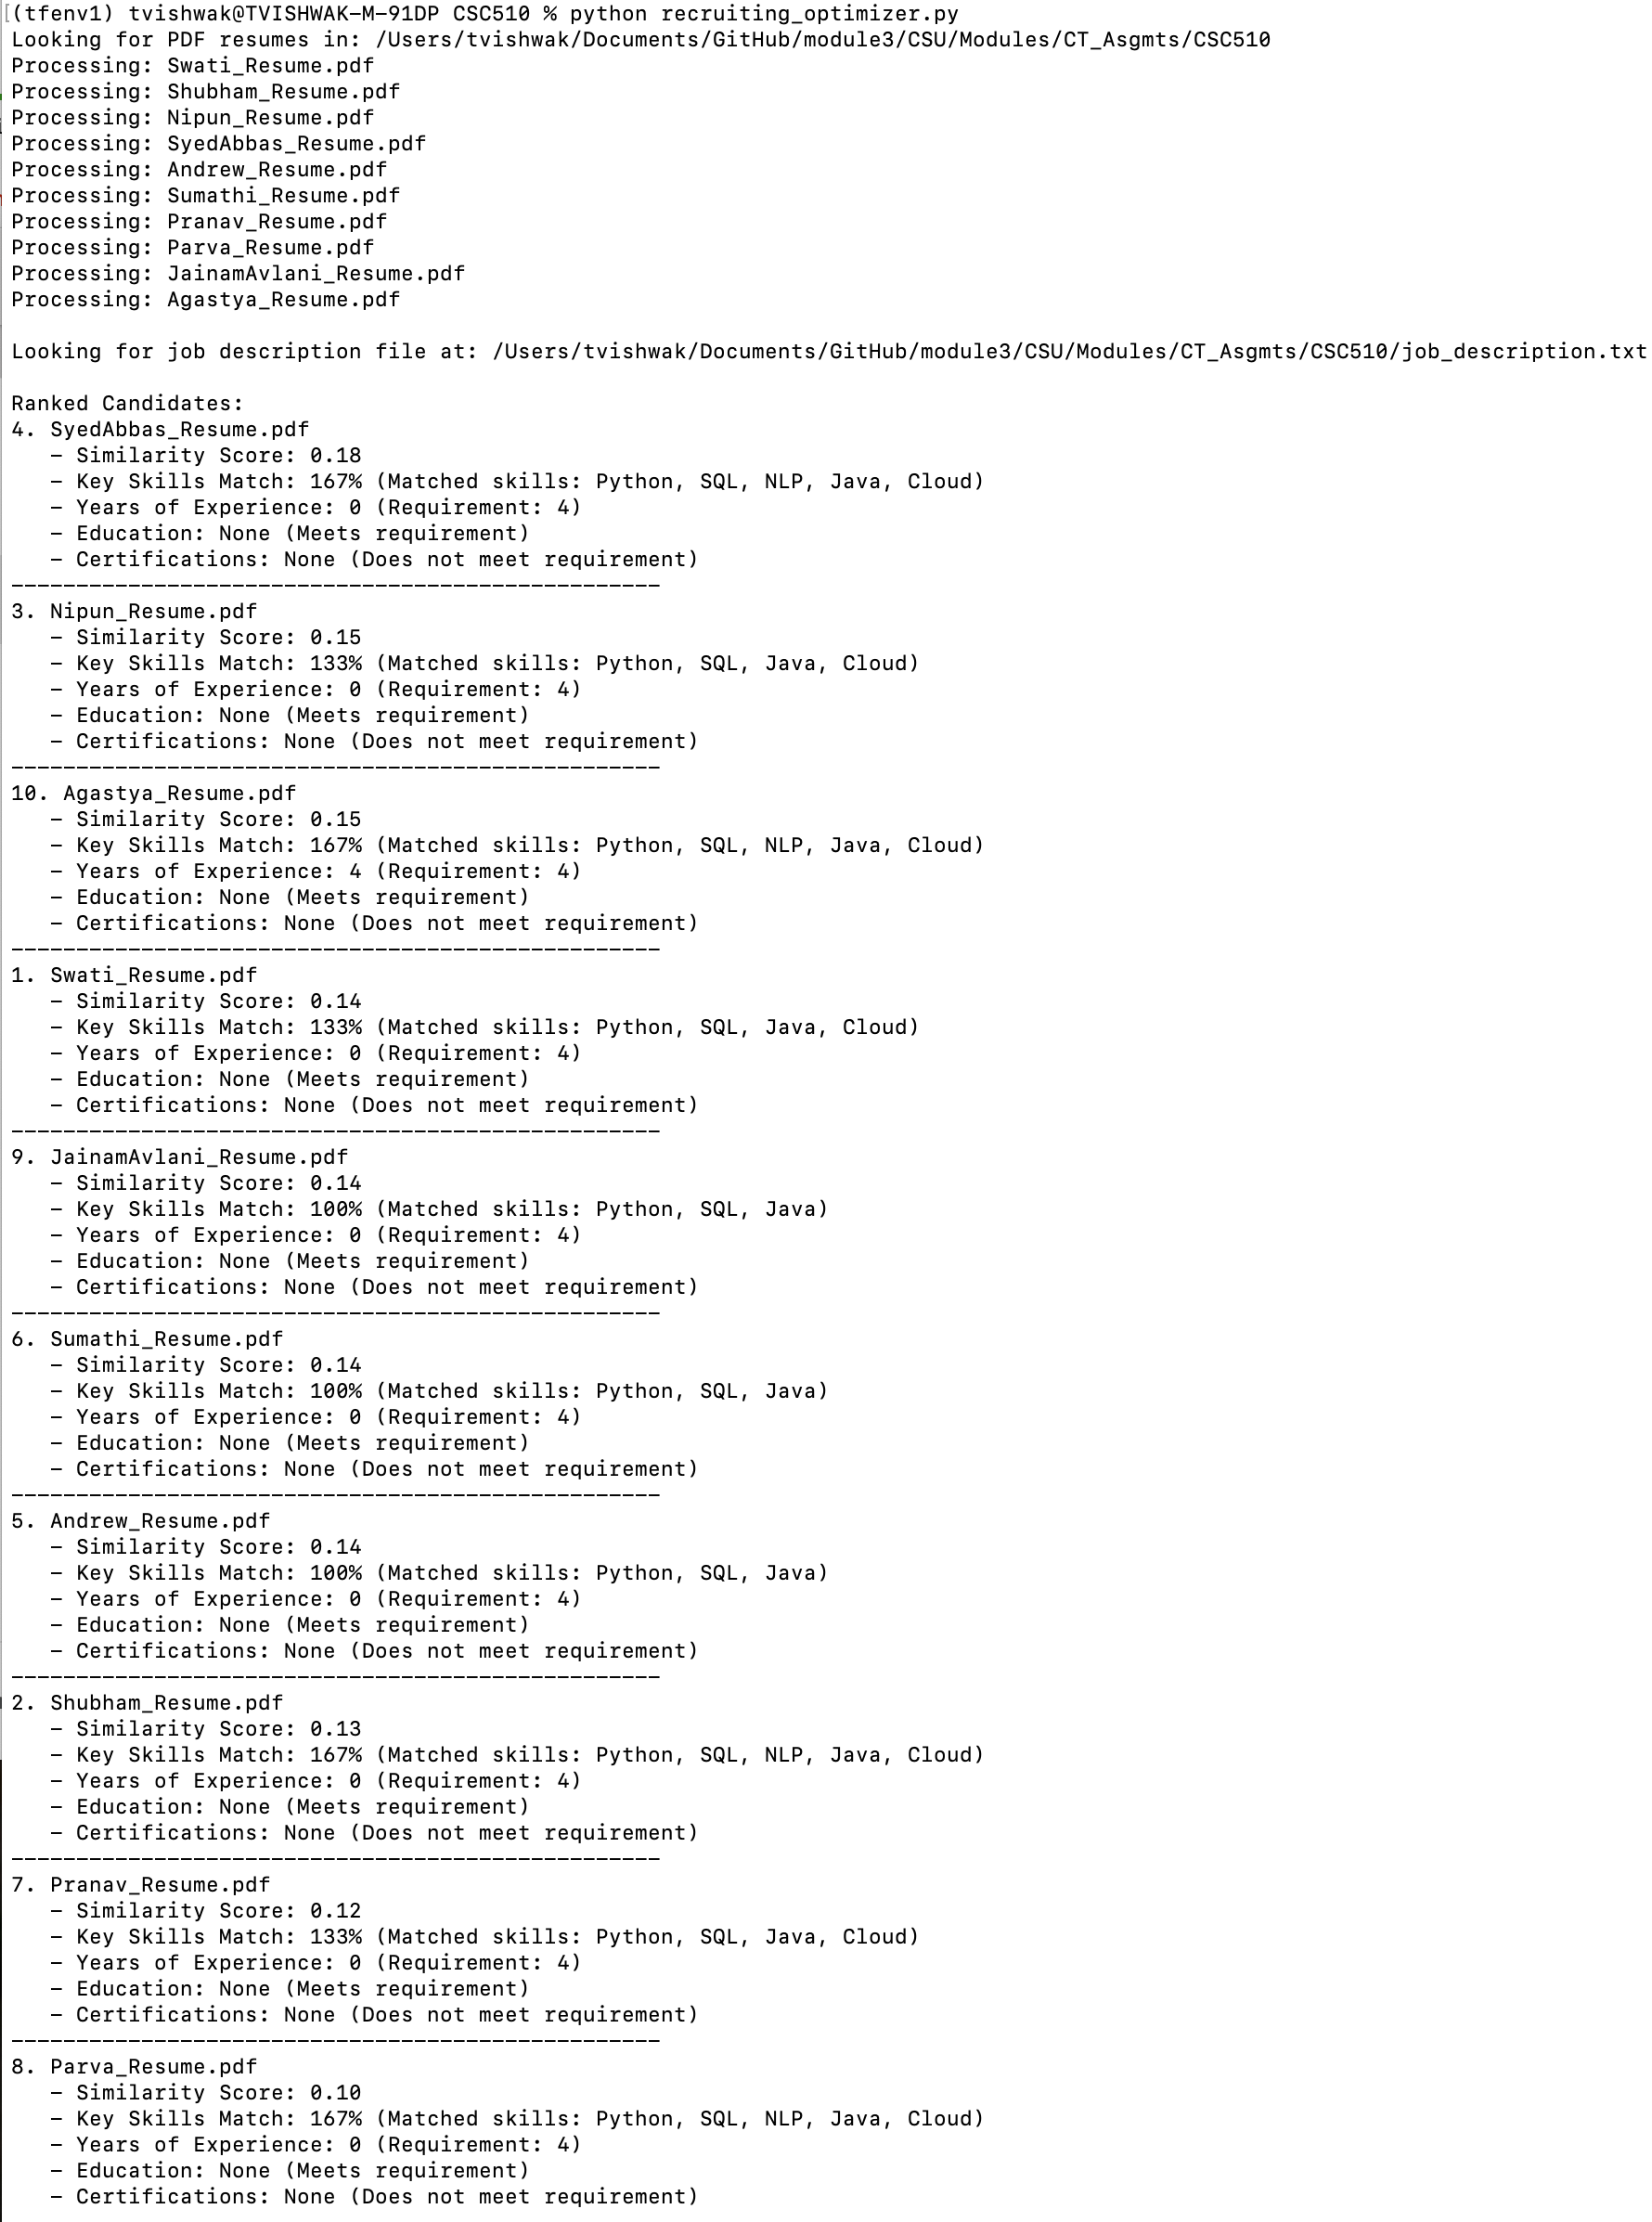

Conclusion

The AI-based Recruiting Optimization Program demonstrates how AI techniques can be applied to improve the efficiency and effectiveness of the hiring process. By leveraging tools like SpaCy, PyPDF2, and scikit-learn, the program automates the evaluation of resumes, reducing the manual workload for recruiters. The integration of expert system concepts and symbolic planning ensures that the program’s decision-making process is both logical and transparent.

While this iteration focuses on TF-IDF and rule-based methods, future enhancements could include deep learning models for better semantic understanding and advanced resume parsing techniques. With its modular design and flexibility, the program serves as a steppingstone toward fully automated and intelligent recruiting systems.

References

Cosine Similarity: https://www.geeksforgeeks.org/cosine-similarity/
Environment Setup: https://medium.com/@lucasthedev/a-comprehensive-guide-to-python-virtual-environments-with-venv-cb76fea6a550
Expert Systems: https://www.geeksforgeeks.org/expert-systems/
Natural Language Processing (NLP): https://en.wikipedia.org/wiki/Natural_language_processing
pandas: https://pandas.pydata.org
PyPDF2: https://pypi.org/project/PyPDF2/
Python: https://www.geeksforgeeks.org/python-programming-language-tutorial/
Regular Expressions (re): https://docs.python.org/3/library/re.html
scikit-learn: https://scikit-learn.org/stable/index.html
spaCy: https://spacy.io
Symbolic Planning: https://www.cs.toronto.edu/~lillanes/papers/IllanesYTM-rldm2019-symbolic.pdfPython
TF-IDF (Term Frequency-Inverse Document Frequency): https://www.geeksforgeeks.org/understanding-tf-idf-term-frequency-inverse-document-frequency/

