Topic: Simulate the First-Fit Algorithm
Tripti Vishwakarma
Colorado State University Global
Course code CSC507 1
Dr. Joseph Issa
Feb 21, 2025

Title: Memory Management - A Study of the First-Fit Algorithm

Introduction
Memory management is a crucial aspect of operating systems, ensuring efficient allocation and utilization of memory resources for various processes. The First-Fit algorithm is one of the simplest methods for memory allocation. It assigns the first available memory block that is large enough to accommodate a process. This paper explores the First-Fit algorithm, compares it with the Best-Fit algorithm, and discusses situations where Best-Fit may be more advantageous.
First-Fit Algorithm Explanation
The First-Fit algorithm operates by scanning memory blocks sequentially and allocating the first block that can fulfill a process's memory requirements. This strategy is straightforward and generally fast, as it minimizes the search time by stopping at the first suitable block.

Python Implementation
Below is a Python implementation of the First-Fit algorithm: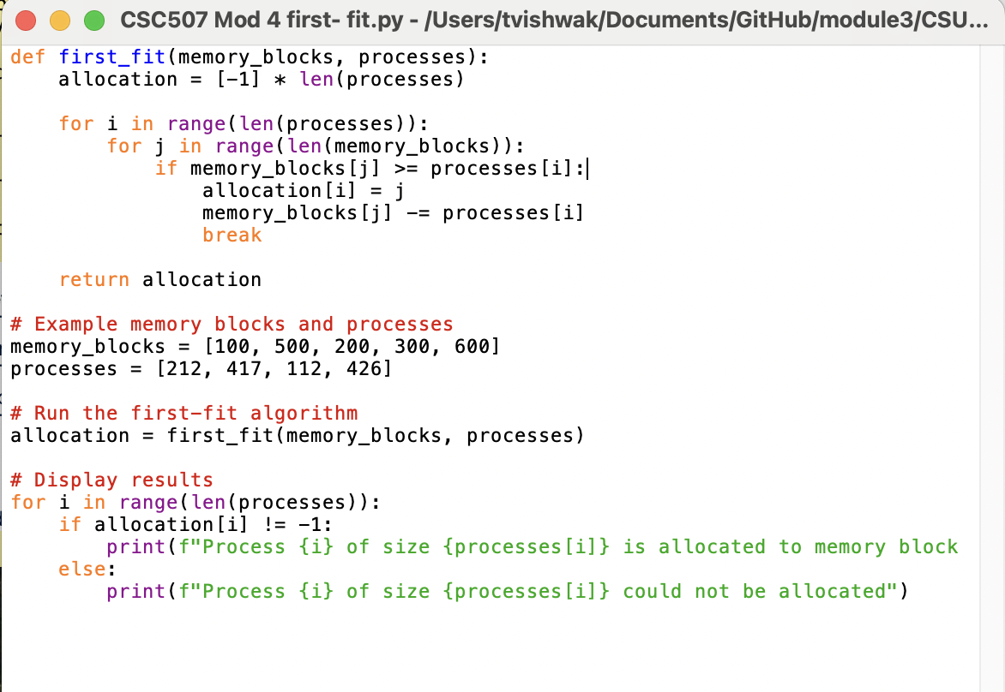
How the Code Works
- The first_fit function takes two parameters: a list of memory blocks and a list of processes.
- It iterates over each process, attempting to allocate it to the first block that is large enough to accommodate it.
- If a process is allocated, the size of the block is reduced by the size of the process.
- An allocation list keeps track of which block each process is allocated to (or -1 if it cannot be allocated).

Execution: 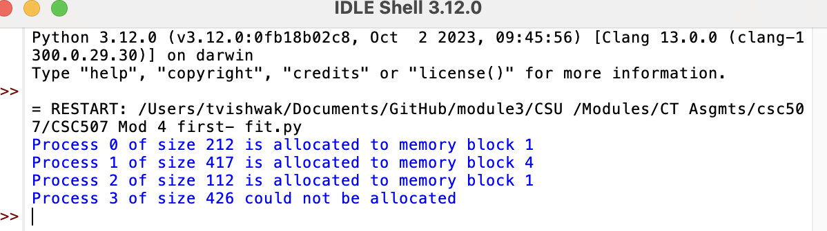

Results
The code above simulates the First-Fit memory allocation. It demonstrates how processes are allocated to memory blocks. The output indicates which process is allocated to which block or if it could not be allocated.
Comparison with Best-Fit Algorithm
The Best-Fit algorithm differs from First-Fit by searching for the smallest available block that is large enough to accommodate the process. This approach aims to minimize wasted space, potentially reducing fragmentation in the memory.

Key Differences
- Efficiency: First-Fit is typically faster because it stops searching once a suitable block is found. Best-Fit requires scanning all blocks, which can be more time-consuming.
- Fragmentation: Best-Fit often results in smaller leftover memory gaps compared to First-Fit, which can leave larger unused spaces if large blocks are allocated early.
Situations Favorable for Best-Fit
- Memory Fragmentation: In systems where memory fragmentation is a significant concern, Best-Fit might be preferable as it can make better use of memory by minimizing unused gaps.
- High Process Turnover: Environments with frequent process allocation and deallocation might benefit from Best-Fit's efficient use of space, ensuring more processes can be accommodated in limited memory.
- Specific Application Needs: Applications that require precise memory management, with little room for waste, may operate more effectively under Best-Fit allocation.

Conclusion
The choice between First-Fit and Best-Fit algorithms depends on the specific requirements and constraints of the operating environment. First-Fit is efficient in terms of speed, making it suitable for scenarios where quick allocation is necessary. In contrast, Best-Fit may be more appropriate in contexts where minimizing fragmentation and optimizing memory usage are critical.

References
- Stallings, W. (2018). Operating Systems: Internals and Design Principles. Pearson.
- Silberschatz, A., Galvin, P. B., & Gagne, G. (2018). Operating System Concepts. Wiley.
- Tanenbaum, A. S., & Bos, H. (2014). Modern Operating Systems. Pearson.

