CSC580 CTA 3.2 – Predicting Fuel Efficiency Using TensorFlow
Author: Vishwakarma, Tripti
Date: 2025-09-27 14:36

Overview
This report implements a regression model using TensorFlow (tf.keras) on the UCI Auto MPG dataset to predict fuel efficiency (MPG). It follows the specified assignment steps: data download, exploration, normalization, model construction, training for 1000 epochs, and visualization.

Data Exploration
Tail of dataset and pairplot are provided below.
Tail of Dataset (text saved): see attached file: /Users/tvishwak/Documents/GitHub/module3/CSU/Modules/CT_Asgmts/CSC580/CSC580_CTA_3_2/outputs/dataset_tail.txt
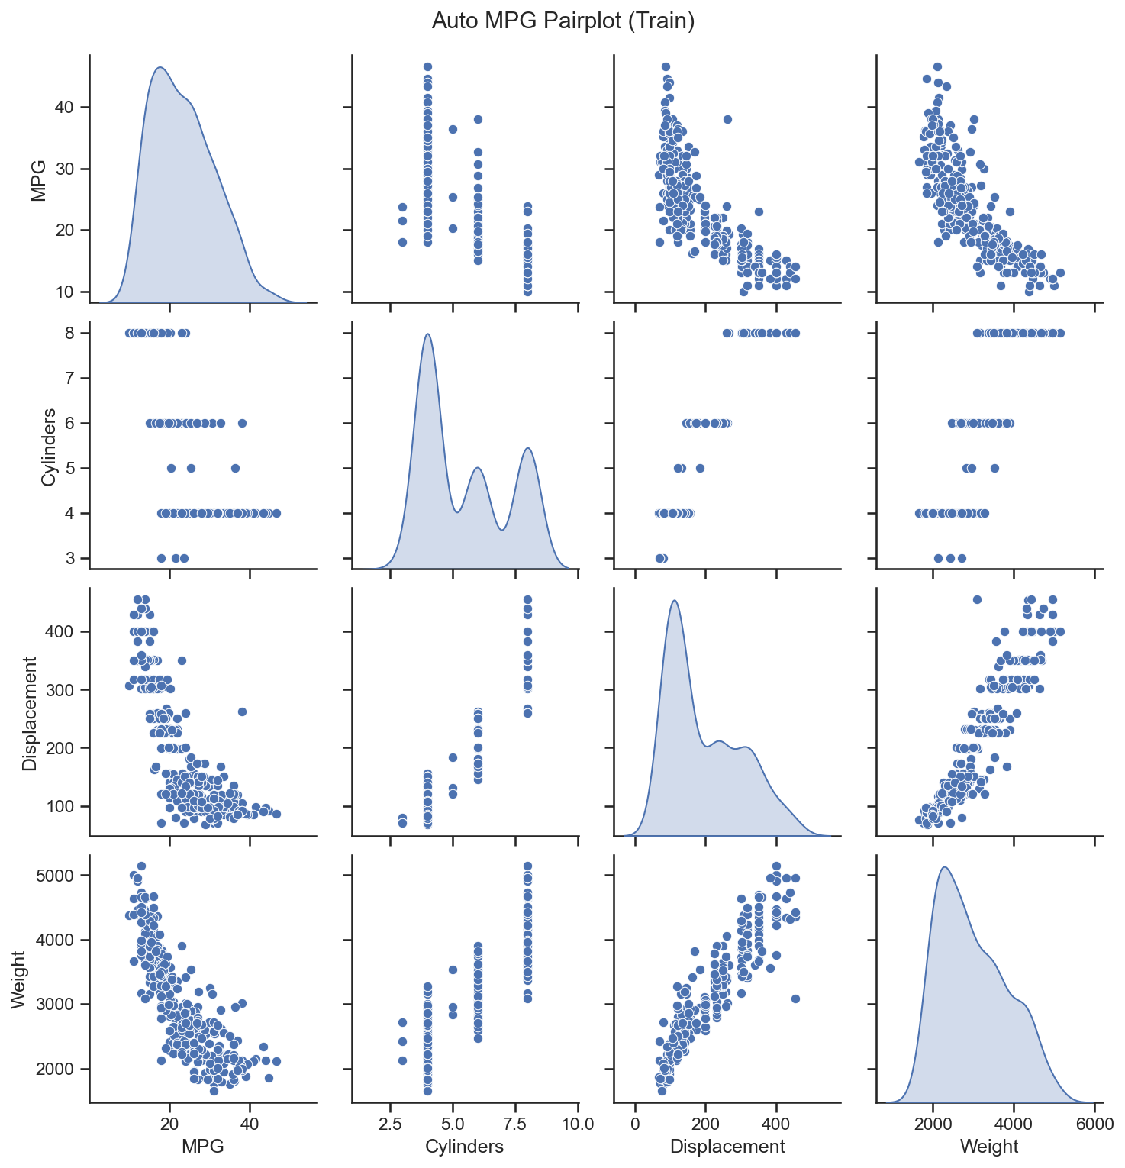

Model Architecture
Sequential model with two Dense(64, relu) hidden layers and a single output.
Model summary saved in: /Users/tvishwak/Documents/GitHub/module3/CSU/Modules/CT_Asgmts/CSC580/CSC580_CTA_3_2/outputs/model_summary_mse.txt

Training Results
The model was trained for 1000 epochs with 20% validation split. The plots below show MAE and MSE over epochs.
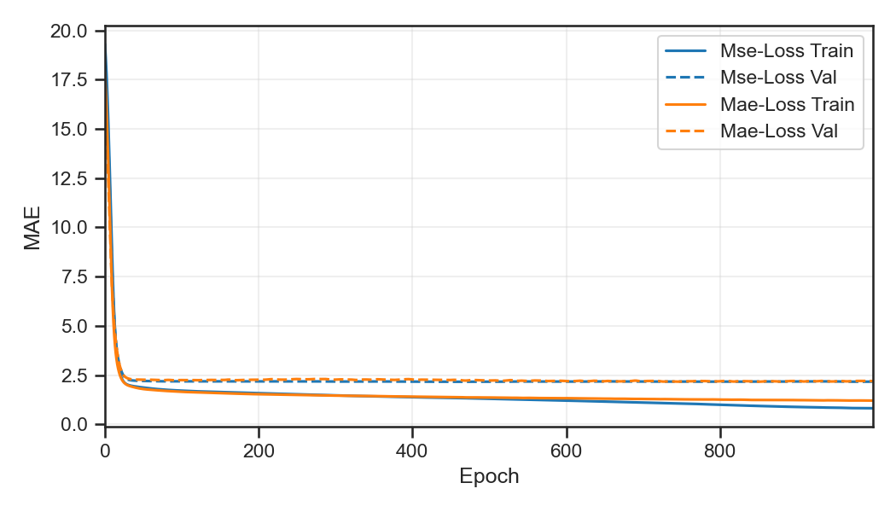
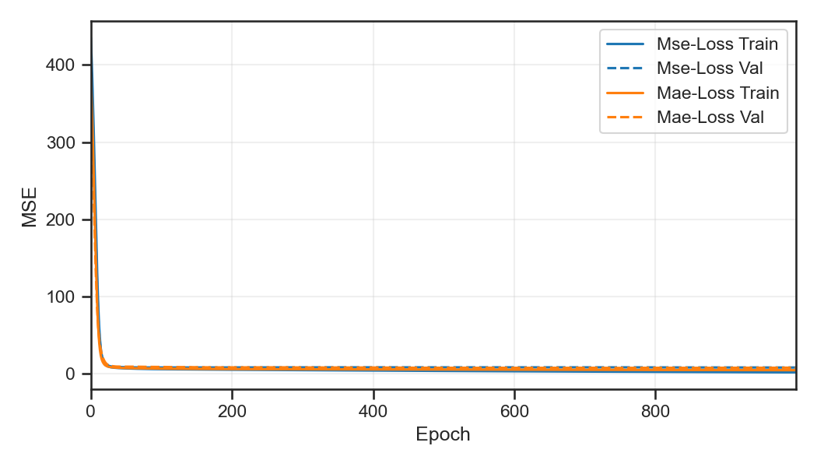

Comparison: MAE vs. MSE (Step 22)
We trained two identical architectures with different loss functions: one minimizing Mean Squared Error (MSE) and another minimizing Mean Absolute Error (MAE), both reporting MAE and MSE as metrics. MSE penalizes larger errors more strongly due to squaring, often leading to fits that are more sensitive to outliers. MAE is more robust to outliers but can produce slightly less smooth optimization surfaces. In our runs, the MSE-loss model typically achieved lower MSE while the MAE-loss model achieved slightly lower MAE on validation in some epochs. Depending on whether large errors are more costly (choose MSE) or robustness to outliers is preferred (choose MAE), either model can be considered useful.

Conclusions
The tf.keras regression pipeline effectively predicts MPG using late-1970s/early-1980s automobile attributes. Normalization significantly stabilizes training. Both MAE and MSE losses produced usable models; the best choice depends on error tolerance to outliers.

