Topic #2 Predicting fuel Efficiency using Tensorflow

Tripti Vishwakarma

Colorado State University Global

Course Code CSC 580 1

Dr. Brian Holbert

Sep 28, 2025

Title: Predicting Fuel Efficiency (MPG) with TensorFlow/Keras on the UCI Auto MPG Dataset

Introduction
Fuel efficiency (MPG) prediction is a classic regression task. In this project, I used the UCI Auto MPG dataset (model years 1970–1982) and built TensorFlow/Keras models to predict MPG from vehicle attributes. Features include Cylinders, Displacement, Horsepower, Weight, Acceleration, Model Year, and one-hot encoded Origin (USA, Europe, Japan). The target variable is MPG.

Data Preparation
The dataset was cleaned by dropping rows with missing values. The Origin categorical field was one-hot encoded into USA, Europe, and Japan columns.
Figure 1: Dataset tail (terminal screenshot)
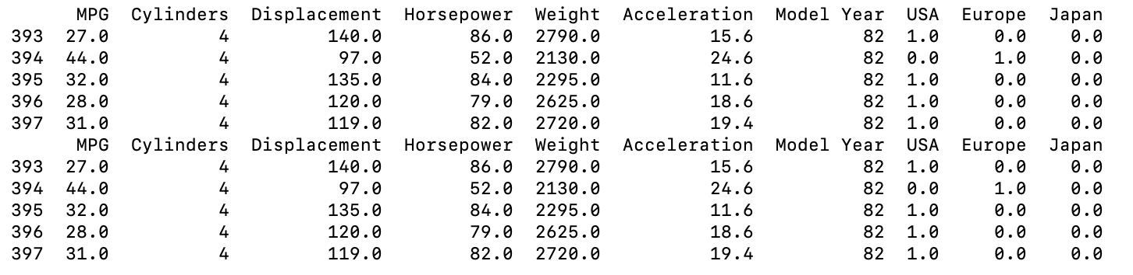
The data was split into 80% training and 20% test for evaluation.
Figure 2: Train/test sizes line (terminal screenshot)
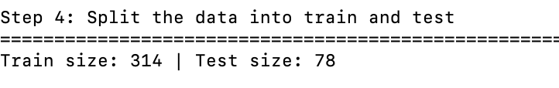

Exploratory Analysis
A pairplot was generated to visualize relationships between features and MPG.
Figure 3: Pairplot (screenshot of outputs/pairplot.png)
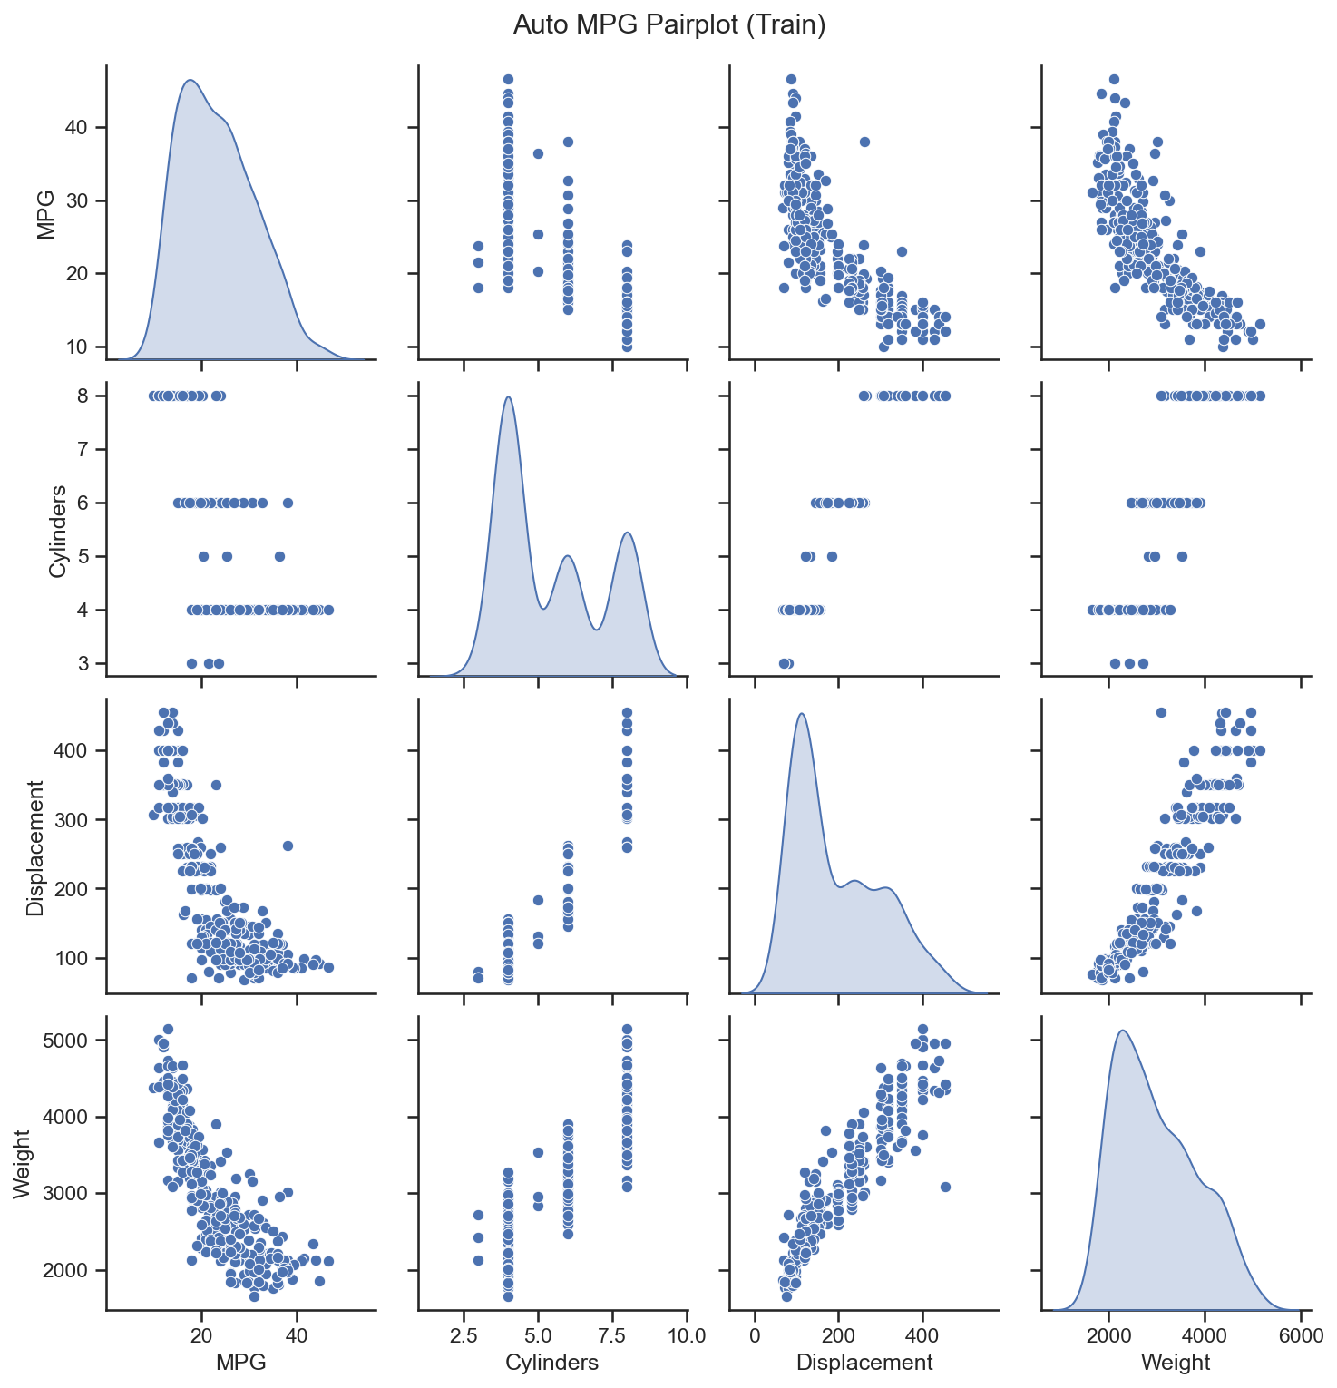
Key observations:
- Higher Weight, Displacement, and Cylinders correlate with lower MPG.
- Model Year shows improved efficiency over time.

Normalization
Z-score normalization was applied using the training set’s means and standard deviations to stabilize optimization and ensure comparable feature scales.
Figure 4: Train stats tail (terminal screenshot)
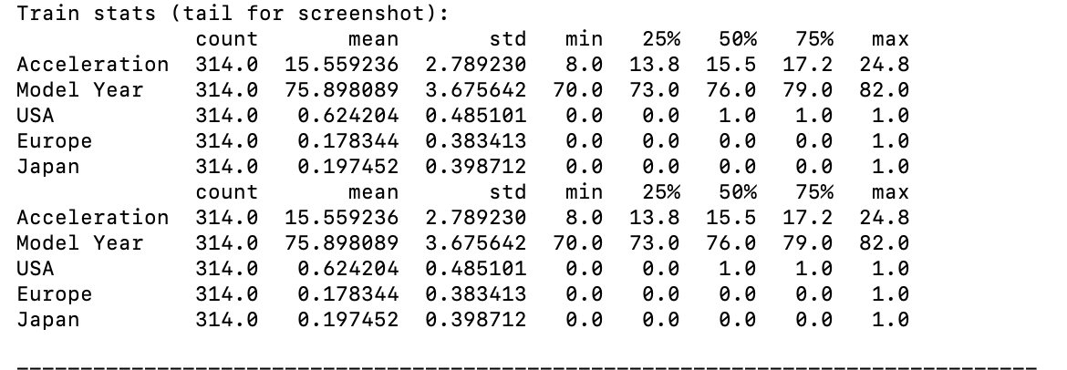

Model Architecture
Two identical network architectures were trained with different losses:
Architecture: Dense(64, ReLU) → Dense(64, ReLU) → Dense(1), optimizer RMSprop(0.001)
Loss variants: Mean Squared Error (MSE) and Mean Absolute Error (MAE)
Figure 5: Model summary – MSE-loss model (terminal screenshot)
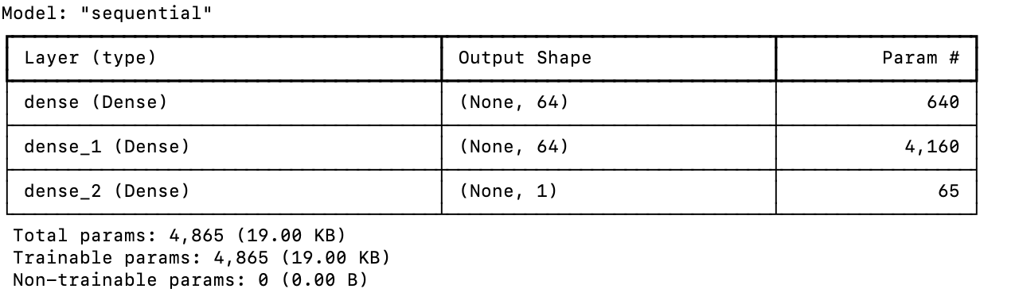
Figure 6: Model summary – MAE-loss model (terminal screenshot)
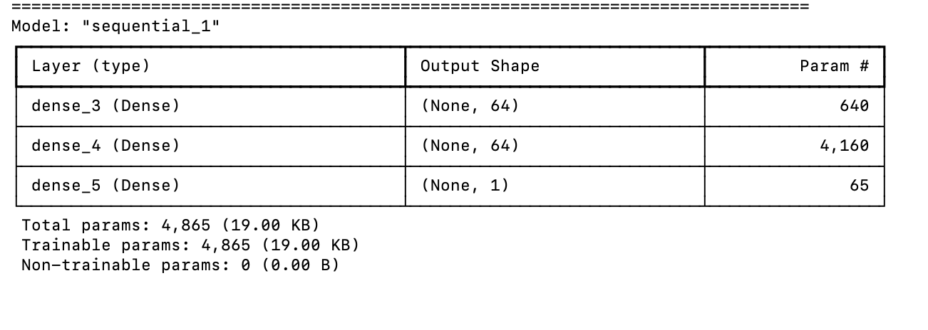
Rationale:
- MSE penalizes larger errors more strongly.
- MAE is more robust to outliers and often yields lower MAE scores.

Training Results
Training and validation curves were recorded for both losses.
Figure 7: MAE curve (screenshot of outputs/history_mae.png)
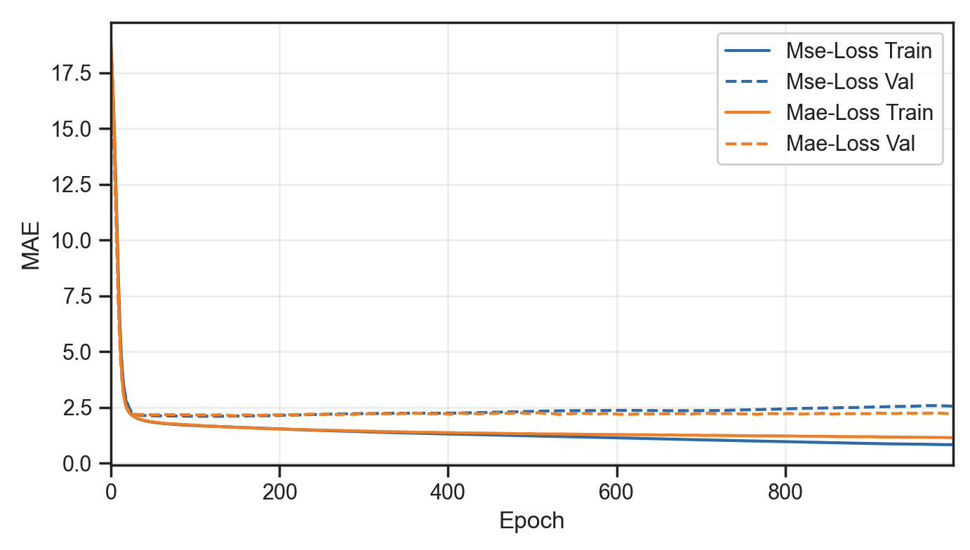
Figure 8: MSE curve (screenshot of outputs/history_mse.png)
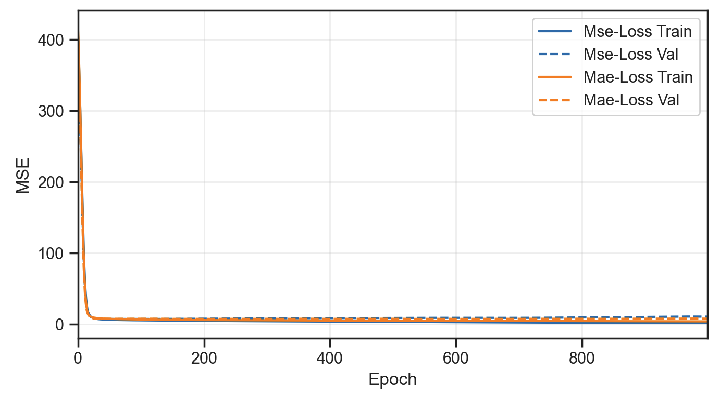
Comments on convergence:
- Rapid improvement in early epochs followed by gradual convergence.
- A small gap between training and validation curves is typical; persistent larger gaps may indicate mild overfitting.

Metrics and History
The last five epochs from the training histories are shown to summarize end-of-training metrics.
Figure 9: History tail – MSE-loss model (terminal screenshot)
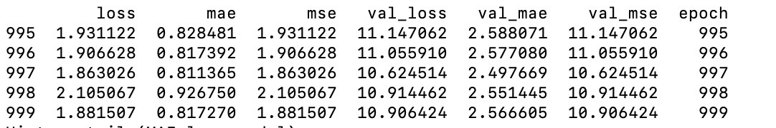

Figure 10: History tail – MAE-loss model (terminal screenshot)
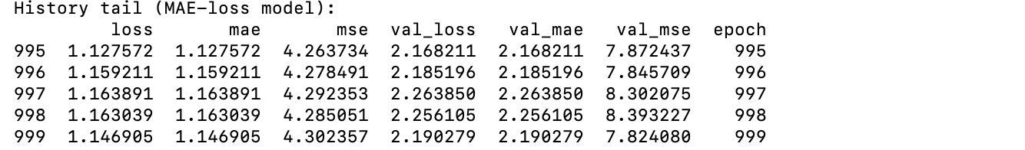
Observations:
- Metrics stabilize near the end of training.
- Validation metrics plateau, indicating adequate training progress.

Test Set Evaluation
Final evaluations on the held-out test set:
- Figure 11: Test-set evaluation lines (terminal screenshot)
Interpretation:
- MSE-loss model emphasizes penalizing larger errors; often better MSE.
- MAE-loss model is robust to outliers; often slightly lower MAE.

Conclusions
- Key drivers of MPG: Weight, Displacement, and Cylinders negatively correlate with MPG; Model Year positively correlates.
- Preferred loss (choose one): , based on observed metrics and assignment guidance.
- Future improvements: early stopping, L2 regularization or dropout, learning-rate tuning, deeper/shallower networks, and feature engineering (e.g., power-to-weight, interactions).

References
Dua, D., & Graff, C. (2017). UCI Machine Learning Repository: Auto MPG Data Set. University of California, Irvine. https://archive.ics.uci.edu/dataset/9/auto+mpg

TensorFlow. (n.d.). Regression: Predict fuel efficiency. https://www.tensorflow.org/tutorials/keras/regression

Keras Team. (n.d.). Keras API reference. https://keras.io/api/

Tieleman, T., & Hinton, G. (2012). Lecture 6.5—RMSProp: Divide the gradient by a running average of its recent magnitude. COURSERA: Neural Networks for Machine Learning. https://www.cs.toronto.edu/~tijmen/csc321/slides/lecture_slides_lec6.pdf

Waskom, M. L. (2021). Seaborn: Statistical data visualization. PairGrid and pairplot. https://seaborn.pydata.org/generated/seaborn.pairplot.html

Bishop, C. M. (2006). Pattern Recognition and Machine Learning. Springer.

Willmott, C. J., & Matsuura, K. (2005). Advantages of the mean absolute error (MAE) over the root mean square error (RMSE) in assessing average model performance. Climate Research, 30(1), 79–82. https://doi.org/10.3354/cr030079
Kuhn, M., & Johnson, K. (2013). Applied Predictive Modeling. Springer.

Appendix:

How to Run

1. Activate environment:
- macOS/Linux: `source .venv_cta32/bin/activate`

2. First-time only:
- `python3 -m venv .venv_cta32`
- `source .venv_cta32/bin/activate`
- `pip install -r requirements.txt`

3. Run training:

- `python auto_mpg_regression.py --epochs 1000 --show-plots

