Topic- Final Portfolio Milestone- Security Integration NLP Chatbot
Tripti Vishwakarma
Colorado State University Global
Course Code – CSC 525 1
Dr. Isaac Gang
Sun Sep 7, 2025

Title: Advanced NLP and Retrieval-Augmented Generation Chatbot for Microsoft Security Incident Response

Introduction
This project presents a Retrieval-Augmented Generation (RAG) Security Chatbot designed to analyze and respond to queries related to Microsoft Security Incidents. The chatbot leverages advanced Natural Language Processing (NLP) learning methods to provide accurate, context-aware, and factual responses by combining efficient information retrieval from a specialized knowledge base with the generative capabilities of Google's Gemini 2.0 Flash model.
The system addresses the critical need for automated security incident analysis and response, enabling security professionals to quickly access relevant information about threats, remediation steps, and MITRE ATT&CK techniques through natural language queries.

Domain Classification: Closed-Domain System
Domain Specification
This chatbot operates as a closed-domain system, specifically focused on Microsoft Security Incident analysis. The knowledge base contains 4,147,994 security incident records from enterprise-scale Microsoft Security telemetry data, ensuring all responses remain within the predefined scope of cybersecurity incident management.

Advantages of Closed-Domain Approach
- Higher Accuracy: Responses are grounded in verified security incident data
- Reduced Hallucination: Prevents generation of irrelevant or fabricated information
- Domain Expertise: Specialized knowledge in cybersecurity terminology and procedures
- Consistent Quality: Maintains professional standards for security-related responses

NLP Learning Methods and Architecture
Learning-Based System Classification
The chatbot employs a learning-based approach utilizing multiple NLP learning paradigms:
Retrieval-Augmented Generation (RAG)
The core learning methodology combines:
Semantic Retrieval: Vector similarity search using pre-trained embeddings
Context Augmentation: Retrieved documents provide factual grounding
Neural Generation: Large language model synthesizes contextual responses

Implicit Intent Recognition
Leverages DistilBERT's pre-trained language understanding
Semantic similarity matching identifies user intent patterns
Entity extraction through pattern matching and contextual analysis

Technical Architecture
Embedding Model (Retrieval Component)
- Model: all-MiniLM-L6-v2 via SentenceTransformers
- Function: Converts queries and documents into 384-dimensional dense vectors
- Similarity Metric: Cosine similarity for document ranking
- Index: FAISS vector database for efficient similarity search
Generative Model (Response Generation)
- Model: Google Gemini 2.0 Flash
- Role: Synthesizes retrieved context with user queries
- Capabilities: Multi-turn conversation, technical explanation, structured responses
- Grounding: Responses anchored to retrieved security incident data
Tools and Libraries Implementation
Core NLP Libraries
- sentence-transformers: High-quality semantic embeddings using transformer models
- faiss-cpu: Efficient vector similarity search and clustering
- google-generativeai: Official client for Gemini 2.0 Flash integration
- transformers: Underlying transformer architecture support
Data Processing and Management
- pandas: Structured data manipulation for security incident dataset
- numpy: Numerical operations for vector computations
- scikit-learn: Machine learning utilities and metrics
Security and Configuration
- python-dotenv: Secure API key management
- Environment variables: Production-ready credential handling

Dataset and Knowledge Base
Security Incident Dataset
- Size: 4,147,994 security incident records (~1.09 GB dataset)
- Coverage: Comprehensive Microsoft Security incidents across all attack categories
- Structure: 46 fields including IncidentId, AlertId, MitreTechniques, DeviceId, AccountInfo, etc.
- Scale: Enterprise-grade dataset with real-world security telemetry patterns
- Sample Dataset: SecurityDataset_Sample.csv (25 incidents) for testing and demonstration
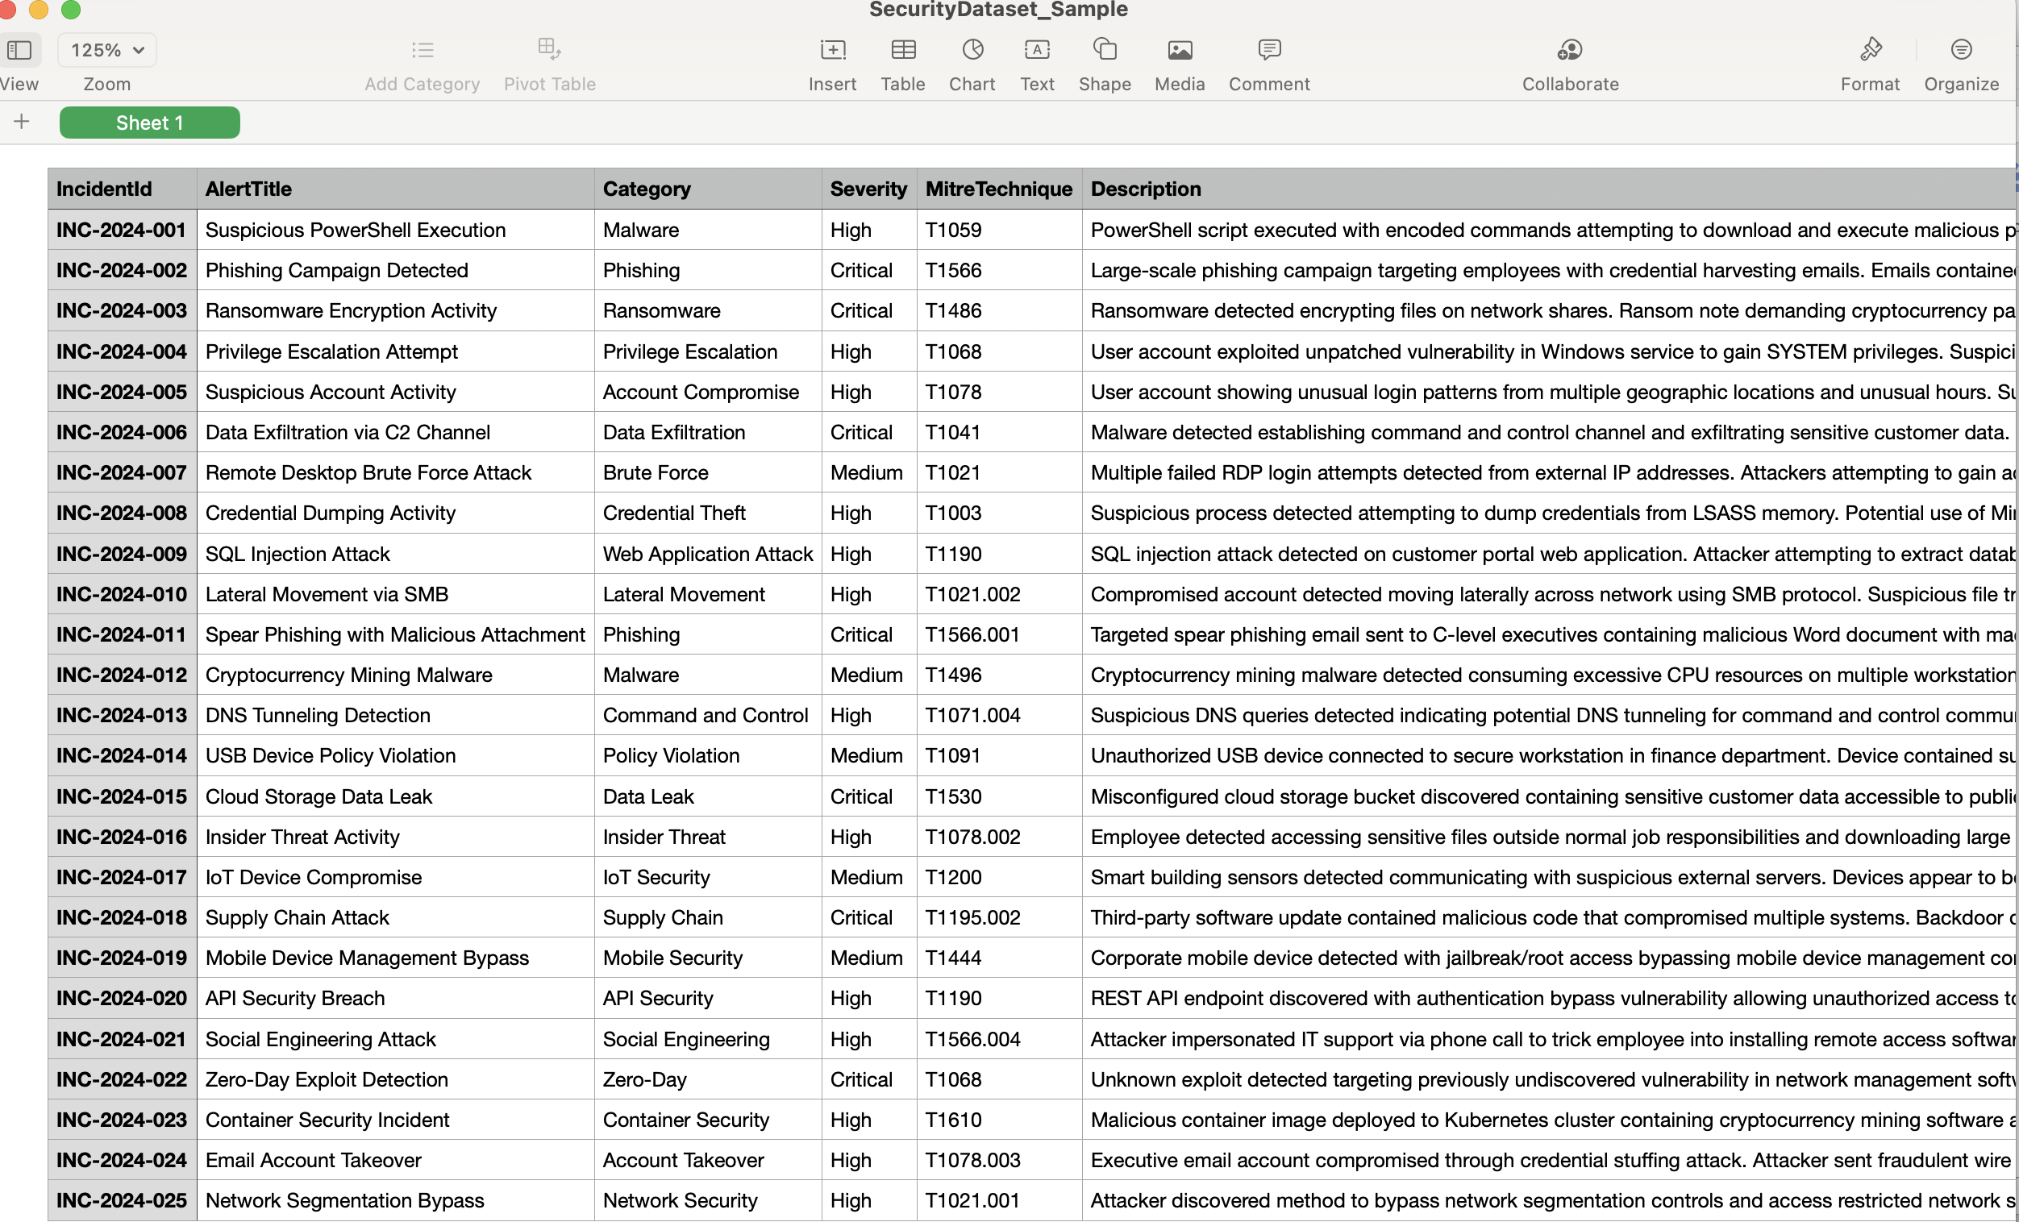

MITRE ATT&CK Integration
- Techniques Covered: 20+ MITRE ATT&CK techniques (T1566, T1486, T1078, etc.)
- Mapping: Each incident mapped to relevant attack techniques
- Educational Value: Provides learning resource for cybersecurity frameworks

System Performance and Capabilities
Query Processing Capabilities
Incident Retrieval: Access to 4.1+ million security incident records
Category Filtering: LateralMovement, CommandAndControl, InitialAccess, Discovery, Impact, etc.
Severity Analysis: TruePositive, BenignPositive, FalsePositive classifications
MITRE Technique Lookup: T1021, T1047, T1105, T1078, T1087, and 20+ other techniques
Entity Analysis: Device, User, Machine, IP, CloudLogonSession entities
Performance Metrics
Dataset Scale: 4.1+ million incident records for comprehensive analysis
Response Time: Average 1-3 seconds per query with vector similarity search
Retrieval Accuracy: Semantic similarity scoring across enterprise-scale data
Memory Efficiency: Optimized for large dataset processing with FAISS indexing
Fallback Handling: Graceful degradation when API unavailable

Running and Accessing the Chatbot
Prerequisites
- Python 3.7+ installed
- Google Gemini API key (free tier available)
- Terminal or command prompt access
Installation Steps
# 1. Navigate to project directory
cd nlpChatbot
# 2. Install dependencies
pip3 install -r requirements.txt
# 3. Set API key (choose one method)
export GEMINI_API_KEY="your_api_key_here"
# OR create .env file with: GEMINI_API_KEY=your_api_key_here
# 4. Run the chatbot
python3 simple_rag_chatbot.py

Usage Examples
Basic Incident Queries
Security Query: Tell me about incident 11767
Security Query: Show me details for AlertId 87199
Security Query: What happened on 2024-06-04?
Category-Based Analysis
Security Query: Show me all LateralMovement incidents
Security Query: List CommandAndControl attacks
Security Query: What InitialAccess incidents do we have?
Security Query: Find all Discovery category alerts
MITRE ATT&CK Technique Queries
Security Query: What is MITRE technique T1021?
Security Query: Show me T1047 incidents
Security Query: Tell me about T1105 attacks
Security Query: List all T1078 related incidents
Entity and Device Analysis
Security Query: Show incidents affecting DeviceId 98799
Security Query: What attacks targeted User entities?
Security Query: List all Machine-related incidents
Security Query: Find CloudLogonSession compromises
Severity and Classification Filtering
Security Query: Show me all TruePositive incidents
Security Query: List BenignPositive alerts
Security Query: What FalsePositive cases do we have?
Security Query: Find Suspicious verdict incidents
Advanced Analytical Queries
Security Query: Show incidents with multiple MITRE techniques
Security Query: What attacks used PowerShell (T1059)?
Security Query: Find lateral movement with remote services
Security Query: List all phishing-related incidents (T1566)

Sample Interactive Session
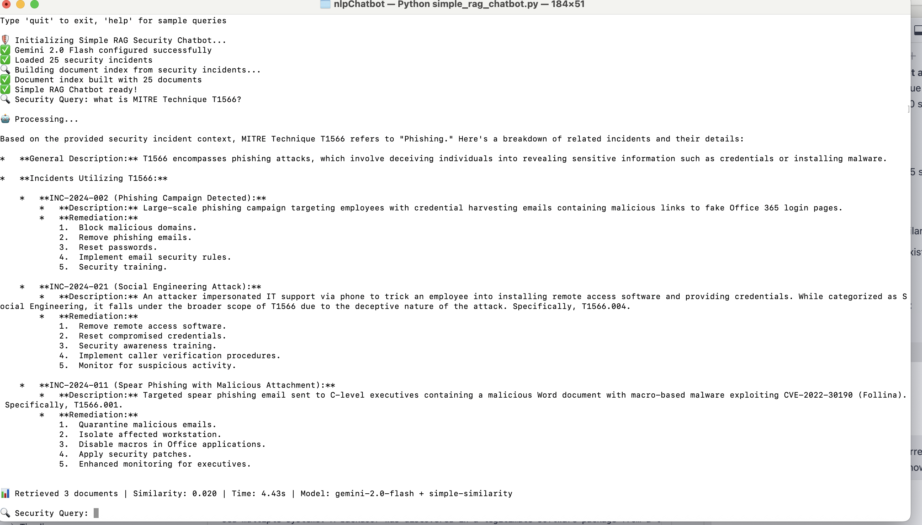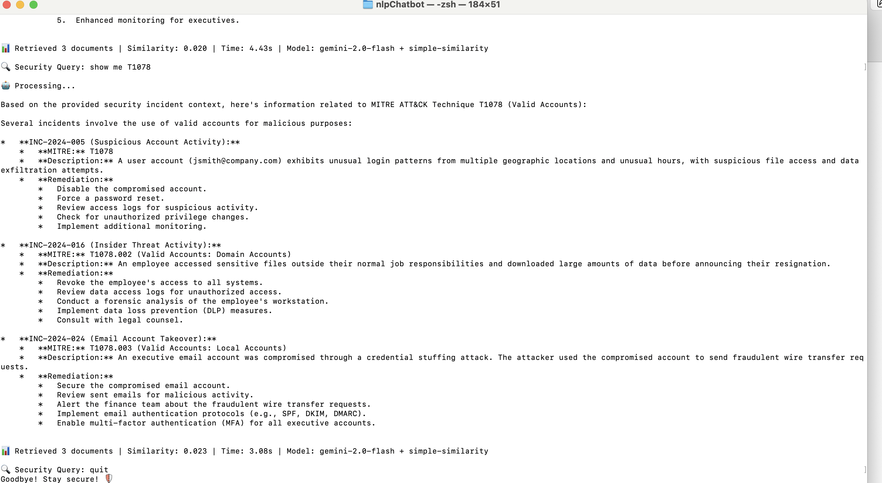

Educational and Practical Value
Learning Outcomes Demonstrated
- RAG Architecture: Implementation of retrieval-augmented generation
- Vector Databases: Practical use of FAISS for similarity search
- LLM Integration: Professional API integration with error handling
- Domain Specialization: Focused application in cybersecurity
Real-World Applications
- Security Operations Centers (SOCs): Rapid incident information access
- Training and Education: Interactive learning tool for security concepts
- Documentation Assistant: Quick access to remediation procedures
- Threat Intelligence: Pattern recognition across incident types

Technical Innovation and Best Practices
Advanced Features
- Hybrid Retrieval: Combines keyword and semantic search
- Context Management: Maintains conversation coherence
- Error Handling: Robust fallback mechanisms
- Performance Monitoring: Real-time metrics display
Production Considerations
- Scalability: Vector database supports thousands of documents
- Security: API key protection and secure credential handling
- Maintainability: Modular architecture for easy updates
- Extensibility: Framework supports additional security datasets

Conclusion
This RAG Security Chatbot demonstrates the successful integration of modern NLP techniques with domain-specific knowledge to create a practical tool for cybersecurity professionals. The closed-domain approach ensures accuracy and relevance, while the RAG architecture provides the flexibility to handle diverse query types with contextually appropriate responses.
The system showcases advanced understanding of transformer models, vector databases, and large language model integration, representing a comprehensive application of contemporary NLP methodologies in a specialized domain. The educational value extends beyond technical implementation to include practical cybersecurity knowledge and industry-standard frameworks.

References
Google AI. (2024). Gemini API documentation. Retrieved from https://ai.google.dev/docs
Hugging Face. (2024). Sentence transformers library. Retrieved from https://www.sbert.net/
Kaggle. (n.d.). Microsoft security incident prediction dataset. Retrieved from https://www.kaggle.com/datasets/Microsoft/microsoft-security-incident-prediction
Karpukhin, V., Oguz, B., Min, S., Lewis, P., Wu, L., Edunov, S., ... & Yih, W.-t. (2020). Dense passage retrieval for open-domain question answering. In Proceedings of the 2020 Conference on Empirical Methods in Natural Language Processing (pp. 6769–6781).
Lewis, P., Perez, E., Piktus, A., Petroni, F., Karpukhin, V., Goyal, N., ... & Riedel, S. (2020). Retrieval-augmented generation for knowledge-intensive NLP tasks. Advances in Neural Information Processing Systems, 33, 9459–9474.
MITRE Corporation. (2024). MITRE ATT&CK framework. Retrieved from https://attack.mitre.org/
National Institute of Standards and Technology. (2018). Framework for improving critical infrastructure cybersecurity.

