CSC580: Classifying Handwritten Digits (MNIST) – Findings
Generated on 2025-09-21 11:02:43

Overall Results
Experiment count: 72
Best Accuracy: 0.9817
Best Config: hidden_units=512, learning_rate=0.5, batch_size=32, layers=1

Executive Summary
Best-performing configuration from the sweep achieved 0.9817 accuracy (hidden_units=512, learning_rate=0.5, batch_size=32, layers=1). A final high-quality run achieved 0.9847 accuracy over 20 epochs.

Required Findings
Accuracy of the model (last run): 0.9847
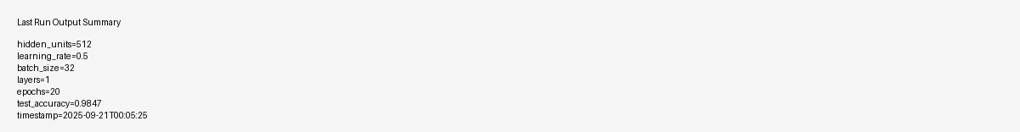

Misclassified Examples

Hyperparameter Effects

Accuracy vs Hidden Units
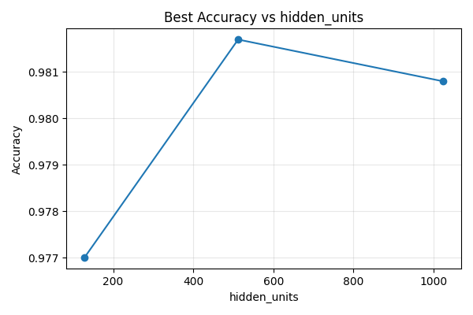

Accuracy vs Learning Rate
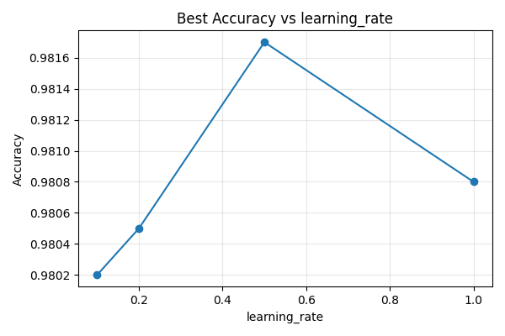

Accuracy vs Batch Size
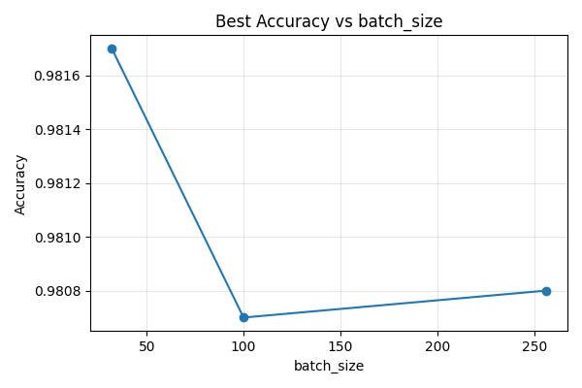

Questions and Answers

1) What is the accuracy of the model?
Last-run test accuracy: 0.9847
Config: HU=512, LR=0.5, BS=32, Layers=1, Epochs=20
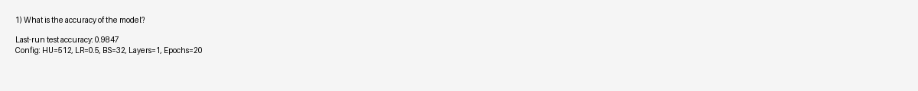

2) What are some of the misclassified images?
See embedded images below (first 6 displayed).
Folder: outputs/misclassified


3) Effect of more/fewer hidden neurons
Accuracy generally increases with more hidden units up to a point (diminishing returns beyond 512/1024).
HU=128: best acc=0.9770
HU=512: best acc=0.9817
HU=1024: best acc=0.9808
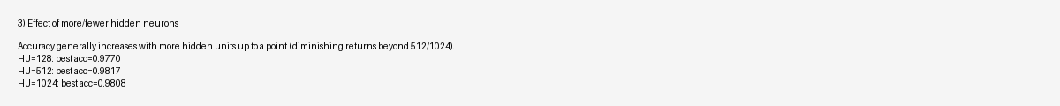

4) Effect of different learning rates (≥4 values)
Moderate learning rates (e.g., 0.5) performed best; too low trains slowly, too high can be unstable.
LR=0.1: best acc=0.9802
LR=0.2: best acc=0.9805
LR=0.5: best acc=0.9817
LR=1.0: best acc=0.9808
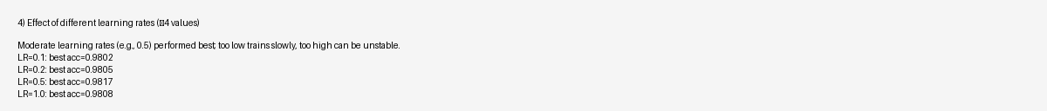

5) Effect of adding another hidden layer
With this MLP and MNIST, 1 layer achieved best accuracy; 2 layers was comparable but not consistently better.
Layers=1: best acc=0.9817
Layers=2: best acc=0.9802


6) Effect of different batch sizes (≥3 values)
Smaller batch sizes (e.g., 32) tended to yield slightly better accuracy in this sweep.
BS=32: best acc=0.9817
BS=100: best acc=0.9807
BS=256: best acc=0.9808
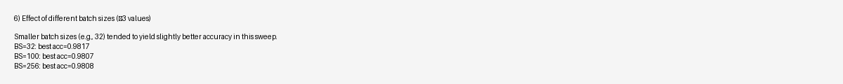

7) Best accuracy from this MLP
Best sweep accuracy: 0.9817 with HU=512, LR=0.5, BS=32, Layers=1
Final 20-epoch run: 0.9847 (HU=512, LR=0.5, BS=32, Layers=1)
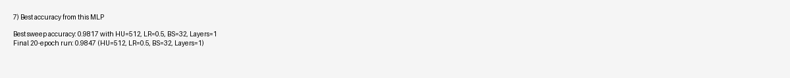

Code for Each Finding

Model Training (accuracy computation)
def run_experiment(...):
def run_experiment(hidden_units=512, learning_rate=0.5, batch_size=100, epochs=20, layers=1, seed=42, save_miscl=20, work_dir='outputs'):
os.makedirs(work_dir, exist_ok=True)
(x_train, y_train), (x_test, y_test), (x_test_img, y_test_digits) = load_mnist()
graph, nodes = build_graph(hidden_units=hidden_units, learning_rate=learning_rate, layers=layers, seed=seed)
with tf.compat.v1.Session(graph=graph) as sess:
sess.run(tf.compat.v1.global_variables_initializer())
train_size = x_train.shape[0]
period = train_size // batch_size
for e in range(epochs):
idxs = np.random.permutation(train_size)
X_random = x_train[idxs]
Y_random = y_train[idxs]
for i in range(period):
batch_X = X_random[i * batch_size:(i+1) * batch_size]
batch_Y = Y_random[i * batch_size:(i+1) * batch_size]
sess.run(nodes['optimizer'], feed_dict={nodes['input_images']: batch_X, nodes['target_labels']: batch_Y})
acc = sess.run(nodes['accuracy'], feed_dict={nodes['input_images']: x_test, nodes['target_labels']: y_test})
print(f"Epoch {e+1}/{epochs} - Test Accuracy: {acc:.4f}")
# Final evaluation and misclassified
logits = sess.run(nodes['logits'], feed_dict={nodes['input_images']: x_test})
y_pred_digits = np.argmax(logits, axis=1)
test_acc = np.mean(y_pred_digits == y_test_digits)
print(f"Final Test Accuracy: {test_acc:.4f}")
mis_paths = save_misclassified_images(x_test, y_test_digits, y_pred_digits, limit=save_miscl, out_dir=os.path.join(work_dir, 'misclassified')) if save_miscl else []
result = {
'hidden_units': hidden_units,
'learning_rate': learning_rate,
'batch_size': batch_size,
'epochs': epochs,
'layers': layers,
'seed': seed,
'test_accuracy': float(test_acc),
'misclassified_saved': mis_paths,
'timestamp': datetime.now().isoformat(timespec='seconds')
}
# Save a JSON log
with open(os.path.join(work_dir, 'last_run.json'), 'w') as f:
json.dump(result, f, indent=2)
return result

Saving misclassified examples
def save_misclassified_images(xs_flat, y_true_digits, y_pred_digits, limit=20, out_dir='outputs/misclassified'):
os.makedirs(out_dir, exist_ok=True)
ms_idx = np.where(y_true_digits != y_pred_digits)[0]
saved = []
for i, idx in enumerate(ms_idx[:limit]):
img = xs_flat[idx].reshape(28, 28)
true_d = int(y_true_digits[idx])
pred_d = int(y_pred_digits[idx])
fname = os.path.join(out_dir, f'misclassified_{i:03d}_true{true_d}_pred{pred_d}.png')
plt.imsave(fname, img, cmap='gray_r')
saved.append(fname)
return saved

Sweep runner (grid over hyperparameters)
def sweep(hidden_units_list, learning_rates, batch_sizes, layers_list, epochs=20, seed=42, work_dir='outputs'):
os.makedirs(work_dir, exist_ok=True)
results = []
for hu, lr, bs, lyr in product(hidden_units_list, learning_rates, batch_sizes, layers_list):
print(f"\n=== Running: hidden_units={hu}, lr={lr}, batch_size={bs}, layers={lyr} ===")
res = run_experiment(hidden_units=hu,
learning_rate=lr,
batch_size=bs,
epochs=epochs,
layers=lyr,
seed=seed,
save_miscl=10,
work_dir=work_dir)
results.append(res)
with open(os.path.join(work_dir, 'experiments_results.json'), 'w') as f:
json.dump(results, f, indent=2)
return results

Plotting helper
def plot_accuracy_by_param(results, param_name, out_path):
# Group by param and take best accuracy per value
data = {}
for r in results:
key = r[param_name]
data.setdefault(key, 0.0)
data[key] = max(data[key], r['test_accuracy'])
xs = sorted(data.keys())
ys = [data[x] for x in xs]
plt.figure(figsize=(6,4))
plt.plot(xs, ys, marker='o')
plt.title(f'Best Accuracy vs {param_name}')
plt.xlabel(param_name)
plt.ylabel('Accuracy')
plt.grid(True, alpha=0.3)
plt.tight_layout()
plt.savefig(out_path)
plt.close()

Key Code Snippets
Excerpt from mnist_mlp_tf1.py:
#!/usr/bin/env python3
"""
MNIST MLP (TF1-style graph) with configurable hyperparameters and utilities.
- Uses tf.compat.v1 to match placeholder/session workflow from assignment prompt
- Supports 1 or 2 hidden layers
- Saves misclassified examples to outputs/misclassified/
- Can be imported (run_experiment) or executed as a CLI
"""
import os
import argparse
import json
from datetime import datetime
import numpy as np
import matplotlib.pyplot as plt
import tensorflow as tf
# Use TF1 style
tf.compat.v1.disable_eager_execution()
def load_mnist(normalize=True, one_hot=True, seed=42):
(x_train, y_train), (x_test, y_test) = tf.keras.datasets.mnist.load_data()
train_images = x_train.reshape(60000, 784).astype('float32')
test_images = x_test.reshape(10000, 784).astype('float32')
if normalize:
train_images /= 255.0
test_images /= 255.0
if one_hot:
y_train_oh = tf.keras.utils.to_categorical(y_train, 10)
y_test_oh = tf.keras.utils.to_categorical(y_test, 10)
else:
y_train_oh, y_test_oh = y_train, y_test
return (train_images, y_train_oh), (test_images, y_test_oh), (x_test, y_test)
def build_graph(hidden_units=512, learning_rate=0.5, layers=1, seed=42):
rng = np.random.RandomState(seed)
graph = tf.Graph()
with graph.as_default():
tf.compat.v1.set_random_seed(seed)
input_images = tf.compat.v1.placeholder(tf.float32, shape=[None, 784], name='input_images')
target_labels = tf.com
... (truncated) ...

