Self-Healing Microservice Mesh
A small, fully working self-healing microservice system written in Go. A group of deliberately fragile microservices is watched by a Go control plane that detects failures with goroutine-based health checks, automatically restarts broken services, and re-routes traffic to healthy replicas. It is a mini Kubernetes-style control loop with a live web dashboard.
Phase-II Capstone project by Tripti (2301010278), Rizpah (2301010219), Raghuveer (2301010268), Ayush (2301010253), Aman (2301010277) and Sarthak (2301010216).

1. Objectives
- Detect service failures (crash, hang, slow responses, error responses) within a few seconds.
- Recover automatically, with no manual steps (restart with exponential backoff).
- Keep users unaffected while a replica is down (health-aware routing with retry).
- Make the system observable: live dashboard, event timeline, MTTD and MTTR metrics.
- Show Go’s concurrency primitives (goroutines, mutexes, atomics, context and tickers) in a real operational story.

2. Key Features
Feature | What it does
Fragile services | 3 services (A, B, C), 2 replicas each, each can be crashed, hung, slowed or made to return errors on demand
Health probing | One goroutine per replica probes /health every second with an 800 ms timeout
Health state machine | healthy, suspect (1 miss), unhealthy (3 misses), restarting, starting, back to healthy (2 passes)
Auto-restart | Supervisor kills and restarts the process with exponential backoff (1s, 2s, 4s … max 16s)
Smart routing | Round-robin only over healthy replicas, retry on a second replica if the first fails
Reconciler | Declarative desired state (replicas per service); scale up or down from the UI and the loop fixes the difference
Chaos controls | Crash, Hang, Slow, Errors and Heal buttons on every replica; optional -random-chaos flag
Live dashboard | KPIs, per-service success-rate sparkline, replica cards, event timeline, MTTD / MTTR

3. Technologies Used
- Go 1.22+, standard library only (net/http, os/exec, context, sync, sync/atomic, embed). No external dependencies.
- HTML, CSS and vanilla JavaScript for the dashboard (embedded into the Go binary with go:embed).
- JSON REST API between the dashboard and the control plane.

4. Architecture
Client / Traffic generator
|
[ Router: round-robin over healthy replicas, retry once ]
| | |
Service A Service B Service C (2 replicas each, separate OS processes)
^ ^ ^
+---- Control plane (Go) ---+
Prober one goroutine per replica, GET /health every 1s
Reconciler every 500ms: desired vs actual state, restarts / scales
Supervisor starts and kills processes, exponential backoff
API + UI /api/state, /api/chaos, /api/scale, /api/traffic, dashboard on /
Failure timeline (hang fault): t=0 replica hangs, t=1s first probe fails (suspect), t=3s third failure (unhealthy, removed from routing), t=4s supervisor restarts it, t=6s two good probes (healthy, back in rotation).

5. Implementation Overview
File | Purpose
cmd/service/main.go | The fragile microservice: /health, /work, /chaos/<mode>
cmd/controlplane/main.go | Prober, reconciler, supervisor, router, REST API
cmd/controlplane/web/index.html | Dashboard UI (served from the binary)
Key design points: probes run concurrently in goroutines; all shared state is protected by a sync.RWMutex; request counters use sync/atomic; probes use HTTP client timeouts so a hung service cannot block detection; the reconciler is level-triggered (it acts on current state, not individual events), so it is safe to repeat.

6. How to Run
Requirements: Go 1.22 or newer (go.dev/dl). Ports 8080 and 9100-9120 must be free.
git clone https://github.com/<your-username>/self-healing-mesh.git
cd self-healing-mesh
go run ./cmd/controlplane
Open http://localhost:8080. The service binary is built automatically on first start. Stop with Ctrl+C (all service processes are stopped too).
Optional flags: -addr :8080, -replicas 2, -random-chaos (services break themselves randomly). Send requests yourself: curl http://localhost:8080/svc/a/work

7. Demo Walkthrough
- Click Start traffic (5 requests/second per service).
- Press Crash on a-1: it is removed from routing instantly and restarted; success rate stays 100%.
- Press Hang on b-1: it turns amber, then red after 3 failed probes, restarts, and returns to green.
- Press Errors on c-1 and watch the suspect state, then Heal to clear the fault.
- Press + on a service to change the desired state; the reconciler starts a new replica.

8. UI Screenshots
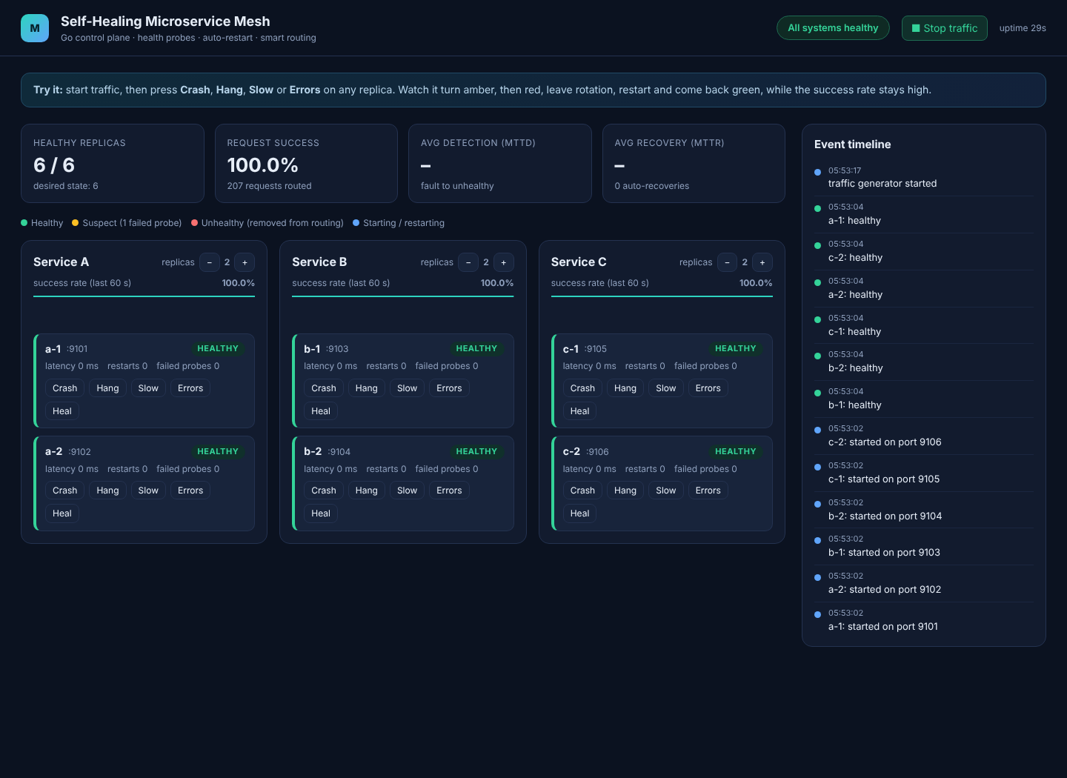
Figure 1: Dashboard with all replicas healthy and traffic running
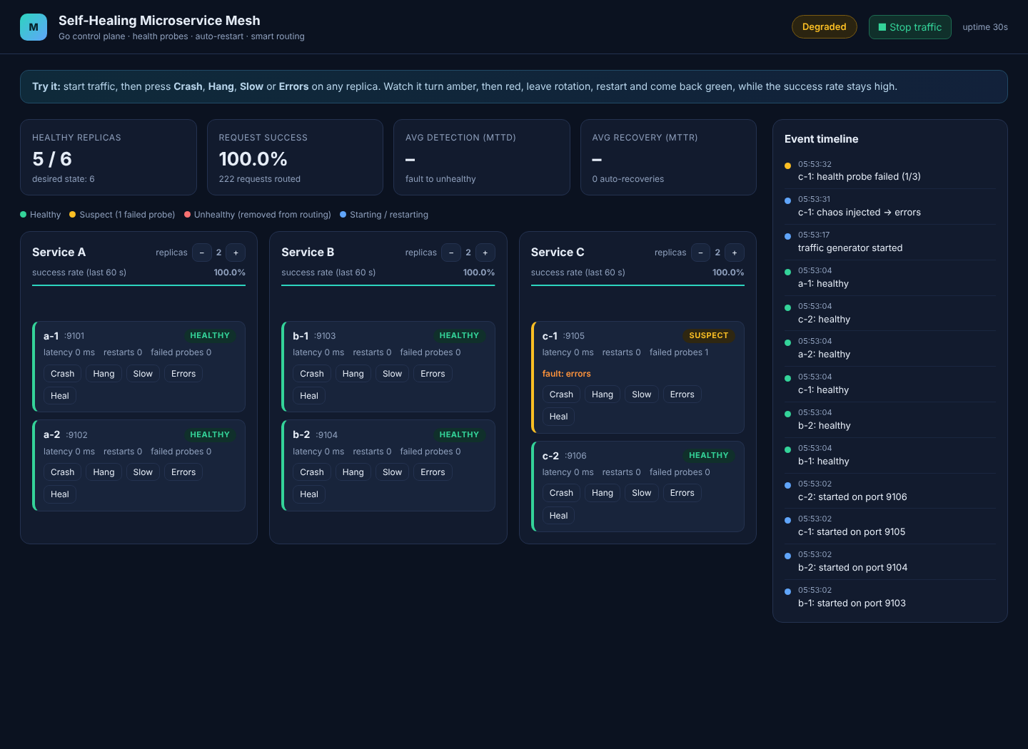
Figure 2: A replica returns errors and becomes Suspect (amber)
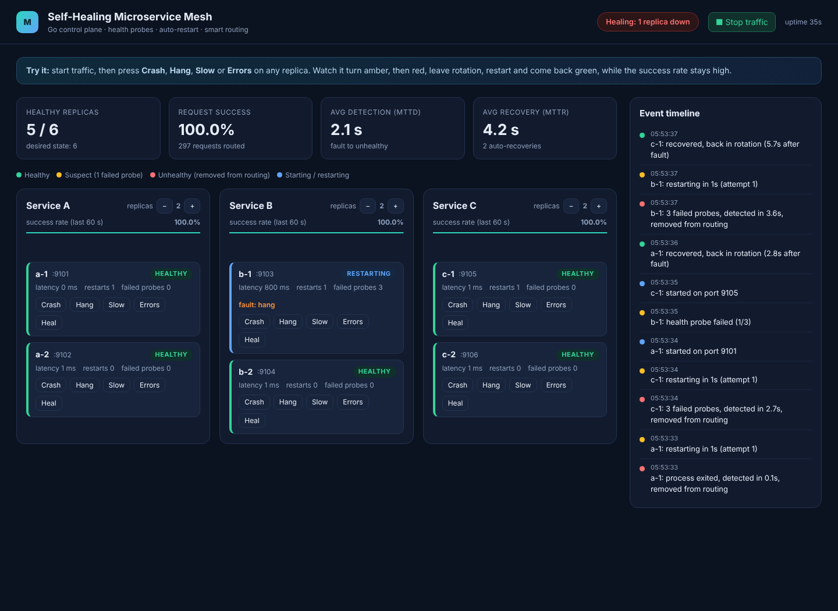
Figure 3: Failures detected, replicas removed from routing and restarting
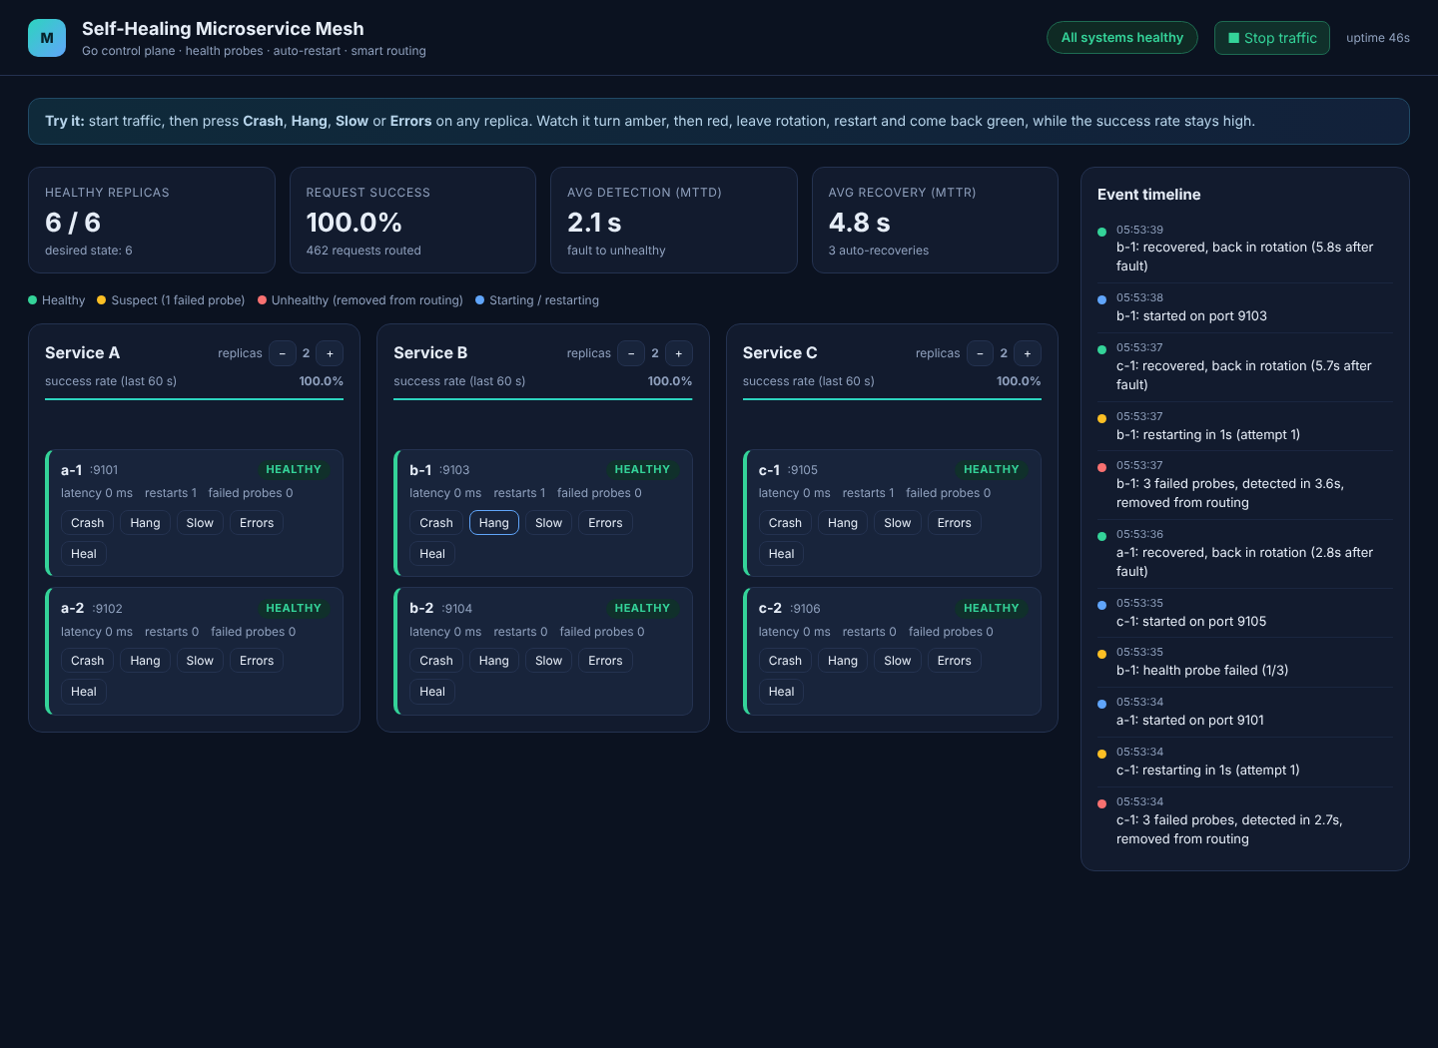
Figure 4: All replicas healed automatically; MTTD and MTTR shown
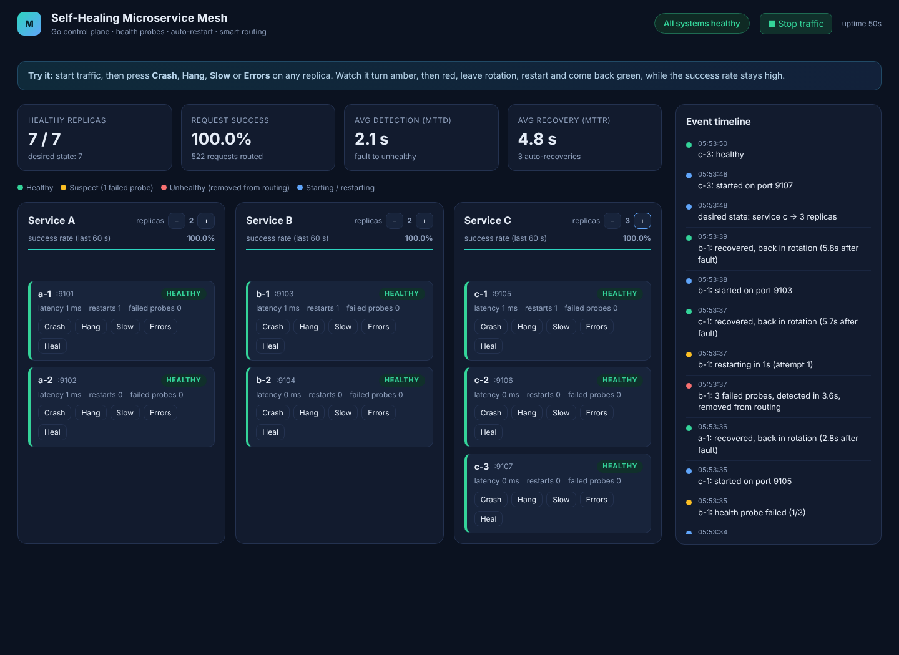
Figure 5: Desired state changed from the UI; reconciler starts a new replica

9. Test Results (local run)
Observed with 2 replicas per service and traffic running: process crash detected in about 0.1 s, hang or error faults detected in about 2 to 4 s, replica back in rotation about 3 to 6 s after the fault, and 100% request success (297 of 297 requests) while replicas were crashing and hanging.

10. Limitations and Future Scope
Single control-plane instance (no leader election), local processes instead of containers, GET requests only through the router. Future work: Raft leader election, Docker or container backend, circuit breakers, Prometheus metrics, auto-scaling by load.

