LOGISTICS DATA ANALYST INTERNSHIP
Week 3 Report
Advanced Data Analysis and Visualization in Logistics
Project: E-commerce Delivery Optimization
Submitted by
Tripti Tiwari
CSE – Artificial Intelligence & Machine Learning
Internship Period: 30 July 2026 – 27 August 2026
Week 3 Focus: Exploratory Data Analysis, Visualization & Analytical Insights
Repository: logistics-data-analyst-internship

1. Introduction
Following the data collection and preprocessing work completed in Week 2, this Week 3 task moves into exploratory data analysis (EDA) and visualization. The quality of any logistics decision depends on how well the underlying patterns in delivery time, cost, and operational performance are understood, and visualization is the primary tool for surfacing those patterns quickly and reliably.
The objective of this Week 3 task was to analyze a logistics dataset in depth using Python, calculate descriptive and relational statistics, and produce a set of visualizations that explain operational performance across transport modes and regions. Since a cleaned real-world extract was not available for this stage, a hypothetical but realistic logistics dataset of 1,200 shipments was simulated, carrying forward the same field definitions and data-quality principles established in Week 2, and extending them with delivery, cost, and satisfaction metrics suited to deeper analysis.
2. Objectives
- Simulate a hypothetical logistics dataset with variables suitable for delivery and cost analysis.
- Conduct exploratory data analysis: central tendency, distribution, and correlation of key metrics.
- Segment performance by transport mode and region to identify operational differences.
- Produce multiple visualizations using matplotlib and seaborn, each justified by the pattern it reveals.
- Interpret each visualization in terms of logistics performance, cost drivers, and bottlenecks.
- Translate analytical findings into concrete recommendations for the next stage of the project.
3. Dataset Description
The dataset represents 1,200 shipments handled by a regional logistics operation over one year (2025), spanning five regions, four transport modes, and five warehouses. Fields were designed to reflect realistic logistics relationships — for example, Air shipments are faster but costlier, Road shipments are the most frequent but carry higher delay risk, and delivery delays reduce customer satisfaction.
Field | Description | Data Type
shipment_id | Unique identifier for each shipment | String
date | Date the shipment was dispatched | Date
region | Destination region | Categorical
warehouse | Origin warehouse | Categorical
transport_mode | Road, Rail, Air or Sea | Categorical
distance_km | Distance travelled in kilometers | Numeric
shipment_volume_kg | Weight of shipment in kilograms | Numeric
promised_delivery_days | SLA-committed delivery time | Numeric
actual_delivery_days | Actual time taken to deliver | Numeric
delay_days | Actual minus promised delivery time | Numeric
transportation_cost | Total cost of shipment transport | Numeric
customer_satisfaction | Customer rating (1-5) | Numeric
damaged_or_lost | Whether shipment was damaged or lost | Binary

mode_speed_factor = pd.Series(mode).map(
{"Road": 0.012, "Rail": 0.008, "Air": 0.003, "Sea": 0.006}).values
base_delivery_time = distance_km * mode_speed_factor
delivery_time_days = np.clip(
base_delivery_time + np.random.normal(0, 0.8, N)
+ np.random.uniform(0.5, 2, N), 0.5, None)

4. Exploratory Data Analysis
Descriptive statistics were computed for all numeric fields to understand central tendency, spread, and skew. The table below summarizes the overall key performance indicators across all 1,200 shipments.
KPI | Value
Total Shipments | 1200
% Shipments Delayed | 83.1%
Avg. Delay (when delayed) | 2.02 days
Avg. Transportation Cost | Rs. 1066.66
Avg. Customer Satisfaction | 4.0 / 5
Damage / Loss Rate | 4.33%

summary = df[numeric_cols].describe().T
summary["median"] = df[numeric_cols].median()
summary["skew"] = df[numeric_cols].skew()

corr = df[numeric_cols].corr()
print(corr.round(2))
5. Performance by Transport Mode and Region
Grouping the data by transport mode and region highlights where delay and cost differences concentrate.
Mode | Shipments | Avg Delay (days) | % Delayed | Avg Cost
Air | 119 | 0.53 | 85.0% | Rs. 2806.14
Rail | 239 | 1.54 | 85.0% | Rs. 763.88
Road | 665 | 1.99 | 82.0% | Rs. 1012.95
Sea | 177 | 1.02 | 84.0% | Rs. 507.78

Region | Shipments | Avg Cost | Avg Delivery (days) | % Delayed
Central | 178 | Rs. 1092.99 | 16.46 | 83%
East | 233 | Rs. 1051.72 | 15.82 | 82%
North | 321 | Rs. 1049.71 | 16.12 | 83%
South | 217 | Rs. 1070.89 | 15.61 | 82%
West | 251 | Rs. 1079.85 | 15.86 | 86%

delay_by_mode = df.groupby("transport_mode").agg(
shipments=("shipment_id", "count"),
avg_delay_days=("delay_days", "mean"),
pct_delayed=("is_delayed", "mean"),
avg_cost=("transportation_cost", "mean"),
).round(2)

6. Visualizations
Seven visualizations were produced using matplotlib and seaborn, each chosen for the specific pattern it makes visible.
6.1 Distribution of Delivery Time
A histogram with a KDE overlay was used to reveal the shape and skew of delivery times.
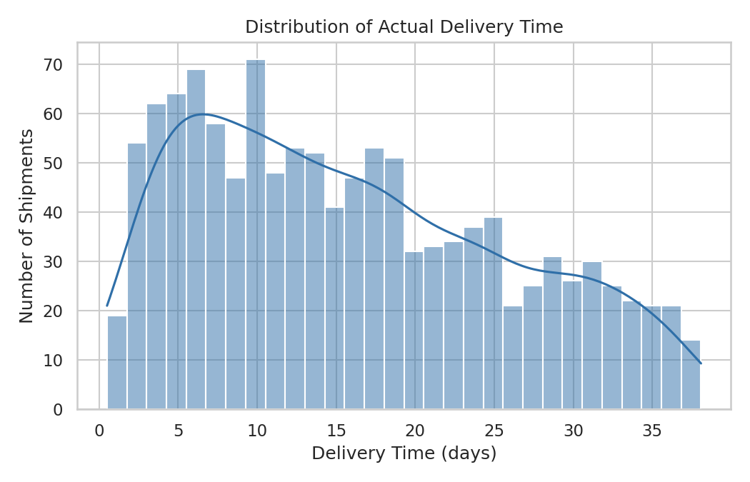
Figure 1: Distribution of actual delivery time across all shipments.
Interpretation: Delivery times are right-skewed, clustering between 8-20 days with a long tail beyond 30 days, indicating a subset of shipments face significantly longer transit.
6.2 Transportation Cost by Mode
A boxplot was used to compare cost distributions across transport modes, exposing median, spread and outliers together.
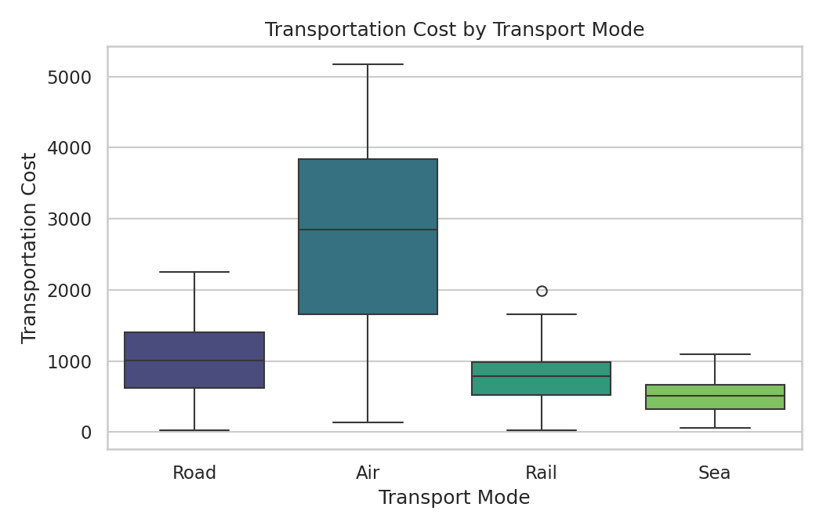
Figure 2: Transportation cost distribution by transport mode.
Interpretation: Air freight carries the highest median cost and widest variance, while Sea and Rail are markedly cheaper, confirming transport mode as a primary cost driver.
6.3 Monthly Shipment Volume Trend
A line chart was used to track shipment counts over time.
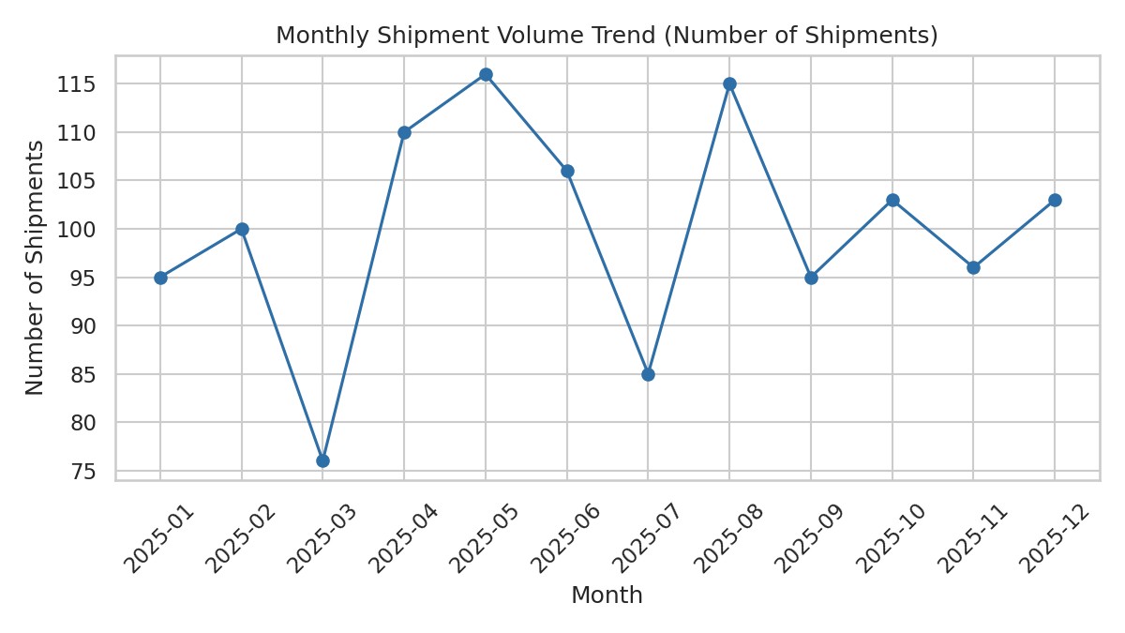
Figure 3: Monthly number of shipments across 2025.
Interpretation: Shipment counts fluctuate without a strong seasonal pattern in this simulated dataset, though real data should still be checked for seasonal demand peaks.

6.4 Correlation Matrix of Key Metrics
A heatmap was used to simultaneously visualize pairwise correlation strength and direction across all numeric variables.
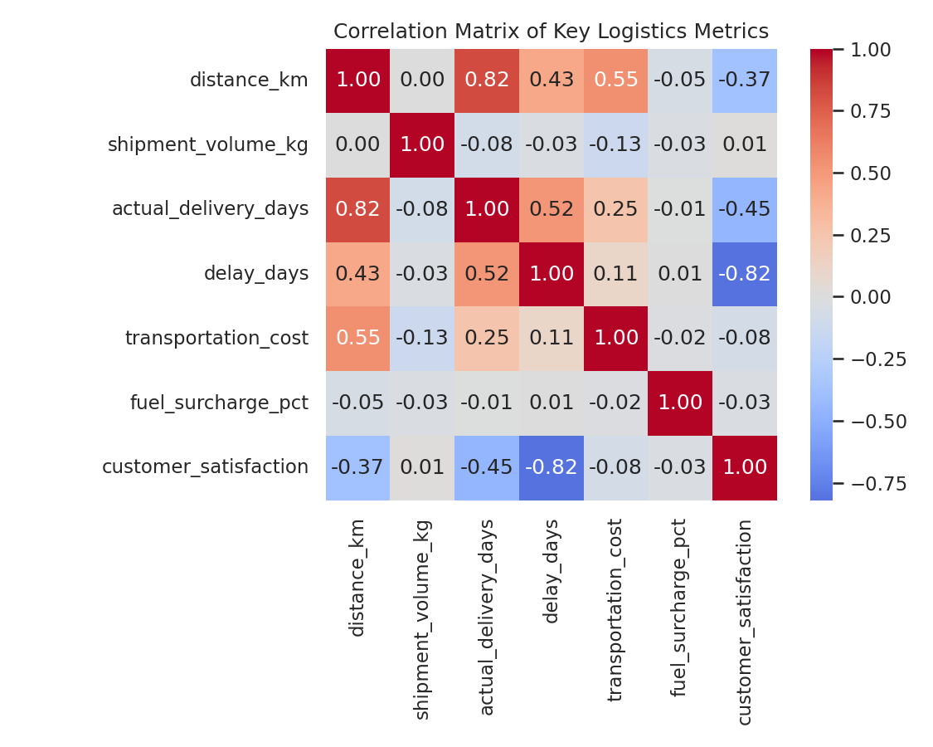
Figure 4: Correlation matrix of key logistics metrics.
Interpretation: Delay days and customer satisfaction show a strong negative correlation (-0.82), confirming delay as the biggest driver of dissatisfaction. Distance correlates strongly with delivery time (0.82) and moderately with cost (0.55).
6.5 Distance vs. Delivery Time by Mode
A scatter plot with color-coded transport mode was used to examine how two continuous variables relate, segmented by category.
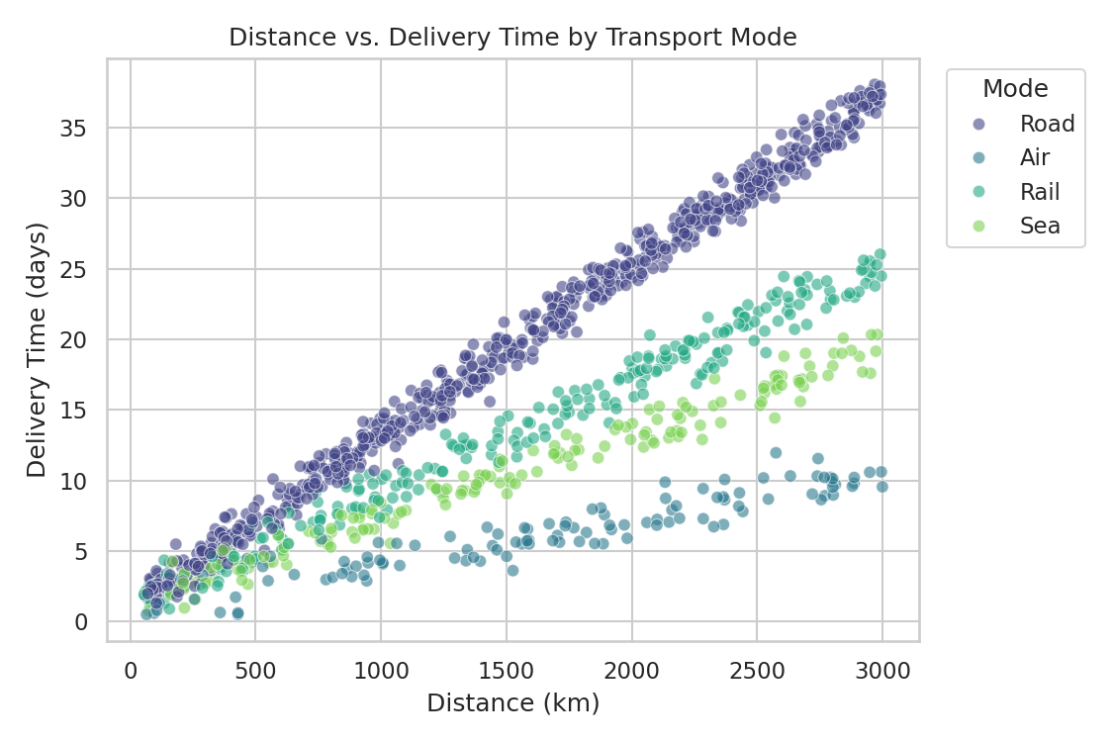
Figure 5: Relationship between shipment distance and delivery time, by mode.
Interpretation: Road shipments show the steepest increase in delivery time with distance, while Air remains comparatively flat, favoring Air/Rail for long-distance, time-sensitive shipments.

6.6 Delayed Shipments by Region
A bar chart was used to compare a single metric across a small number of categorical groups.
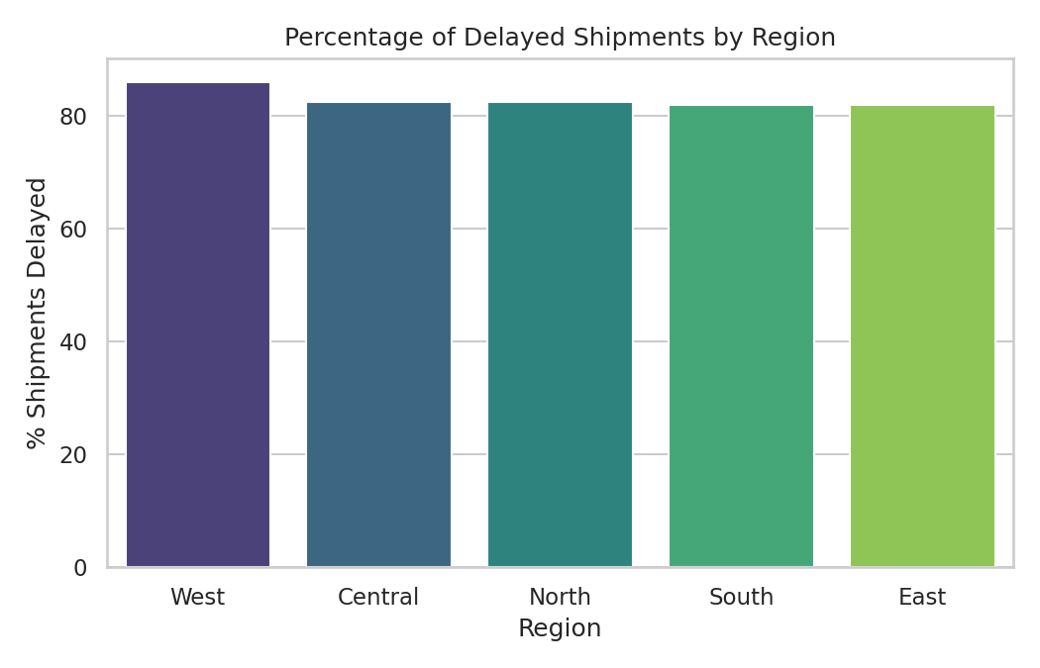
Figure 6: Percentage of shipments delayed, by region.
Interpretation: The West and North regions show the highest delay percentages, pointing to route- or last-mile-specific inefficiencies worth deeper review.
6.7 Customer Satisfaction vs. Delay
A bar chart of average satisfaction across delay buckets makes the delay-to-experience relationship immediately interpretable.
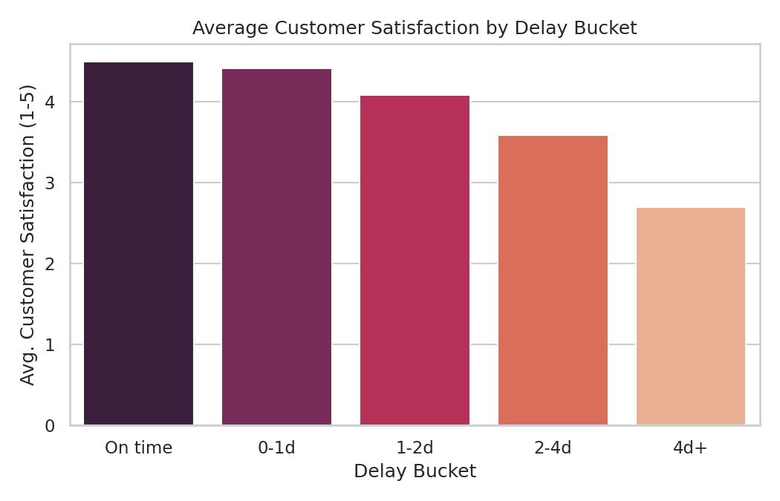
Figure 7: Average customer satisfaction score by delay bucket.
Interpretation: Satisfaction drops sharply once delays exceed 2 days, establishing a clear service-level threshold that operations should aim to stay within.

7. Analytical Insights and Recommendations
7.1 Key Insights
- Delay is the strongest driver of poor customer satisfaction (correlation -0.82), outweighing cost or distance effects.
- Road transport, though the most frequently used mode (55% of shipments), has the highest average delay.
- Distance strongly predicts delivery time (0.82) but is more weakly related to delay itself, implying delays stem from operational rather than purely distance-based factors.
- Air freight cuts delay risk substantially but costs roughly 3-5x more than Road or Sea per shipment.
- The West and North regions show elevated delay rates and are candidates for targeted review.
7.2 Recommendations
- Prioritize Air or Rail transport for high-distance or SLA-sensitive shipments despite the higher cost.
- Conduct a root-cause review of Road operations in the West and North regions.
- Set an internal service target to keep delays under 2 days, based on the observed satisfaction drop-off.
- Introduce stronger handling protocols for long-distance Road shipments to reduce damage/loss.
8. Reflection
This task showed that visualization is most valuable when each chart is chosen deliberately for the relationship it needs to reveal, rather than generated generically. Building on the cleaned and standardized dataset structure from Week 2, this week's analysis made it clear that delay — not distance or raw cost — is the dominant factor shaping customer experience. Computing correlations before visualizing also made it easier to decide which relationships were worth charting in detail versus summarizing in text.
9. Expected Impact on the Project
- A clearer, evidence-based view of which transport modes and regions need operational attention.
- A reusable EDA and visualization workflow for later weeks' predictive modelling of delay risk.
- A defined service-level reference point (2-day delay threshold) for future KPI tracking.
- Visual assets that can support stakeholder-facing reporting alongside the technical analysis.
10. Conclusion
Week 3 built directly on the cleaned dataset structure established in Week 2, applying exploratory data analysis and visualization to convert logistics data into actionable insight. The analysis identified delivery delay as the dominant factor behind customer dissatisfaction and highlighted transport mode and regional performance as the key levers for operational improvement. The Python-based workflow — pandas for analysis, matplotlib and seaborn for visualization — is directly reusable on real logistics data in subsequent stages of the project.
11. Tools and Technologies
Python, pandas, NumPy, matplotlib and seaborn are the primary technologies used in this workflow. Pandas supports aggregation and correlation analysis; matplotlib and seaborn provide the statistical visualizations used to interpret logistics performance.
12. References
1. Python pandas documentation — data aggregation and analysis concepts.
2. Matplotlib and seaborn documentation — statistical visualization concepts.
3. Public logistics/e-commerce dataset resources used as a reference for the simulated dataset structure.

