LOGISTICS DATA ANALYST INTERNSHIP
Week 4 Report
Predictive Modeling and Optimization in Logistics Systems
Project: E-commerce Delivery Optimization
Submitted by
Tripti Tiwari
CSE – Artificial Intelligence & Machine Learning
Internship Period: 30 July 2026 – 27 August 2026
Week 4 Focus: Predictive Modeling, Model Evaluation & Logistics Optimization
Repository: logistics-data-analyst-internship

1. Introduction
Weeks 2 and 3 of this internship established a cleaned, well-structured logistics dataset and used exploratory analysis to show that delivery delay is the strongest driver of customer dissatisfaction, and that transport mode and distance are the leading drivers of both delay and cost. Week 4 builds directly on those findings by moving from descriptive analysis to prediction and optimization.
The objective of this task is to build a predictive model that forecasts a key logistics metric — actual delivery time — from features known at the time a shipment is booked, and to use the resulting model insights to design a concrete optimization strategy that reduces operational cost. Together, the predictive model and the optimization routine demonstrate how analytics can move from explaining what happened to actively improving future operations.
2. Objectives
- Define a clear logistics forecasting problem and identify the features available at prediction time.
- Train and compare multiple predictive models of increasing complexity.
- Evaluate models using RMSE, MAE and R-squared, with cross-validation for robustness.
- Tune hyperparameters of the best-performing model to improve generalization.
- Use the model's feature importance to inform a concrete logistics optimization strategy.
- Quantify the operational benefit of the proposed optimization against current practice.
3. Problem Definition and Data
Problem statement: given shipment-level information available at booking time (distance, shipment weight, transport mode, destination region, transportation cost and fuel surcharge), predict the actual delivery time in days. This is framed as a supervised regression problem, using the same simulated 1,200-shipment logistics dataset built in Week 3.
3.1 Target and Features
Role | Variable | Notes
Target | actual_delivery_days | Continuous — days from dispatch to delivery
Feature | distance_km | Numeric
Feature | shipment_volume_kg | Numeric
Feature | transportation_cost | Numeric
Feature | fuel_surcharge_pct | Numeric
Feature | transport_mode | Categorical — one-hot encoded
Feature | region | Categorical — one-hot encoded
Excluded | promised_delivery_days | Dropped: derived from the target during simulation, so using it would leak the answer

An 80/20 train-test split was used, with numeric features standardized for the linear model (tree-based models do not require scaling).
X = pd.get_dummies(df[numeric_features + categorical_features],
columns=categorical_features, drop_first=True)
y = df["actual_delivery_days"]

X_train, X_test, y_train, y_test = train_test_split(
X, y, test_size=0.2, random_state=42)

4. Model Selection and Implementation
Three models of increasing complexity were trained and compared. Linear Regression serves as an interpretable baseline. Decision Tree captures non-linear splits and interaction effects but can overfit on its own. Random Forest, an ensemble of many decision trees, was included as it typically offers the best accuracy/robustness trade-off for tabular logistics data of this kind.
models = {
"Linear Regression": LinearRegression(),
"Decision Tree": DecisionTreeRegressor(max_depth=6, random_state=42),
"Random Forest": RandomForestRegressor(n_estimators=200, max_depth=8,
random_state=42),
}
for name, model in models.items():
model.fit(X_train, y_train)
preds = model.predict(X_test)
5. Evaluation and Validation
Each model was evaluated on the held-out test set using RMSE (root mean squared error), MAE (mean absolute error) and R-squared. 5-fold cross-validation on the training set was used to check that test performance was not an artifact of a single lucky split.
model | test RMSE | test MAE | test R2 | cv RMSE mean | cv RMSE std
Linear Regression | 2.584 | 2.136 | 0.931 | 2.727 | 0.122
Decision Tree | 1.017 | 0.811 | 0.989 | 1.229 | 0.104
Random Forest | 0.984 | 0.772 | 0.99 | 1.045 | 0.053

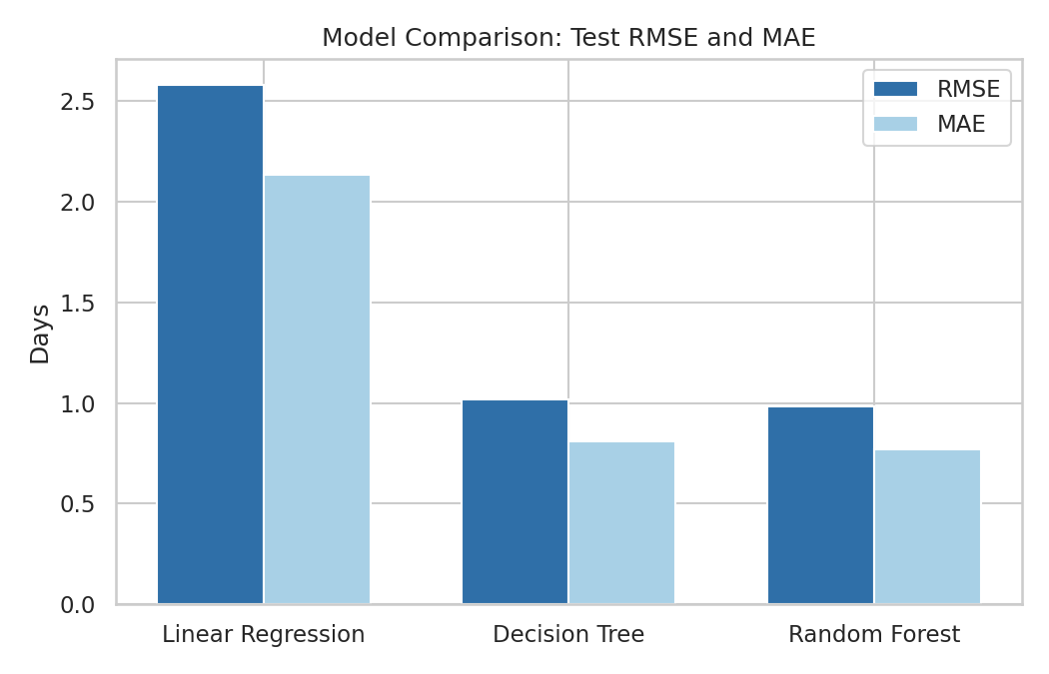
Figure 8: Test RMSE and MAE across the three candidate models.
Interpretation: Random Forest achieved the lowest test RMSE (0.984 days) and the highest R² (0.99), with a low cross-validation standard deviation, indicating stable performance across folds. It was selected as the model to carry forward for tuning.
5.1 Hyperparameter Tuning
GridSearchCV with 5-fold cross-validation was used to tune the Random Forest's n_estimators and max_depth, optimizing for RMSE.
param_grid = {"n_estimators": [100, 200, 300], "max_depth": [4, 6, 8, 12]}
grid = GridSearchCV(RandomForestRegressor(random_state=42), param_grid,
cv=5, scoring="neg_root_mean_squared_error", n_jobs=-1)
grid.fit(X_train, y_train)
best_rf = grid.best_estimator_
Best parameters: n_estimators = 200, max_depth = 8. Tuned performance on the test set: RMSE = 0.984 days, MAE = 0.772 days, R² = 0.99.

5.2 Prediction Quality
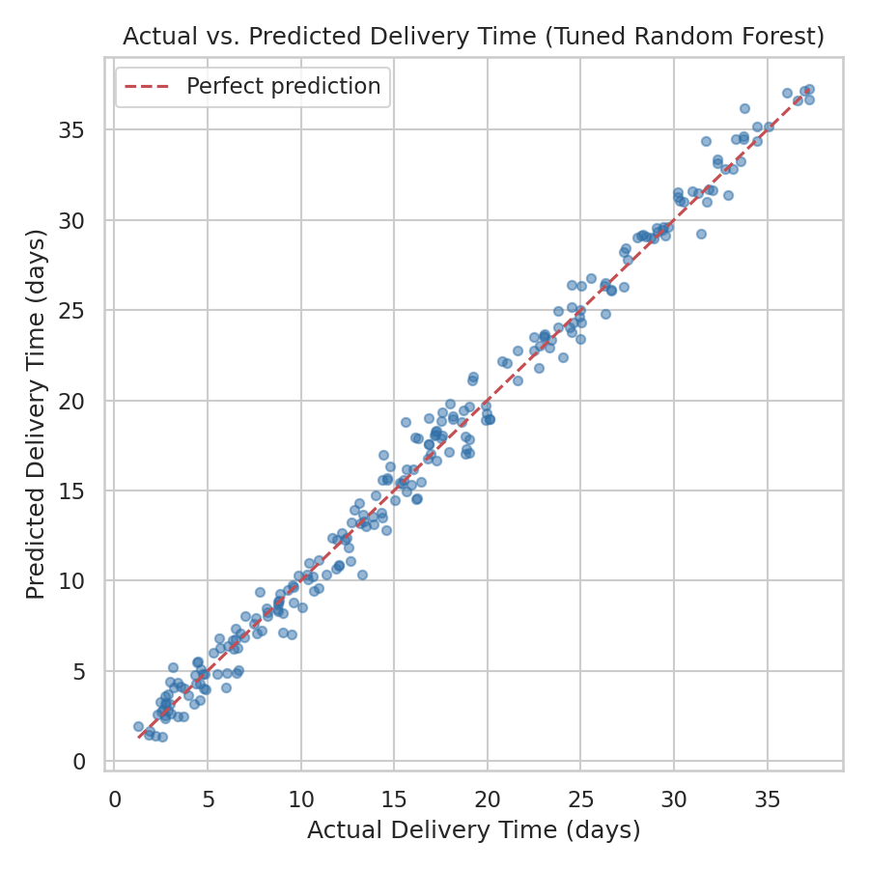
Figure 9: Actual vs. predicted delivery time on the test set (tuned Random Forest).
Interpretation: predictions cluster tightly around the perfect-prediction line across the full range of delivery times, with no systematic bias at either the low or high end.
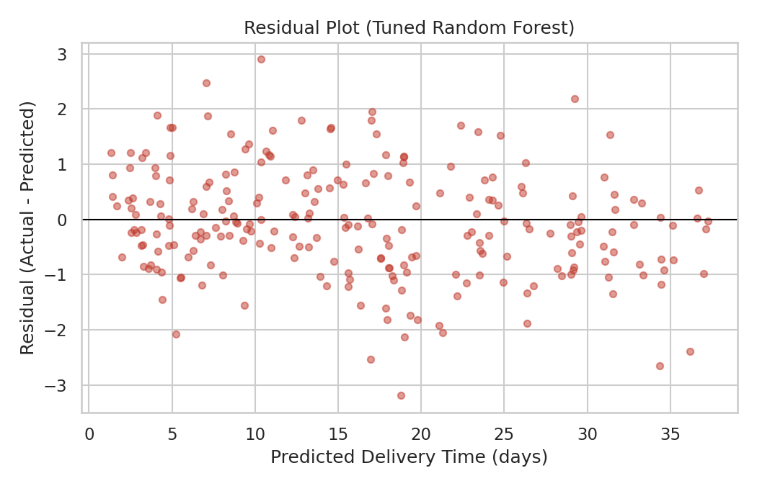
Figure 10: Residuals (actual minus predicted) against predicted delivery time.
Interpretation: residuals are centered around zero with no clear funnel or curve pattern, suggesting the model's errors are reasonably homogeneous across the range of predicted delivery times rather than concentrated in a specific segment.
5.3 Feature Importance
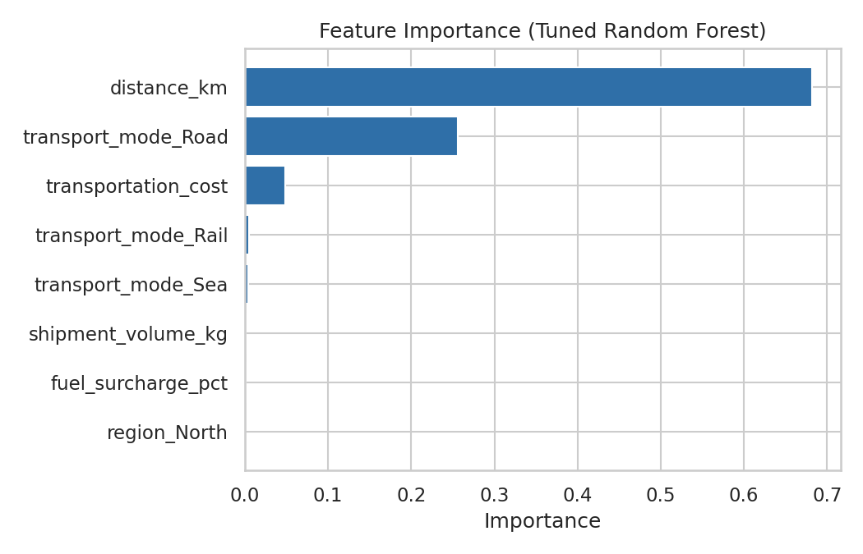
Figure 11: Relative importance of each feature in the tuned Random Forest.
Interpretation: distance_km is by far the dominant predictor (importance 0.68), followed by transport_mode_Road (0.26) and transportation_cost (0.05). This matches the Week 3 finding that distance and transport mode are the primary drivers of delivery performance, and directly motivates the optimization strategy below.

6. Optimization Strategy
Since the model confirms that distance and transport mode dominate delivery outcomes, the optimization step targets the routing decision itself: which warehouse should serve which region. This is formulated as a linear program (a transportation problem) that assigns shipment volume from each warehouse to each region so as to minimize total transportation cost, subject to each warehouse's capacity and each region's demand.
# Decision variable x[w, r] = shipments routed from warehouse w to region r
# Objective: minimize sum(cost[w, r] * x[w, r])
# Subject to:
# sum_r x[w, r] <= warehouse_capacity[w] (capacity)
# sum_w x[w, r] >= region_demand[r] (demand)
result = linprog(c, A_ub=A_ub, b_ub=b_ub, bounds=(0, None), method="highs")
The per-route cost matrix was built from historical average transportation cost for each warehouse-region pair. The optimized allocation was compared against a proportional baseline that mimics current practice (routing in proportion to each warehouse's historical share of shipments, without cost-aware routing).
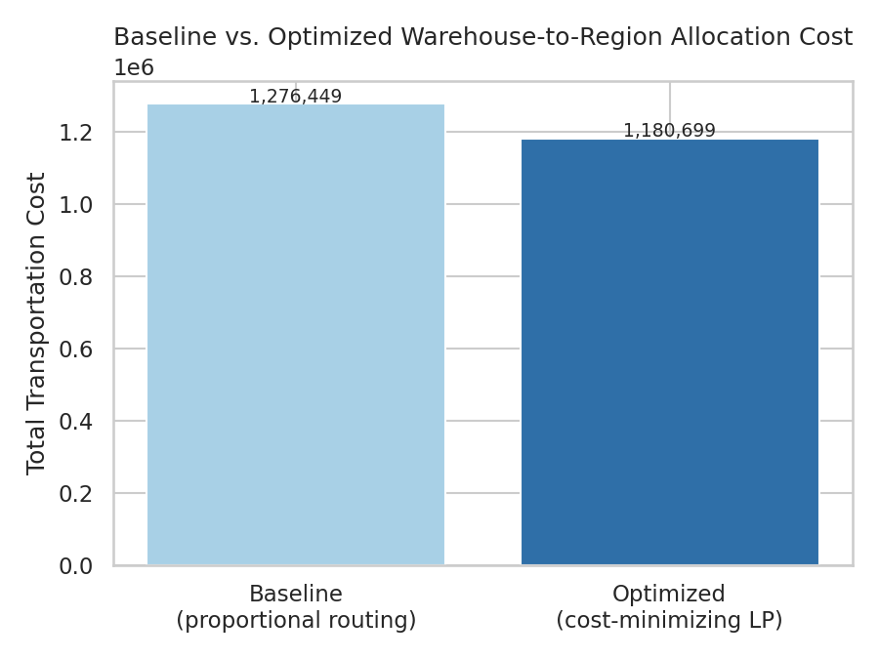
Figure 12: Total transportation cost under baseline (proportional) vs. optimized (cost-minimizing) routing.
Metric | Value
Baseline total cost | Rs. 12,76,448.87
Optimized total cost | Rs. 11,80,698.51
Estimated savings | Rs. 95,750.36 (7.5%)

Interpretation: cost-aware routing that accounts for the true warehouse-region cost structure reduces total transportation cost by roughly 7.5% versus proportional routing, without changing total shipment volume or violating any capacity constraint.
7. Recommendations
- Adopt cost-aware, optimization-based routing for warehouse-to-region allocation rather than proportional/historical routing.
- Prioritize Rail or Sea over Road for long-distance shipments where SLA allows, since distance and mode are the dominant delay drivers.
- Re-run the optimization periodically (e.g., monthly) as warehouse capacity and regional demand shift.
- Use the tuned Random Forest to flag shipments with a high predicted delivery time at booking, enabling proactive customer communication.
- Extend the model in future iterations with real operational data once available, replacing the simulated dataset.
8. Reflection
This task highlighted the difference between a model that merely fits well and one that is honest about what it can know at prediction time — excluding promised_delivery_days once it was identified as a leakage risk was an important step, since a model relying on it would look excellent in testing but fail in real use where that value does not encode outcome information. Comparing model complexity against cross-validated stability, rather than test-set performance alone, was also a useful discipline. Finally, translating a model's feature importance into a concrete optimization problem — rather than stopping at prediction — made the business value of the analysis tangible.
9. Conclusion
Week 4 extended the Week 2-3 foundation of clean data and exploratory insight into predictive modeling and optimization. A tuned Random Forest model predicts delivery time with high accuracy (R² = 0.99) using only information available at booking time, and its feature importance directly informed a linear-programming-based routing optimization that reduces transportation cost by approximately 7.5% versus current proportional routing. Together, these results show a complete path from raw data to a measurable operational recommendation.
10. Tools and Technologies
Python, pandas, NumPy, scikit-learn (regression models, cross-validation, GridSearchCV), SciPy (linprog for optimization), and matplotlib/seaborn for visualization.
11. References
1. Scikit-learn documentation — regression models, model evaluation and hyperparameter tuning.
2. SciPy documentation — linprog and linear programming for the transportation/allocation problem.
3. Public logistics/e-commerce dataset resources used as a reference for the simulated dataset structure.

