

NAME : NANDAWULA MARIA

REG NO : S20B23/207

ACCESS NO : A90651

COURSE : BSCS

COURSE UNIT : SOFTWARE PROJECT MANAGEMENT

LECTURER : MR. SIMON FRED LUBAMBO

**Define a statement of work and outline the work products of your course  
project.**

**Statement of Work**

1. **Project Introduction**

The project is abouta digital agricultural online resource map, that identifies available

markets, service providers, processing industries and farmers and gives them an opportunity to connect and interact which is aimed at reducing poor market features in different parts of Uganda

There is a limitation of not knowing which farmer, processor or trader deals in what and where, due to information thus bringing up an agro-map to locate different agriculture resources, business nearby and get easy contact with them

1. **Scope of the project**

All different activities will be assigned different milestones and timelines to be finished

Different documentations and diagrams of the project will be done like the user requirement document, proposal ui/ux prototype, flowchart, erd model, sketches.

The app will be an agricultural online resource map, that identifies available

markets, service providers, processing industries and farmers and gives them an opportunity to connect and interact.

This app will work by connecting people using maps. The App will allows users

to connect and engage using the GPS to link the user to a nearby famer, service providers, processing industries to trade.

1. **Objectives**
2. To create organized market systems
3. To increase on the product to market.
4. To Increase  market interaction between farmer, trader, service provider and processor
5. To increase access to agricultural information
6. To increase visibility of individual farmers
7. **Technologies used**

The app is developed using hybrid native languages to build our platform to cater from both IOS and android users

* React native for mobile applications
* React JS for web apps

Backend language

* laravel framework

In our project app we shall embedding both Google maps API and Open Street

Mapping in our App to locate and search the nearby Agricultural trader in the area. We shall mainly use the Open Street Maps for remotely-mapped rural farmers who have no

access to the internet.

1. **Deliverables**

|  |  |  |
| --- | --- | --- |
| Deliverables | Delivered by | Due date |
| Ideation | Nandawula Maria | Sept 18-Sept 28,2022 |
| Analysing and collection for information relevant for the project | Nandawula Maria | Sept 18-Sept 28,2022 |
| Documentation of the Software requirements specification | Nandawula Maria | Sept 18-Sept 28,2022 |
| choosing the technology to be used | Nandawula Maria | Sept 18-Sept 28,2022 |
| Designing the ,sketches, databases, flowcharts,erd models | Nandawula Maria | Oct 2-Oct 14, 2022 |
| Development and programming of the the backend | Nandawula Maria | Oct 16-Nov 22, 2022 |
| Development of the front end and integration with backend | Nandawula Maria | Oct 16-Nov 22, 2022 |
| Testing the mobile application | Nandawula Maria | Nov 26-Nov 28, 2022 |
| launching and deplayment of the app | Nandawula Maria | Dec 1-Dec 3, 2022 |

1. **Work products**
2. Proposal
3. Software requirements specifications included functional and non function requirements
4. Designs and Drawings

* Class diagram
* Flowcharts
* Erd model design
* Physical database design
* System UI/UX Prototype designed in Figma

1. Architecture specifications
2. Source code which is uploaded on github every after changes
3. software packages
4. Test plans
5. Defect reports
6. Methodology

**Project schedule**

**Designed using a gantt chart**

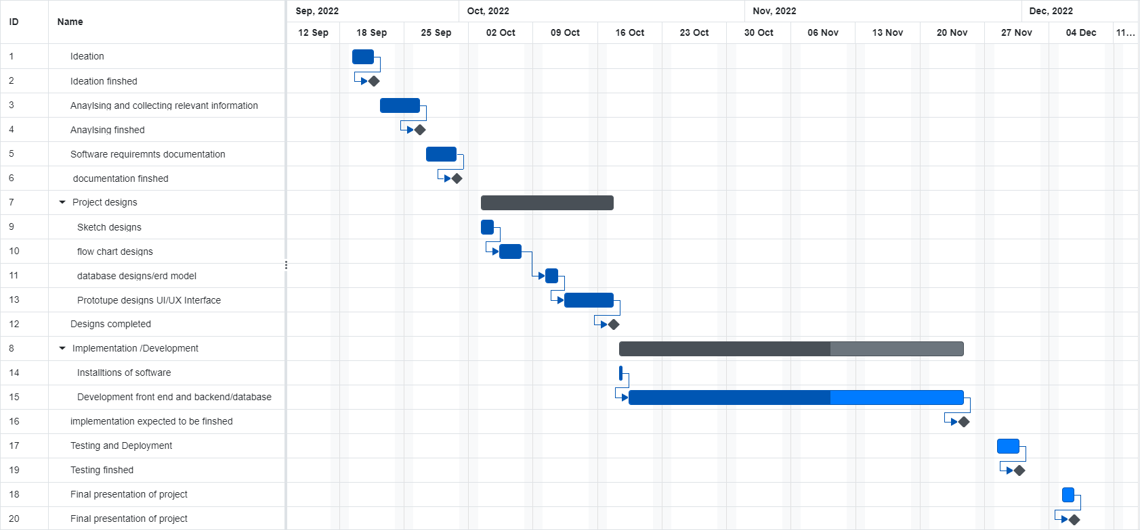

**Elaborate 5 potential risks likely to threaten your project and how to they  
can be mitigated.**

**1.Scope Creep**

This risk would happen when there is

1. **Unclear Scope Definition**

This is when the parameters of the project were not well-defined from the outset

If you don’t know what the goals of the project are, you can’t have a clear idea of how to reach them. Those issues have to be worked out in the midst of the project, leading inevitably to wasted time and resources.

1. **Poor Communication With Project Stakeholders**

Managing the relationship between interested parties like the team ,sponsors. If that’s not done properly, it is possible to waste time and resources due to disagreements and too many stakeholders could also cause problems, as the more difficult communication becomes, the more likely creep is.

1. **Improper Collection of Requirements**

Another aspect of working with stakeholders is a clear process for collecting requirements. Stakeholders may see opportunities to add new features, find aspects they personally like and wish to be included, or otherwise add ‘requirements’ that don’t actually work toward the overall goal.

The problem with scope creep is that it often contributes to [project failure](https://kissflow.com/project/why-projects-fail/). You haven’t budgeted the time or resources necessary to complete the extra tasks, so what might have been a smashing success ends up a frustrating failure.

#### How to manage it the scope creep

To prevent scope creep, making sure that your client knows exactly what they need and has included all the details in a written request. Creating a [project charter](https://kissflow.com/project/project-charter/) document for the client describing what the team will deliver and when, and include a section that explains what will happen if the client adds to the agreed-upon parameters.

Depending on the request, it may be possible to accommodate a bit of scope creep, but be sure to explain to your client that such additions will result in changes to the cost and/or timeline of the project.

### 2. Budget creep

Changes in [project scope](https://kissflow.com/project/project-scope-management/) certainly can affect the bottom line adversely, but so can other factors. Overly optimistic cost estimates can result in a budget overrun, as when one underestimates the time or external resources required to complete the project.

Sometimes there are unforeseen changes in material or labor costs. Poor planning nearly can always affect the budget, as can poor communication.

#### How to manage it budget creep

To mitigate against budget-related risks, do research very carefully, and don’t present a finalized budget until your project plan and schedule are complete.

Creating [transparency around your project](https://kissflow.com/project/how-to-improve-project-transparency/) can also prevent budget overruns; both the client and team members can help keep the project within the budget if they have access to relevant information.

### 3. Communication issues

communication is among the most important factors in successful project management, and having poor communication poses a huge and unnecessary risk.

Choosing good [project collaboration tools](https://kissflow.com/project/project-collaboration-tools/) and explaining them to the team at the outset of your project.

Most teams utilize some combination of email, text messaging, a chat service, and/or [Google integrated apps](https://kissflow.com/project/google-project-management-apps/). Beyond the method of communication, make sure to be clear with expectations about response times and set a good example of professional communication style and tone.

#### How to manage it:

To mitigate communication risks, you should simplify your [project communication](https://kissflow.com/project/communication-in-project-management/) streams to the smallest number that will allow your team to remain effective. Research what communication and [collaboration](https://kissflow.com/project/project-team-collaboration-tips/) platforms will best serve the people and the project you’re managing. You may also need to coach some team members toward developing better communication skills.

### 4. Lack of clarity

Poor communication from clients and stakeholders can introduce another risk: that of unclear requirements. Just as you need to establish good communication with your team, you must also develop good communication with your client and other stakeholders so that project requirements are clear from the start.

Most people have had the unfortunate experience of investing significant time into a project only to find out they misunderstood what was being asked.

#### How to manage it:

Good listening skills go a long way toward mitigating this risk. As the project manager, it falls on you to get clarification from the client on what they need and to listen carefully to all the [project stakeholders](https://kissflow.com/project/project-stakeholder-management/) as they provide input. Ask as many questions as it takes to get a clear picture of the desired final product and its purposes.

Ask for hard data in the form of numbers, but also ask for stories about what success looks like for the end-user. A clear, shared vision can prevent problems and provide inspiration for the team.

### 5. Poor scheduling

[Project scheduling](https://kissflow.com/project/basics-of-project-scheduling/) is a major component of successful project management, and poor scheduling can introduce a multitude of risks to your project. Scheduling involves creating a document, these days usually a digital document, that details the [project timeline](https://kissflow.com/project/project-management-timeline/) and the organizational resources required to complete each task.

The project schedule must be accessible to every team member. Its purpose is to communicate critical information to the team, so it must be comprehensive and easy to understand. Project scheduling can be broken down into eight steps and even though it can be time-consuming, proper [project scheduling software](https://kissflow.com/project/top-project-scheduling-tools/) can help you avoid many of the risks that might otherwise arise in your project.

#### How to manage it:

Detailed planning is essential to creating a project schedule. If you plan well, there are many [project roadmap tools](https://kissflow.com/project/project-roadmap-tools/) that can prove helpful in staying on track. Depending on the scope and complexity of your project, you may find a simple shared different tools that would be effective for example Gantt charts ,calendars with timelines and milestones.

**Explain the five stages of your project.**

## Project Initiation Phase

The first phase in the my project is initiation phase. This phase is the starting point for my agromap project when my team and I need to make a positive decision about the objectives we need to achieve.

It consists of a few steps. Firstly, identifying the primary problem that the project will fix and then identifying the [project scope](https://www.projectmanagement.ie/blog/successful-project-manager-iv-project-scope-planning-2/) and finally, identifying the stakeholders.

After that step, we can start developing a business case and a statement of work.

A business case is used to determine if the project will be moving forward. It compares the potential costs and benefits of the project. The other important document, the statement of work, contains information about the project's objectives, deliverables and other project scope details.

## Project Planning Phase

In Project Management, project planning means breaking large tasks down into smaller, more easily managed chunks which can produce a more realistic schedule, thus removing the danger of “ground rush”, which is a term used in parachuting when in the last stages of a jump the ground rushes to hit you when you are unprepared.

The first step of this planning phase is to identify the project timeline and divide it into phases that will contain specific tasks that need to be performed within those phases.

The next step is to estimate the budget and determine how much to spend on the project to get the maximum return on investment. You also need to gather the resources and start building the team. During this stage, you should be paying attention to potential risks and quality roadblocks. Identify issues and start [planning to mitigate those risks](https://www.projectmanagement.ie/blog/project-risk-management/) to maintain the project’s quality and timeline.

Make a risk assessment that allows you to quantify and qualify any predictable problems in a project, and it is acknowledged that by taking a proactive stance, we can better cope with problems if they do arise in our work or social lives.We can develop contingency plans to give us planned alternatives if problems occur in our lives or our work, instead of having to react to unplanned emergencies.

You can use techniques, which ensure that you only concern yourself with the really important issues and confront these first

## Project Execution Phase

In the execution phase, work begins on implementing the project plan. This means putting it into action as soon as possible.

This is the stage where everyone starts doing the work. You'll want to officially kick off the execution stage with in-person meetings to ensure everyone has what they need to begin executing their part of the project. Getting the team started on the right track is integral to a project's success, so articulate the schedule and communications plan clearly.

## Project Monitor and Control Phase

This phase focuses on monitoring the processes as the work is performed.

Tracking and assessing project performance is the most effective technique to assure progress and development. Making sure team members are meeting the time and quality goals of their assigned tasks is needed in this stage.

There are a variety of ways you can monitor and control a project. Casual check-ins with team leaders, organized daily "stand-ups," or more formal weekly status meetings are effective. The information that comes out of these meetings or communication channels will inform the feedback loop and ultimately any re-planning and adjustments that may be necessary to the project.

**Additional important activities in this stage include:**

* Adhering to your pre-established communication plan to ensure stakeholder awareness of the project status
* Monitoring work teams and work activities on the critical path
* Identifying opportunities to improve schedule performance by fast-tracking or completing activities in parallel or, where necessary, crashing the schedule by adding resources
* Monitoring actual vs. planned costs
* In some cases, monitoring, calculating and reporting on earned value for the project plan
* Monitoring and mitigating risks and refining the risk plan as needed

## Project Close

The first step if that after completion of the project ,documentation of all the information from the project and organizing it neatly would be done first.

This is also a good time to hold a post-mortem on the project so all team members can reflect on what went right or wrong during the project. All important project notes should also be documented so the outcome can be shared with other project members and filed in a project history folder.

Projects should only be considered closed when all stakeholders are satisfied with the successful completion of the project’s objectives.

**Is your project objective driven or product driven, elaborate on the  
difference.**

My project is object driven this is because objective is characterized with wanting to find a solution for a problems identified while product is more like a project being given a user and designed by an external user

## Product Driven Projects

Here the base problem is identified and only have to develop a previously determined or designed product. That means only the implementation part of the project is remaining.

## Objective Driven Projects

In object driven projects the main objective of the final outcome is considered. But doesn’t take much effort to build the finalized fully functioning expected version at the initial iteration. Incremental approach is considered until the final objective is accomplished.

My project is objective driven because I identified a problem of disorganized market arrangements in Uganda, limitations of not knowing which farmer, processor or trader deals in what and where, due to this problem I wanted to find a solution using technology that would help solve this problem. Therefore coming up an agro-map to locate different agriculture resources, business nearby and get easy contact with them

**Explain the Agile Methods**

### 1.Scrum

Projects in Scrum are broken into Sprints, which are typically two or three weeks long. A Sprint is a set of features that must be produced within a certain amount of time. Multiple sprints may be merged to make a Release, which is the formal delivery of software/product to the customer/market.

The Product Owner breaks down the overall product functionality into smaller pieces. Each Sprint or Iteration prioritizes and tackles these Stories. The goal of the process is for the team to be able to show the Product Owner working bits of the product at the conclusion of each Sprint to ensure that it is operating as intended.

Overall, the Scrum technique divides the long waterfall process into smaller cycles, allowing product teams and end-customers to assess functioning software on a regular basis and ensure that it satisfies their business needs. This guarantees that the completed product fulfills the customer's ultimate specifications.

### 2 . Extreme Programming

It is a framework that enables teams to create high-quality software that helps improve their quality of life. It enables software development alongside appropriate engineering practices. It is applicable while handling changing software requirements risks caused due to new software, working with a small, extended development team, and technology that allows automated unit and functional tests.

### 3. Kanban

It is a method that’s used to design, manage, and improve the flow of systems. Kanban enables organizations to visualize their flow of work and limit the amount of work in progress. It is used in situations where work arrives unpredictably, and where it needs to be deployed immediately without waiting for other work items.

### 4. Lean

It is a set of tools and principles that focuses on identifying and removing waste to speed up process development. Value is maximized, and waste is minimized. It is used in just about every industry that produces waste in some form.

### 5. Crystal

It focuses on people and their interactions, rather than on tools and processes. Aimed to streamline processes and improve optimization, Crystal works on the principle that projects are unique and dynamic. It is used when the focus is on strengthening team communication, continuous integration, active user involvement, and configurable processes.

Draw a product break down structure for your project

Mobile agro mapping app

Systems Designs

Software

Documentation

Login page

Sketches

User interface module

Project plan

Registration page

Flowchart

Map page

Requiements document

Erd database model

Information page

User manual

Backend module

UI/UX Design prototype

Login logic

Registration logic

Map logic

Database module

Real time database

III. Draw the product flow diagram and the derived activity network

Product flow diagram

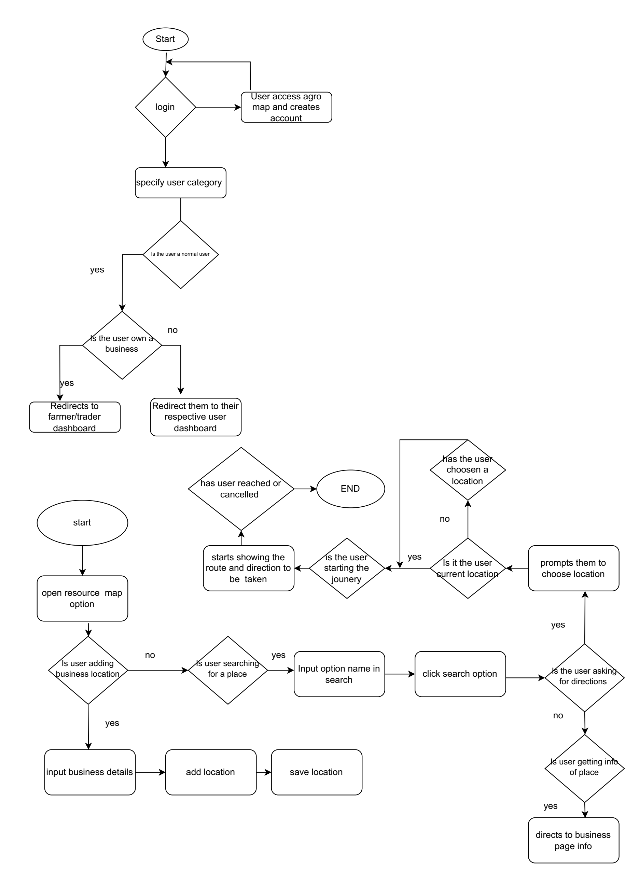

activity network

Requirements Documentation

Ideation

Testing application

Implementation

Designs,sketch,flowchart,ui/ux prototype

Anaylzing and information collection

Deplyment of app on play store

**Question Three**Define the different types of contracts in software projects

## Fixed Price Contracts(FP)

With fixed price contracts, also known as lump sum contracts, the buyer and service provider agree on a fixed price for the services in question. This type of contract is low-risk for the buyer, but high-risk for the seller since the time and costs of the project could exceed the fixed price. For this reason, a fixed price contract should include a detailed scope of work that clearly outlines what the buyer can expect for the agreed-upon price. When the contract is signed, the seller must complete the task or deliver the goods as agreed or risk being in [breach of contract](https://www.thebalance.com/breach-of-contract-398138).

Types of fixed price contracts

* **Firm Fixed Price Contracts:** This type of fixed price contract is typically used in government and partial government projects where the scope is defined in detail. This makes it easy to create a request for proposals and to compare the bids you receive. The downside for this contract is that deviating from the defined scope can be expensive.
* **Fixed Price Incentive Fee Contracts:** With this type of fixed price contract, the buyer also offers a performance-based incentive as an extra payment to the seller. Performance can be measured for this purpose by various metrics, including time, cost, or performance.
* **Fixed Price Award Fee Contracts:** As with the fixed price incentive fee, this type of contract offers a bonus for exceeding a [specific performance](https://www.upcounsel.com/specific-performance) metric. For example, if the seller delivers the product early, he or she could be eligible for a bonus equal to 10 percent of the total contract.
* **Fixed Price With Economic Price Adjustment:** With this type of contract, although the price is fixed, it can be readjusted with fluctuations in the market.

## Cost Reimbursable Contract(CR)

When the scope of a project is unclear or subject to change, you should consider a cost reimbursable contract. This document, sometimes called cost disbursable, is also useful when the risk of a specific project is high. The seller provides work for a fixed time period or project, then increases the bill to create profit after finishing the work.

The amount of profit in this type of contract is often based on performance metrics detailed in the document itself. The downside of this type of contract lies with the buyer, who carries the risk for this type of contract since he or she pays all costs. The full cost of the contract won't be defined until the work is done. For this reason, few businesses opt to use a cost reimbursable contract.

Types of cost reimbursable [contracts](https://www.upcounsel.com/commercial-agreements-contracts-legal-services)

* **Cost Plus Percentage of Costs/Cost Plus Fee:** With this variation, the seller receives a defined percentage of the total cost of the project upon completion. This is also an arrangement that mainly benefits the seller.
* **Cost Plus Fixed Fee:** The seller receives costs incurred plus an additional flat fee that is fixed in the contract. This amount is received when the contract is fulfilled regardless of performance.
* **Cost Plus Incentive Fee:** This is a performance-based fee paid on top of actual costs. It is a flat amount rather than a percentage.
* **Cost Plus Award Fee:** Similar to a cost plus incentive fee, this contract provides an award on top of the costs incurred.

### Time and Material Contract (T&M)

it is a hybrid of both FP and CR. One of the parties agrees to pay the other the time and materials that are used for the project within a reasonable limit. It can be cost reimbursable when the customer agrees to pay the cost for all the genuine and legitimate expenses. Or, it can be more like a FP type when the customer sets the limit.

In this case, the vendor is selected based on the capabilities and experience, having the required manpower and materials. The cost for supplies is negotiated and is paid according to the quantity of the resources consumed or purchased. The contract is pretty simple and convenient for both parties, and it is possible to establish a not-to-exceed price to avoid massive cost overruns.

### Unit Price Contract

This type is less popular than the other three options and is also known as an hourly rate contract. It combines the elements of the FP and CR models, just like T&M. However, this option differs on setting the price per item or unit not per hour rate along with the receipts for all the resources used in the overall process.

If you choose the unit price contract, it will ensure that the party that is engaged in the development process is paid a specified hourly rate for every hour its members spent on the overall software development process. This is the main advantage of this type. That is why it is usually used by freelance workers.

### Purchase Orders

As for this one, it is a specific type that is used only to purchase commodities and goods.