CMPSC 473 - PROJECT 3

TEAM: Trisha Mandal and Varun Jani

**Implementation:**

As for the actual code itself, we have managed to implement various components of the virtual memory management system described in the instructions file. We decided to create different files for different components and added them all together in the make file. This is important because it makes the debugging task a lot easier as well as makes the overall performance of the code much better. If all the stuff is clustered in one file it can be very tricky to handle the code and debug it, especially the infamous segmentation fault.

**Experiment 1:**

The snippet below shows the output of the simulator given experiment 1 on input1.txt processes. As you can see below and if compared with the second snippet below that, all the values are same. This means that given N1, N2 and N3 bits and the updated DRAM size, the output remains the same in case of input1.txt processes. The main reason for this is because all the processes in input1.txt file have non-memory instructions. Other cases shown later in this report with memory instructions will help us understand other input files and processes better.

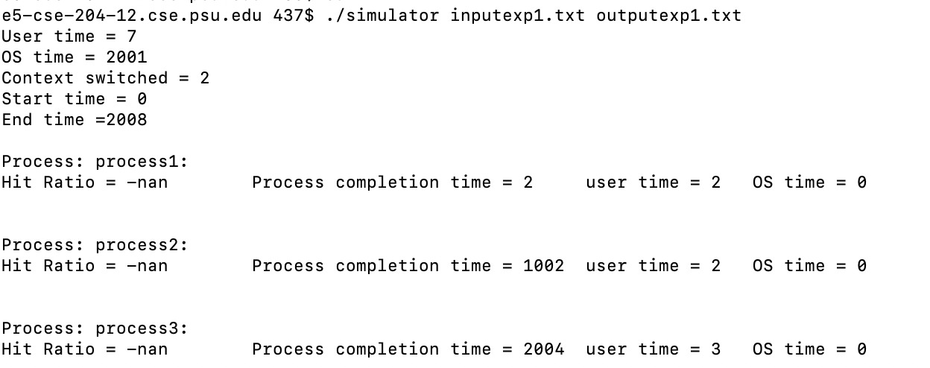

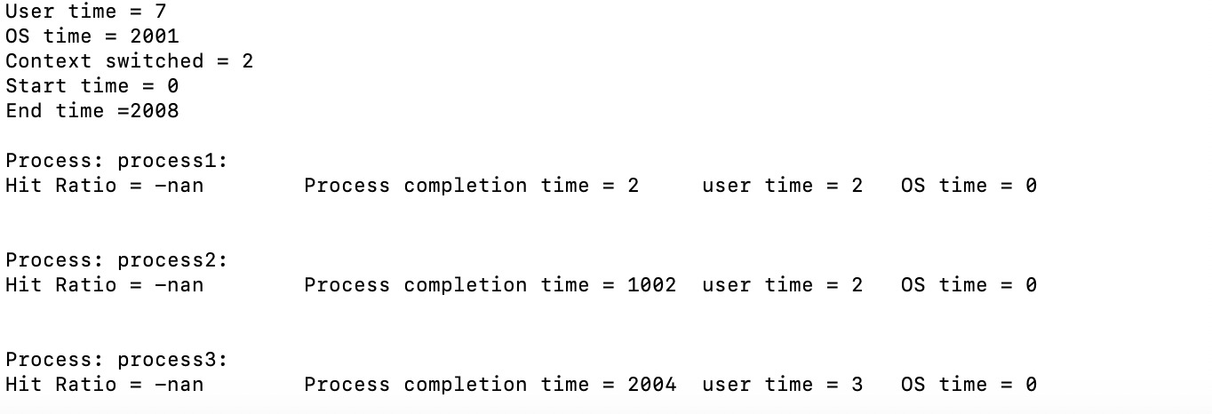

**Result:**

Command: ./simulator input1.txt output1.txt

Aggregate statistics:

|  |  |  |  |  |  |  |  |  |
| --- | --- | --- | --- | --- | --- | --- | --- | --- |
| total number of context switches | total number of disk interrupts | total number of TLB misses | % of TLB misses | total number of page faults | % of page faults | total fraction of time in blocked state | total amount of time spent in OS mode | total amount of time spent in user mode |
| 2 | 0 | 0 | 0 | 0 | 0 | 0 | 2001 | 7 |

Per-process statistics:

|  |  |  |  |  |  |  |  |  |  |
| --- | --- | --- | --- | --- | --- | --- | --- | --- | --- |
| Process name | number of context switches | number of disk interrupts | number of TLB misses | % of TLB misses | number of page faults | % of page faults | fraction of time in blocked state | amount of time spent in OS mode | amount of time spent in user mode |
| Process1 | 2 | 0 | 0 | 0 | 0 | 0 | 0 | 2 | 2 |
| Process2 | 2 | 0 | 0 | 0 | 0 | 0 | 0 | 1002 | 2 |
| Process3 | 2 | 0 | 0 | 0 | 0 | 0 | 0 | 2004 | 3 |

**Extra Credit:**

We have managed to create an implementation of clock but unfortunately not been able to call it in the actual code. We hope the implementation is good enough as we understand how to create it but we ran out of time.