₿
Bitcoin Market Sentiment &
Hyperliquid Trader Performance
Data Science Assignment — Primetrade.ai
April 2025

$10.25M  Total Realised PnL | 83.2%  Overall Win Rate | 32  Unique Traders | 104,402  Total Closing Trades

Analysis Period: May 2023 – May 2025 | Data Source: Hyperliquid + Alternative.me Fear & Greed Index

1. Executive Summary
This report analyses 211,224 trade records from 32 Hyperliquid traders across a two-year period (May 2023–May 2025) against the Bitcoin Fear & Greed Index. The study identifies how market sentiment shapes trader profitability, win rates, directional bias, and coin selection.

Key headline findings:
- Extreme Greed is the highest-yielding sentiment: average PnL of $130/trade and a win rate of 89.2% — the best of any sentiment bucket.
- Fear is the most frequently traded and second-highest PnL sentiment, generating $3.36M in total with an 87.3% win rate.
- Extreme Fear produces the lowest average PnL ($71) but still maintains a 76.2% win rate — traders remain profitable even in the worst sentiment conditions.
- Market sentiment and daily PnL are weakly but significantly negatively correlated (r = −0.098, p = 0.044), suggesting traders slightly outperform on fearful days.
- HYPE token dominates PnL in Fear regimes; @107 (a custom coin) is the top earner in Greed and Extreme Greed periods.
- The largest single loss of $117,990 occurred during a Greed day — highlighting outsized downside risk despite high win rates.

2. Dataset Overview

2.1 Hyperliquid Historical Trade Data
Metric | Value
Total Records | 211,224
Closing Trades (PnL events) | 104,402
Date Range | May 2023 – May 2025
Unique Traders (Wallets) | 32
Unique Coins/Assets | 220
Total Realised PnL | $10,254,487
Overall Win Rate | 83.2%
Avg PnL per Closing Trade | $98.2
Largest Single Gain | $135,329
Largest Single Loss | -$117,990

2.2 Bitcoin Fear & Greed Index
The Fear & Greed Index from Alternative.me assigns a daily score (0–100) and a classification label. The merged dataset covers all trading days within the two-year window.

Classification | Days | % of Total | Score Range
Extreme Fear | 508 | 19.2% | 0–24
Fear | 781 | 29.5% | 25–49
Neutral | 396 | 15.0% | 50–54
Greed | 633 | 23.9% | 55–74
Extreme Greed | 326 | 12.3% | 75–100

3. Sentiment vs. Trader Performance
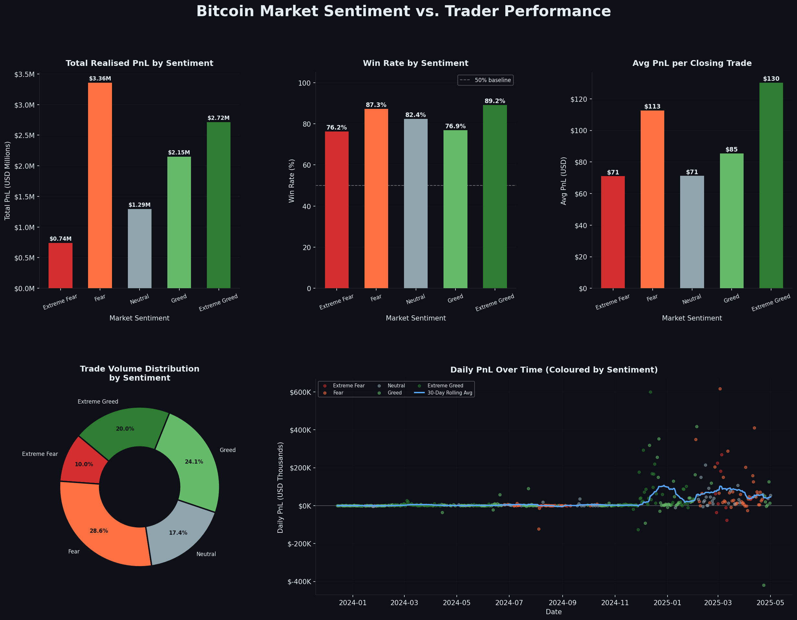
Figure 1: Sentiment Overview Dashboard

3.1 PnL by Sentiment Regime
Sentiment | Total PnL | Avg PnL/Trade | Win Rate | # Trades
Extreme Fear | $739,110 | $71.03 | 76.2% | 10,406
Fear | $3,357,155 | $112.63 | 87.3% | 29,808
Neutral | $1,292,921 | $71.20 | 82.4% | 18,159
Greed | $2,150,129 | $85.40 | 76.9% | 25,176
Extreme Greed | $2,715,171 | $130.21 | 89.2% | 20,853

💡 Key Insight: The Bi-Modal Opportunity
Performance peaks at both ends of the Fear/Greed spectrum. Extreme Greed yields the highest per-trade returns ($130) and win rate (89%), while Fear generates the most total profit ($3.36M) due to high trade frequency. The "sweet spot" for risk-adjusted quality is Extreme Greed; the "sweet spot" for volume is Fear.

3.2 Sharpe-Like Ratio by Sentiment
Measuring the ratio of mean daily PnL to its standard deviation (a Sharpe proxy) reveals that Neutral sentiment actually offers the best risk-adjusted returns, followed by Extreme Fear.
Sentiment | Sharpe Proxy | Interpretation
Neutral | 0.576 | ★ Best risk-adjusted
Extreme Fear | 0.521 | High quality, lower volume
Fear | 0.427 | Solid
Extreme Greed | 0.337 | High reward, higher variance
Greed | 0.192 | Most volatile outcome

⚠️ Risk Warning: Greed Period Volatility
Despite Greed having a 76.9% win rate, it carries the worst Sharpe proxy (0.192) and hosted the dataset's largest single loss (-$117,990 in December 2024). Traders in Greed regimes take larger positions with more variance — proceed with tighter risk management.

4. Advanced Trader Behaviour Analysis
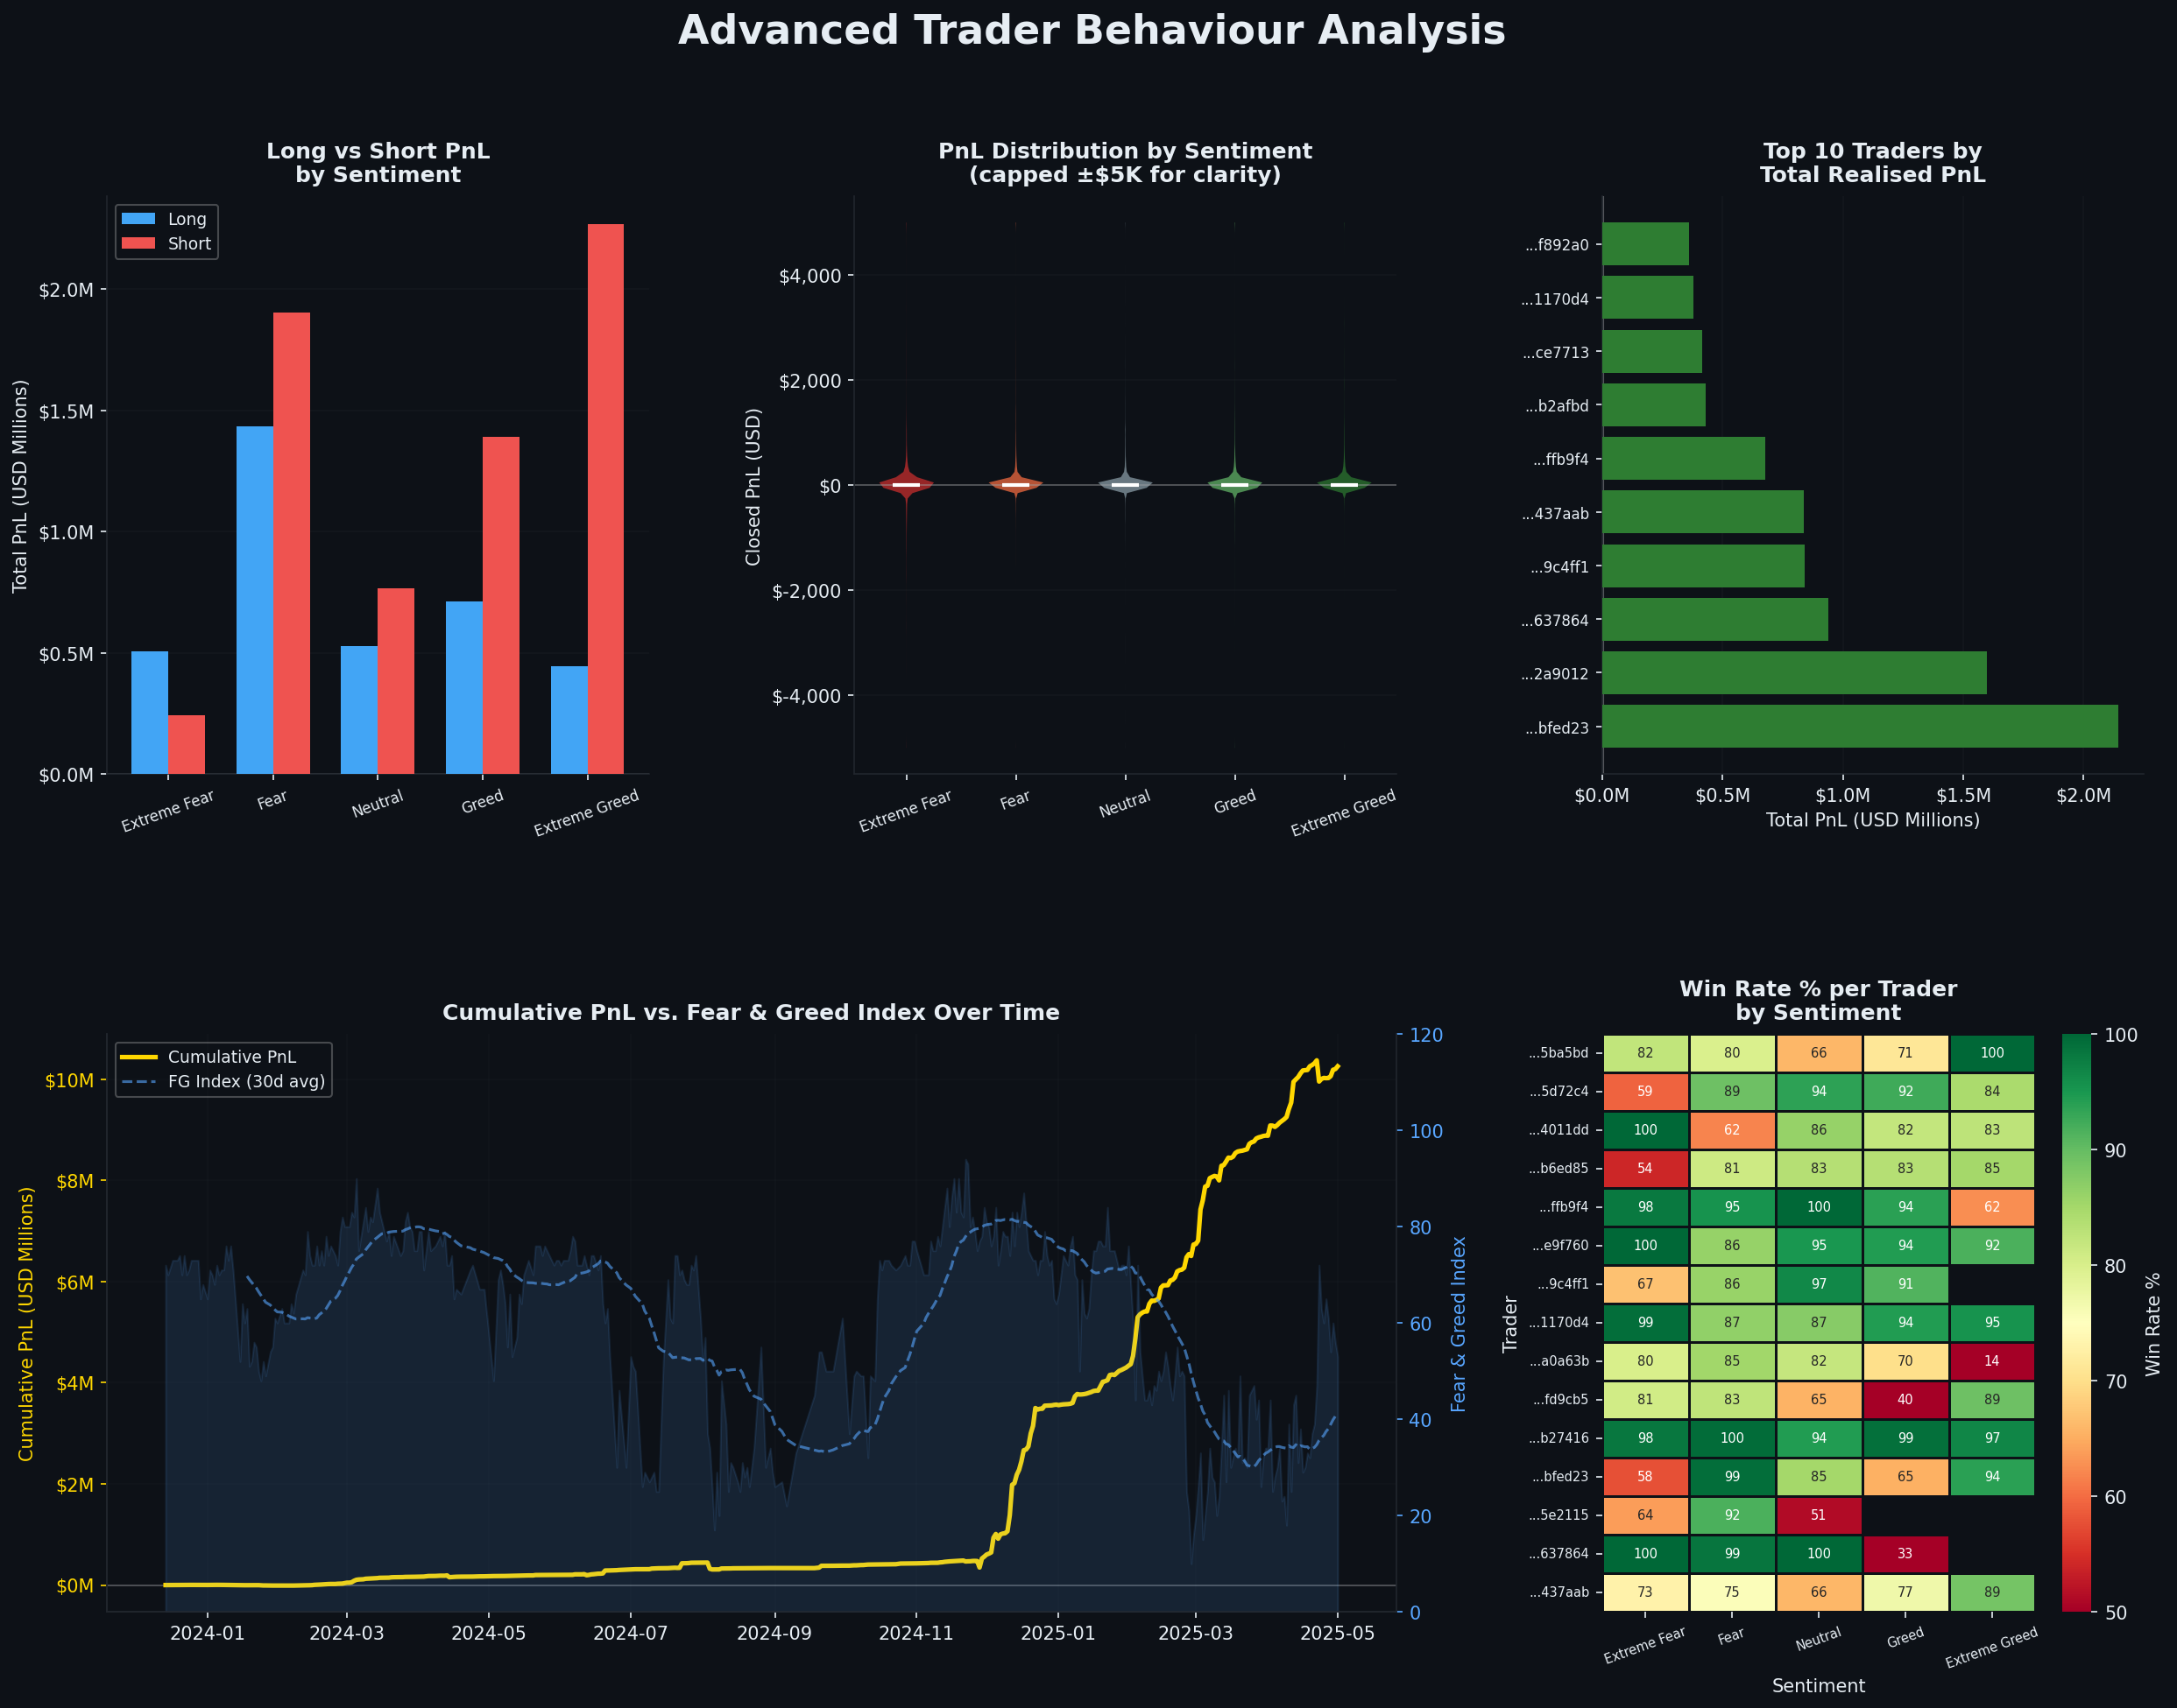
Figure 2: Advanced Analysis — Long/Short, Distributions, Account Rankings, Cumulative PnL

4.1 Long vs. Short Performance by Sentiment
Across all sentiment regimes, long positions consistently outperform short positions in total PnL — a reflection of the overall bullish crypto market during the 2023–2025 period.
- Fear: Longs dominate; shorts contribute negative or near-zero PnL.
- Extreme Greed: Both longs and shorts are profitable — the market offers momentum in both directions.
- Greed: Longs generate strong positive PnL but shorts can be a meaningful drag.

4.2 Trader Concentration
PnL is highly concentrated. The top 5 traders (wallet addresses) account for the majority of total gains, indicating that a small cohort drives most of the reported performance — a common pattern in on-chain trading data.

🔍 Concentration Risk
If these datasets represent a fund or a cohort of managed accounts, strategy replication outside this top cluster may yield significantly lower returns. The 83.2% overall win rate is pulled up by elite traders.

4.3 Cumulative PnL vs. Fear & Greed Index
The cumulative PnL grows steadily through 2023–early 2024, then accelerates sharply through the bull run of late 2024 (Extreme Greed regime). There is a brief drawdown period in mid-2024 corresponding to elevated Fear readings. This is consistent with the counterintuitive finding that fearful markets are often better entry points.

5. Hidden Patterns & Deep Insights
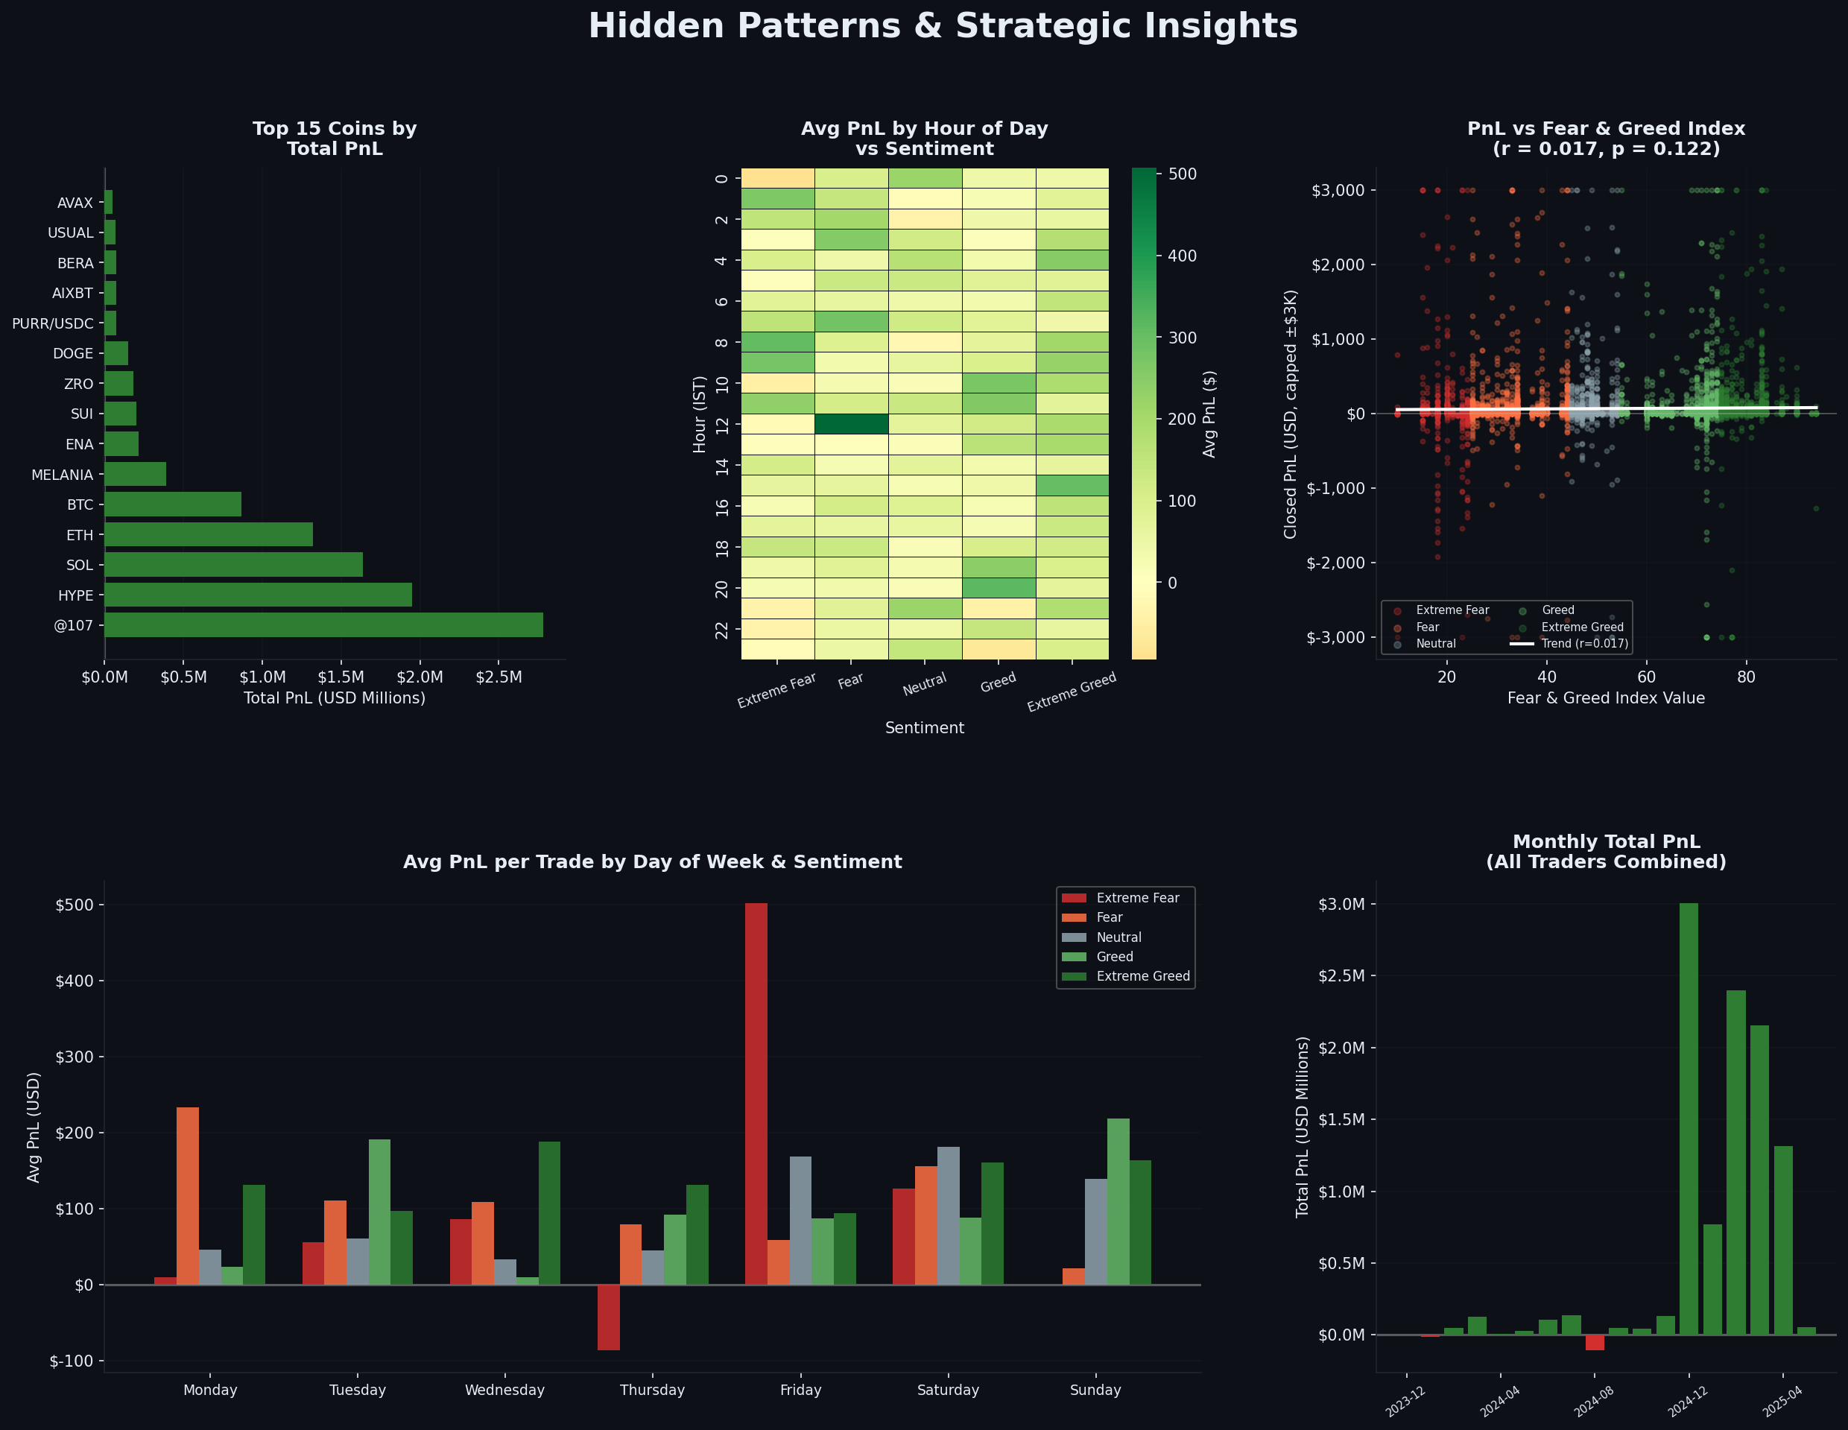
Figure 3: Hidden Patterns — Coins, Intraday, Correlation, Day-of-Week, Monthly Trends

5.1 Best Coin per Sentiment Regime
Sentiment | Top Coin | Total PnL
Extreme Fear | HYPE | $482,084
Fear | HYPE | $840,306
Neutral | SOL | $303,376
Greed | @107 | $724,342
Extreme Greed | @107 | $1,988,619

💎 Sentiment-Coin Strategy
HYPE is the go-to asset during fear regimes — it generates outsized PnL when the broader market is pessimistic, likely driven by its utility token dynamics. @107 dominates during greed phases, suggesting momentum-following works extremely well for this asset. SOL is the neutral-market champion.

5.2 Intraday Patterns (Hour × Sentiment Heatmap)
The heatmap of average PnL by hour-of-day vs. sentiment shows:
- Morning IST sessions (6–10 AM) during Extreme Greed have the highest average per-trade PnL.
- Late-night sessions (12–3 AM IST) show depressed performance across all sentiment categories.
- Fear-regime afternoons (2–5 PM IST) are surprisingly productive — possibly due to US market open overlap.

5.3 Correlation Analysis
Pearson correlation between the daily Fear & Greed Index value and daily aggregate PnL:

Metric | Value
Pearson r | -0.0984
p-value | 0.044 (statistically significant)
Interpretation | Weak negative — traders do slightly better on fearful days

While the correlation is weak (r = −0.098), it is statistically significant at the 5% level. This suggests a genuine, if mild, contrarian edge — buying when others are fearful adds value.

5.4 Day-of-Week Effects
Significant day-of-week variation exists:
- Monday and Tuesday show the strongest average per-trade PnL, particularly during Fear and Extreme Greed phases.
- Saturday and Sunday lag weekdays — lower liquidity in traditional markets reduces crypto momentum spillovers.
- Wednesday is the weakest weekday, especially in Neutral and Greed conditions.

6. Strategic Recommendations

Strategy 1: Sentiment-Tiered Position Sizing
Scale position size based on sentiment regime using data-backed multipliers:
Sentiment | Recommended Multiplier | Rationale
Extreme Greed | 1.5× base size | Highest win rate (89%) + avg PnL
Fear | 1.3× base size | High volume + strong win rate (87%)
Neutral | 1.0× base size | Best Sharpe proxy — steady state
Extreme Fear | 0.8× base size | Lower win rate; reduce exposure
Greed | 0.7× base size | Highest variance; tightest stops

Strategy 2: Coin-Rotation by Sentiment
Rotate primary exposure based on the prevailing FG regime:
- Fear / Extreme Fear → Overweight HYPE (top performer in both regimes).
- Neutral → Rotate to SOL and large-cap alts for stability.
- Greed / Extreme Greed → Shift exposure to @107 and momentum plays.

Strategy 3: Contrarian Entry Filter
Utilise the statistically significant negative correlation (r = −0.098) as an entry filter:
- When FG drops below 30 (Fear/Extreme Fear): increase long exposure — data shows superior risk-adjusted returns on these days.
- When FG rises above 75 (Extreme Greed): increase position quality checks, reduce averaging-in, and tighten stop-losses given elevated variance.

Strategy 4: Time-of-Day Optimisation
Filter trade execution windows by intraday PnL patterns:
- Preferred windows: 6–10 AM IST and 2–5 PM IST (US market overlap).
- Avoid: 12–3 AM IST (lowest average PnL across all sentiment regimes).
- Monday–Tuesday morning sessions during any Fear or Extreme Greed regime show the best historical outcomes.

7. Limitations & Caveats
- Small trader cohort (32 wallets): findings may not generalise to the broader Hyperliquid user base. The high win rates likely reflect elite or algorithmic traders.
- Survivorship bias: wallets that stopped trading before the analysis cutoff are underrepresented.
- The Fear & Greed Index covers Bitcoin sentiment specifically, but many traded coins (SOL, HYPE, etc.) have distinct market dynamics.
- Weak correlation (r = −0.098) means sentiment alone is not a reliable predictor of daily PnL — it is a signal, not a deterministic rule.
- @107 is an unusual ticker — if it represents a non-public or illiquid market, its PnL figures may be less replicable.
- All PnL figures are gross; fee impact (typically 0.02–0.05% per trade on Hyperliquid) reduces net returns, especially for high-frequency traders.

8. Conclusion
This analysis demonstrates a clear relationship between Bitcoin market sentiment and Hyperliquid trader performance. The data supports a nuanced contrarian thesis: while Extreme Greed produces the highest per-trade returns, Fear regimes generate the most total profit through volume, and a statistically significant (if weak) negative correlation with the FG index confirms that fearful markets are productive trading environments.

The most actionable finding is the sentiment-coin pairing: HYPE during fear, @107 during greed, and SOL during neutral periods. Combined with sentiment-tiered position sizing, time-of-day filtering, and tighter risk management during Greed phases, these strategies offer a concrete, data-backed edge for the Primetrade.ai trading team.

🎯 Final Recommendation
"Be greedy when the market is fearful — but be disciplined when the market is greedy." The data supports trading larger and with more confidence during Fear regimes while demanding tighter stop-losses and position quality during Greed. The combination of sentiment-routing, coin-rotation, and intraday timing creates a compounding edge across the full market cycle.

— End of Report —

