Load Balancer Simulator
Detailed Implementation Guide
Java • Queues • Hashing • Circular Linked List • REST API
Prepared for project planning, implementation, and interview preparation

1. Executive Summary
This document explains how to build a load balancer simulator in Java that distributes incoming requests across a pool of servers using multiple routing strategies. The project is intentionally designed to combine backend engineering with data structures and design patterns so that it can be used both as a portfolio project and as a strong interview discussion topic.
The simulator will support Round Robin, Least Connections, Weighted Routing, and an optional Hash-Based routing mode. It will expose REST APIs to manage servers, send requests, switch strategies, and inspect metrics. Internally, it will use queues for server workloads, a circular linked list for round robin iteration, and hashing for deterministic request-to-server mapping.

2. Why This Project Is Valuable
- It demonstrates core computer science concepts in a realistic system design problem.
- It lets you show Java OOP, collections, concurrency concepts, and REST API design together.
- It is easy to explain in interviews because the problem maps to real-world backend infrastructure.
- It is extensible: you can add server health checks, failover, session affinity, and consistent hashing later.

3. System Architecture
The simulator should be split into four main layers:
- Request Layer: accepts and represents incoming traffic.
- Load Balancing Layer: chooses a server according to the active strategy.
- Server Simulation Layer: tracks queues, active connections, and request completion.
- REST API Layer: exposes endpoints for external interaction and testing.
The architecture diagram below shows the major components and how data flows through the system.
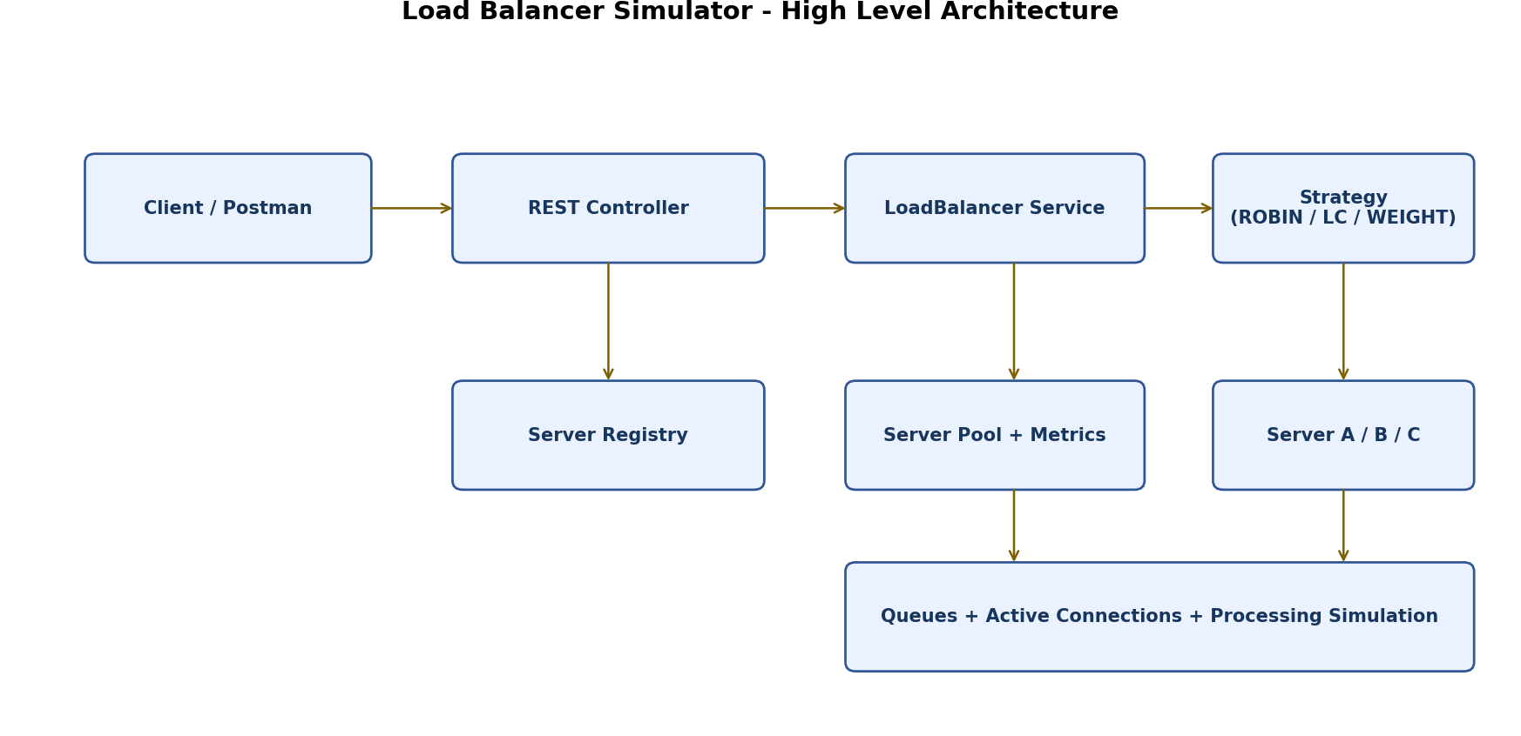
What this diagram means: the controller receives a request, passes it to the load balancer service, which delegates server choice to the currently active strategy. The request is then enqueued on the selected server, and the simulation engine updates processing state and metrics.

4. Detailed Design: What, Why, and How

4.1 Request Object
What: Represents a single incoming call or job.
Why: The balancer needs a uniform way to identify, track, and route traffic.
How: Store request ID, timestamp, payload, optional client IP, and processing metadata such as status or duration.

4.2 Server Object
What: Represents a backend server in the pool.
Why: The load balancer must know each server’s state and capacity.
How: Store server ID, weight, queue, active connection count, processed count, and current status (UP/DOWN).

4.3 LoadBalancingStrategy Interface
What: A common contract for all routing algorithms.
Why: Different balancing policies should be swappable without changing the balancer core.
How: Define a method like selectServer(List<Server> servers, Request request). Each strategy class implements this method.

4.4 LoadBalancer Service
What: The central coordinator of request distribution.
Why: It provides one place for server management, strategy selection, and metrics updates.
How: It stores the server pool, current strategy, and service methods such as addServer(), removeServer(), routeRequest(), and changeStrategy().

4.5 Simulation Engine
What: A component that simulates request execution and completion.
Why: Without completion, least-connections logic would never reflect real load changes.
How: Move requests from queue to in-progress state, wait for a simulated duration, then complete and decrement active connections.

4.6 Metrics Service
What: Collects statistics about routing behavior.
Why: A simulator is useful only if you can measure and compare strategies.
How: Track request counts, server distribution, queue length, average latency, and strategy-specific performance.

5. Data Structures and Why They Fit

5.1 Circular Linked List for Round Robin
What: A linked list where the last node points back to the first node.
Why: Round robin needs cyclic traversal of the server pool. A circular linked list naturally models this behavior.
How: Keep a pointer to the current server node. After routing a request, move the pointer to the next node. When the last node is reached, continue from the head automatically.

5.2 Queue for Each Server
What: A FIFO queue stored inside each Server object.
Why: Requests are generally processed in arrival order, and queue size is a simple but powerful load indicator.
How: When a request is assigned to a server, enqueue it. A simulation worker later dequeues and processes it.

5.3 Hashing for Deterministic Routing
What: A technique that maps a request attribute such as client IP to a server index.
Why: Hashing is useful for sticky sessions and consistent user affinity.
How: Compute hash(clientIp) mod numberOfServers, or use a consistent hashing ring if you want a more advanced version.

6. Request Flow Diagram
The next diagram shows the lifecycle of a request from arrival to queueing.
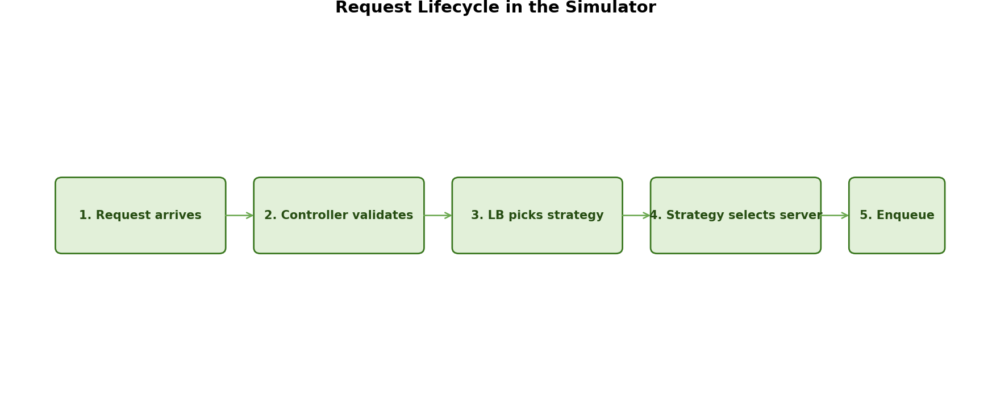
This flow is important because it separates selection from processing. The load balancer only chooses the target server; the server and simulation engine own the processing lifecycle.

7. Strategy Pattern Flow
The strategy pattern is the best design choice because you want to switch balancing algorithms at runtime without rewriting the load balancer.
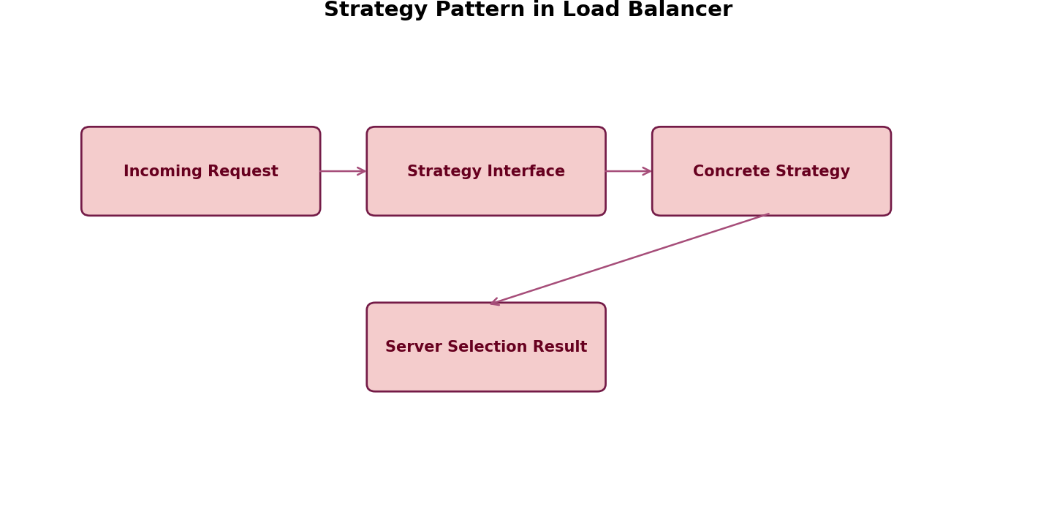
What: The load balancer delegates server selection to a strategy object.
Why: This keeps the system open for extension and easy to test.
How: Implement a LoadBalancingStrategy interface and create one class for each algorithm.

8. Full Class Design

8.1 Request
Responsibility: Represents incoming traffic to be routed.
Key Fields:
- String requestId
- String clientIp
- String payload
- long timestamp
- RequestStatus status
- int simulatedProcessingTimeMs
Key Methods:
- getters / setters
- markQueued()
- markProcessing()
- markCompleted()
- markFailed()
Why it exists: This is the atomic unit of traffic in the simulator.

8.2 Server
Responsibility: Represents one backend server in the cluster.
Key Fields:
- String serverId
- int weight
- Queue<Request> requestQueue
- int activeConnections
- long processedCount
- ServerStatus status
Key Methods:
- enqueueRequest(Request request)
- dequeueRequest()
- incrementActiveConnections()
- decrementActiveConnections()
- isHealthy()
- getQueueSize()
Why it exists: This class stores the load state that strategies depend on.

8.3 LoadBalancingStrategy (Interface)
Responsibility: Defines the contract for all routing strategies.
Key Fields:
- No fields; interface only.
Key Methods:
- Server selectServer(List<Server> servers, Request request)
Why it exists: This abstraction allows you to switch strategies at runtime and test them independently.

8.4 RoundRobinStrategy
Responsibility: Selects servers in a cyclic order.
Key Fields:
- CircularLinkedList<Server> serverRing
- Node<Server> currentPointer
Key Methods:
- selectServer(...)
- moveToNext()
Why it exists: It gives a simple and fair baseline distribution.

8.5 LeastConnectionsStrategy
Responsibility: Selects the server with the fewest active connections.
Key Fields:
- No special persistent state required, unless you optimize with a heap.
Key Methods:
- selectServer(...)
- findMinLoadServer(...)
Why it exists: It reacts to live load and is better when request durations vary.

8.6 WeightedRoutingStrategy
Responsibility: Routes requests proportionally to server capacity.
Key Fields:
- Optional cumulative weight list
- Optional current weight pointer if implementing weighted round robin
Key Methods:
- selectServer(...)
- buildWeightedSchedule()
Why it exists: It simulates production environments where servers have different capacities.

8.7 LoadBalancer
Responsibility: Main service that manages servers, strategies, and routing.
Key Fields:
- List<Server> servers
- LoadBalancingStrategy strategy
- MetricsService metricsService
- SimulationService simulationService
Key Methods:
- addServer(Server server)
- removeServer(String serverId)
- routeRequest(Request request)
- setStrategy(LoadBalancingStrategy strategy)
- getServerStats()
Why it exists: It acts as the facade for the whole simulator.

8.8 SimulationService
Responsibility: Simulates request processing and completion.
Key Fields:
- ExecutorService / ScheduledExecutorService (optional)
- Processing delay configuration
Key Methods:
- process(Server server, Request request)
- completeRequest(Server server, Request request)
Why it exists: It makes the balancing decisions meaningful by changing server load over time.

8.9 MetricsService
Responsibility: Collects performance and distribution statistics.
Key Fields:
- Map<String, Integer> requestsPerServer
- Map<String, Long> averageLatencyPerServer
- int totalRequests
- int failedRequests
Key Methods:
- recordAssignment(...)
- recordCompletion(...)
- recordFailure(...)
- snapshot()
Why it exists: It provides visibility into how each strategy behaves.

9. Implementation Roadmap (Step-by-Step)

Step 1: Define your domain models
What to do: Create Request, Server, enums, and basic DTOs.
Why this step matters: This gives a clean foundation for all other layers.

Step 2: Build the strategy interface
What to do: Define the common contract for routing algorithms.
Why this step matters: This makes future algorithms easy to plug in.

Step 3: Implement Round Robin first
What to do: Use a circular linked list to cycle through servers.
Why this step matters: It is the simplest baseline and proves the system works end-to-end.

Step 4: Add request queues and server processing
What to do: Simulate execution and completion.
Why this step matters: Without this, load-based algorithms are unrealistic.

Step 5: Implement Least Connections
What to do: Pick the server with the minimum active connections.
Why this step matters: This shows the simulator reacting to dynamic load.

Step 6: Implement Weighted Routing
What to do: Allocate more traffic to higher-capacity servers.
Why this step matters: This makes the simulator closer to heterogeneous production clusters.

Step 7: Add hashing-based routing (optional)
What to do: Route clients deterministically using a hash of clientIp or sessionId.
Why this step matters: This demonstrates sticky sessions and affinity routing.

Step 8: Expose REST APIs
What to do: Create endpoints for server management, routing, strategy switching, and metrics.
Why this step matters: This lets you interact with the simulator externally.

Step 9: Add monitoring and metrics
What to do: Track distribution, queue lengths, latency, and failures.
Why this step matters: This allows you to compare strategies objectively.

Step 10: Add failure handling
What to do: Mark servers down and reroute traffic.
Why this step matters: This makes the simulator more production-like and interview-ready.

10. Pseudocode

10.1 Route Request Flow
function routeRequest(request):
if no servers available:
return error "No healthy server available"
server = strategy.selectServer(servers, request)
if server is null or server.status != UP:
return error "No valid server selected"
server.enqueue(request)
server.incrementActiveConnections()
metrics.recordAssignment(server.id, request.id)
simulation.process(server, request)
return success response with selected server details

10.2 Round Robin Selection
function selectServerRoundRobin():
current = currentPointer
if current is null:
return null
selected = current.data
currentPointer = currentPointer.next
return selected

10.3 Least Connections Selection
function selectServerLeastConnections(servers):
best = null
for each server in servers:
if server.status == UP:
if best is null or server.activeConnections < best.activeConnections:
best = server
else if server.activeConnections == best.activeConnections:
if server.queueSize < best.queueSize:
best = server
return best

10.4 Weighted Routing Selection
function selectServerWeighted(servers):
totalWeight = sum(server.weight for each healthy server)
pick = random(1, totalWeight)
running = 0
for each server in servers:
if server.status == UP:
running += server.weight
if pick <= running:
return server
return null

10.5 Hash-Based Routing
function selectServerByHash(request, servers):
index = hash(request.clientIp) mod servers.size
return servers[index]

11. REST API Design with Request / Response Examples

11.1 Add Server
POST /servers
Content-Type: application/json
{
"serverId": "S1",
"weight": 3
}
200 OK
{
"message": "Server added successfully",
"server": {
"serverId": "S1",
"weight": 3,
"status": "UP",
"activeConnections": 0,
"queueSize": 0
}
}

11.2 Submit Request
POST /requests
Content-Type: application/json
{
"requestId": "R101",
"clientIp": "192.168.1.10",
"payload": "user-login",
"simulatedProcessingTimeMs": 500
}
200 OK
{
"message": "Request routed successfully",
"requestId": "R101",
"selectedServer": "S2",
"strategy": "LEAST_CONNECTIONS",
"serverQueueSize": 4,
"activeConnections": 7
}

11.3 Switch Strategy
POST /strategy
Content-Type: application/json
{
"strategy": "ROUND_ROBIN"
}
200 OK
{
"message": "Strategy switched successfully",
"activeStrategy": "ROUND_ROBIN"
}

11.4 Get Server Stats
GET /stats
200 OK
{
"totalRequests": 1200,
"failedRequests": 12,
"activeStrategy": "WEIGHTED",
"servers": [
{
"serverId": "S1",
"weight": 1,
"activeConnections": 4,
"queueSize": 2,
"processedCount": 420
},
{
"serverId": "S2",
"weight": 3,
"activeConnections": 9,
"queueSize": 6,
"processedCount": 780
}
]
}

12. Interview Explanation Section
This project is excellent for interviews because it combines data structures, design patterns, backend APIs, and simulation thinking. Below is how to explain it clearly.

12.1 Problem Statement
I built a load balancer simulator that distributes requests across multiple servers using different balancing strategies. The simulator supports Round Robin, Least Connections, Weighted Routing, and optional hash-based routing. It also exposes REST APIs so that servers can be added, removed, and monitored dynamically.

12.2 Why I Chose This Design
- I used the Strategy Pattern because balancing rules should be swappable without changing the load balancer core.
- I used a Circular Linked List for Round Robin because cyclic iteration is a natural fit for that structure.
- I used queues because servers should process requests in arrival order.
- I used hashing to demonstrate sticky routing and deterministic server selection.

12.3 What I Would Say in an Interview
I designed the system in layers: request intake, load balancing, server simulation, and REST APIs.
For Round Robin, I used a circular linked list so I could move through the server pool in a loop.
For Least Connections, I tracked active connections per server and routed the next request to the least loaded server.
For Weighted Routing, I assigned capacity-based weights so stronger servers receive a larger share of traffic.
I also added metrics so that I can compare how each strategy behaves under different traffic patterns.
This makes the project practical, extensible, and a good foundation for more advanced features like health checks and failover.

12.4 Good Follow-Up Interview Questions
- How would you handle a server going down mid-processing?
- How would you implement consistent hashing for better server stability?
- How would you make least-connections efficient for thousands of servers?
- How would you add retry logic without causing duplicate request processing?
- How would you collect latency metrics per server over time?

13. Testing Strategy
- Unit test each strategy independently.
- Integration test the complete request-routing flow.
- Run simulation scenarios with equal weights, unequal weights, and burst traffic.
- Test edge cases such as no servers, all servers down, and zero-weight configuration.
- Test whether metrics and queue sizes reflect the expected state after routing and completion.

14. Possible Enhancements
- Server health checks and automatic removal of unhealthy servers.
- Retry and failover logic for selected servers that become unavailable.
- Consistent hashing ring instead of simple hashing for better server stability when nodes are added or removed.
- A dashboard to visualize traffic distribution and queue depth.
- A latency-aware strategy that routes traffic based on response time rather than only connection count.

15. Final Summary
This project is a strong blend of algorithms, object-oriented design, and API engineering. It is small enough to complete as a portfolio project, but rich enough to discuss in interviews. If you build it carefully with clean abstractions, measurable metrics, and a few advanced features, it can easily stand out from typical CRUD projects.

