**Create a flume agent that streams data from Twitter and stores it in the HDFS cluster.**

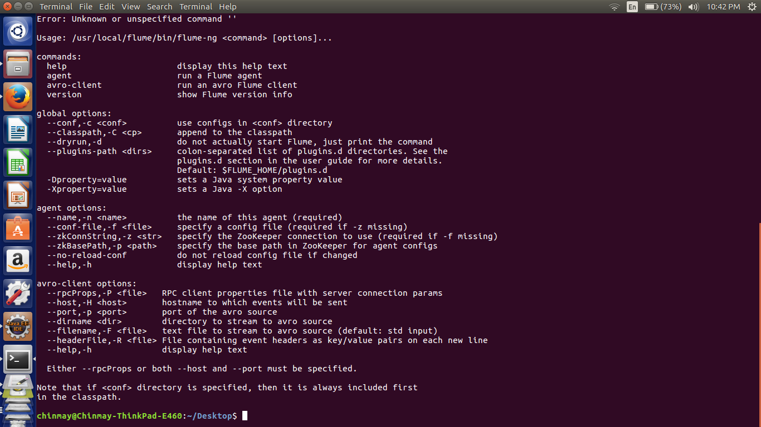

**Creation Of Keys**

C:\Users\613048\Desktop\Capture.PNG

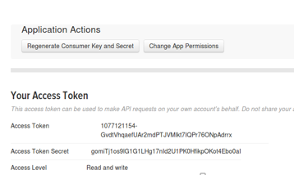

**Command used to execute the agent.**

flume-ng agent -n TwitterAgent -f /usr/local/flume/conf/twitteragent.conf

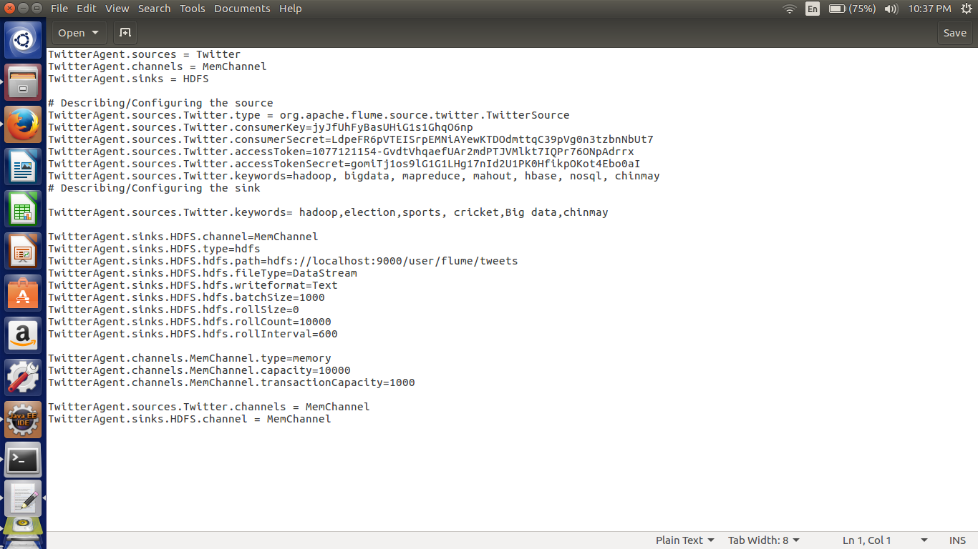

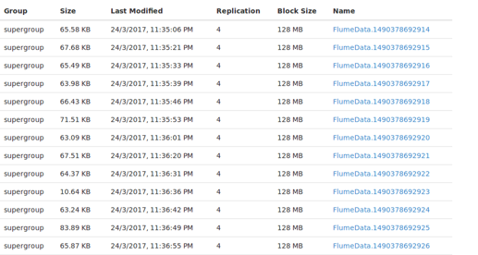

**Output**



