1. Write a map reduce program to join the below given two datasets using map side join. You can download the datasets from the below link https://drive.google.com/open?id=0ByJLBTmJojjzSWhfXzI5NGh4RGM Dataset description of dataset1.csv is as follows: id,first_name,last_name,email,gender,ip_address Dataset description of tdataset2.csv is as follows: id,first_name,last_name Note : You can just join the datasets using map side join.

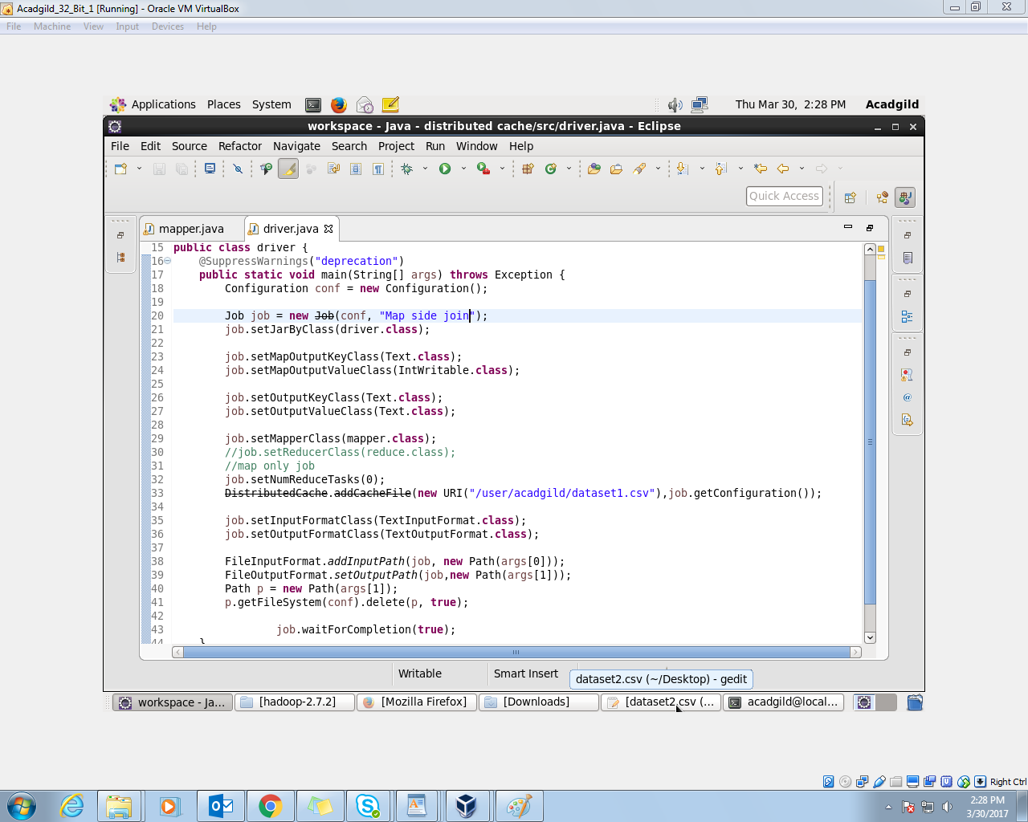

//mapper

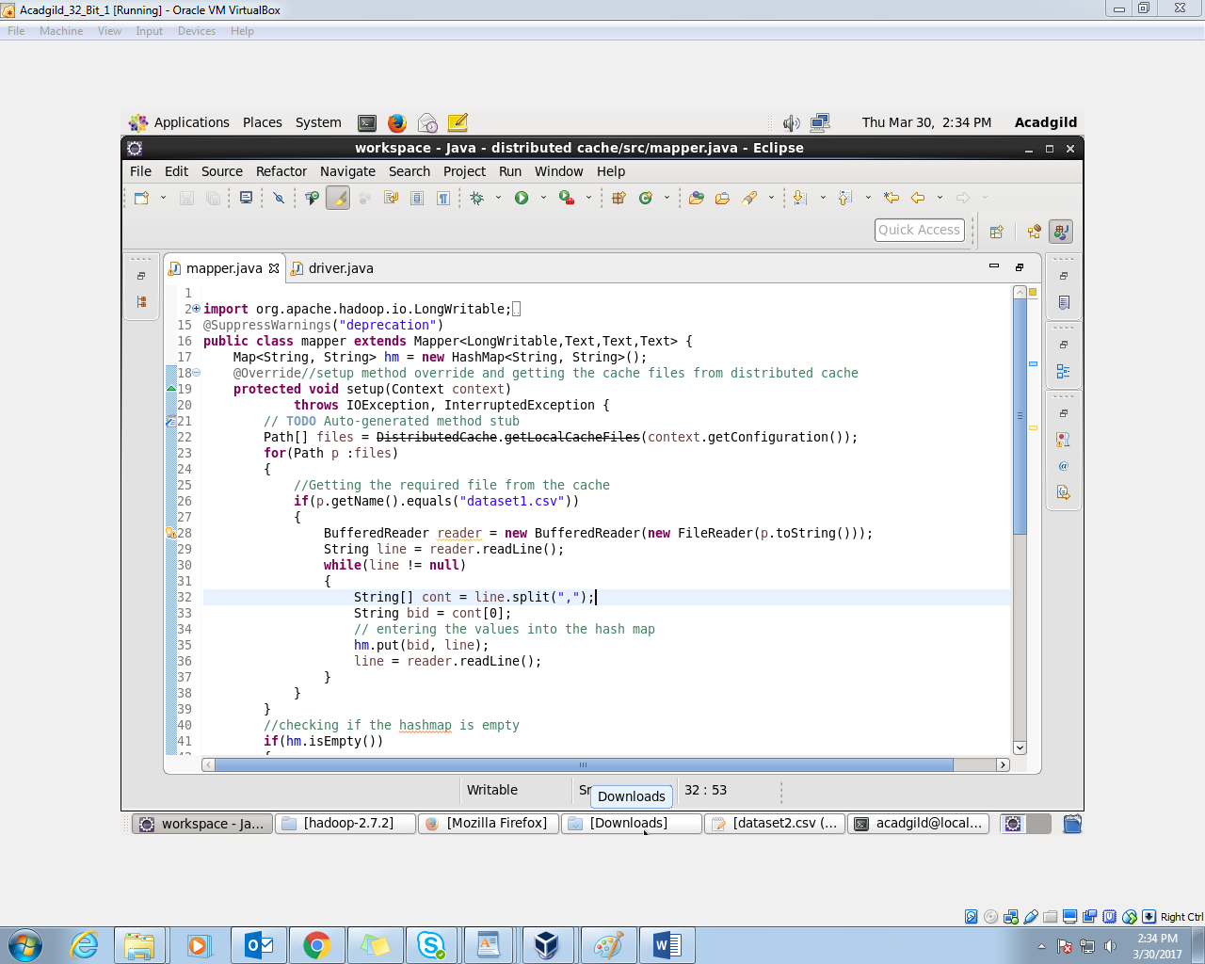

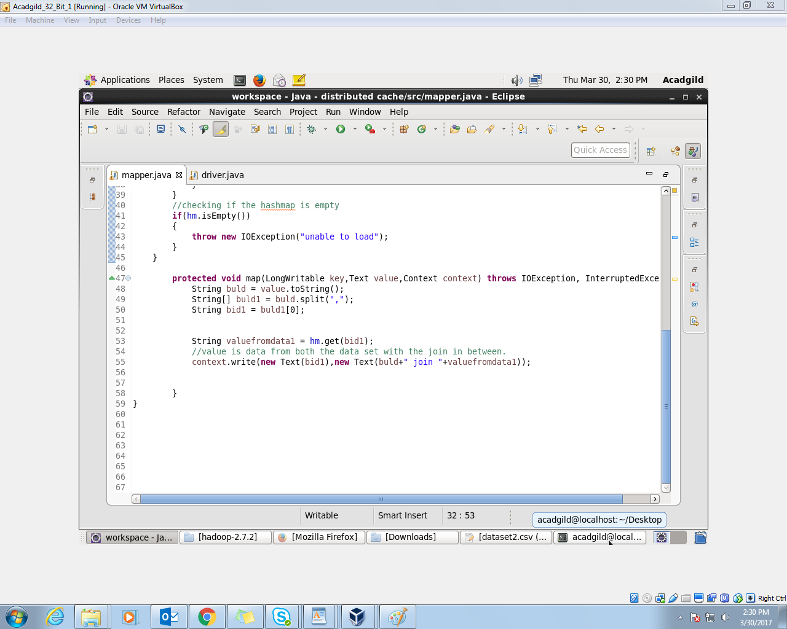

//implementation

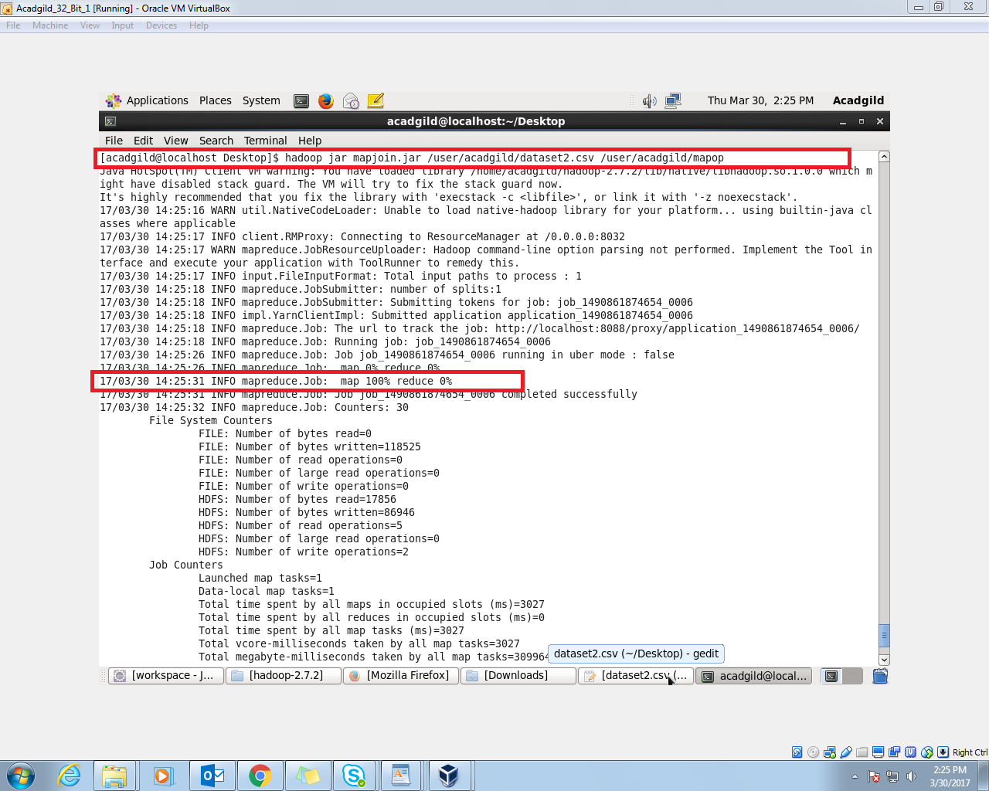

//output

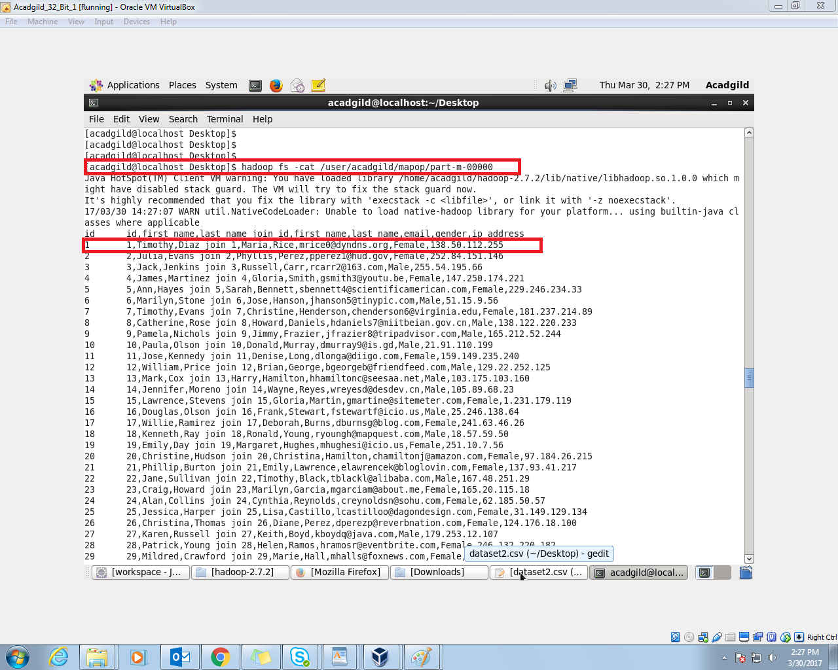

JOIN is done using the map side join with the help of the distributed cache.

The output shows only few of the output