1. **Write a map reduce program to join the below given two datasets using Reducer side join.**

You can download the datasets from the below link https://drive.google.com/open?id=0ByJLBTmJojjzSWhfXzI5NGh4RGM

Dataset description of dataset1.csv is as follows: id,first_name,last_name,email,gender,ip_address

Dataset description of tdataset2.csv is as follows: id,first_name,last_name Note : You can just join the datasets using reducer side join

**//Driver class**

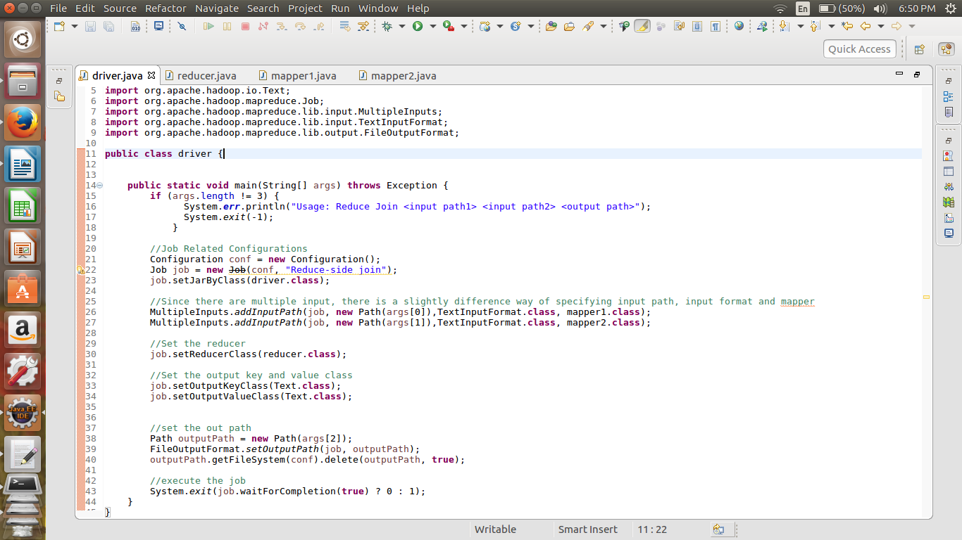

**Multiple inputs are taken to take inputs from two different files.**

**Mapper class**

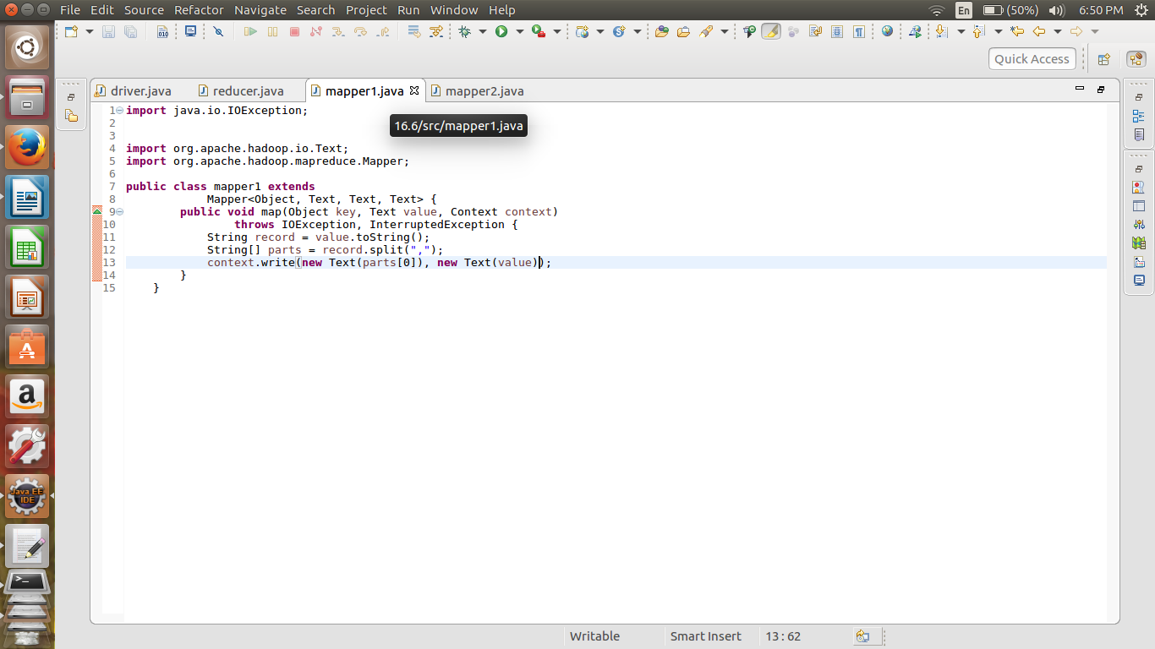

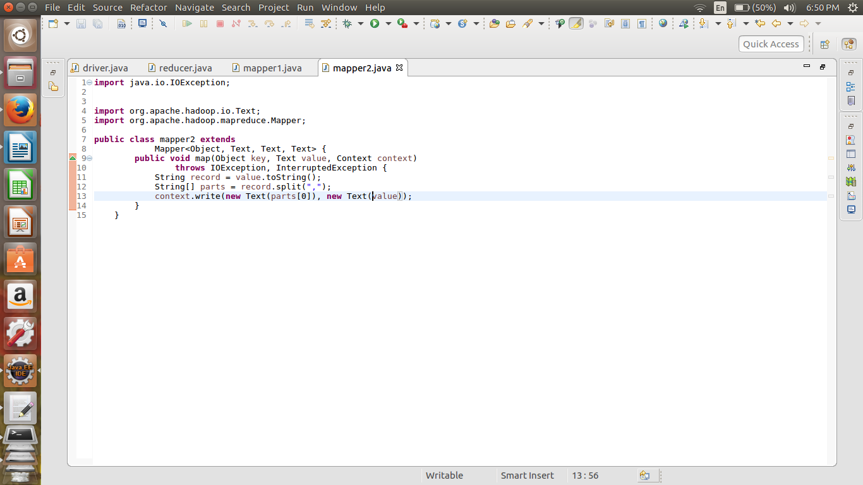

**reducer class**

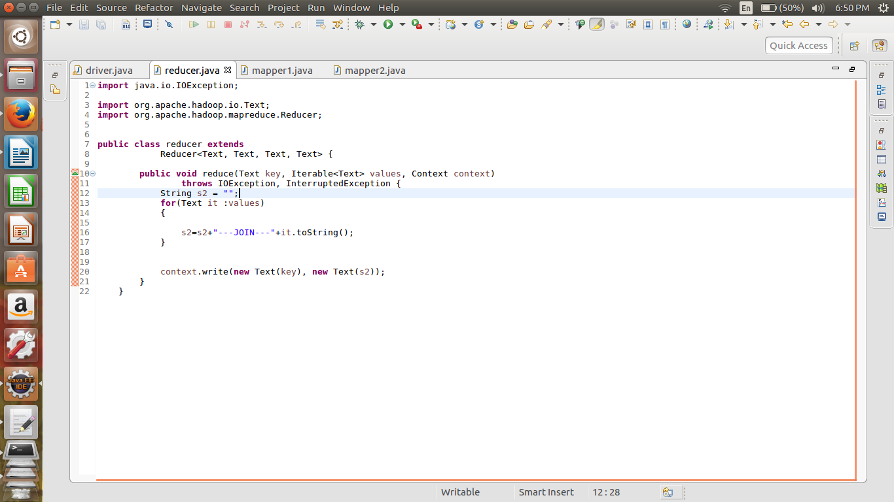

In this reduce join we are joining the values of both columns with the common field of “ID”.

//Implementation command

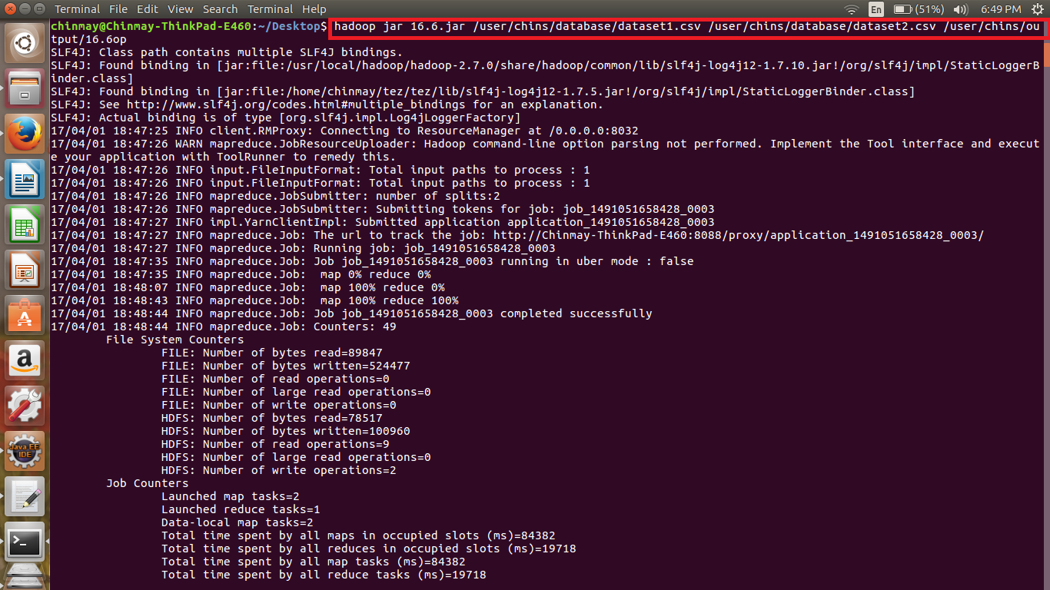

**Output**

