**Write a secondary sort program to generate the top 2 maximum temperatures corresponding to every year from the temperature dataset.**

**Driver:-**

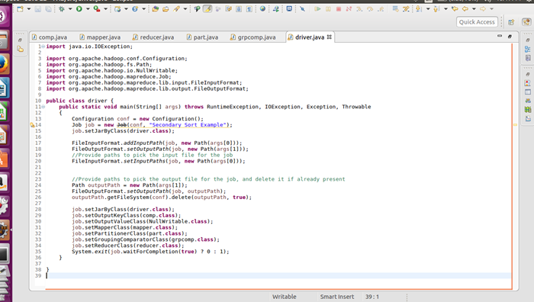

**Mapper:-**

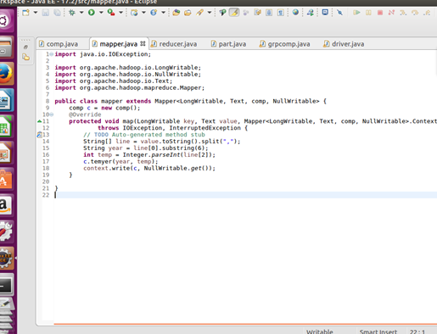

**Comparable writable :-**

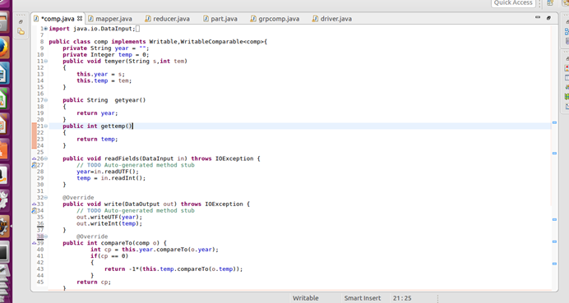

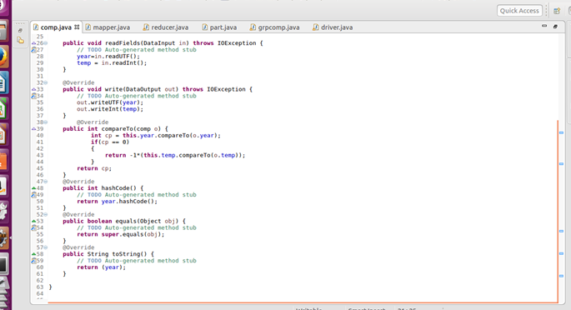

**Partitioner:-**

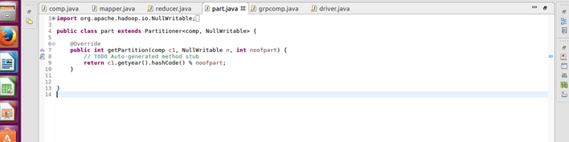

**Group comparator:-**

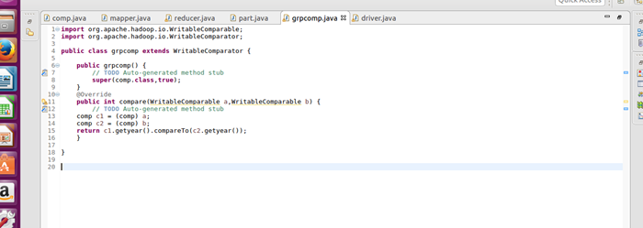

**Reducer:-**

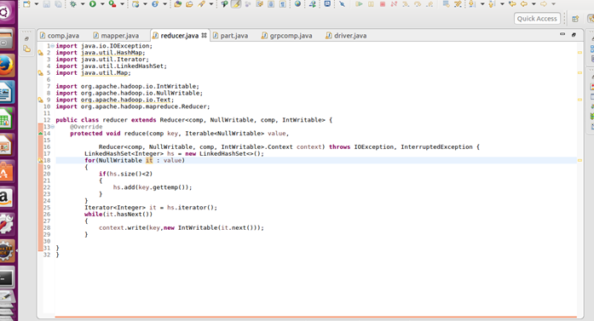

**Output:-**

