Write a mapreduce job that takes configuration from command line. Based on the configuration, it should perform count of words from a document and produce only those words in the output whose count is greater than or equal to the configuration.

**Code:-**

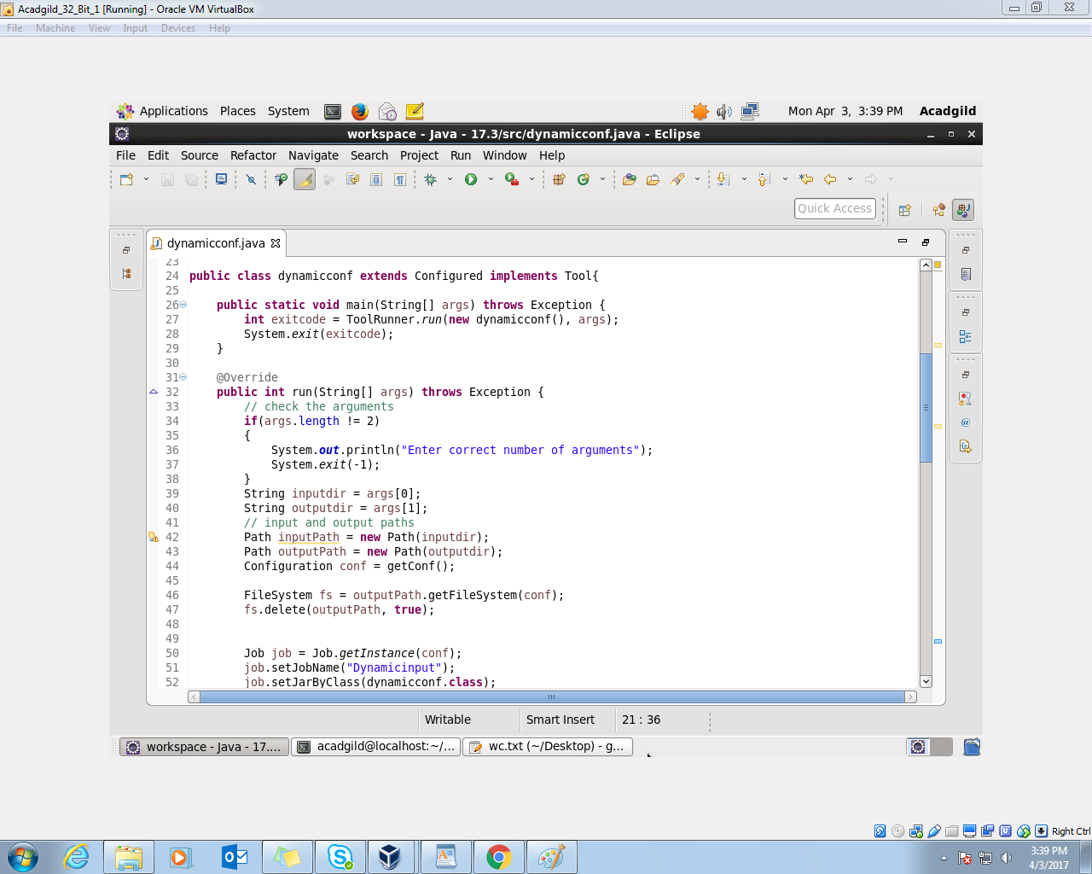

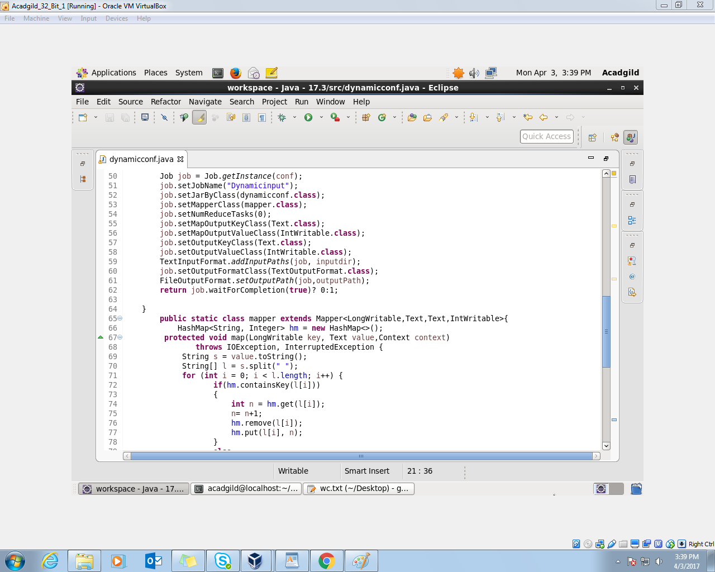

Set as map only job

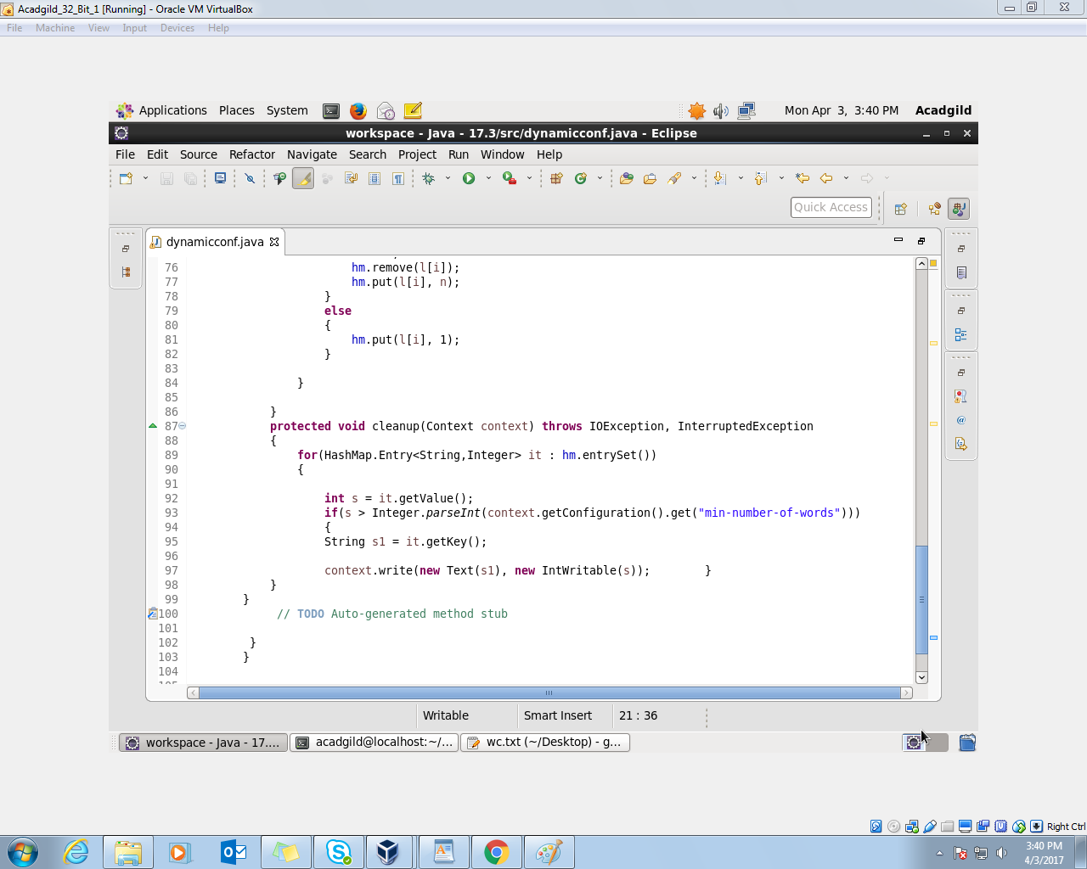

storing the words in the hasmap with the number of occurrences and then passing only those whose values are greater than the given value. In the above example it is 2.

We can give whatever value we want.

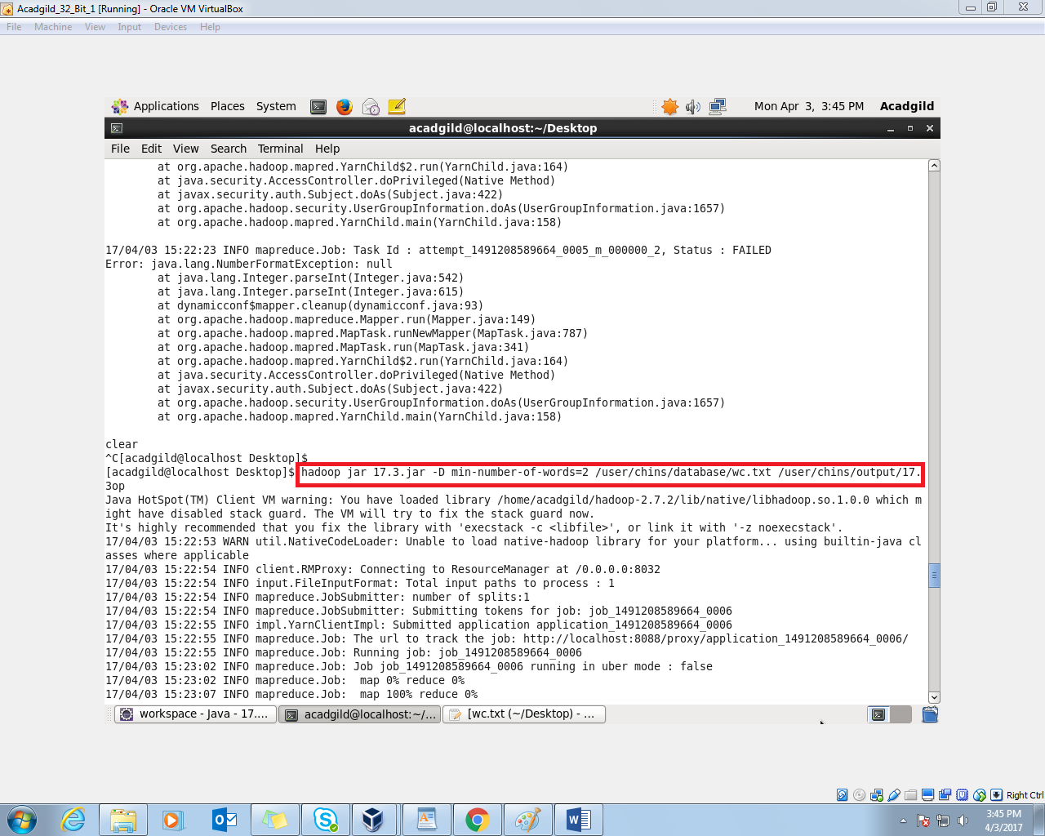

Mentioned the min number of words as 2

Output:-

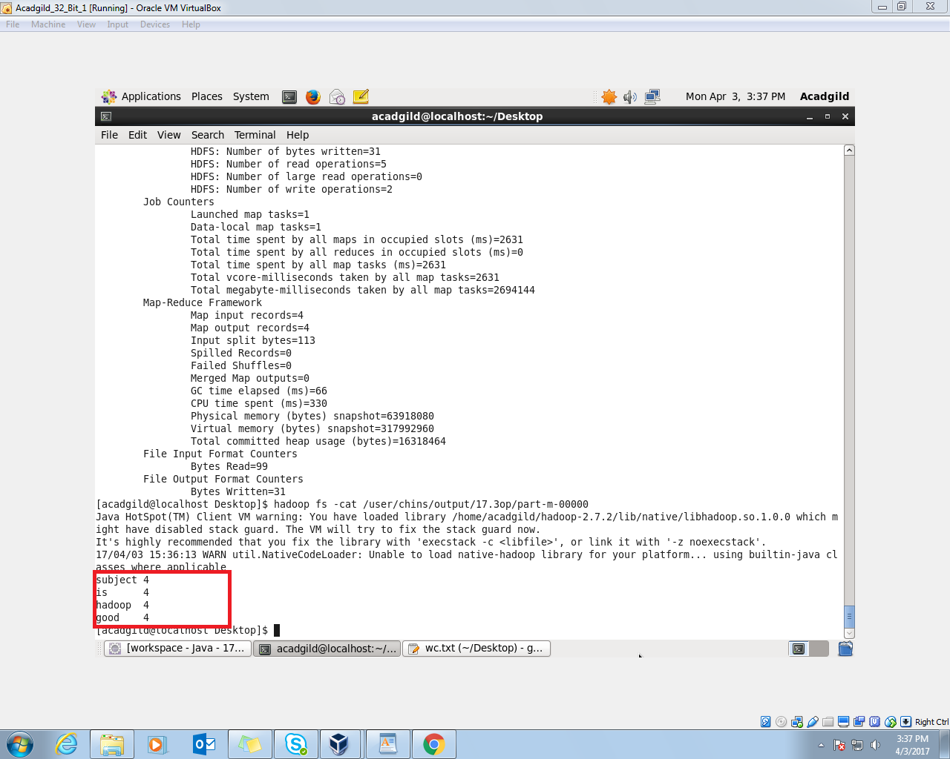

Input File:-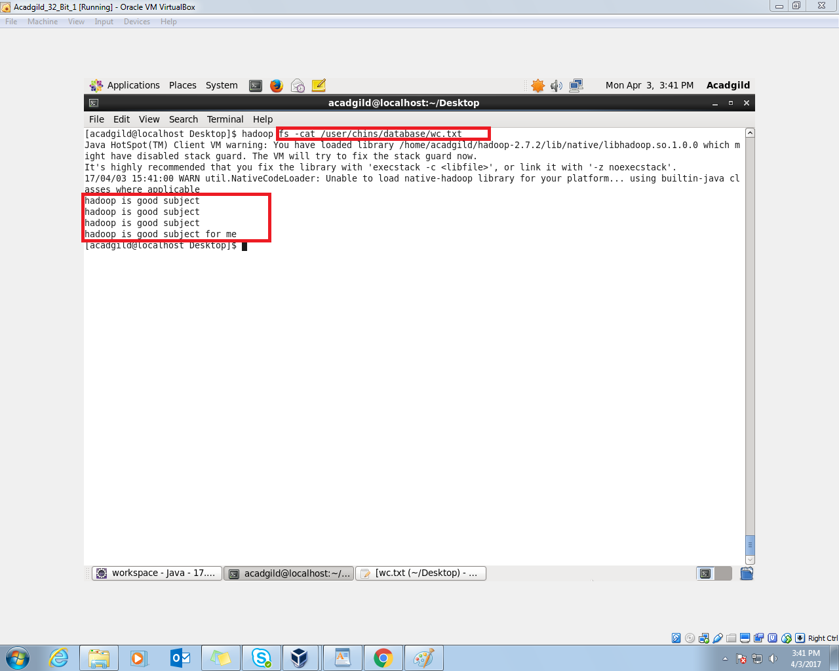

As we can see word “for”, “me” are not present in the output as they appear only once in the file.