Q -Merge the small files in hadoop by following the below blog.
https://acadgild.com/blog/merging-files-hdfs/

Input files

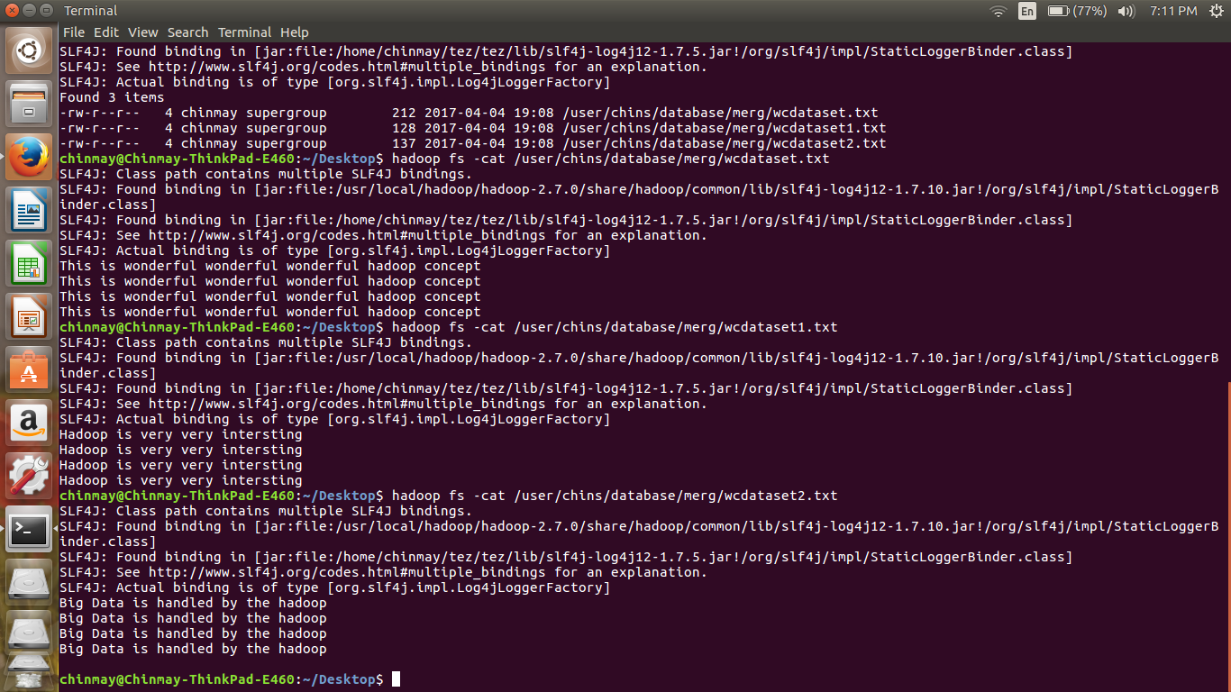
Output

