**Assignment 22.1**

**Write a Wordcount program and Store the result in Mysql db.**

Since we want to store result in mysql ,set DBOutputformat class in Driver

pass the reducer output to customized DBOutput class which will store the result in mysql

**Driver:**

Since we want to store the output in mysql ,we want sql connector jar and add the jar file to your build path

In driver set output format as DBOutputFormat with 4 parameters in order  
**configuration,tablename(word_count),column in tables**

**In configureDB give conf , driverclass,dDBuri,username,password Of the Database**

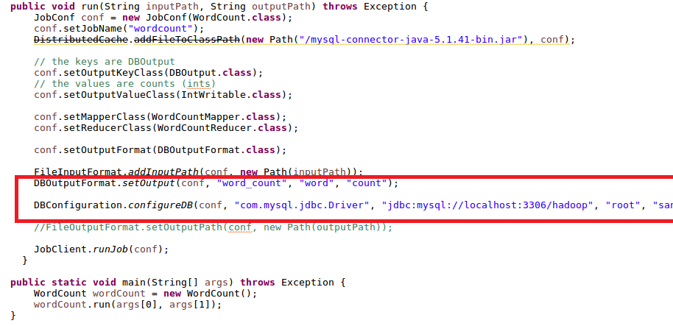

Mapper:

Split the input by comma and write the word as Key and a count of 1 as value

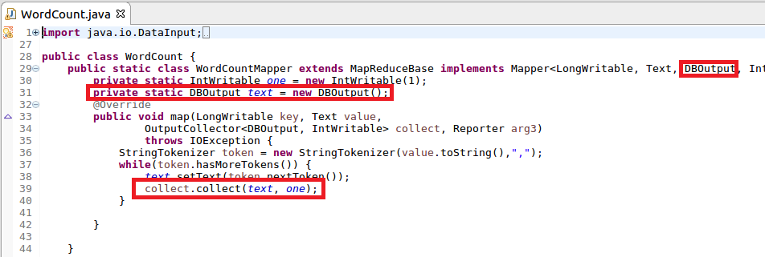

Reducer:

Since we want the store the output in mysql ,pass the word and count in DBOutput which enables the storage of output in mysql DB

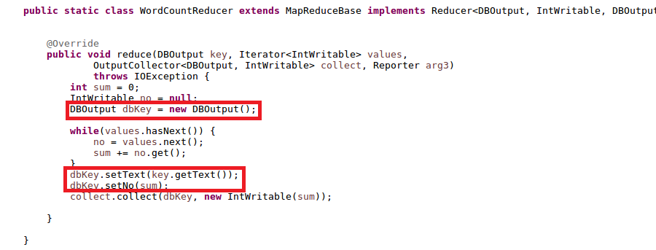

**Configuring MySql DBOutput**

Here we are mainly configuring 4 methods

**2 for reading and writing from hadoop framework**

**2 for reading and writing from sqlDB**

**1.readfields() and writefield()**

**Read and write data to and fro the framework**

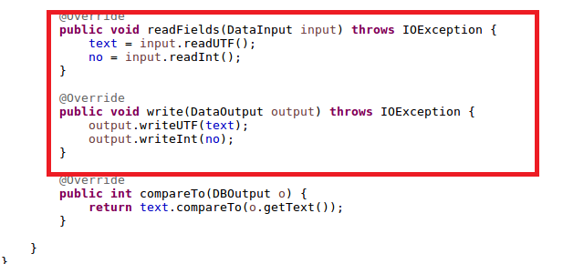

**2.readfields() and writefield()**

**Read fields and write fields is used for storing and reading from mysql**

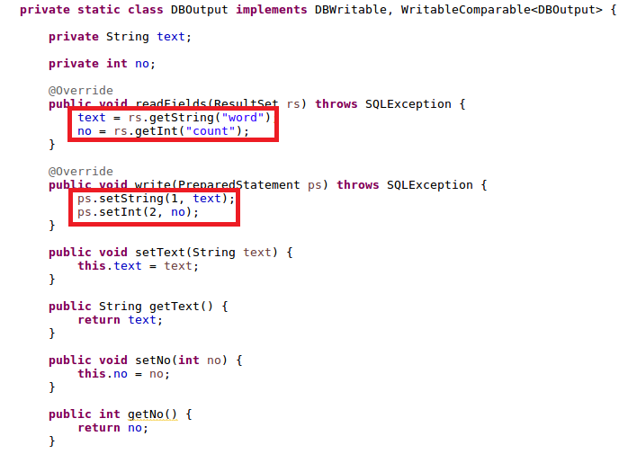

**Full DB Output code:**

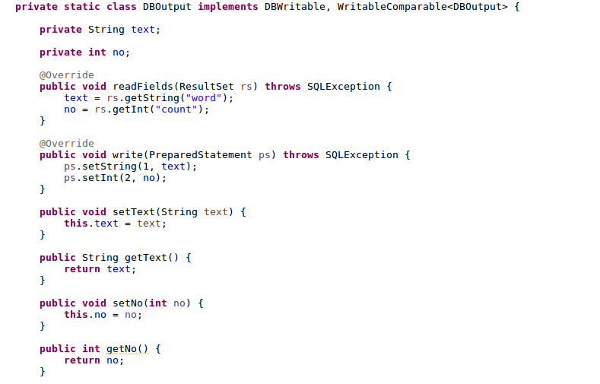

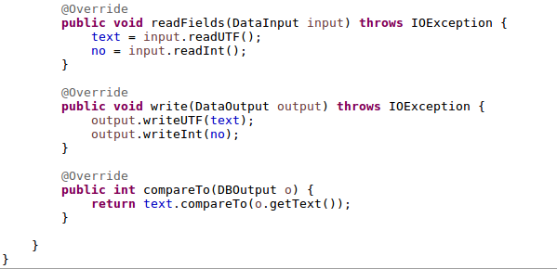

**Input File**

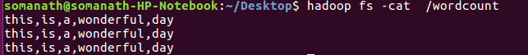

**Running mysql jar**

Give Input path and dummy output path

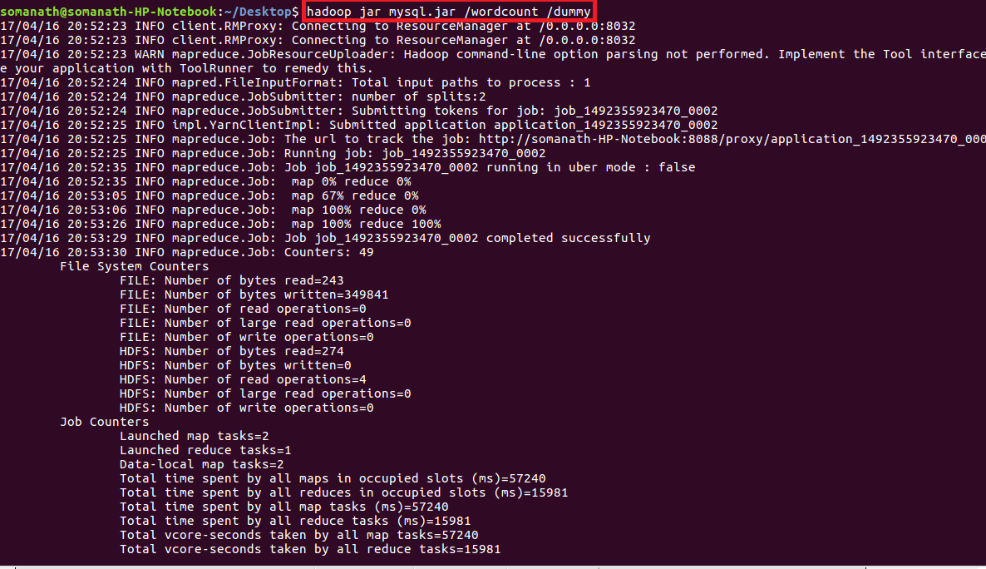

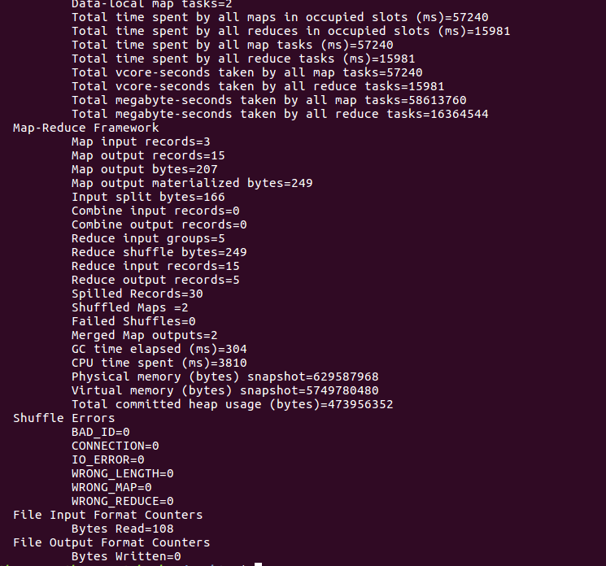

**Mysql Output:**

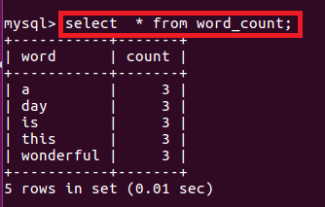

**Inference: Map reduce output is stored in table word_count as specified in DBOutput Format**