**ASSIGNMENT 24.2**

* Creating databases:-

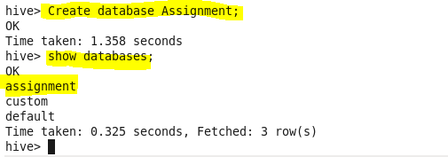

* Creating table:-

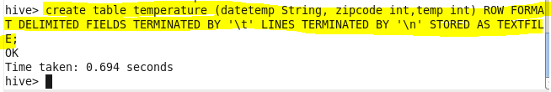

* Loading data from data file:-

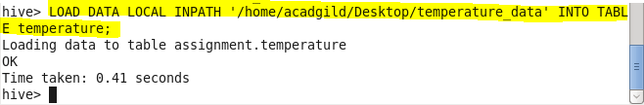

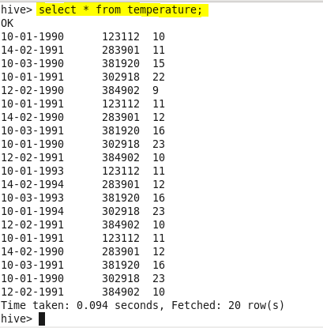

* Fetch date and temperature from temperature_data where zip code is greater than 300000 and less than 399999?

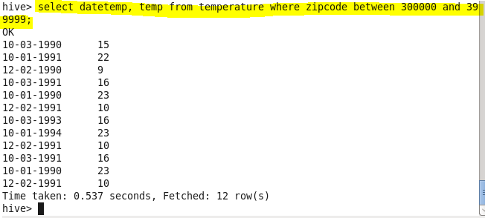

* Calculate maximum temperature corresponding to every year from temperature_data table.?
* Extract year from date and group by year

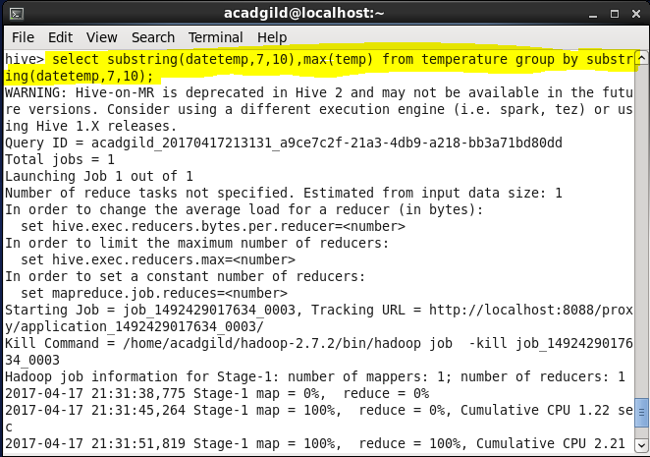

Output:

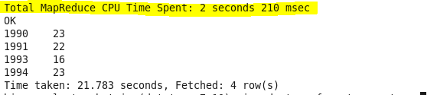

* Calculate maximum temperature from temperature_data table corresponding to those years which have at least 2 entries in the table.
* Group by year and count their occurrences. Display the max temperature accordingly.

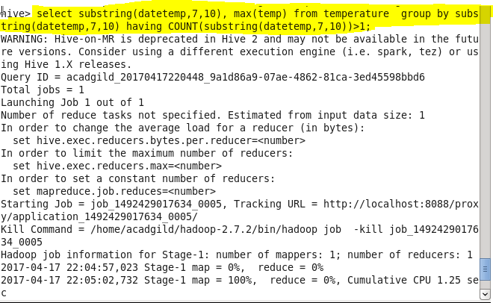

**Output:**

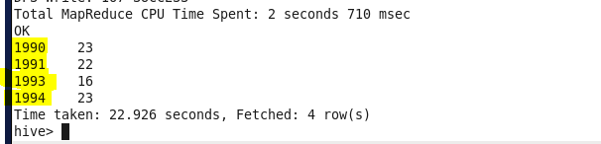

* Create a view on the top of last query, name it temperature_data_vw.

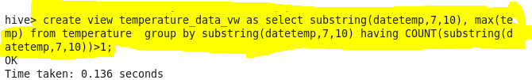

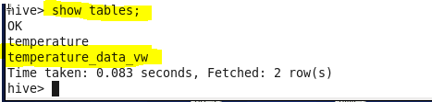

Output:

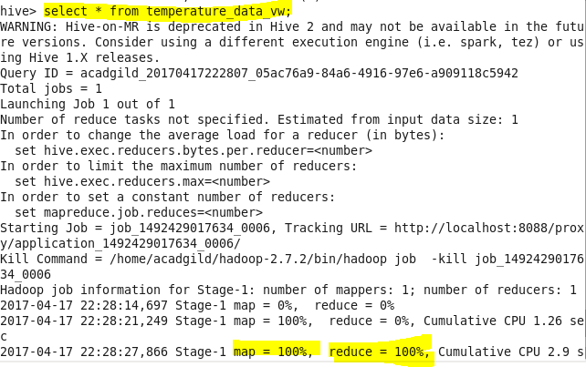

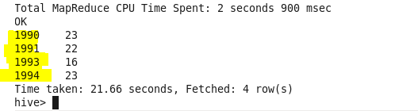

* Export contents from temperature_data_vw to a file in local file system, such that each file is '|' delimited.

