**Perform word count in Hive for above given dataset.**

Input file:-

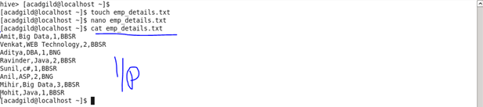

Creating table and loading data:-

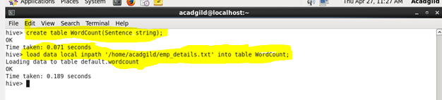

Split command

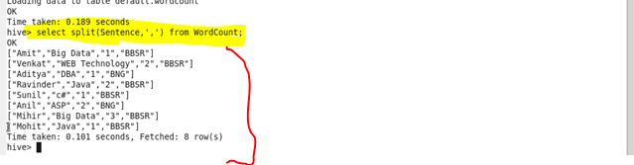

Explode command

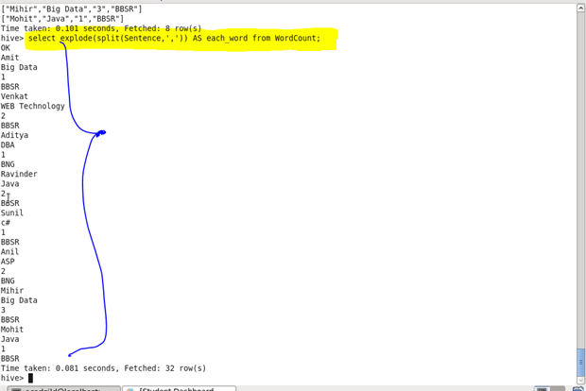

Counting each word

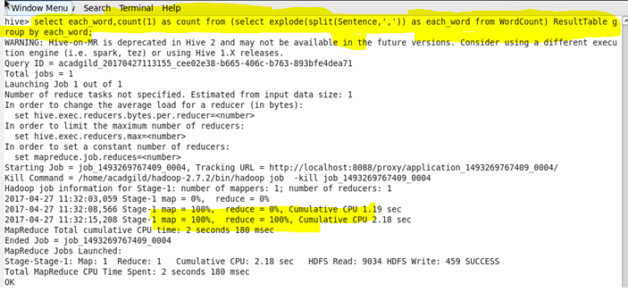

**Output :-**

