**Assignment 32.3**

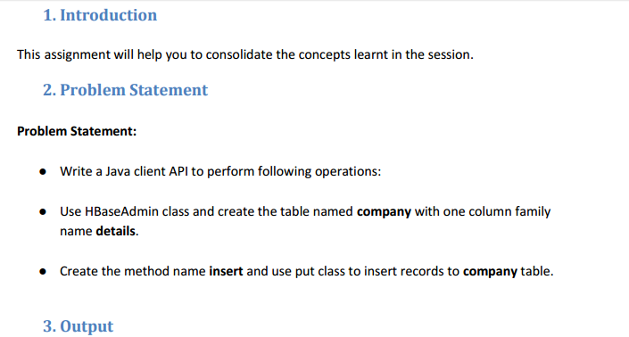

**Writing A Java Code To Create A Table In Hbase:**

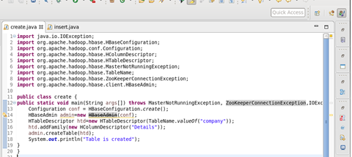

**Table Is Created In Hbase By Running The Java Code (Run As Application) In Eclipse**

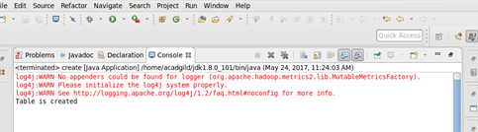

**Using ‘List’ Command , Showing The Tables In Hbase**

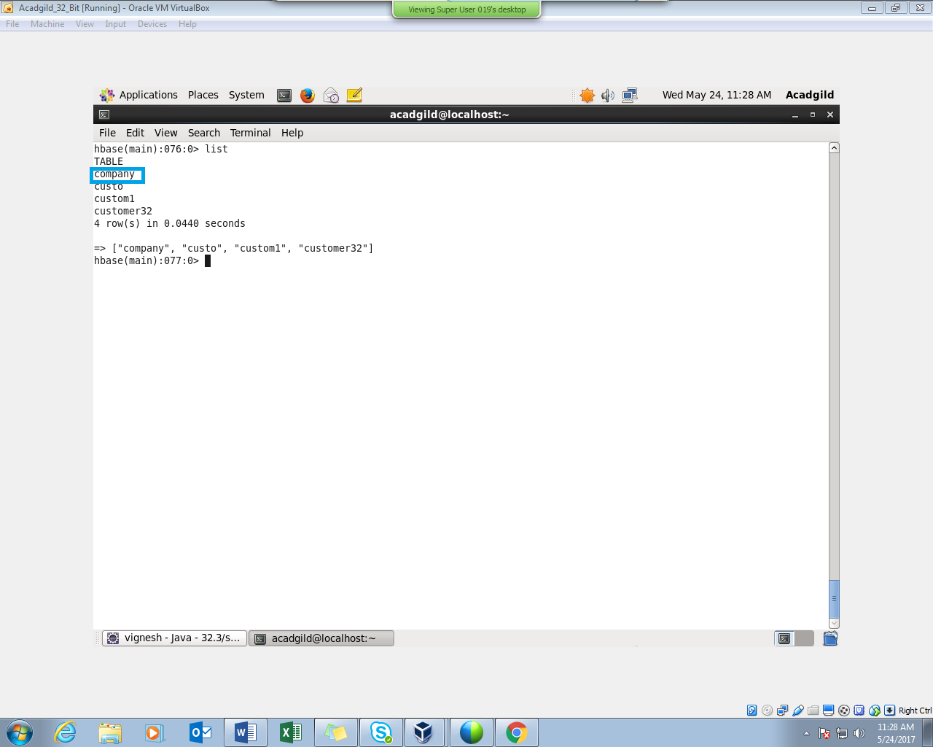

**Writing A Java Code To Insert Data Into The Table “Company”**

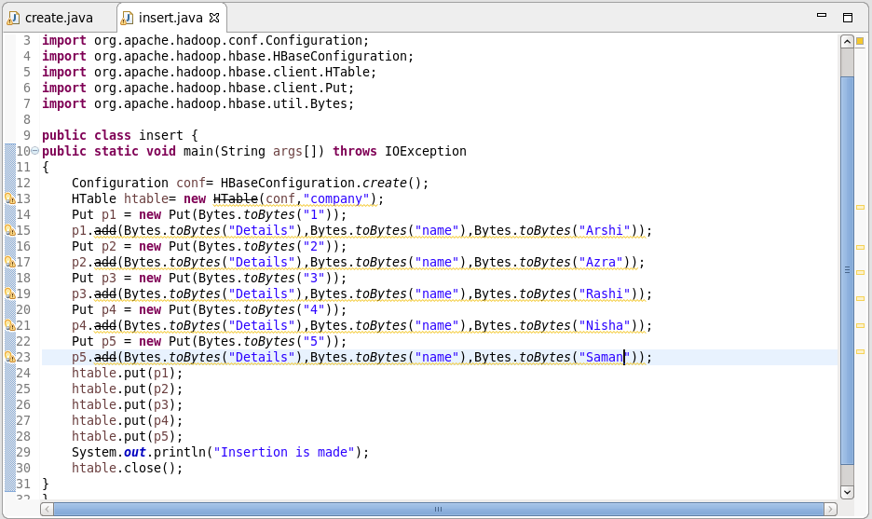

**Insertion Is Made By Running The Java Code In Eclipse (Run As Application)**

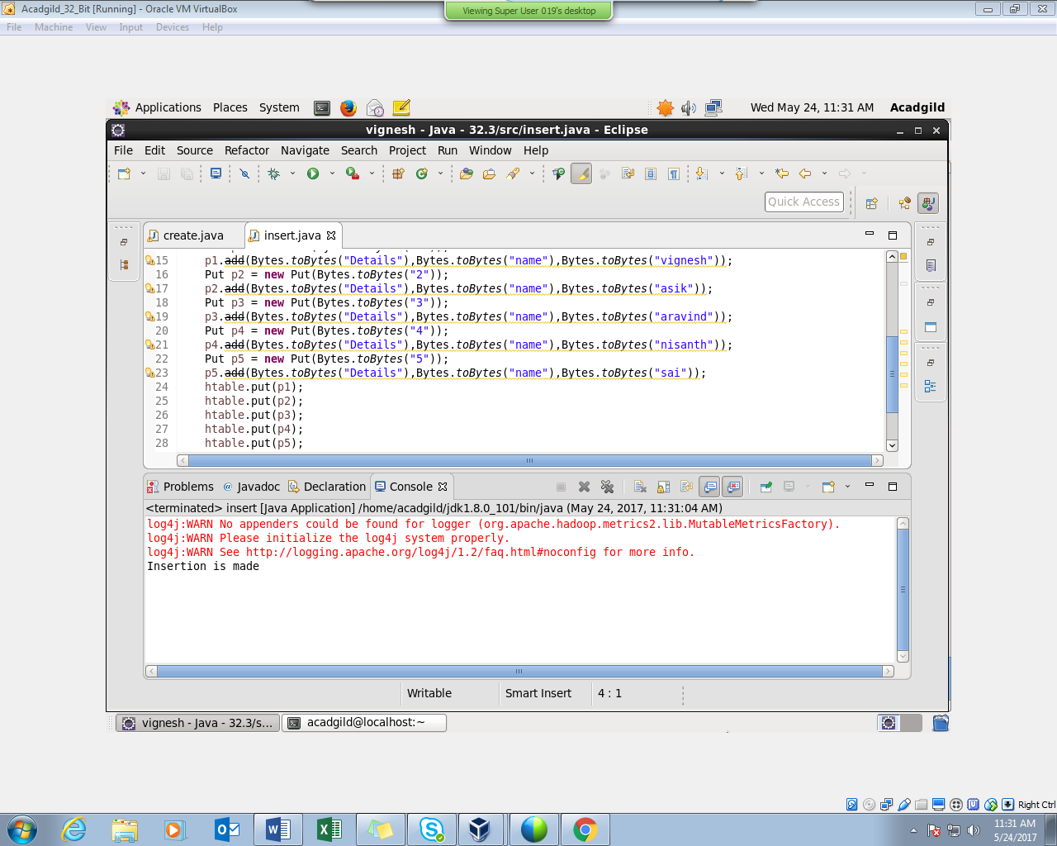

Here We Can See That Insertion Was Successful

PERFORMING SCAN COMMAND :

