Driver class:

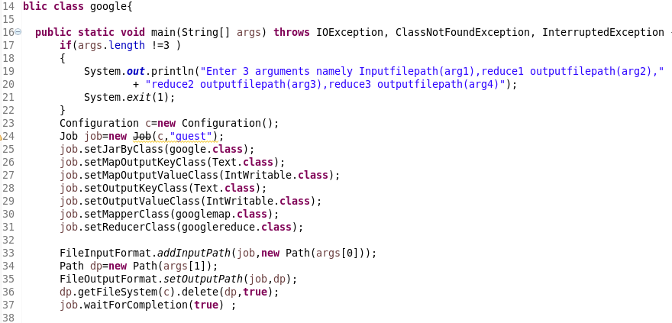

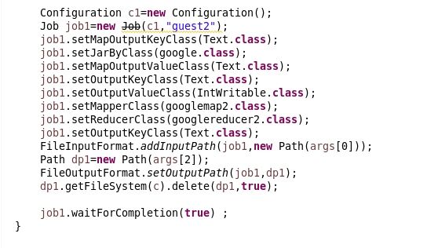

Mapper (qn1)

LOGIC:-splitting by comma and then filter them by date between the given dates BY USING LOCAL DATE and then sending the guest as key and value as 1 for each people

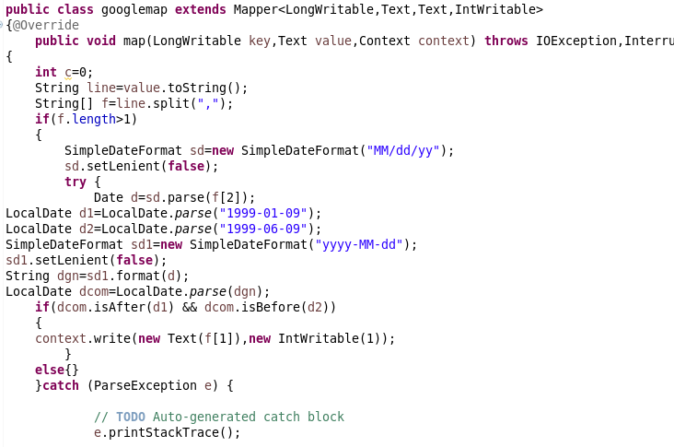

REDUCER

Count the number of guests

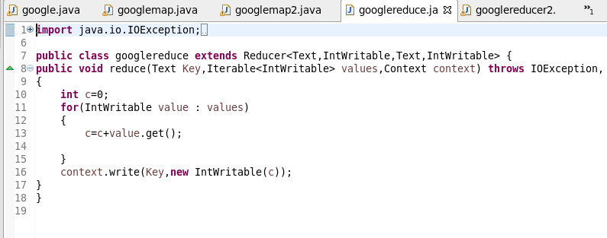

MAPPER (qn2)

Splitting by comma and then sending Group and the Guests as key and value

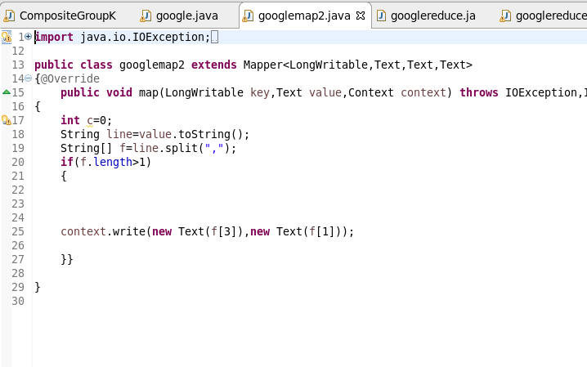

REDUCER

USED hash set to remove Duplicate guests and then send it as value as we want unique number of guests in each group

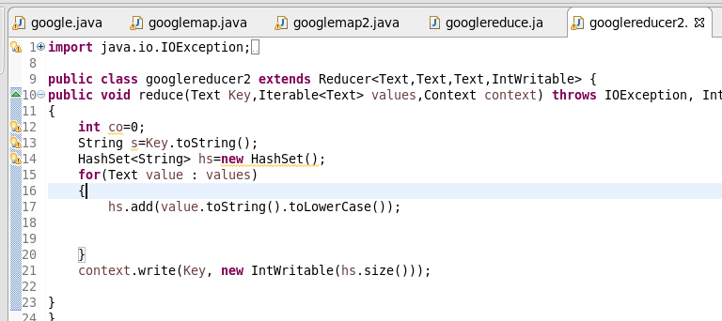

RUNNING JAR

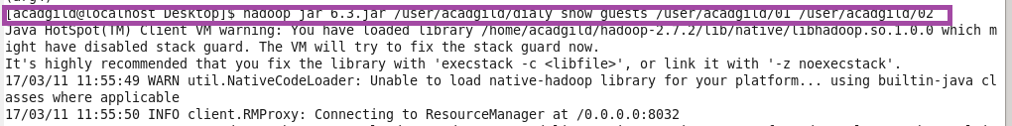

Output 1

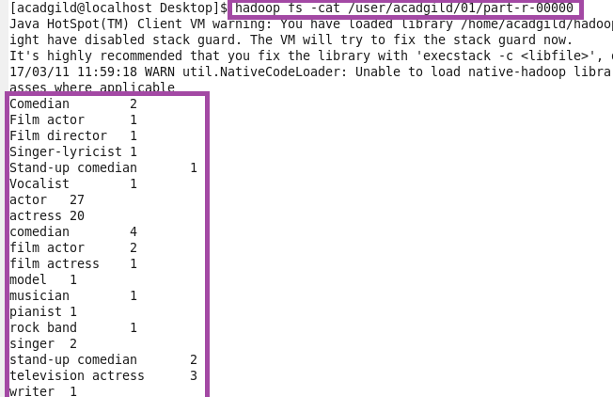

Output 2

