**Q -Merge the small files in hadoop by following the below blog.**

[**https://acadgild.com/blog/merging-files-hdfs/**](https://acadgild.com/blog/merging-files-hdfs/)

**Input files**

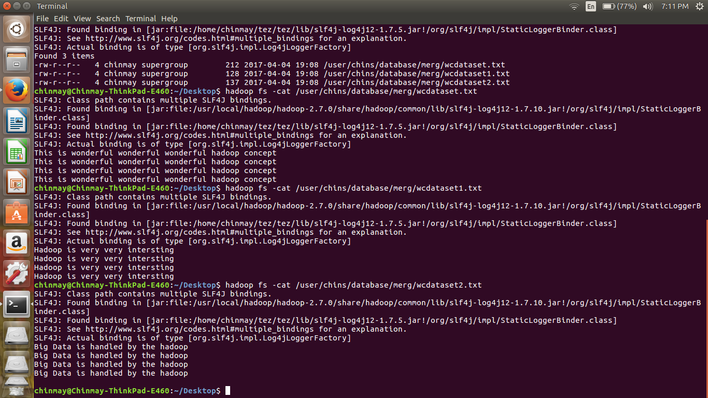**Output**

