2 Find out the top 10 cities that generate high airline revenues for travel, so that the site can concentrate on offering discount on booking, to those cities to attract more bookings.

**Mapper**

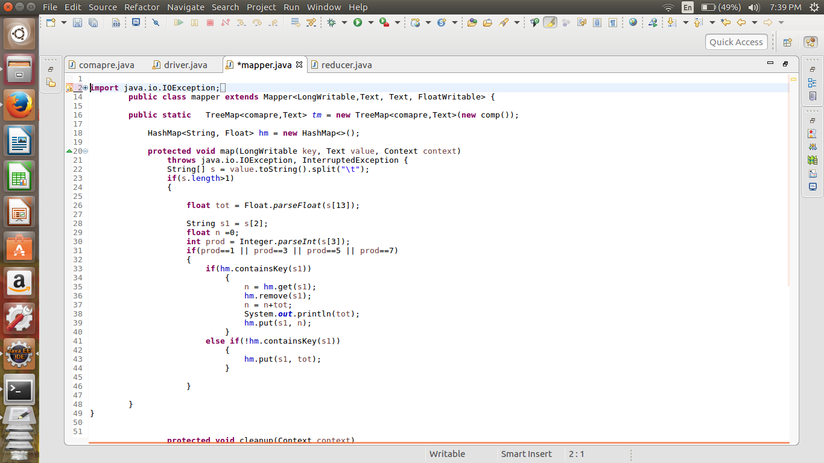

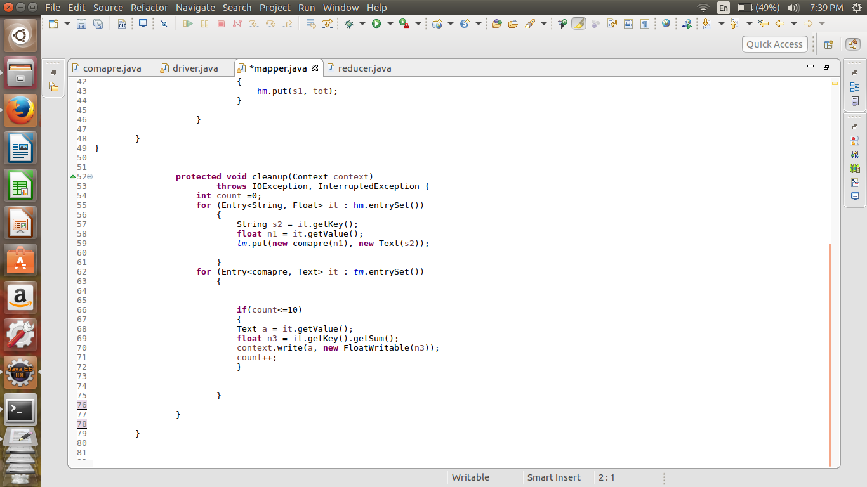

**Reducer**

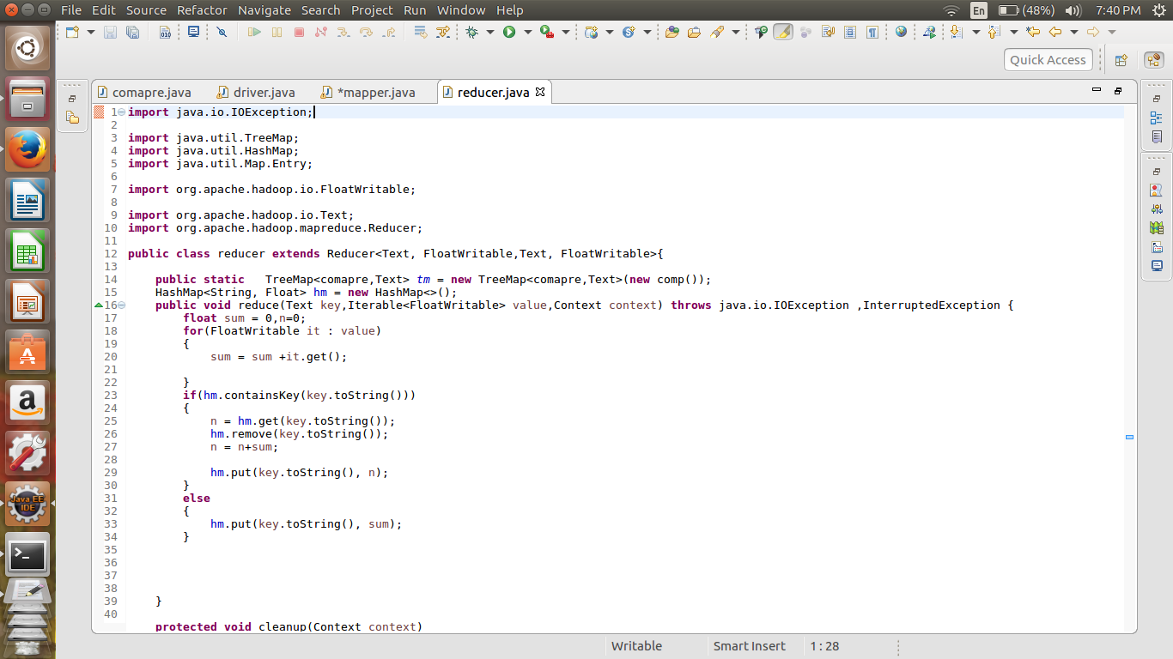

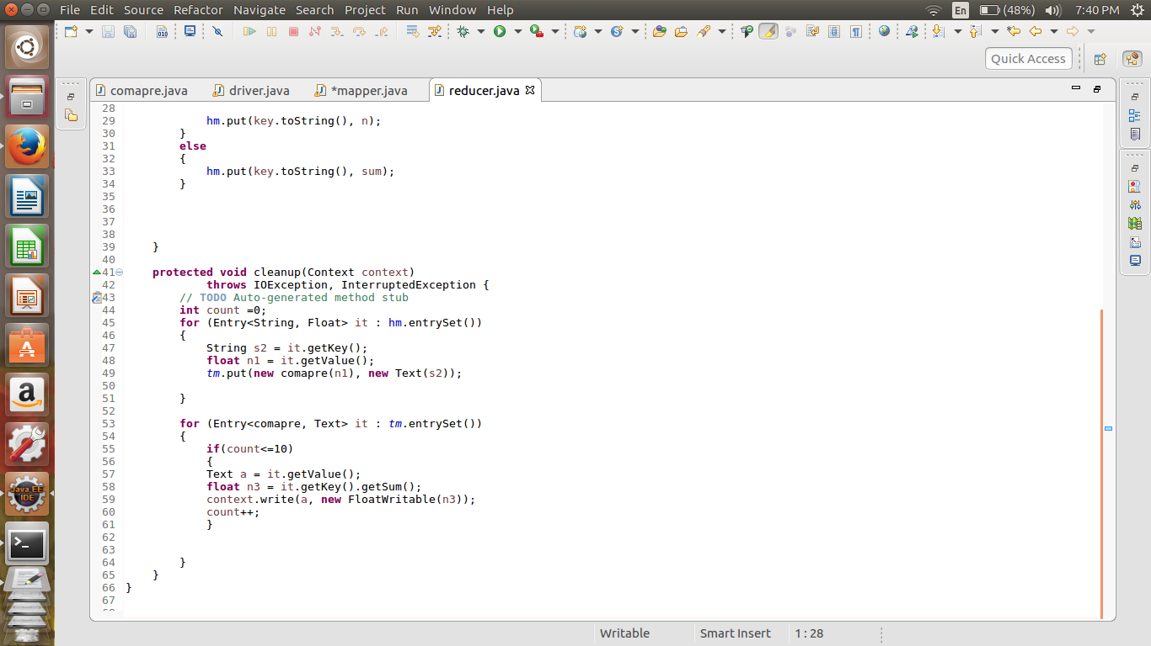

**Compare Method**

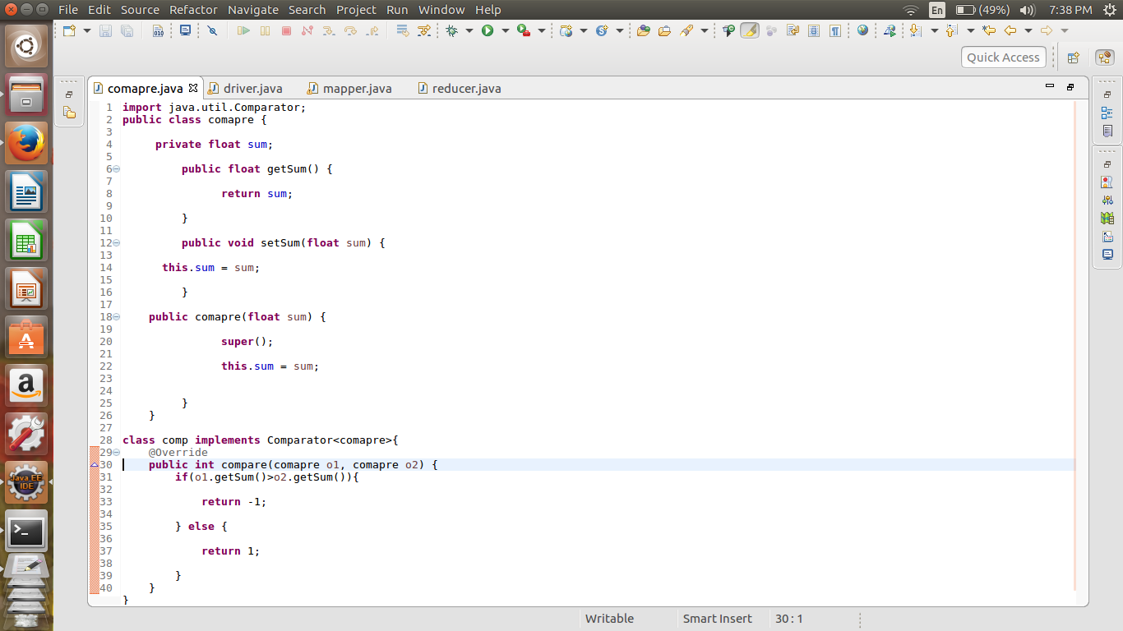

**Output**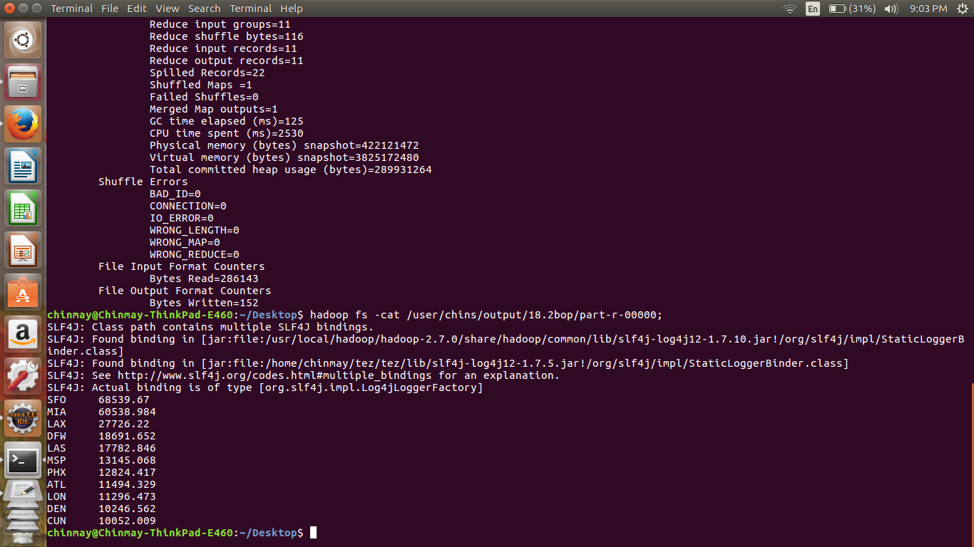

First used the hash map to store and update the amount than sorting is done by initializing the tree map with custom comparator. And finding the top 10 each mapper in the cleaup method. Similar process is done in the reducer.