**Poultry Health Management:**

**BACKEND:**

1. Difference in frequencies of unhealthy, noise and healthy data

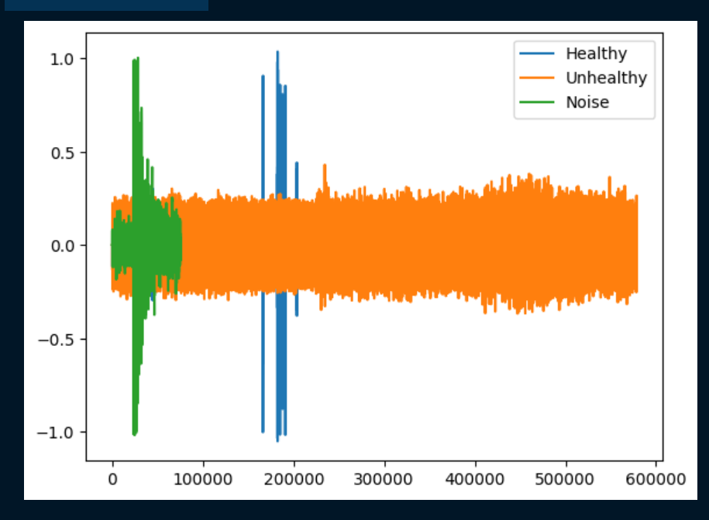

1. The spectrogram of a healthy voice data that is fed to the model.

1. The model and its layers (5, 2-Dense, 2-Covolutional, & 1 Flatten layer) that were used to train data.

1. Precision and accuracy after final training of model.

1. Output of the model on feeding it a set of mixed data.

**FRONTEND:**

The website consisted of the following:

Data that is displayed in users dashboard.

