STUDENT PERFORMANCE & ATTENDANCE ANALYZER
A PROJECT REPORT
Submitted by
ROLL No | Registration No | Name | Student Code
26102410008 | 26102000128 | Trisha Chakraborty | BWU/MCA/26/010

in partial fulfillment for the award of the degree of
MASTER OF COMPUTER APPLICATIONS
IN
DEPARTMENT OF COMPUTATIONAL SCIENCES

BRAINWARE UNIVERSITY
398, Ramkrishnapur Road, Barasat, North 24 Parganas, Kolkata - 700 125

Dec 2026
Student Performance & Attendance Analyzer
Submitted by
ROLL No | Registration No | Name | Student Code
26102410008 | 26102000128 | Trisha Chakraborty | BWU/MCA/26/010

in partial fulfillment for the award of the degree of
MASTER OF COMPUTER APPLICATIONS
in
DEPARTMENT OF COMPUTATIONAL SCIENCES

BRAINWARE UNIVERSITY
398, Ramkrishnapur Road, Barasat, North 24 Parganas, Kolkata - 700 125

ACKNOWLEDGEMENT
I express my sincere gratitude to Brainware University and the Department of Computational Sciences for providing the academic environment and resources required to undertake this project.
I am thankful to my project supervisor, Dr. Rahul Kumar Ghosh, for academic guidance, technical feedback and encouragement during the planning, implementation, testing and documentation of the Student Performance & Attendance Analyzer.
I also acknowledge the support of Dr. Jayanta Aich, Head of the Department of Computational Sciences, and the faculty members whose classroom instruction in programming, data management, web technologies and software engineering provided the foundation for this work.
Finally, I appreciate the opportunity to work on a practical problem that connects Python programming, Pandas-based analysis, a REST-style web service, CSV persistence and data visualisation in a single academic application.
Student Code | Name | Signature
BWU/MCA/26/010 | Trisha Chakraborty

ABSTRACT
The Student Performance & Attendance Analyzer is a lightweight, locally hosted application that stores student marks and attendance, derives grades automatically and turns raw records into statistics, alerts and charts. It addresses the common problem of teachers calculating totals, percentages and grades by hand while attendance is tracked separately, which makes it hard to notice early which students are at risk.
The system is written in Python. Pandas performs the calculations (total, average, percentage, grade and attendance percentage) and the statistical analysis; Matplotlib produces bar, line, histogram and attendance charts; and a menu-driven console application provides every operation from the terminal with input validation based on exceptions. A second front end, a browser dashboard branded EduPulse, is served by a small REST API built on Python’s standard-library HTTP server and uses HTML, CSS, JavaScript and Chart.js for KPI cards, five interactive charts, a searchable and sortable roster, an add/edit dialog with live grade projection, CSV import and export, an attendance-threshold slider and printable report cards. Both front ends share one analysis package and one CSV file.
The supplied dataset contains eight students assessed in five subjects with 100 classes held each. The class average is 68.63% and the average attendance 79.38%. Meera Ghosh is the overall topper with 472 out of 500 (94.4%, grade A+); the grade distribution is A+ 1, A 2, B 2, D 2 and F 1. Three students — Kabir Das, Rohan Paul and Tanmay Nag — fall below the default 75% attendance threshold, and they are also the three lowest scorers.
This report documents the requirements, design, algorithms (with pseudocode and flowcharts), implementation, and test results of the project, including screenshots of the running dashboard and the output of the submitted code. Automated unit tests, console checks and fifteen REST API requests all behaved as specified, showing that a simple CSV-backed system can deliver validated record keeping, analytics and visual reporting without a database server.

TABLE OF CONTENTS
Chapter | Title | Page No.
 | ABSTRACT | iii
 | LIST OF TABLES | v
 | LIST OF FIGURES | v
 | LIST OF SYMBOLS, ABBREVIATIONS AND NOMENCLATURE | vi
1. | INTRODUCTION | 1
 | 1.1 Background | 1
 | 1.2 Project Context | 1
 | 1.3 Problem Statement & Scope | 1
2. | OBJECTIVE | 2
 | 2.1 Primary Objective | 2
 | 2.2 Specific Objectives | 2
 | 2.3 Success Criteria | 2
3. | PLANNING | 3
 | 3.1 Development Methodology | 3
 | 3.2 Planning Principles | 3
 | 3.3 Project Planning | 3
 | 3.4 Risk Analysis and Mitigation | 4
4. | REQUIREMENT ANALYSIS | 5
 | 4.1 User Requirements | 5
 | 4.2 Stakeholders | 5
 | 4.3 Functional Requirements | 5
 | 4.4 Non-Functional Requirements | 5
 | 4.5 System Requirements and Execution | 6
 | 4.6 CSV Data Model and Grading Scheme | 6
 | 4.7 Supplied Dataset Snapshot | 6
5. | SYSTEM ANALYSIS & DESIGN | 7
 | 5.1 System Architecture | 7
 | 5.2 Context Level Diagram (CLD) | 7
 | 5.3 Data Flow Diagrams | 7
 | 5.4 Use Case Diagram | 8
 | 5.5 Entity–Relationship View | 8
 | 5.6 Sequence Diagram — Adding a Student in the Web App | 9
 | 5.7 Flowcharts | 9
 | 5.8 Algorithms | 10
6. | PROPOSED DESIGN & IMPLEMENTATION | 13
 | 6.1 Design Approach and Architecture | 13
 | 6.2 Module Structure | 13
 | 6.3 Core Logic — calculations.py | 14
 | 6.4 Persistence and Validation | 14
 | 6.5 REST API | 15
 | 6.6 Web Dashboard | 15
7. | EXPERIMENTAL RESULT | 17
 | 7.1 Testing Strategy and Environment | 17
 | 7.2 Dataset Results | 17
 | 7.3 Console and Unit-Test Results | 18
 | 7.4 REST API Results | 18
 | 7.5 Dashboard Evidence | 18
 | 7.6 Matplotlib Chart Results | 20
 | 7.7 Result Analysis | 21
8. | LIMITATIONS & FUTURE SCOPE | 21
 | 8.1 Limitations | 21
 | 8.2 Future Scope | 22
9. | CONCLUSION | 22
 | APPENDICES | 23
 | Appendix A: User Interface Screens | 23
 | Appendix B: Sample Code | 23
 | Appendix C: Data Structure | 24
 | Appendix D: Test Cases | 24
 | REFERENCES | 25

LIST OF TABLES
Table No. | Title | Page No.
Table 1.1 | Scope of the system modules | 2
Table 3.1 | Work breakdown structure | 3
Table 3.2 | Planned project schedule | 3
Table 3.3 | Risks and mitigation | 4
Table 4.1 | Functional requirements | 5
Table 4.2 | Non-functional requirements | 5
Table 4.3 | Software and hardware requirements | 6
Table 4.4 | Stored fields of students.csv | 6
Table 4.5 | Grading scheme (calculate_grade) | 6
Table 4.6 | Dataset summary | 6
Table 5.1 | Architectural layers | 7
Table 5.2 | Logical constraints | 9
Table 5.3 | Inventory of documented algorithms | 10
Table 6.1 | Source files and responsibilities | 13
Table 6.2 | REST API endpoints | 15
Table 7.1 | Summary of test results | 17
Table 7.2 | Analysed results for the eight students | 17
Table 7.3 | Subject-wise statistics | 17
Table D.1 | Test cases and observed results | 24

LIST OF FIGURES
Figure No. | Title | Page No.
Figure 5.1 | Context Level Diagram | 7
Figure 5.2 | Data Flow Diagram — Level 0 | 8
Figure 5.3 | Data Flow Diagram — Level 1 | 8
Figure 5.4 | Use Case Diagram | 8
Figure 5.5 | Entity–Relationship view of the student record | 9
Figure 5.6 | Sequence diagram for POST /api/students | 9
Figure 5.7 | Flowcharts: (a) Add student — validation path; (b) analyze() computation | 10
Figure 5.8 | Flowcharts: (a) Low-attendance detection; (b) REST request handling | 10
Figure 6.1 | System architecture diagram | 13
Figure 7.1 | Dashboard header, toolbar and KPI cards (8 students, 68.63%, 79.38%, Meera Ghosh, 3 alerts) | 18
Figure 7.2 | Student Rankings chart (total marks, highest first) | 18
Figure 7.3 | Subject Mastery chart | 19
Figure 7.4 | Attendance vs Marks scatter chart (below-threshold points in red) | 19
Figure 7.5 | Grade Breakdown chart | 19
Figure 7.6 | Score Curve (percentage distribution) | 20
Figure 7.7 | Subject Benchmarking and Statistics cards | 20
Figure 7.8 | Student Performance & Attendance Roster with class benchmark row | 20
Figure 7.9 | Matplotlib charts: (a) total marks, (b) subject-wise performance, (c) percentage histogram, (d) attendance with 75% threshold | 21
Figure A.1 | (a) Add Student dialog with live projection; (b) report card for Aarav Sen | 23
Figure A.2 | Roster filtered with “Low Attendance” — 3 of 8 students | 23

LIST OF SYMBOLS, ABBREVIATIONS AND NOMENCLATURE
Term | Meaning
API | Application Programming Interface
CLI | Command-Line Interface (console menu, main.py)
CORS | Cross-Origin Resource Sharing
CRUD | Create, Read, Update, Delete
CSS / HTML / JS | Cascading Style Sheets / HyperText Markup Language / JavaScript
CSV | Comma-Separated Values
DFD / CLD | Data Flow Diagram / Context Level Diagram
ER | Entity–Relationship
HTTP / JSON | HyperText Transfer Protocol / JavaScript Object Notation
KPI | Key Performance Indicator
REST | Representational State Transfer
Roll | Student roll number (primary key)
Total | Sum of marks in the five subjects (maximum 500)
Percentage | Total ÷ 500 × 100
Attendance% | ClassesAttended ÷ ClassesHeld × 100
Threshold | Minimum acceptable attendance % (default 75)
DataFrame | Pandas two-dimensional table used for all analysis
A+ … F | Grades for percentages ≥ 90, 80, 70, 60, 50, 40 and below 40

1. INTRODUCTION

1.1 Background
Monitoring student progress is one of the most routine yet most time-consuming activities in any educational institution. For every examination a teacher must add the marks of several subjects, convert the total into a percentage, assign a grade, compare the result with the rest of the class, and separately keep track of how many classes each student has attended. When these tasks are carried out in paper registers or loosely structured spreadsheets, the calculations are repeated by hand, mistakes creep in, and — more importantly — the relationship between a student’s attendance and academic results is rarely examined until it is too late to intervene.
The Student Performance & Attendance Analyzer addresses this problem with tools that are already part of a Computer Applications curriculum: Python for the programming logic, Pandas for tabular analysis, Matplotlib for static charts, and standard HTML, CSS and JavaScript (with the Chart.js library) for an interactive browser dashboard branded EduPulse. Marks for five subjects and the number of classes held and attended are stored for each student; the system then derives total, average, percentage, grade and attendance percentage, flags students whose attendance falls below a configurable threshold, and presents class-level statistics and charts.

1.2 Project Context
The application is a self-contained, locally hosted academic project. All records live in a single CSV file (data/students.csv), so no database server, account or internet connection is required. Two interchangeable front ends sit on top of one shared analysis package (analyzer/): a menu-driven console application (main.py) and a web dashboard served by server.py, a small REST API built only on Python’s standard-library http.server module. Both front ends read and write the same CSV file, so a student added through one interface is visible in the other after a reload.
The dashboard also contains a JavaScript copy of the grading and percentage rules (kept consistent with analyzer/calculations.py) that powers the instant “live projection” in the Add Student form. If the page is opened without the server — for example directly from disk — it falls back to browser local storage and the built-in sample data, which allows it to be demonstrated on any machine.

1.3 Problem Statement & Scope

1.3.1 Problem Statement
Teachers and students lack a lightweight, offline, easy-to-inspect tool that records marks and attendance together, computes grades automatically, highlights low-attendance students for early intervention, and turns the numbers into statistics and charts — without requiring a database installation, a paid service or advanced technical skill. This project builds such a tool from first principles so that every calculation and every file remains visible and auditable.

1.3.2 Scope
As implemented and verified against the supplied code and data, the system covers:
- Recording a student (roll number, name, marks in Maths, Science, English, History and Computer, classes held, classes attended) through the console or the web Add/Edit modal, with validation before saving.
- Automatic calculation of Total (out of 500), Average, Percentage, Grade (A+ to F) and Attendance%.
- Low-attendance detection against a user-chosen threshold (console prompt; web slider from 50% to 95%, default 75%).
- Sorting by total marks (console) and by any column, plus search by name or roll and grade/attendance filters (web).
- Pandas-based subject statistics (mean, minimum, maximum, standard deviation), subject toppers, grade distribution, class averages and overall topper.
- Four Matplotlib charts (bar, line, histogram, attendance) and five interactive Chart.js views in the dashboard, plus a printable report card per student.
- CSV import and export, reset to sample data, and immediate persistence of every change to data/students.csv.

1.3.3 Boundaries
The project deliberately excludes user authentication, multi-class or multi-semester records, historical trend tracking, e-mail or SMS alerts, and a relational database. These exclusions keep the work a moderate, syllabus-oriented deliverable; several are revisited as future enhancements in Chapter 8.
Table 1.1 — Scope of the system modules
Module | Capability
Data layer (storage.py) | Reads and writes students.csv; returns an empty frame on a missing or malformed file; loads sample data
Logic layer (calculations.py) | Total, average, percentage, grade and attendance% for every student
Console layer (main.py, features.py) | Menu: add, view, low-attendance list, sort, statistics, charts, sample data, launch web app
Visualisation (charts.py) | Bar, line, histogram and attendance charts saved as PNG in charts/
Web service (server.py) | Static file server and REST API (list, add, edit, delete, import, export, reset)
Web dashboard (web/) | KPI cards, five Chart.js views, roster with filters, report card, import/export dialogs

2. OBJECTIVE

2.1 Primary Objective
To design and implement a Python-based system that stores student marks and attendance reliably, validates every input before it is saved, and converts the raw records into grades, alerts, statistics and visual reports through both a console interface and a web dashboard that share a single analysis and storage layer.

2.2 Specific Objectives
- Build a reusable analyzer package (configuration, validators, calculations, storage, features, charts) so that business rules exist in one place.
- Calculate total, average, percentage and grade with a clearly documented seven-band grading scheme.
- Detect students whose attendance is below a threshold chosen by the user, in the console and live in the dashboard.
- Provide Pandas-based analysis: subject-wise mean, minimum, maximum and standard deviation, subject toppers, grade distribution and class averages.
- Visualise performance with Matplotlib (bar, line, histogram, attendance) and with interactive Chart.js charts in the browser.
- Handle invalid input gracefully using exceptions (InvalidInputError, ValueError) and HTTP status codes (400, 404, 409) instead of crashing or corrupting the data file.
- Expose the functionality through a documented REST API consumed by a responsive single-page dashboard that works online with the server and offline with local storage.
- Document each core algorithm with pseudocode and flowcharts and verify the results with automated and manual tests.

2.3 Success Criteria
The project is successful if (a) a student can be added and is immediately reflected in every table, statistic and chart; (b) invalid marks, attendance values, names and duplicate roll numbers are rejected with a clear message; (c) the grade and percentage produced by the console, the server and the browser are identical for the same record; (d) all charts render for the supplied dataset; and (e) every algorithm in this report corresponds to a function in the submitted source code.

3. PLANNING

3.1 Development Methodology
An incremental, bottom-up approach was followed. The configuration, validators and calculation functions were written first because every other part depends on them. The CSV storage layer and the console menu (main.py) came next, giving a working command-line tool that exercised the logic end to end with minimal overhead. The Matplotlib charts were then added on top of the same analyze() function. Finally the REST server and the browser dashboard were layered over the existing package, reusing its rules rather than duplicating them. At every stage a working, demonstrable version of the application existed.

3.2 Planning Principles
- Single source of truth — one CSV file and one analyze() function feed every interface.
- Fail fast on bad input — validation happens before any write, so the CSV file always stays well-formed.
- Separation of concerns — validation, storage, calculation, charts, console UI, server and web UI are separate modules.
- No premature infrastructure — no database, ORM or authentication layer; configuration (subjects, maximum marks, paths) is kept in config.py.

3.3 Project Planning

3.3.1 Work Breakdown Structure
Table 3.1 — Work breakdown structure
No. | Work Package | Key Deliverables
1 | Requirement gathering | Problem statement, feature list, grading and attendance rules
2 | Core analysis package | config.py, validators.py, calculations.py, storage.py
3 | Console interface | features.py, main.py menu, sample data
4 | Visualisation layer | charts.py bar, line, histogram, attendance charts
5 | REST server | server.py endpoints, JSON analysis payload, CSV import/export
6 | Web dashboard | index.html, styles.css, app.js, Chart.js bundle
7 | Testing | tests/test_calculations.py, API and CLI checks
8 | Documentation | README.md, this project report

3.3.2 Schedule
Table 3.2 — Planned project schedule
Period | Activity
Week 1 | Requirement gathering, scoping, grading rules
Week 2 | Core package: config, validators, calculations, storage
Week 3 | Console menu and features; sample data
Week 4 | Matplotlib charts and statistics
Week 5 | REST server and API design
Week 6 | Web dashboard and Chart.js integration
Week 7 | Testing, edge cases and bug fixing
Week 8 | Documentation, screenshots and final review

3.4 Risk Analysis and Mitigation
Table 3.3 — Risks and mitigation
Risk | Mitigation in the project
Malformed or missing CSV file | load_records() catches FileNotFoundError, EmptyDataError, ParserError and returns an empty typed frame
Invalid marks or attendance values | Console validators loop until valid; server returns HTTP 400 for out-of-range marks, bad attendance or empty names
Duplicate roll numbers | Rejected in the console and with HTTP 409 by the server; the web form shows an inline error
Server not available to the browser | Dashboard falls back to local storage and built-in sample data
Divide-by-zero in attendance | Console requires ClassesHeld ≥ 1; server rejects held ≤ 0; JavaScript guards the division

4. REQUIREMENT ANALYSIS

4.1 User Requirements
- Enter a student’s marks and attendance quickly, with immediate feedback when a value is invalid.
- See total, percentage, grade and attendance for every student without manual calculation.
- Identify, at the click of a slider or a menu option, which students are below the attendance requirement.
- Rank students, search by name or roll number, and filter by grade or attendance status.
- Understand class performance through subject averages, toppers and charts rather than raw rows.
- Print or save an individual report card, and move data in and out of the system as CSV.

4.2 Stakeholders
The primary stakeholders are the teacher or class coordinator who maintains the records and the students whose progress is tracked. The secondary stakeholder is the academic evaluator who assesses the project against its objectives, code quality and documentation. The requirements were derived from the needs of a single local user; no multi-tenant or organisational roles are in scope.

4.3 Functional Requirements
Table 4.1 — Functional requirements
ID | Requirement | Description
FR-1 | Add student | Roll, name, five marks, classes held and attended; validated before saving
FR-2 | Edit / delete student | Web modal edits a record; delete removes it by roll number
FR-3 | View records | Table with Total, Average, Percentage, Grade and Attendance%
FR-4 | Grade calculation | Seven bands from A+ (≥ 90%) to F (< 40%)
FR-5 | Low-attendance detection | List or flag students with Attendance% below a chosen threshold
FR-6 | Sort | Console: by total marks, asc/desc. Web: by any column
FR-7 | Search and filter | Web: name/roll search; grade and attendance filters
FR-8 | Subject statistics | Mean, min, max, standard deviation and topper for each subject
FR-9 | Class summary | Class average %, average attendance, overall topper, grade distribution, pass rate
FR-10 | Charts | Console: bar, line, histogram, attendance. Web: five interactive views
FR-11 | Report card | Printable per-student report with class comparison and remarks
FR-12 | Import / export CSV | Download current file; import a file that has all required columns
FR-13 | Sample data | Load or reset the eight sample students
FR-14 | Persistence | Every change is written to data/students.csv immediately

4.4 Non-Functional Requirements
Table 4.2 — Non-functional requirements
Attribute | Requirement
Usability | Numbered console menu; responsive dashboard with light/dark theme, toasts and live form preview
Reliability | Invalid input never reaches the CSV; unreadable CSV yields an empty frame instead of a crash
Portability | Runs on Windows, macOS or Linux with Python 3 and pandas, matplotlib; Chart.js bundled locally
Performance | All analysis is in-memory Pandas/JavaScript on a small dataset and completes in a fraction of a second
Maintainability | Subjects and maximum marks are changed in one file (config.py); each concern is in its own module
Consistency | Grade and percentage rules are identical in Python and JavaScript

4.5 System Requirements and Execution
Table 4.3 — Software and hardware requirements
Component | Requirement
Operating system | Windows / macOS / Linux
Language runtime | Python 3 (the supplied bytecode was produced by CPython 3.13)
Python libraries | pandas ≥ 2.0, matplotlib ≥ 3.7 (requirements.txt); unittest and http.server from the standard library
Browser | Any modern browser (Chrome, Edge, Firefox, Safari) with JavaScript enabled
Hardware | Any x86-64 or ARM computer capable of running Python; about 2 GB RAM; under 50 MB disk space

The console tool is started with python3 main.py. The dashboard is started with python3 server.py --open (default port 8080, trying up to four further ports if it is busy) or by choosing option 0 in the console menu. Unit tests run with python3 -m unittest discover tests.

4.6 CSV Data Model and Grading Scheme
Each student is one row of data/students.csv with nine stored columns. Total, Average, Percentage, Grade and Attendance% are never stored; they are derived by analyze() each time the data is read.
Table 4.4 — Stored fields of students.csv
Field | Type | Validation
Roll | integer | ≥ 1 and unique
Name | text | Letters and spaces only (console, title-cased); non-empty (server)
Maths, Science, English, History, Computer | number | 0 to 100 each (MAX_MARKS)
ClassesHeld | integer | ≥ 1 (console); > 0 (server)
ClassesAttended | integer | 0 to ClassesHeld

Table 4.5 — Grading scheme (calculate_grade)
Percentage | ≥ 90 | ≥ 80 | ≥ 70 | ≥ 60 | ≥ 50 | ≥ 40 | < 40
Grade | A+ | A | B | C | D | E | F

4.7 Supplied Dataset Snapshot
The project ships with eight sample students, each assessed in five subjects out of 100 (500 in total) and with 100 classes held. Key aggregates computed by the application are summarised below.
Table 4.6 — Dataset summary
Metric | Value
Students / subjects / max total | 8 / 5 / 500
Class average percentage | 68.63%
Average attendance | 79.38%
Overall topper | Meera Ghosh — 472 / 500 (94.4%, grade A+)
Lowest total | Tanmay Nag — 191 / 500 (38.2%, grade F)
Students below 75% attendance | 3 (Kabir Das 66%, Rohan Paul 71%, Tanmay Nag 58%)
Pass rate (grade ≠ F) | 7 of 8 students (88%)

5. SYSTEM ANALYSIS & DESIGN

5.1 System Architecture
The system follows a layered architecture. At the base is the persistence layer, a single CSV file. storage.py loads it into a Pandas DataFrame and saves it back. Above it, calculations.py turns raw rows into analysed rows, and validators.py protects the console inputs. Two presentation layers share these modules: the console (main.py with features.py and charts.py) and the browser dashboard, which talks to server.py over HTTP and JSON. The two presentation layers never call each other; they share only the analysis package and the CSV file.
Table 5.1 — Architectural layers
Layer | Modules | Responsibility
Persistence | data/students.csv | Durable storage of all student records
Data access | storage.py | load_records, save_records, load_sample_data
Logic | calculations.py, config.py | Grade, total, average, percentage, attendance%; subjects and limits
Validation | validators.py | read_int, read_float, read_name, InvalidInputError
Console UI | main.py, features.py, charts.py | Menu, reports, statistics, Matplotlib charts
Web service | server.py | Static files, REST API, JSON analysis payload
Web UI | web/index.html, styles.css, app.js | Dashboard, Chart.js charts, modals, report card

5.2 Context Level Diagram (CLD)
The Context Level Diagram treats the whole application as one process exchanging data with a single external entity, the user (teacher or administrator). The user supplies student details, thresholds, filters and requests; the system returns grades, statistics, alerts, charts and report cards. No other external system or data source is involved.
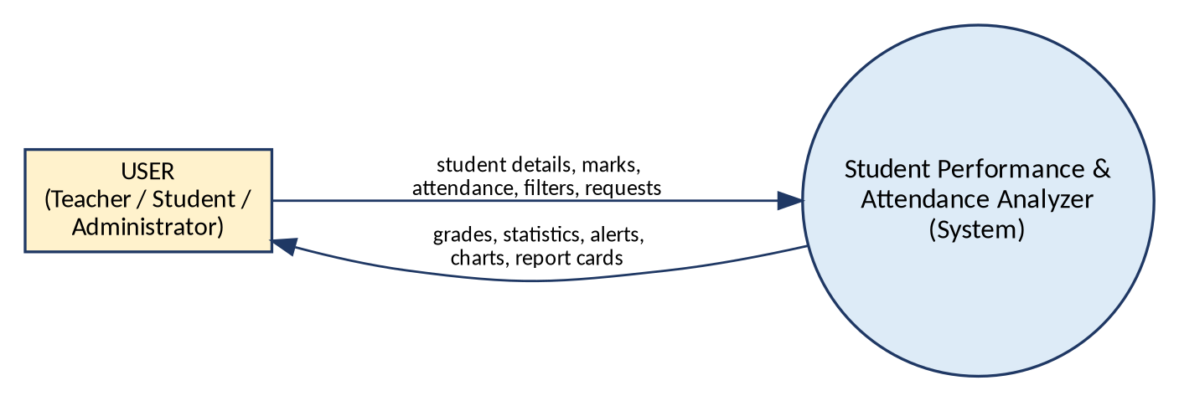
Figure 5.1 — Context Level Diagram

5.3 Data Flow Diagrams
At Level 0 the CSV file becomes an explicit data store, D1. At Level 1 the process is decomposed into six sub-processes that map directly to the code: 1.1 validates and stores a record (features.add_student, server.do_POST); 1.2 computes metrics (calculations.analyze); 1.3 detects low attendance; 1.4 sorts and filters; 1.5 produces subject statistics; and 1.6 generates charts and report cards.
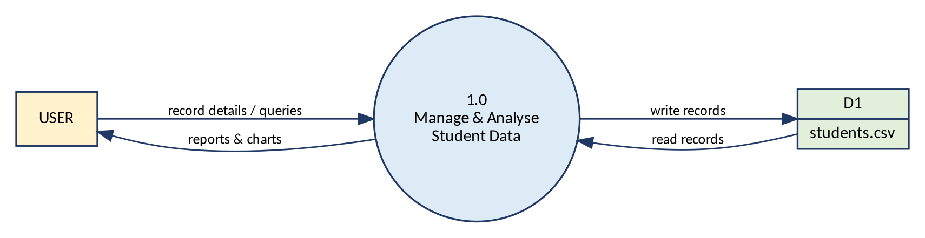
Figure 5.2 — Data Flow Diagram — Level 0
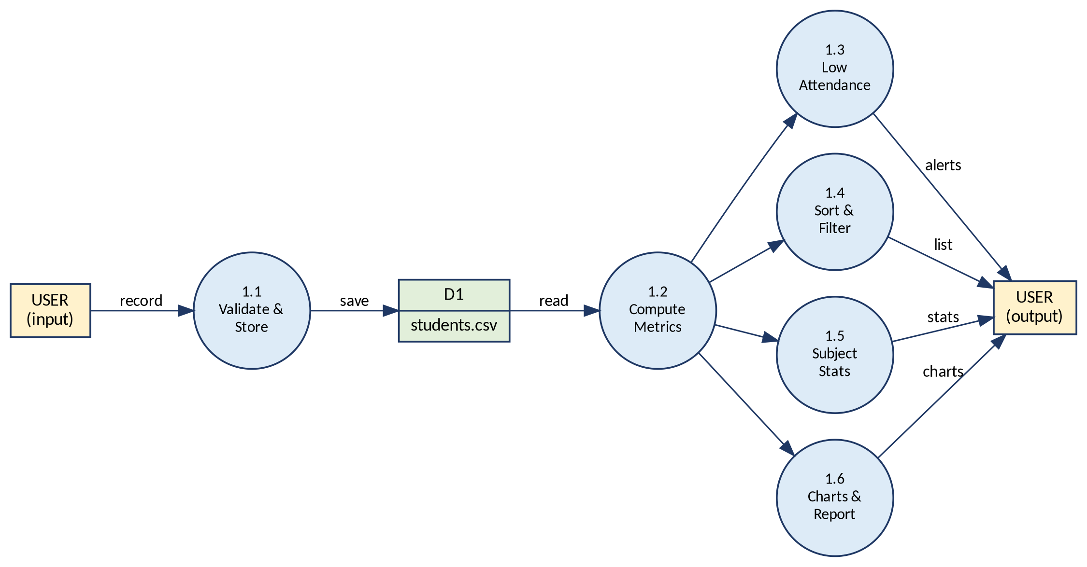
Figure 5.3 — Data Flow Diagram — Level 1

5.4 Use Case Diagram
A single actor, the User, interacts with ten use cases. Because the system has no login, no role distinction is made between teacher and administrator.
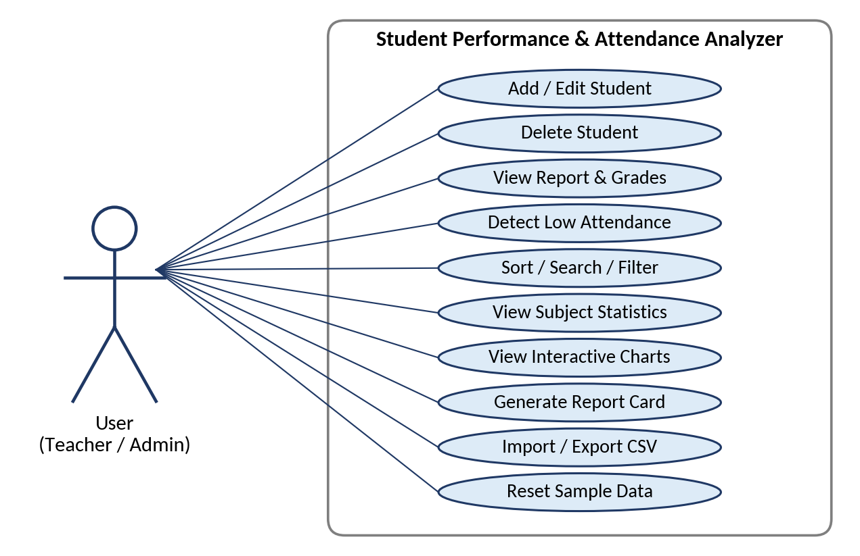
Figure 5.4 — Use Case Diagram

5.5 Entity–Relationship View
The data model is intentionally a single entity. The stored entity STUDENT has nine attributes with the roll number as primary key; the analysis attributes are derived on demand and are therefore shown separately.
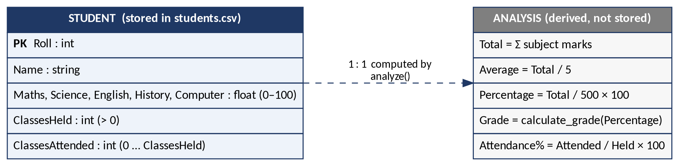
Figure 5.5 — Entity–Relationship view of the student record
Table 5.2 — Logical constraints
Attribute | Constraint
Roll | Integer ≥ 1; must not already exist
Name | Not empty; letters and spaces (console) / non-blank (server)
Subject marks | Numeric, 0 ≤ mark ≤ 100
ClassesHeld | Integer, > 0
ClassesAttended | Integer, 0 ≤ attended ≤ held

5.6 Sequence Diagram — Adding a Student in the Web App
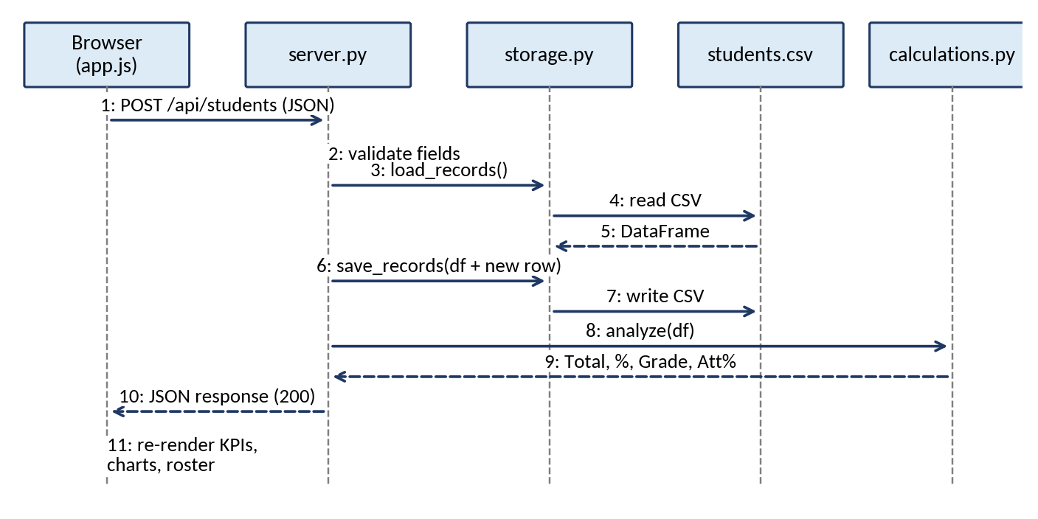
Figure 5.6 — Sequence diagram for POST /api/students

5.7 Flowcharts
The flowcharts below describe the four most important control flows: adding a student, computing the analysis, detecting low attendance and handling a REST request.
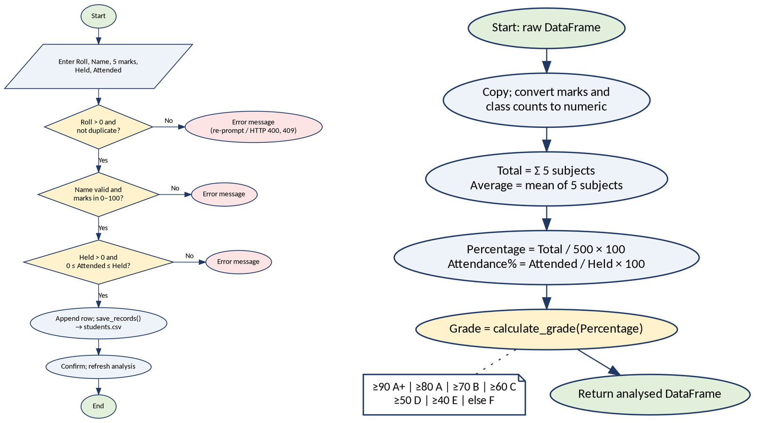
Figure 5.7 — Flowcharts: (a) Add student — validation path; (b) analyze() computation
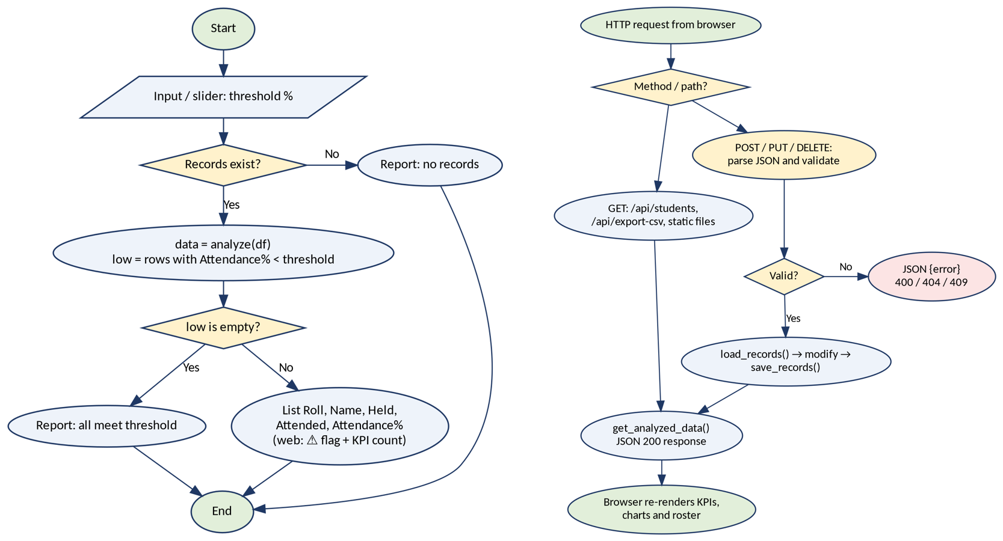
Figure 5.8 — Flowcharts: (a) Low-attendance detection; (b) REST request handling

5.8 Algorithms
Each algorithm below corresponds to a function in the submitted source code. Pseudocode uses the same conditions as the Python and JavaScript implementations.
Table 5.3 — Inventory of documented algorithms
No. | Algorithm | Source function
1 | Calculate Grade | calculations.calculate_grade; app.js calculateGrade
2 | Analyse Records | calculations.analyze
3 | Add Student (validated) | features.add_student; server.do_POST
4 | Load Records (defensive) | storage.load_records
5 | Low-Attendance Detection | features.low_attendance; app.js threshold filter
6 | Subject Statistics and Toppers | features.statistics; server.get_analyzed_data
7 | Search, Filter and Sort (web) | app.js getFilteredAndSortedStudents

Algorithm 1 — Calculate Grade
Input: percentage (0 – 100)
Output: grade ∈ {A+, A, B, C, D, E, F}
1: | if percentage ≥ 90 then return "A+"
2: | else if percentage ≥ 80 then return "A"
3: | else if percentage ≥ 70 then return "B"
4: | else if percentage ≥ 60 then return "C"
5: | else if percentage ≥ 50 then return "D"
6: | else if percentage ≥ 40 then return "E"
7: | else return "F"

Algorithm 2 — Analyse Records
Input: df — DataFrame with Roll, Name, 5 subject columns, ClassesHeld, ClassesAttended
Output: result — copy of df with Total, Average, Percentage, Grade, Attendance%
1: | result ← COPY(df)
2: | result[numeric columns] ← TO_NUMERIC(result[numeric columns])
3: | result.Total ← SUM(result[SUBJECTS], axis = 1)
4: | result.Average ← ROUND(MEAN(result[SUBJECTS], axis = 1), 2)
5: | result.Percentage ← ROUND(result.Total / (MAX_MARKS × LEN(SUBJECTS)) × 100, 2)
6: | result.Grade ← APPLY(result.Percentage, Algorithm 1)
7: | result.Attendance% ← ROUND(ClassesAttended / ClassesHeld × 100, 2)
8: | return result

Algorithm 3 — Add Student (console flow; the server applies the same rules)
Input: roll, name, marks[1..5], held, attended
Output: updated DataFrame (saved) or unchanged DataFrame
1: | roll ← READ_INT(low = 1)
2: | if roll ∈ df.Roll then PRINT "already exists"; return df
3: | name ← READ_NAME() // letters and spaces only, title-cased
4: | for each subject do marks[i] ← READ_FLOAT(0, MAX_MARKS)
5: | held ← READ_INT(low = 1)
6: | attended ← READ_INT(0, held)
7: | row ← [roll, name] + marks + [held, attended]
8: | df ← CONCAT(df, row); SAVE_RECORDS(df)
9: | return df

Algorithm 4 — Load Records (defensive)
Input: path to the CSV file
Output: DataFrame with BASE_COLUMNS, or an empty DataFrame on error
1: | try
2: | df ← READ_CSV(path)
3: | missing ← [c ∈ BASE_COLUMNS if c ∉ df.columns]
4: | if missing ≠ ∅ then raise InvalidInputError
5: | return df[BASE_COLUMNS]
6: | catch FileNotFoundError, EmptyDataError do return EMPTY_FRAME()
7: | catch InvalidInputError, ParserError do PRINT message; return EMPTY_FRAME()

Algorithm 5 — Low-Attendance Detection
Input: df, threshold (0 – 100)
Output: rows whose Attendance% < threshold
1: | if df is empty then PRINT "No records"; return
2: | data ← ANALYSE(df) // Algorithm 2
3: | low ← data[data.Attendance% < threshold]
4: | if low is empty then PRINT "all students meet the threshold"
5: | else PRINT low[Roll, Name, ClassesHeld, ClassesAttended, Attendance%]

Algorithm 6 — Subject Statistics and Toppers
Input: data — analysed DataFrame
Output: mean, min, max, std per subject; topper per subject; overall topper; grade counts
1: | for each s ∈ SUBJECTS do
2: | stats[s] ← {MEAN(data[s]), MIN(data[s]), MAX(data[s]), STD(data[s])}
3: | topper[s] ← data.Name at INDEX_OF_MAX(data[s])
4: | end for
5: | grade_counts ← VALUE_COUNTS(data.Grade)
6: | overall_topper ← data.Name at INDEX_OF_MAX(data.Total)
7: | class_avg ← MEAN(data.Percentage); attendance_avg ← MEAN(data.Attendance%)

Algorithm 7 — Search, Filter and Sort (dashboard)
Input: students, query, gradeFilter, attendanceFilter, threshold, sortColumn, direction
Output: ordered list of matching students
1: | list ← COPY(students)
2: | if query ≠ "" then list ← {s : LOWER(s.Name) contains LOWER(query) or STR(s.Roll) contains query}
3: | if gradeFilter ≠ ALL then list ← {s : s.Grade = gradeFilter}
4: | if attendanceFilter = LOW then list ← {s : s.Attendance% < threshold}
5: | else if attendanceFilter = GOOD then list ← {s : s.Attendance% ≥ threshold}
6: | SORT(list, by sortColumn, direction) // text: locale compare; numbers: difference
7: | return list

6. PROPOSED DESIGN & IMPLEMENTATION

6.1 Design Approach and Architecture
The design follows a lightweight Model–View separation. The analyzer package plays the role of the Model: it owns the rules for validating, storing and analysing student data and knows nothing about how results are displayed. main.py and server.py are two interchangeable Views that translate user actions into package calls. This is why the console, the server and (through its mirrored JavaScript rules) the browser report identical grades for identical marks.
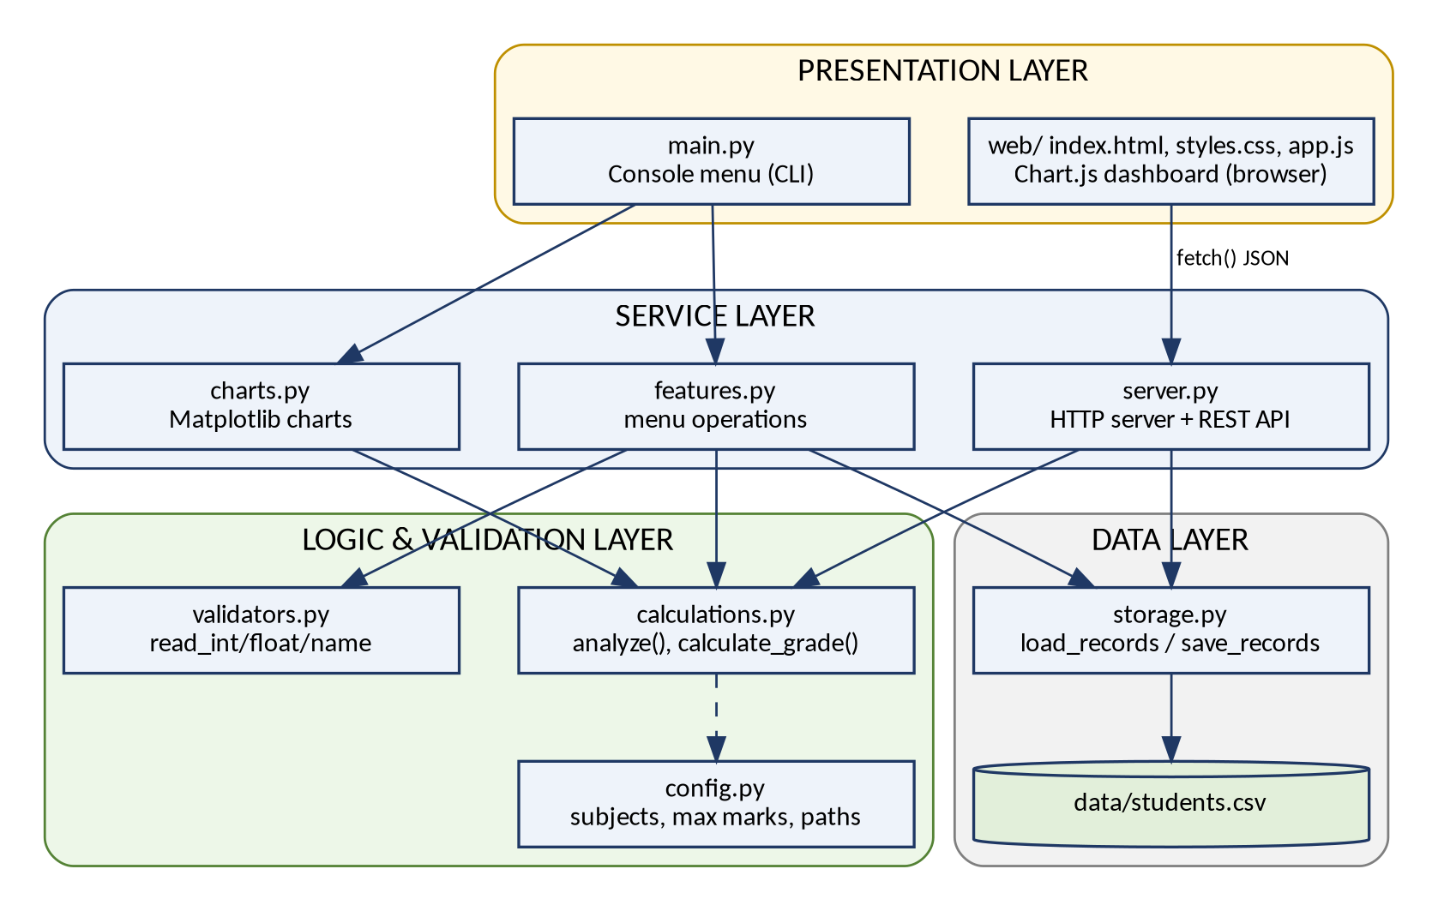
Figure 6.1 — System architecture diagram

6.2 Module Structure
Table 6.1 — Source files and responsibilities
File | Lines | Responsibility
main.py | 80 | Entry point; numbered menu (options 0–9); launches the web server in a background thread
server.py | 269 | AppRequestHandler (GET/POST/PUT/DELETE/OPTIONS), get_analyzed_data(), run_server()
analyzer/config.py | 11 | SUBJECTS, MAX_MARKS, BASE_COLUMNS, file and chart paths
analyzer/validators.py | 45 | InvalidInputError, read_int, read_float, read_name
analyzer/calculations.py | 36 | calculate_grade, analyze
analyzer/storage.py | 52 | load_records, save_records, load_sample_data, SAMPLE_ROWS
analyzer/features.py | 79 | add_student, show_report, low_attendance, sorted_by_marks, statistics
analyzer/charts.py | 83 | bar_chart, line_graph, histogram, attendance_chart, charts_menu
web/index.html | 590 | Dashboard markup: header, KPI cards, chart tabs, roster, dialogs
web/styles.css | 1515 | Dark/light design system, responsive layout, print styles
web/app.js | 1416 | State, rendering, Chart.js charts, form logic, API calls, report card
tests/test_calculations.py | 30 | Unit tests for grade boundaries and analyze()

6.3 Core Logic — calculations.py
calculate_grade() implements Algorithm 1 and analyze() implements Algorithm 2. Every console report, chart and server response is built from the DataFrame that analyze() returns, which is the main reason all interfaces agree.
def calculate_grade(percentage):
"""Grade calculation using if-elif-else."""
if percentage >= 90:
return "A+"
elif percentage >= 80:
return "A"
elif percentage >= 70:
return "B"
elif percentage >= 60:
return "C"
elif percentage >= 50:
return "D"
elif percentage >= 40:
return "E"
else:
return "F"

def analyze(df):
"""Return a copy of df with Total, Average, Percentage, Grade, Attendance%."""
result = df.copy()
result[NUMERIC_COLS] = result[NUMERIC_COLS].apply(pd.to_numeric)
result["Total"] = result[SUBJECTS].sum(axis=1)
result["Average"] = result[SUBJECTS].mean(axis=1).round(2)
result["Percentage"] = (result["Total"] / (MAX_MARKS * len(SUBJECTS)) * 100).round(2)
result["Grade"] = result["Percentage"].apply(calculate_grade)
result["Attendance%"] = (result["ClassesAttended"] / result["ClassesHeld"] * 100).round(2)
return result

6.4 Persistence and Validation
load_records() (Algorithm 4) never raises on a missing, empty or malformed file; it prints a message where useful and returns an empty frame so the application always starts. The console validators keep asking until the user supplies an acceptable value, converting ValueError and InvalidInputError into friendly messages.
def load_records(path=CSV_FILE):
"""Read records from CSV; return an empty DataFrame if file is missing/bad."""
try:
df = pd.read_csv(path)
missing = [c for c in BASE_COLUMNS if c not in df.columns]
if missing:
raise InvalidInputError(f"CSV is missing columns: {missing}")
return df[BASE_COLUMNS]
except (FileNotFoundError, pd.errors.EmptyDataError):
return empty_frame()
except (InvalidInputError, pd.errors.ParserError) as err:
print(f" Could not read '{path}': {err}")
return empty_frame()

def read_int(prompt, low=None, high=None):
"""Keep asking until a valid integer within [low, high] is entered."""
while True:
try:
value = int(input(prompt).strip())
if (low is not None and value < low) or (high is not None and value > high):
raise InvalidInputError(f"Value must be between {low} and {high}.")
return value
except ValueError:
print(" Invalid input: please enter a whole number.")
except InvalidInputError as err:
print(f" Invalid input: {err}")

6.5 REST API
server.py extends SimpleHTTPRequestHandler so that static files in web/ are served unchanged while /api/... paths are intercepted. Every JSON response carries permissive CORS headers. After each successful change the server returns the complete, freshly analysed dataset from get_analyzed_data(), so the browser never has to merge partial updates.
Table 6.2 — REST API endpoints
Method | Route | Description / status codes
GET | /api/students | All students with computed fields, summary and subject statistics (200; 500 on error)
POST | /api/students | Add a student (200; 400 invalid data; 409 duplicate roll)
PUT | /api/students/{roll} | Update name, marks and attendance (200; 400; 404 not found)
DELETE | /api/students/{roll} | Delete a student (200; 404 not found)
GET | /api/export-csv | Download students.csv as an attachment (200)
POST | /api/import-csv | Replace data from uploaded CSV text (200; 400 if columns are missing)
POST | /api/reset-sample | Restore the eight sample students (200)
GET | / and static files | Serves web/index.html, app.js, styles.css, chart.umd.min.js

The validation block of the POST handler below is the web counterpart of Algorithm 3:
if path == "/api/students":
try:
payload = json.loads(body.decode("utf-8"))
roll = int(payload["Roll"])
name = str(payload["Name"]).strip()
if not name:
return self._send_json({"error": "Name cannot be empty"}, status=HTTPStatus.BAD_REQUEST)

marks = [float(payload[s]) for s in SUBJECTS]
held = int(payload["ClassesHeld"])
attended = int(payload["ClassesAttended"])

if held <= 0 or attended < 0 or attended > held:
return self._send_json({"error": "Invalid attendance numbers"}, status=HTTPStatus.BAD_REQUEST)

for m in marks:
if m < 0 or m > MAX_MARKS:
return self._send_json({"error": f"Marks must be between 0 and {MAX_MARKS}"}, status=HTTPStatus.BAD_REQUEST)

df = load_records()
if roll in df["Roll"].values:
return self._send_json({"error": f"Roll {roll} already exists"}, status=HTTPStatus.CONFLICT)

new_row = pd.DataFrame([[roll, name] + marks + [held, attended]], columns=BASE_COLUMNS)
df = pd.concat([df, new_row], ignore_index=True) if not df.empty else new_row
save_records(df)

6.6 Web Dashboard
The dashboard is a single page built with semantic HTML, a CSS design system and vanilla JavaScript — no framework or build step. app.js keeps one state object (students, search text, filters, sort column, attendance threshold, chart settings) and re-renders KPIs, subject cards, roster and the active chart whenever it changes. Chart.js is bundled as chart.umd.min.js, so charts work offline.
- KPI cards: total enrolled with pass rate, class average with grade, average attendance, overall topper, and the count of students below the threshold.
- Interactive analytics: Student Rankings (bar), Subject Mastery (bar), Attendance vs Marks (scatter, points below threshold in red), Grade Breakdown (doughnut) and Score Curve (histogram), with metric and sort toggles and PNG download.
- Roster: sortable columns, name/roll search, grade and attendance filters, progress bars, warning icons for low attendance and row actions (report card, edit, delete).
- Add/Edit dialog: live projection of total, percentage, grade and attendance while typing; Import dialog with CSV preview; theme toggle; toast notifications.
- Report card: subject-wise marks against class average, attendance status and automatically chosen faculty remarks, printable from the browser.
If fetch("/api/students") fails, the page switches to “Local Storage Mode”, labels the status badge accordingly and stores edits in the browser instead of the CSV file.
function calculateGrade(percentage) {
if (percentage >= 90) return "A+";
if (percentage >= 80) return "A";
if (percentage >= 70) return "B";
if (percentage >= 60) return "C";
if (percentage >= 50) return "D";
if (percentage >= 40) return "E";
return "F";
}

7. EXPERIMENTAL RESULT

7.1 Testing Strategy and Environment
Testing combined automated unit tests, scripted checks of the console menu and validators, HTTP-level tests of every REST endpoint, and visual verification of the running dashboard in a headless Chromium browser. All results quoted in this chapter were produced by running the submitted code on the supplied eight-record dataset in a scratch copy of the project (so the original CSV was left unchanged). The complete list of test cases is given in Appendix D.
Table 7.1 — Summary of test results
Test group | Cases | Result
Unit tests (unittest) | 2 tests, 8 grade boundaries + 1 full record | Ran 2 tests — OK
Console menu and validators | Options 2, 3, 5, 6; invalid number; invalid name | All behaved as specified
REST API (HTTP) | 15 requests: success, 400, 404, 409, export, import, static | All status codes and messages as expected
Matplotlib charts | 4 PNG files generated | All rendered and saved
Dashboard (headless browser) | KPIs, five charts, roster, modals, filter | Rendered correctly; figures match the console

7.2 Dataset Results
The table below was produced by analyze() and matches the console report (menu option 2) and the dashboard roster exactly.
Table 7.2 — Analysed results for the eight students
Roll | Name | Maths | Sci. | Eng. | Hist. | Comp. | Total | % | Grade | Att. %
1 | Aarav Sen | 88 | 92 | 79 | 85 | 95 | 439 | 87.8 | A | 94
2 | Diya Roy | 72 | 65 | 80 | 70 | 68 | 355 | 71.0 | B | 82
3 | Kabir Das | 45 | 52 | 38 | 60 | 55 | 250 | 50.0 | D | 66
4 | Meera Ghosh | 95 | 98 | 91 | 89 | 99 | 472 | 94.4 | A+ | 97
5 | Rohan Paul | 58 | 49 | 62 | 55 | 47 | 271 | 54.2 | D | 71
6 | Sneha Bose | 81 | 77 | 85 | 90 | 83 | 416 | 83.2 | A | 88
7 | Tanmay Nag | 34 | 41 | 29 | 48 | 39 | 191 | 38.2 | F | 58
8 | Isha Saha | 67 | 74 | 70 | 62 | 78 | 351 | 70.2 | B | 79

Table 7.3 — Subject-wise statistics
Subject | Mean | Min | Max | Std (sample, CLI) | Std (population, web) | Topper
Maths | 67.50 | 34 | 95 | 21.04 | 19.68 | Meera Ghosh (95)
Science | 68.50 | 41 | 98 | 20.51 | 19.19 | Meera Ghosh (98)
English | 66.75 | 29 | 91 | 22.46 | 21.01 | Meera Ghosh (91)
History | 69.88 | 48 | 90 | 16.30 | 15.24 | Sneha Bose (90)
Computer | 70.50 | 39 | 99 | 22.09 | 20.66 | Meera Ghosh (99)

The two standard-deviation columns differ because the console uses Pandas’ default sample deviation (ddof = 1) while the server and dashboard use population deviation (ddof = 0); each is correct for its definition, and the difference is noted in Section 8.1.

7.3 Console and Unit-Test Results
python3 -m unittest discover tests reported “Ran 2 tests … OK”. In the console, option 3 with a 75% threshold listed exactly three students — Kabir Das (66%), Rohan Paul (71%) and Tanmay Nag (58%). Option 5 (descending) ranked Meera Ghosh (472) first and Tanmay Nag (191) last. Option 6 printed the grade distribution A+ 1, A 2, B 2, D 2, F 1, a class average percentage of 68.62–68.63% (68.625 exactly) and an average attendance of 79.38%. Invalid entries such as “abc” or “12a” were rejected with the messages “please enter a whole number” and “Name must contain only letters and spaces”, after which the prompt repeated.

7.4 REST API Results
Fifteen HTTP requests were issued against a running server (Appendix D, TC-10 to TC-24). A valid POST returned 200 with the new dataset; a duplicate roll returned 409 (“Roll 9 already exists”); attendance greater than classes held returned 400 (“Invalid attendance numbers”); a mark of 101 returned 400 (“Marks must be between 0 and 100”); an empty name returned 400; PUT and DELETE on a missing roll returned 404; an import without all columns returned 400; an unknown endpoint returned 404; and the CSV export was delivered as text/csv with an attachment header.

7.5 Dashboard Evidence
The screenshots below were captured from the running dashboard (python3 server.py) and can be compared line by line with the console output above.
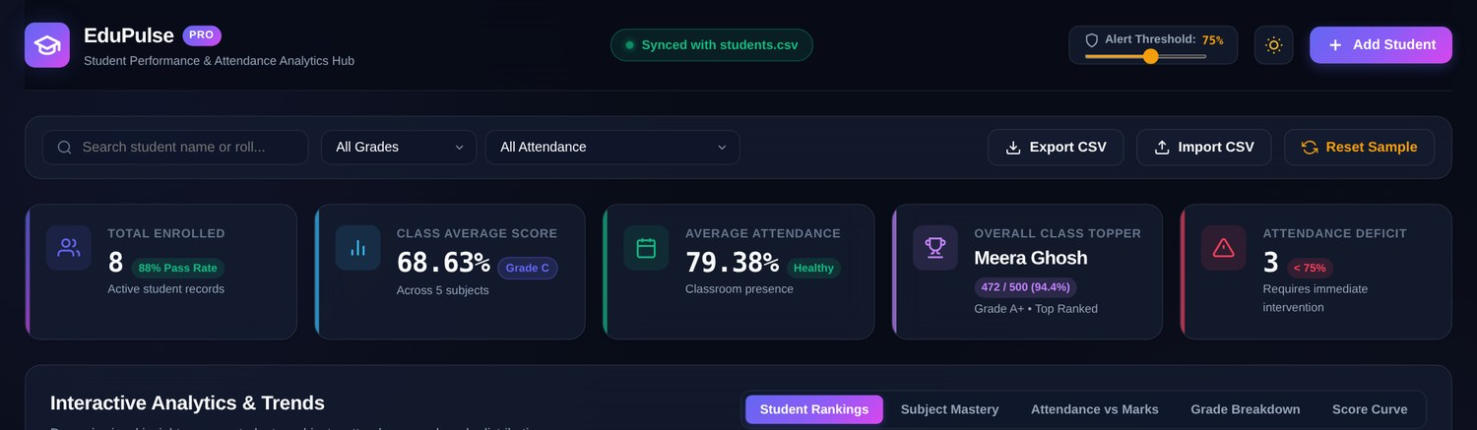
Figure 7.1 — Dashboard header, toolbar and KPI cards (8 students, 68.63%, 79.38%, Meera Ghosh, 3 alerts)
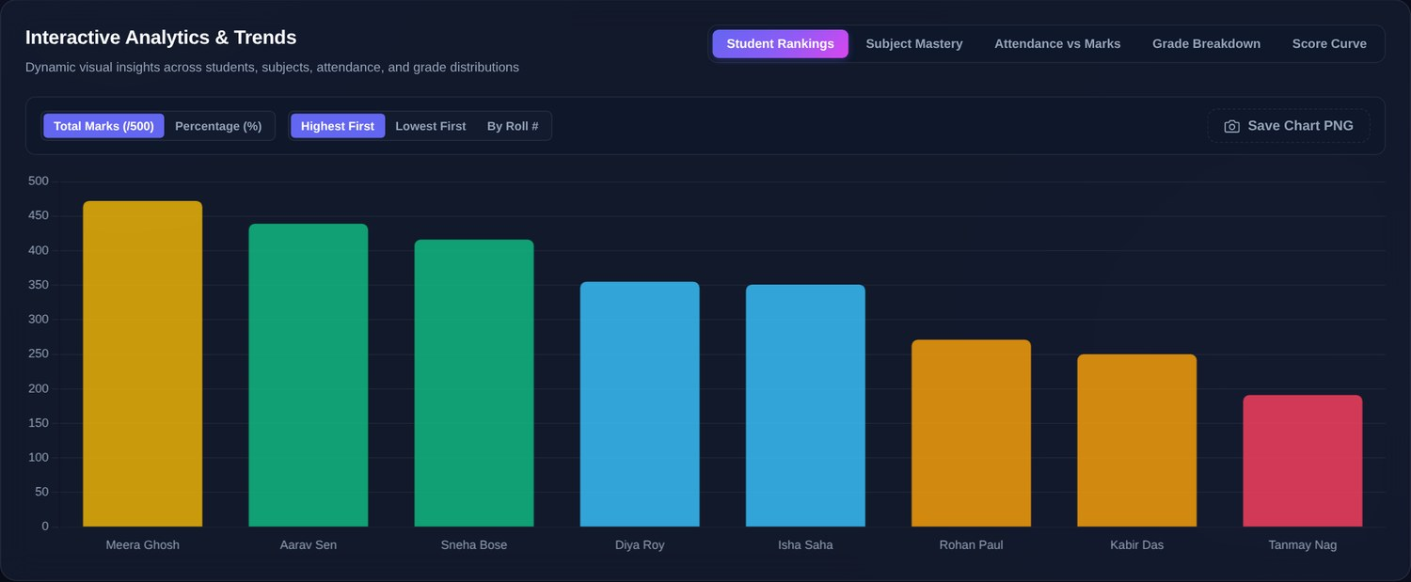
Figure 7.2 — Student Rankings chart (total marks, highest first)
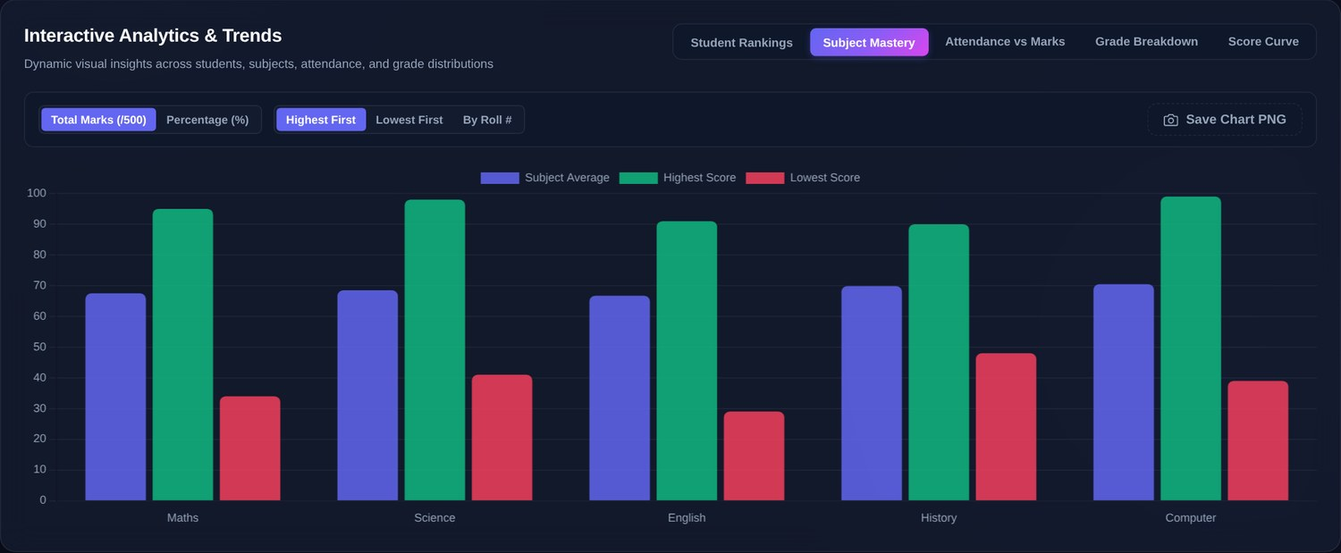
Figure 7.3 — Subject Mastery chart
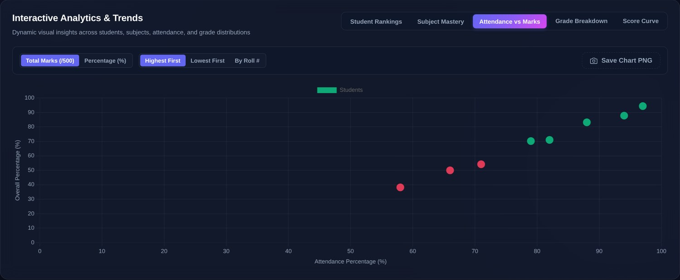
Figure 7.4 — Attendance vs Marks scatter chart (below-threshold points in red)
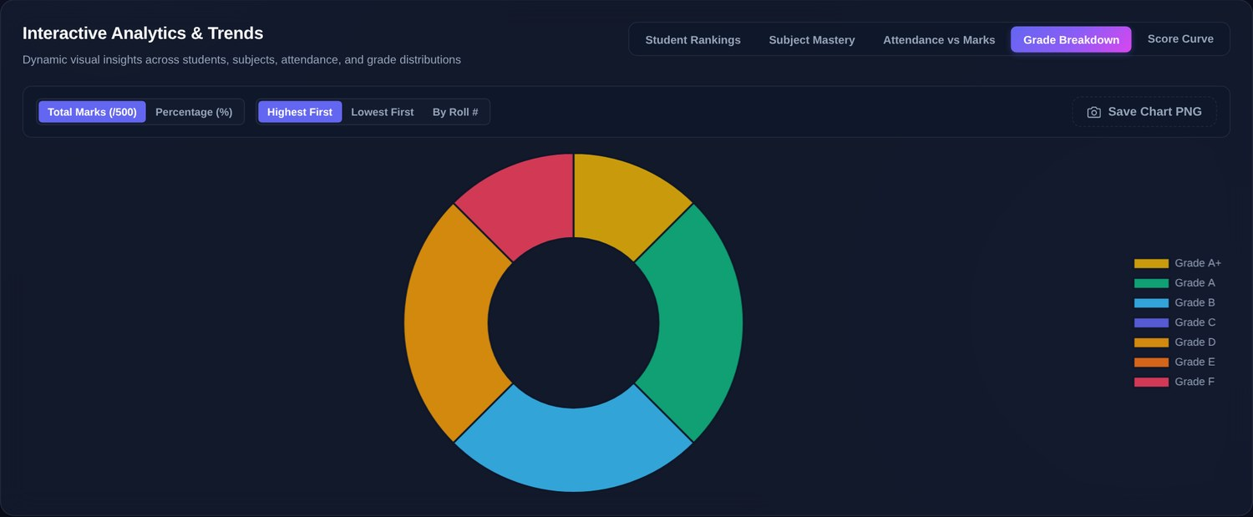
Figure 7.5 — Grade Breakdown chart
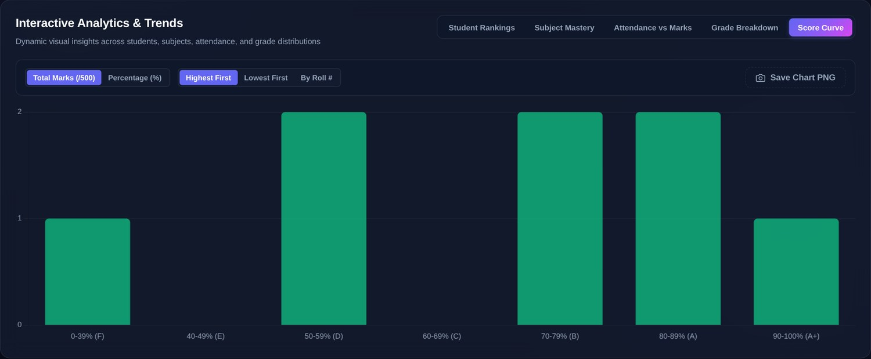
Figure 7.6 — Score Curve (percentage distribution)
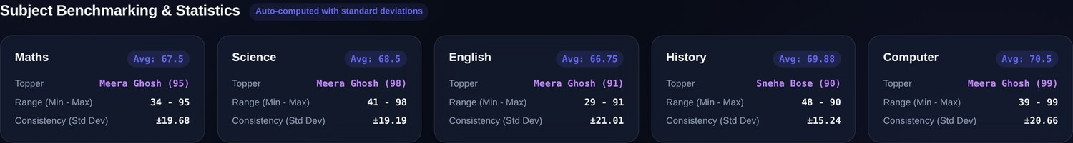
Figure 7.7 — Subject Benchmarking and Statistics cards
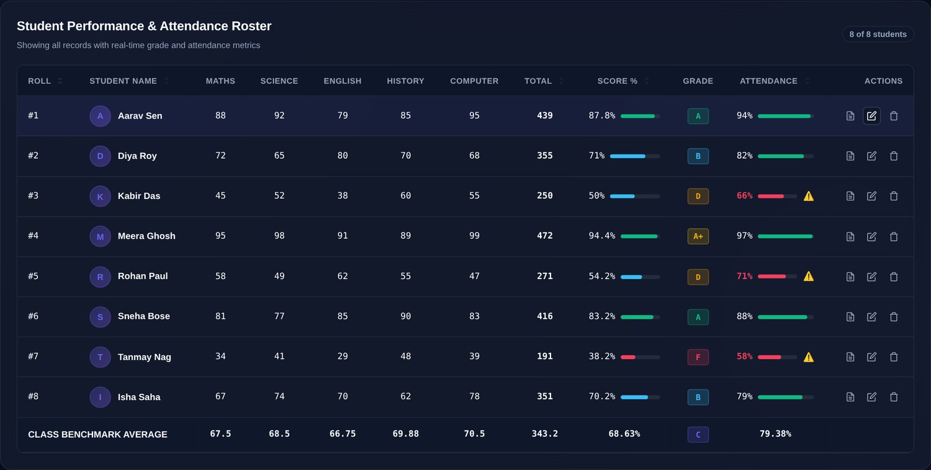
Figure 7.8 — Student Performance & Attendance Roster with class benchmark row

7.6 Matplotlib Chart Results
The console charts (menu option 7) are produced by charts.py from the same analysed data and saved to the charts/ folder.
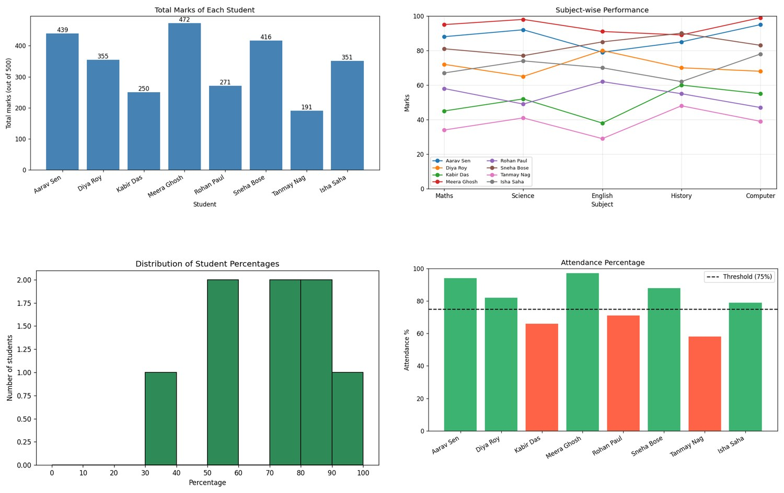
Figure 7.9 — Matplotlib charts: (a) total marks, (b) subject-wise performance, (c) percentage histogram, (d) attendance with 75% threshold

7.7 Result Analysis
- Top and bottom performers. Meera Ghosh leads with 472/500 (94.4%, A+) and is the subject topper in four of five subjects; Sneha Bose tops History. Tanmay Nag is the only student with grade F (38.2%).
- Distribution. Five of eight students score between 70% and 100%; the histogram shows one student each in the 30–40 and 90–100 bands and two each in 50–60, 70–80 and 80–90, with the 40–50 and 60–70 bands empty. The class average (68.63%) is pulled down by the weakest three students.
- Subjects. Computer has the highest class mean (70.50) and English the lowest (66.75). History is the most consistent subject (lowest deviation) while English varies most.
- Attendance and marks. The three students below 75% attendance are exactly the three lowest scorers (D, D and F). For these eight records the Pearson correlation between attendance% and percentage is 0.996. With so few records and sample data this is illustrative only, but it shows the kind of insight the combined view is designed to expose.
- Pass rate. The dashboard defines a pass as any grade other than F, giving 7 of 8 students (88%).

8. LIMITATIONS & FUTURE SCOPE

8.1 Limitations
- The CSV file is rewritten completely on every change and has no locking; it suits one user and tens or hundreds of students, not concurrent editing.
- There is no authentication; anyone who can reach the server port can read or change the data (CORS is open to all origins).
- Validation differs slightly between interfaces: the console enforces letters-only names and held ≥ 1, whereas the server only requires a non-empty name and held > 0.
- Grade and percentage rules exist in both Python and JavaScript and must be kept in sync by hand; standard deviation is sample-based in the console and population-based on the web.
- Subjects are fixed by config.py and the web form has five hard-coded inputs; there is no support for several classes, semesters or historical comparison. Test coverage is limited to two unit tests plus manual and scripted checks.

8.2 Future Scope
- Replace the CSV with SQLite or a server database and add user accounts with teacher and student roles.
- Track marks over several examinations and semesters to show trends, and predict at-risk students from attendance and marks.
- Make subjects, maximum marks and grade bands configurable from the web interface; harmonise validation rules and the standard-deviation definition.
- Send automatic e-mail or SMS alerts for low attendance and export report cards in bulk as PDF.
- Expand automated tests to cover the REST API and the JavaScript logic, and deploy the dashboard on a school server or cloud service.

9. CONCLUSION
The Student Performance & Attendance Analyzer meets its objectives. It stores marks and attendance in a transparent CSV file, validates every input, calculates totals, percentages and grades through one shared function, flags low-attendance students against a threshold the user controls, and presents the results as statistics, Matplotlib charts, an interactive Chart.js dashboard and printable report cards. Its modular design allowed the console tool and the web dashboard to be built on the same package, and testing on the supplied dataset confirmed that all interfaces produce identical figures: a class average of 68.63%, average attendance of 79.38%, a topper score of 472/500 and three students under the 75% attendance mark.
The project demonstrates that a modest stack — Python, Pandas, Matplotlib, the standard-library HTTP server and vanilla JavaScript — can deliver a practical, auditable academic tool without any database or paid service. With the enhancements outlined in Section 8.2 it can grow from a classroom utility into a more complete student-monitoring platform.

APPENDICES

Appendix A: User Interface Screens
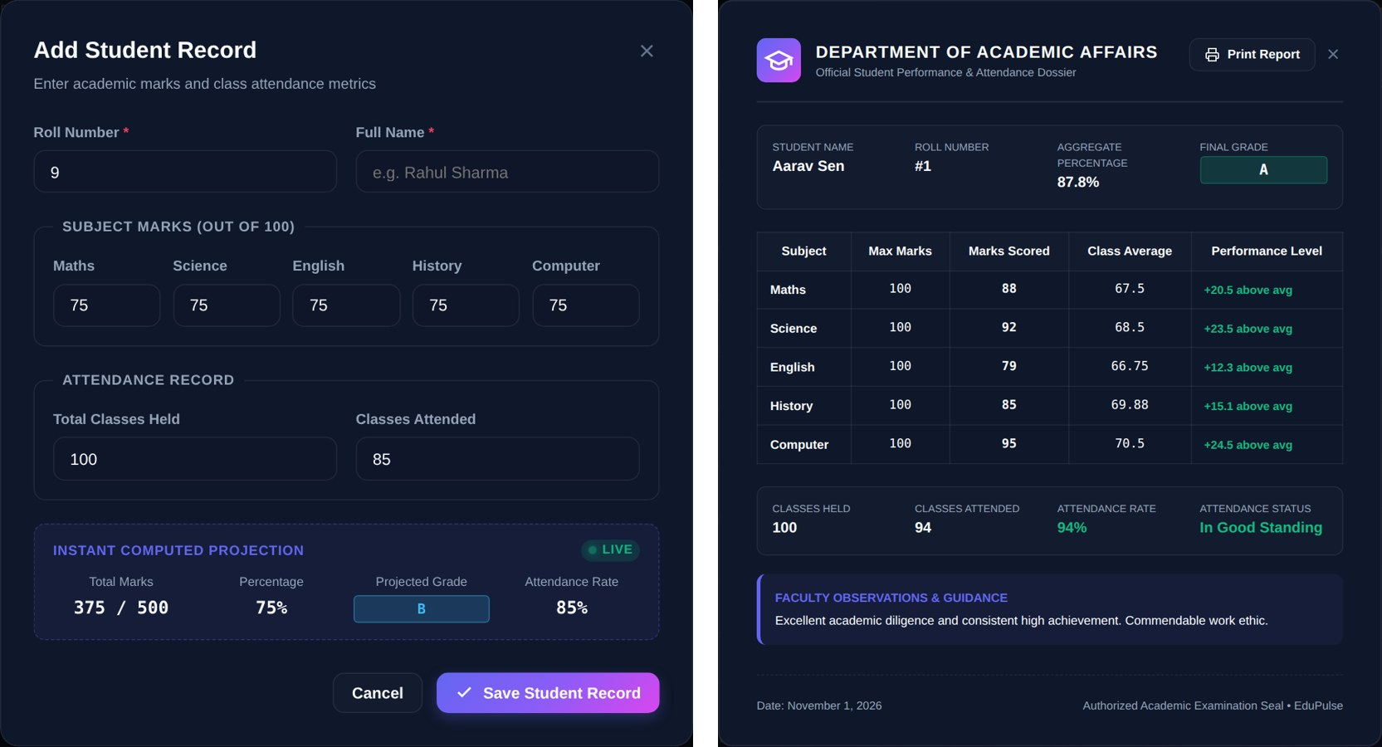
Figure A.1 — (a) Add Student dialog with live projection; (b) report card for Aarav Sen
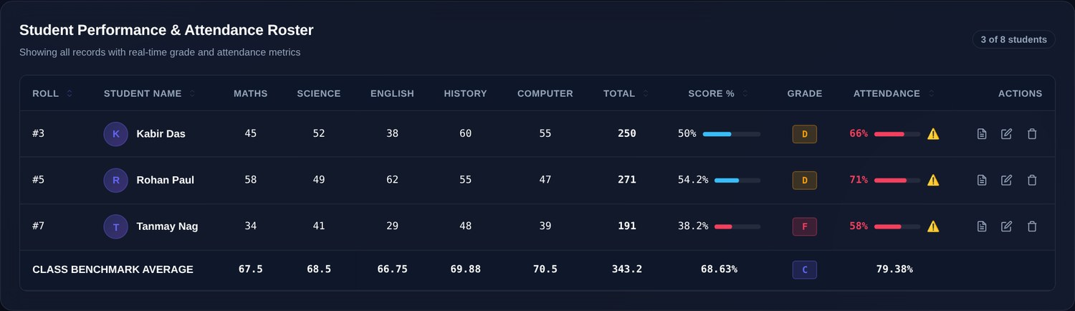
Figure A.2 — Roster filtered with “Low Attendance” — 3 of 8 students

Appendix B: Sample Code
Low-attendance detection (analyzer/features.py) and the entry-point loop of main.py:
def low_attendance(df):
if df.empty:
print("\n No records available.")
return
threshold = read_float("Attendance threshold % (e.g. 75): ", 0, 100)
data = analyze(df)
low = data[data["Attendance%"] < threshold]
if low.empty:
print(f"\n All students have attendance of {threshold}% or more.")
else:
print(f"\n=== Students below {threshold}% attendance ===")
print(low[["Roll", "Name", "ClassesHeld", "ClassesAttended", "Attendance%"]].to_string(index=False))

def main():
df = load_records()
print(f"Loaded {len(df)} record(s) from '{CSV_FILE.name}'.")
while True:
print(MENU)
try:
choice = read_int("Enter choice: ", 0, 9)
if choice == 0:
launch_web_app()
elif choice == 1:
df = add_student(df)
elif choice == 2:
show_report(df)
elif choice == 3:
low_attendance(df)
elif choice == 4:
df = load_records()
print(f" Reloaded {len(df)} record(s).")

Appendix C: Data Structure
Contents of data/students.csv and the project-wide configuration in analyzer/config.py:
Roll,Name,Maths,Science,English,History,Computer,ClassesHeld,ClassesAttended
1,Aarav Sen,88,92,79,85,95,100,94
2,Diya Roy,72,65,80,70,68,100,82
3,Kabir Das,45,52,38,60,55,100,66
4,Meera Ghosh,95,98,91,89,99,100,97
5,Rohan Paul,58,49,62,55,47,100,71
6,Sneha Bose,81,77,85,90,83,100,88
7,Tanmay Nag,34,41,29,48,39,100,58
8,Isha Saha,67,74,70,62,78,100,79

SUBJECTS = ["Maths", "Science", "English", "History", "Computer"]
MAX_MARKS = 100 # maximum marks per subject
BASE_COLUMNS = ["Roll", "Name"] + SUBJECTS + ["ClassesHeld", "ClassesAttended"]

Appendix D: Test Cases
Table D.1 — Test cases and observed results
ID | Test case | Expected / observed result | Status
TC-01 | Unit: grade boundaries 95, 90, 85, 75, 65, 55, 45, 39.9 | A+, A+, A, B, C, D, E, F | Pass
TC-02 | Unit: analyze() on one record | Total 400, Avg 80, % 80, Grade A, Att 80 | Pass
TC-03 | Console option 2 — view all records | 8 rows with computed columns | Pass
TC-04 | Console option 3, threshold 75 | Kabir Das, Rohan Paul, Tanmay Nag | Pass
TC-05 | Console option 5, descending | Meera Ghosh first (472), Tanmay Nag last (191) | Pass
TC-06 | Console option 6 — statistics | Means 67.5 / 68.5 / 66.75 / 69.88 / 70.5; toppers; A+1 A2 B2 D2 F1 | Pass
TC-07 | read_int with “abc”, then “-5”, then 7 | Two error messages, then 7 accepted | Pass
TC-08 | read_name with “12a”, then “John Doe” | Letters-only error, then “John Doe” accepted | Pass
TC-09 | Console option 7 — four charts | Four PNG files saved in charts/ | Pass
TC-10 | GET /api/students | 200; 8 students, summary, subject stats | Pass
TC-11 | POST valid student (roll 9) | 200; dataset now has 9 students | Pass
TC-12 | POST duplicate roll 9 | 409 “Roll 9 already exists” | Pass
TC-13 | POST attended (85) > held (50) | 400 “Invalid attendance numbers” | Pass
TC-14 | POST mark = 101 | 400 “Marks must be between 0 and 100” | Pass
TC-15 | POST blank name | 400 “Name cannot be empty” | Pass
TC-16 | PUT /api/students/9 | 200; record updated | Pass
TC-17 | PUT /api/students/99 | 404 “Roll 99 not found” | Pass
TC-18 | DELETE /api/students/9 | 200; record removed | Pass
TC-19 | DELETE /api/students/99 | 404 “Roll 99 not found” | Pass
TC-20 | POST /api/import-csv with missing columns | 400 “Missing columns in CSV: [...]” | Pass
TC-21 | POST unknown endpoint | 404 “Endpoint not found” | Pass
TC-22 | GET /api/export-csv | 200; text/csv, attachment | Pass
TC-23 | POST /api/reset-sample | 200; 8 sample students restored | Pass
TC-24 | GET /index.html (static) | 200 | Pass
TC-25 | Dashboard KPIs on load | 8; 68.63%; 79.38%; Meera Ghosh; 3 alerts | Pass
TC-26 | Add Student dialog defaults | Projection 375/500, 75%, B, 85% | Pass
TC-27 | Report card for roll 1 | Aarav Sen, 87.8%, grade A, attendance 94% | Pass
TC-28 | Attendance filter = Low | 3 of 8 students listed | Pass

REFERENCES
- Python Software Foundation, “http.server — HTTP servers,” Python 3 documentation. https://docs.python.org/3/library/http.server.html
- Python Software Foundation, “unittest — Unit testing framework,” Python 3 documentation. https://docs.python.org/3/library/unittest.html
- The pandas development team, “pandas documentation.” https://pandas.pydata.org/docs/
- J. D. Hunter, “Matplotlib: A 2D graphics environment,” Computing in Science & Engineering, vol. 9, no. 3, 2007. Documentation: https://matplotlib.org/stable/
- Chart.js contributors, “Chart.js documentation.” https://www.chartjs.org/docs/latest/
- MDN Web Docs, “Fetch API.” https://developer.mozilla.org/en-US/docs/Web/API/Fetch_API
- Y. Shafranovich, “Common Format and MIME Type for Comma-Separated Values (CSV) Files,” RFC 4180, IETF, 2005. https://www.rfc-editor.org/rfc/rfc4180
- R. Fielding et al., “HTTP Semantics,” RFC 9110, IETF, 2022. https://www.rfc-editor.org/rfc/rfc9110

