1. Description of the System

Dojo 8 CoWorking Space is a work space where everyone collaborates and shares their ideas and skills. Dojo 8 is open to tech and non-tech communities, organizations or teams, professionals, and students. It is considered first ever coworking space in the city to cater all professionals, small business, freelancers and start-ups to collaborate and get creative. This unique business offers coworking areas with suitable rates for its wide range of customers.

The current system of the study generally makes use of manual methods in the processing of their daily transactions. These methods lead to slower process and transaction time which then affects the succeeding transactions, an impact in the quality of the system. The major flaw encountered in Dojo 8’s current timekeeping system is the use of these manual methods pertaining to customer records and logbook records. Since a customer can redeem their hours, the staff may have difficulty searching through customer records in order to retrieve the customer’s information, remaining hours and its validity. A manual logbook is used for timing customers in and out. These details in the logbook must then be transferred into an excel file to be stored as logbook records.

The system is a simple timekeeping system. It features administrator access to the information and database of Dojo 8. An administrator may add, edit or delete staff and customer details and add of packages and promos. A regular staff, however, can only add and edit customer information. The system records the time in and time out of customers. Computation of hours remaining and the storing of specific log details such as hours spent, staff in charge and etcetera is a main feature in the timekeeping aspect. Accuracy is a key factor to ensure reliability of the system. The system also generates reports, consumer and logbook reports, on a daily, monthly or yearly basis.

As it is only a timekeeping system, the system cannot compute or generate reports for sale transactions. The system is limited to only storing data and information of customers, staff, packages and promos.

1. Entity Relationship Diagram



1. Relational Model

tblCustomer

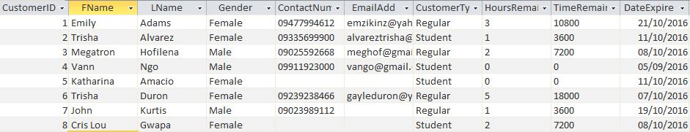

tblStaff

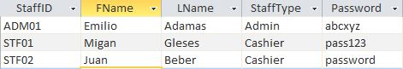

tblPackage

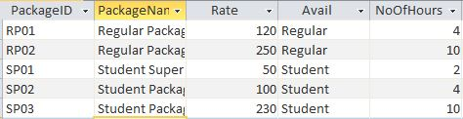

tblPromo

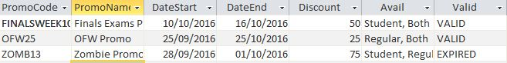

tblOrder

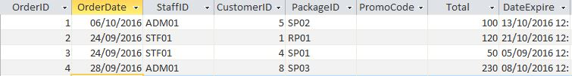

tblRecord

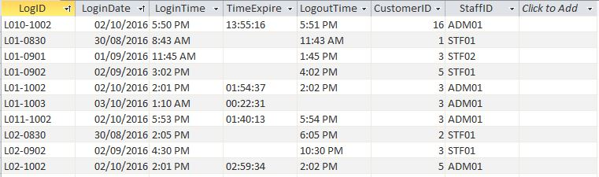

tblRecordDetails

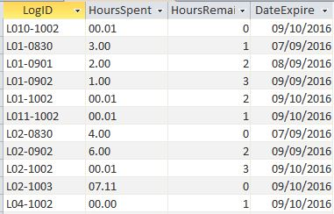

IV. Data Dictionary

tblStaff

|  |  |  |
| --- | --- | --- |
| StaffID | VarChar(255) | Primary key, the staff ID |
| FName | VarChar(255) | First name of the staff |
| LName | VarChar(255) | Last name of the staff |
| StaffType | VarChar(255) | If the staff is an admin or cashier |
| Password | VarChar(255) | Password for the staff |

tblCustomer

|  |  |  |
| --- | --- | --- |
| CustomerID | Number(Auto-Increment) | Primary key, the Customer ID |
| FName | VarChar (255) | First name of Customer |
| LName | VarChar (255) | Last name of Customer |
| Gender | VarChar (255) | Gender of Customer (Male/Female) |
| ContactNum | VarChar (255) | Contact number of Customer |
| EmailAdd | VarChar (255) | Email Address of Customer |
| CustomerType | VarChar (255) | Type of Customer (Regular/Student) |
| HoursRemain | Number | Hours Remaining of Customer |
| TimeRemain | Number | Hours remaining converted to seconds |
| DateExpire | Date/Time | Date when a customer’s redeemable hours will expire |

tblPackage

|  |  |  |
| --- | --- | --- |
| PackageID | VarChar(255) | Primary Key, the Package ID |
| PackageName | VarChar(255) | Package name |
| Rate | Number | Rate or price of a package |
| Avail | VarChar(255) | Type of customer that can avail package |
| NoOfHours | Number | Number of hours in a package |

tblPromo

|  |  |  |
| --- | --- | --- |
| PromoCode | VarChar(255) | Primary key, the Promo code |
| PromoName | VarChar(255) | Promo name |
| DateStart | Date/Time | Date when a promo starts |
| DateEnd | Date/Time | Date when a promo ends |
| Discount | Number | Discount for a promo |
| Avail | VarChar(255) | Type of customer that can avail promo |
| Valid | VarChar(255) | Ensures if the promo is still valid |

tblOrder

|  |  |  |
| --- | --- | --- |
| OrderID | Number(Auto-Increment) | Primary key, the Order ID |
| OrderDate | Date/Time | Date when the order was made |
| StaffID | VarChar(255) | Foreign key. Primary key of tblStaff |
| CustomerID | Number | Foreign key. Primary key of tblCustomer |
| PackageID | VarChar(255) | Foreign key. Primary key of tblPackage |
| PromoCode | VarChar(255) | Foreign key. Primary key of tblPromo |
| Total | Number | Total Amount |
| DateExpire | Date/Time | Date when the customer’s purchased hours will expire |

tblRecord

|  |  |  |
| --- | --- | --- |
| LogID | VarChar(255) | Primary key, the Log ID |
| LoginDate | Date/Time | Date of Login |
| LoginTime | VarChar(255) | Time of Login |
| TImeExpire | Date/Time | Time when a login expires |
| LogoutTime | VarChar(255) | Time of Logout |
| CustomerID | Number(Auto-Increment) | Foreign key. Primary key of tblCustomer |
| StaffID | VarChar(255) | Foreign key. Primary key of tblStaff |

tblRecordDetails

|  |  |  |
| --- | --- | --- |
| LogID | VarChar(255) | Foreign key. Primary key of tblRecord |
| HoursSpent | Number | Hours that a customer spent |
| HoursRemain | Number | Remaining hours of a customer |
| DateExpire | Date/Time | Date when a customer’s remaining hours will expire |