Lab 1: Requirements Engineering & UML Use-Case Modelling
Problem Statement #08 – Digital Campus Library Reservation Gateway
Actors: Student Member, Head Librarian, Notification Service (system), Fine Payment Gateway (system)

Part 1 – Requirements Table
Req ID | Type | Description | Priority | Acceptance Criteria | Rationale
FR-001 | Functional | The system shall allow a Student Member to search the ISBN catalog and place a hold request on a currently loaned book, entering the member into a FIFO waitlist for that title. | High | Pass: Member is assigned the correct sequential position in the queue and can view it. Fail: A member who already holds the maximum allowed number of reservations (3) is blocked from placing an additional hold. | Core reservation functionality; enables fair, first-come-first-served access to limited physical copies.
FR-002 | Functional | The system shall automatically notify the next member in the FIFO queue via email/SMS within 15 minutes of a held title being checked in, and shall hold the copy for that member for a 48-hour pickup window. | High | Pass: Notification log shows a message dispatched within 15 minutes of check-in, and the copy is auto-released to the next queue position if not collected within 48 hours. Fail: No notification is generated, or the copy remains reserved beyond the 48-hour window. | Prevents indefinite blocking of scarce copies and keeps the waitlist moving fairly.
FR-003 | Functional | The system shall automatically compute and post an overdue fine transaction of a configurable daily rate for every loaned item not returned by its due date, updating the member's fine balance in real time. | High | Pass: A fine transaction record is created the day after the due date and the balance increments daily until return. Fail: An overdue item does not generate any fine transaction, or the balance is not updated after return. | Ensures accurate, auditable tracking of overdue fines without manual librarian intervention.
FR-004 | Functional | The system shall allow the Head Librarian to view, reorder, or cancel any entry in a book's holding queue, including manually overriding a member's queue position for exceptional cases. | Medium | Pass: Librarian's cancel/reorder action is reflected immediately in the queue and logged with a timestamp and librarian ID. Fail: A queue change made by the librarian is not persisted or not visible to affected members. | Gives library staff administrative control to resolve disputes, holds errors, and special-access cases.
FR-005 | Functional | The system shall allow a Student Member to pay outstanding overdue fines online through an integrated payment gateway, and shall block new hold requests while the member's outstanding balance exceeds INR 500. | Medium | Pass: A successful payment reduces the outstanding balance and a receipt is generated; a member with a balance above INR 500 is prevented from placing a new hold. Fail: Balance is not updated after payment, or a member over the threshold is still able to place a hold. | Encourages timely fine settlement and protects book availability from members who repeatedly incur overdue fines.
NFR-001 | Performance & Security | The catalog search query shall return paginated results for a repository of 50,000 titles in under 150 ms, and all search/authentication endpoints shall enforce HTTPS with role-based access control. | High | Pass: Benchmark tests confirm sub-150 ms latency for search under simulated peak load, and a security scan confirms encrypted transport and correct role enforcement. | Ensures a responsive experience during peak enrollment periods and protects member data from unauthorized access.
NFR-002 | Data Security & Integrity | All overdue-fine transaction records and payment data shall be encrypted at rest (AES-256) and stored in an immutable, timestamped audit log accessible only to the Head Librarian role. | High | Pass: A security/penetration audit confirms encryption at rest and verifies that no audit log entry can be modified or deleted post-write. Fail: Any fine or payment record can be altered without a corresponding audit trail entry. | Protects financial transaction integrity and supports institutional compliance/audit requirements.
Note: FR-001 and NFR-001 correspond to the requirement templates supplied in the problem statement; FR-002–FR-005 and NFR-002 were authored to complete the set of exactly five functional and two nonfunctional requirements.

Part 2 – UML Use-Case Diagram
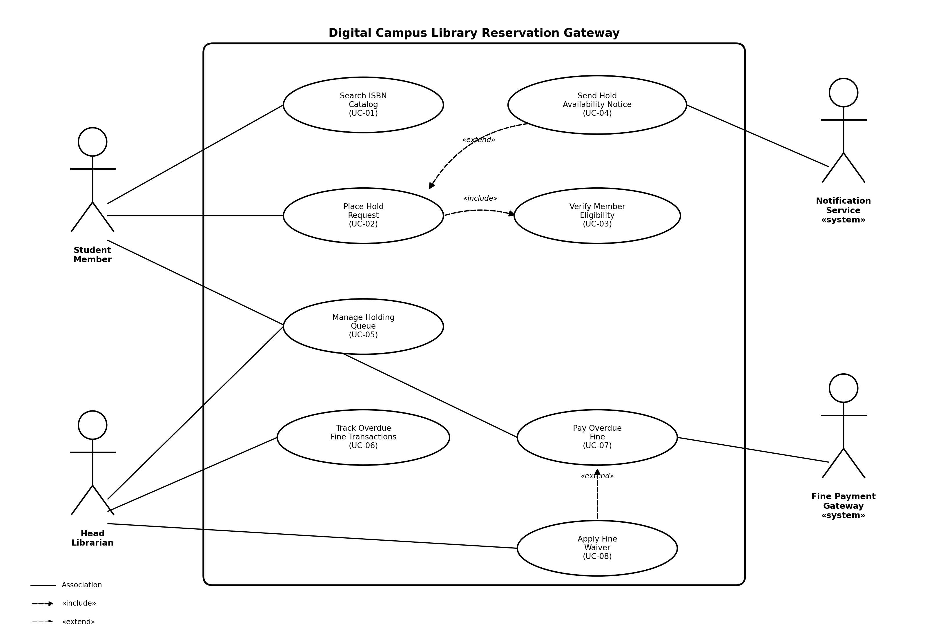
Includes one «include» relationship (Place Hold Request → Verify Member Eligibility) and two «extend» relationships (Send Hold Availability Notice → Place Hold Request; Apply Fine Waiver → Pay Overdue Fine).

Part 3 – Use-Case Flow Specification
Core use case detailed below: UC-02 Place Hold Request.
Use Case ID | UC-02
Use Case Name | Place Hold Request
Primary Actor | Student Member
Secondary Actors | Head Librarian (queue oversight), Notification Service (system)
Related Use Cases | «include» UC-03 Verify Member Eligibility; «extend» UC-04 Send Hold Availability Notice (triggered later, when the title becomes available)
Preconditions | 1) The Student Member is authenticated in the Library Reservation Gateway. 2) The requested title exists in the ISBN catalog and its current status is “On Loan.”
Postconditions | Success: The member is added to the title's FIFO holding queue at the correct position and a confirmation is displayed. Failure: No queue entry is created and the member is informed of the reason.
Main Success Scenario
- Student Member logs into the Library Reservation Gateway and searches the ISBN catalog for a title (UC-01 Search ISBN Catalog).
- System displays the search results, including each title's availability status (Available / On Loan, with number currently in queue).
- Member selects a title marked “On Loan” and clicks “Place Hold.”
- System invokes Verify Member Eligibility (UC-03, «include») to confirm the member's account is active, has no blocking fines above INR 500, and has fewer than 3 existing active holds.
- System confirms the member is eligible.
- System adds the member to the title's FIFO holding queue and computes their queue position.
- System displays a confirmation screen showing the assigned queue position and an estimated wait time.
- Use case ends successfully. (Later, when the title is returned and reaches the front of the queue, UC-04 Send Hold Availability Notice «extends» this use case to notify the member.)
Alternate Flow – 4a. Member Not Eligible
4a1. Eligibility check (UC-03) fails because the member already has 3 active holds or an outstanding fine above INR 500.
4a2. System displays the specific reason for ineligibility (e.g., “Maximum holds reached” or “Outstanding fine exceeds limit – please pay via UC-07 Pay Overdue Fine”).
4a3. System does not create a queue entry; the member may resolve the issue (return a book or pay the fine) and retry from step 3.
4a4. Use case ends without success.

