# Ideation Phase

## Empathize & Discover

Date: 21 June 2025

Team ID: LTVIP2025TMID54506

Project Name: ResolveNow: Your Platform for Online Complaints

Maximum Marks: 4 Marks

### Empathy Map Canvas

An empathy map is a simple, easy-to-digest visual that captures knowledge about a user’s behaviours and attitudes.  
It is a useful tool that helps teams better understand their users.  
  
Creating an effective solution requires understanding the true problem and the person who is experiencing it. The exercise of creating the map helps participants consider things from the user’s perspective along with his or her goals and challenges.  
Reference: <https://www.mural.co/templates/empathy-map-canvas>

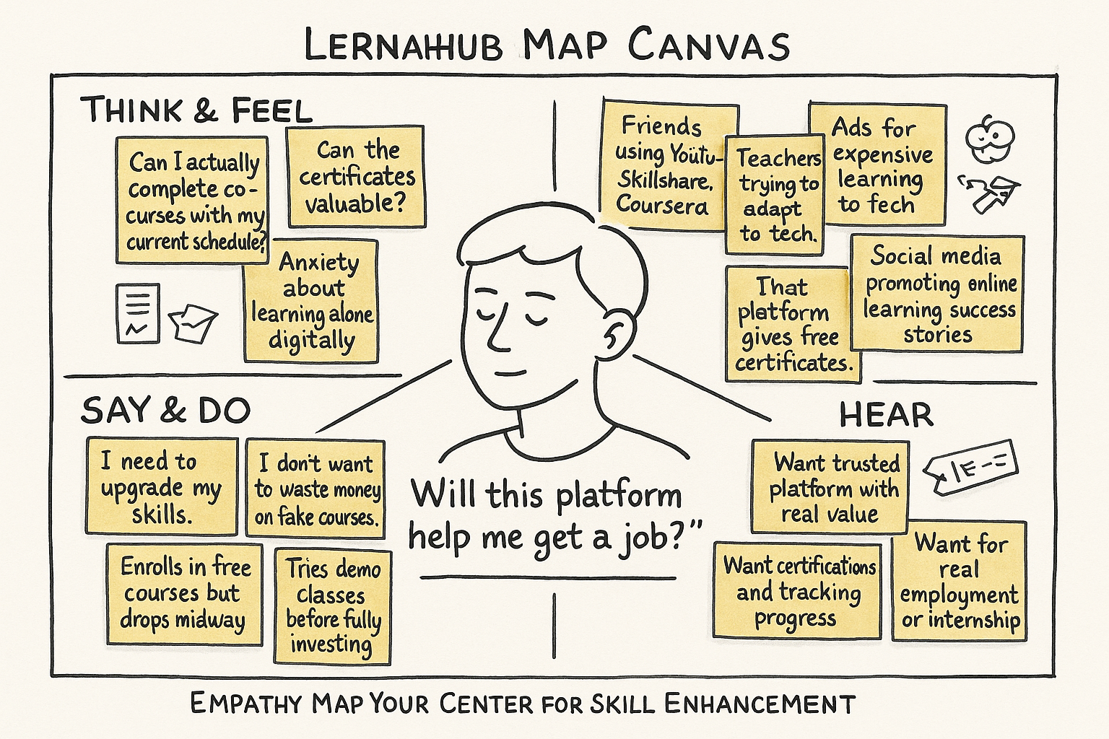

### Empathy Map Canvas – For ResolveNow Users (Citizens)

* THINK & FEEL
* “Will my complaint actually be resolved?”
* “Is this platform trustworthy?”
* “How long will it take to hear back?”
* Concerned about being ignored or passed between departments
* SEE
* Lack of transparency in public issue redressal
* Others complaining on social media or news
* No single portal for all services
* SAY & DO
* “I’ve raised complaints before but nothing happened.”
* “I don’t trust government apps.”
* Uses WhatsApp, Twitter or calls helplines instead
* HEAR
* “You’ll never get a reply.”
* “Use RTI or contact your local rep.”
* “This app worked for me, try it.”
* PAINS
* Long response times
* No updates or closure reports
* Repetition of complaint steps
* GAINS
* Timely updates and response
* Assurance of issue visibility and accountability
* Clear tracking of complaint status