**Part 1. High Fidelity Prototype**

***Scenario and the “User Needs”***

We have imagined a scenario where group members need to share multiple files with multiple group members within one interaction, with the ability to group the files and add a relevant message accordingly. As such, our high-fidelity prototype focuses on the following user needs:

* Ability to share one or more files.
* Ability to share with one or more group members.
* Grouping files into different sections.
* Ability to leave a different message for each section.

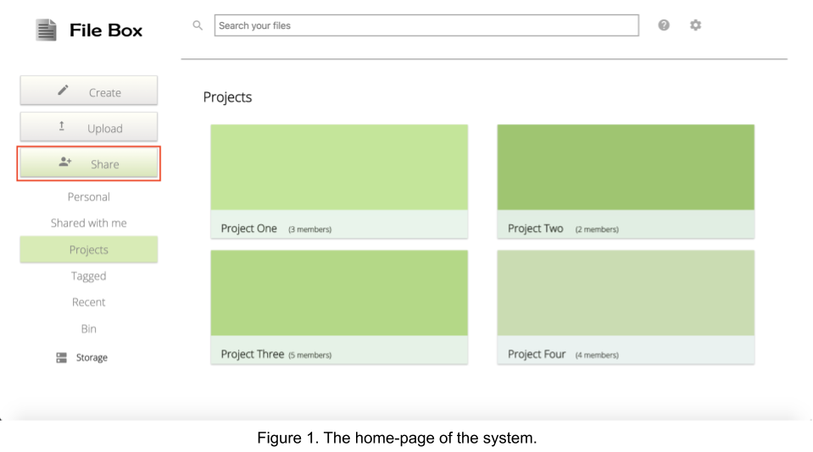All these user needs have been accounted for in our prototype will be detailed below.

***System Functionality (Core Function: Share Function)***

The focal point of our high-fidelity prototype is the user’s ability to share multiple files with multiple people within one interaction. This includes the ability to create sections and title them, as well as have different messages for each section.

To begin sharing files and using this functionality, the user must click on the ‘Share’ button located in the navigation sidebar, on the left-hand side of the page (as indicated by the red box in Figure 1). This will prompt the “Share Multiple Documents” pop-up to appear, allowing the user to begin the process of sharing files.

As shown in Figure 2, the user can choose which persons can directly edit the file(s) or only view them. By entering their details (name or email) in the associated text fields, the permissions are immediately specified.

One or multiple files can be sent to one or multiple people within one interaction. To share more than one file, the user must click on ‘New Section’ (red box). The maximum number of files that can be shared within one interaction is five.

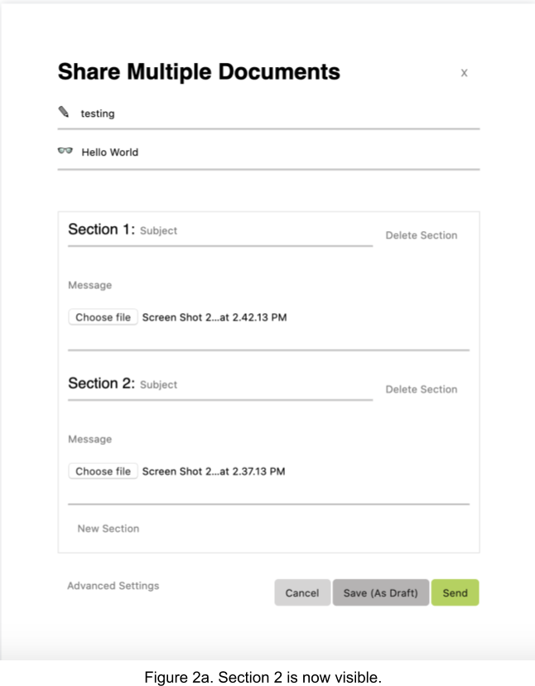

Upon clicking the “New Section” button in Figure 2, a new section will appear - this is shown clearly in Figure 2a. This is one of the core functionalities of our system, wherein the files can be split into different sections for clarity. The sections each include an optional title and message that can be added by the user.

The user can also opt to delete unwanted sections by clicking the “Delete Section” text adjacent to the relevant section. This can be seen circled in red on Figure 2a. In the current high-fidelity prototype, the deletion only works for Section 5 as to show what the deletion process would look like.

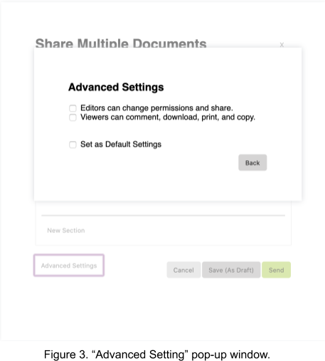

The user may choose to add additional permissions for the people that the user has chosen to share the files to. This can be done by clicking on ‘Advanced Settings’ at the bottom left of the share file popup and the additional permissions are displayed by another popup (as shown by Figure 3).

The user has the option to share the files at a later time by saving it as a draft, cancel the file-sharing or proceed with sharing the files.

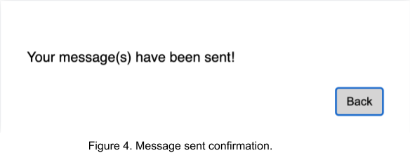Upon clicking the “Send” button that can be seen in Figure 2., the confirmation receipt in Figure 4. will appear. This is to ensure that there will be no confusion as to whether the message has been sent, or saved as a draft, or deleted by accident. The “Back” button on the same pop-up will lead to the home page as seen in Figure 1.

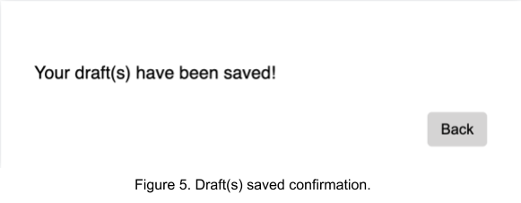Along the same vein, clicking the “Save As Draft” button as seen in Figure 2. And Figure 6. will lead to a receipt message. This will ensure that the user knows the message has been successfully saved as a draft, rather than accidentally sent or deleted.

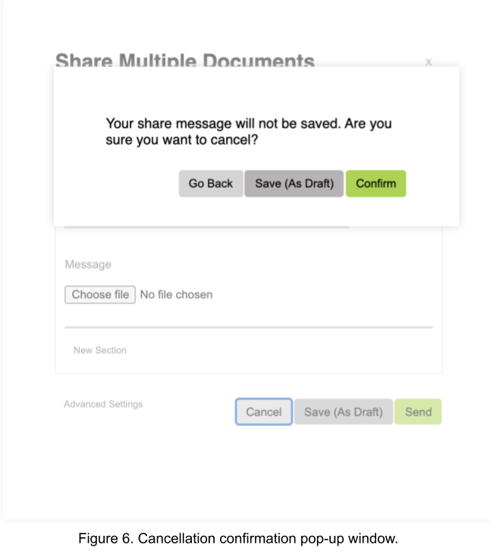

Figure 6. shows the pop-up confirmation window if the user clicks the “Cancel” button or “x” in the upper right corner of Figure 1. The user must confirm that they wish to close the window, to ensure that they did not accidentally close the “Share Multiple Documents” pop-up window and lose all the progress they have made.

There is also the option to go back to the “Share Multiple Documents” pop-up window (Figure 2) in the case of a mis-click, or to save as a draft instead of deleting the entire message. This encompasses all the possible options that the user may wish for.

***Other functionalities***

The high-fidelity prototype displays other functionalities that ***are not currently functional.*** These mostly exist in the home page (Figure 1).



Conceptually, the search bar (Figure 7) allows the user to search for files from both personal and shared drives. This would ensure ease of navigation within the system so that the user can always quickly locate the sought-after document.

~~If the user were to click on ‘Projects’, their projects are displayed on the webpage as in Figure 1. The user can then select a project (for example, Project One), and a list of files with details will be displayed on the page (Figure 8). The same can be said for the ‘Personal’ tab (Figure 8, side navigation), conceptually this would display the different files that the user has uploaded into the system.

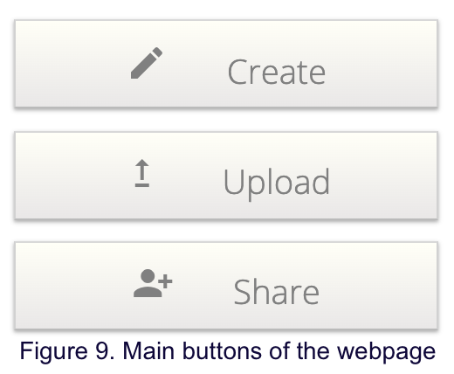

Shown by Figure 9, the ‘Create’ button would allow the user to create a new file in the system, like a document, powerpoint, spreadsheet, etc. The ‘Upload’ button would enable the user to upload any file into the system.

***Why this prototype is appropriate for student coursework***

Nowadays, student coursework in university involves many digital resources and files, from lecture slides to Jupyter notebooks used in lectures to files used in assignments.

A key element of success is sharing resources and studying with classmates. Our system provides a way to share multiple files with multiple different people. However, files may not be related - our system also allows the user to share multiple files with sectioning and different messages for added clarity.

For example, some assignments have multiple parts, requiring different files and file types. Being able to share all the files in one go, split into multiple sections and a different message for each section will contribute greatly to clarity; this is also convenient as we can share these files in a single interaction.

Students may take part in one or multiple group assignments, therefore the ‘Projects’ page acts as a repository where groups can upload and share files with other group members.

Lastly, as files are only shared to people who have been given permission for access (including group members within a shared project repository), it ensures data integrity, which is essential for these types of coursework.

***Visual Design Choices***

A variety of design principles have been considered for the implementation of the high-fidelity prototype. Three ***Gestalt principles*** have been used in the prototype, such as the Proximity, Common Fate, and Closure principles.

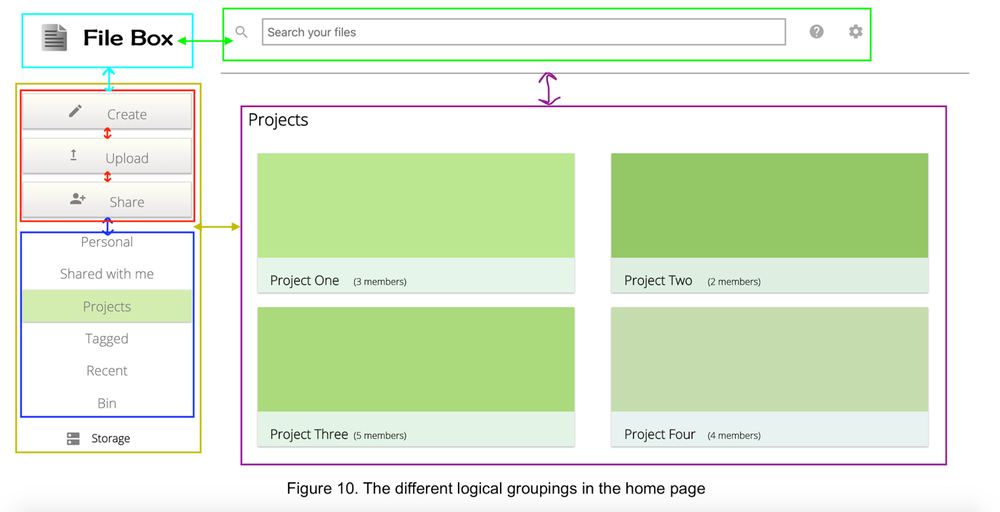

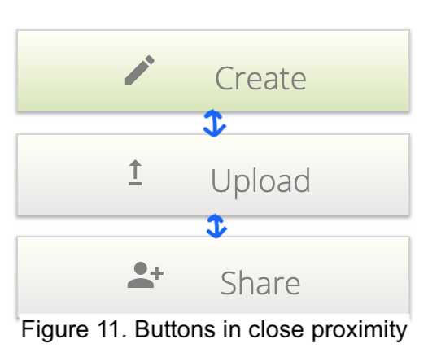

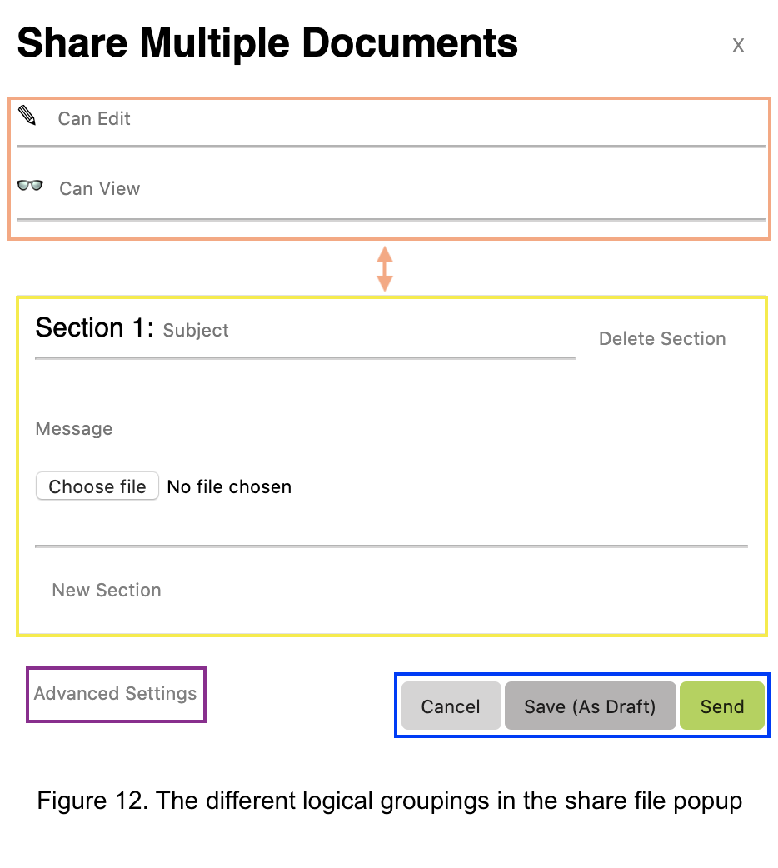The **Proximity** principle can be seen by the different logical groupings on the homepage (Figure 10). For example, the create/upload/share buttons (Figure 11) are located within the same proximity to each other, with small gaps between each button. There is whitespace between the side navigation bar (buttons and links) and the space on the web page containing ‘Projects’ to reinforce the different groupings on the homepage. A horizontal line separates the search bar and the ‘Projects’ section as shown in Figure 10, with whitespace surrounding the horizontal line to separate the elements around it. The Proximity principle can also be seen in the share file popup (Figure 12), where there is whitespace between sections, the three buttons, and the logical grouping where members can enforce file usage rights.

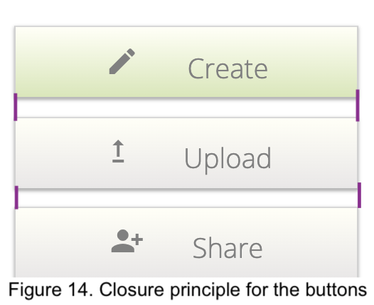The **Common Fate** principle is shown by the share file popup with the sections (Figure 13). If the user chooses to write a message, they would fill the message subject first, then write their message, choose a file and proceed to the bottom of the page to click ‘send’. Each action made by the user requires them to make their way down the share file popup, from filling in the file participants to filling in the sections and clicking either ‘Cancel’, ‘Save (as draft)’ or ‘Send’. Each section in the share file popup represents one logical grouping, as well as the three buttons located at the bottom of the popup.

The **Closure** principle can be seen with the three buttons (“Create”/”Upload”/”Share”) in Figure 14. Since the gaps between each button are small, the buttons altogether can be seen as one big rectangular object, and therefore seen as one logical grouping.

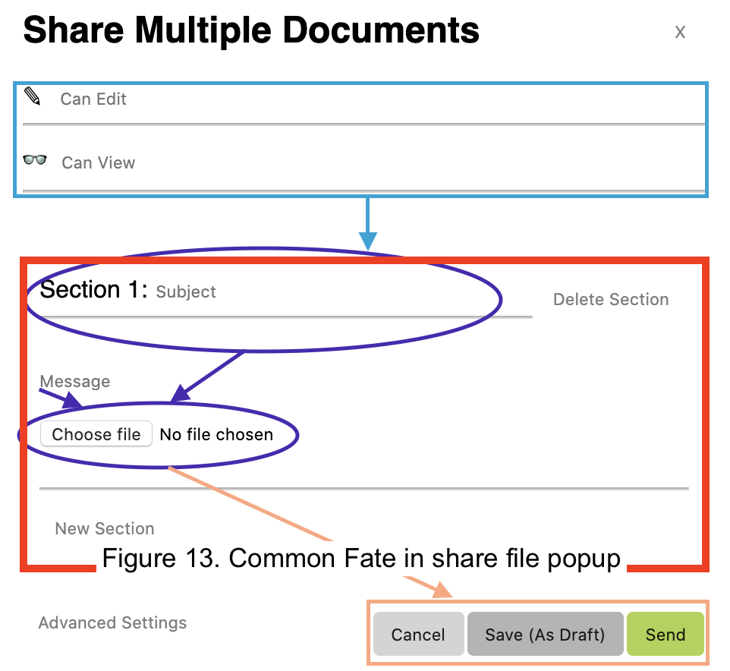Two out of the three **design principles** have been used, such as Balance and Emphasis.

The design principle of **Balance** is demonstrated by the 4 projects in Figure 10. The four different project blocks are displayed symmetrically, with 2 blocks on each side to create harmony and balance. The share file popup also demonstrates balance, though not in a symmetric way. This can be seen by the three buttons located at the bottom of Figure 13 and the ‘Advanced Settings’ tab. By having both of these elements placed there, balance is achieved.

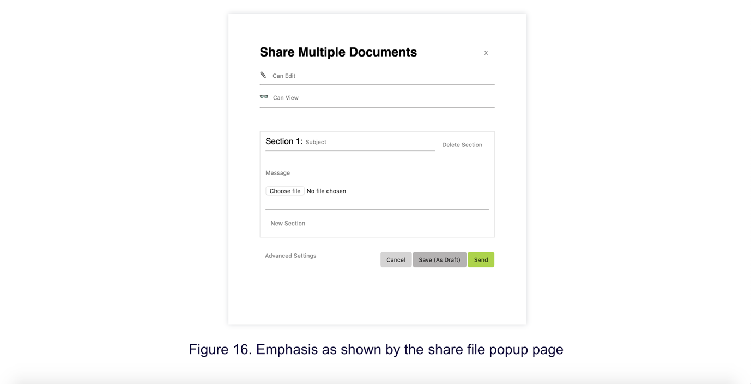**Emphasis** (in terms of placement and isolation) can be seen in Figure 16, with the share file popup centred in the webpage. The surrounding whitespace shows that the user’s focus must be aimed at the popup displayed on their screen.

The high-fidelity prototype uses minimalist **colours** such as white and grey, for a clean and sleek looking webpage. For a touch of colour, varying shades of green have been added to give the high fidelity prototype a monochromatic colour scheme (as seen in Figure 10). Green was chosen as it creates ease and relaxation for the user’s eyes, and it provides a sense of contrast against the white background without overwhelming the user.

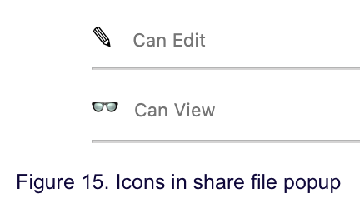The high-fidelity prototype has icons that act as an aid for the user when deciding to interact with the shared icon. It acts as a visual indicator for which button the user must click to perform a certain task in the system. For example, as shown in Figure 14, each button in the navigation bar has icons which indicate their functions. In the share file popup, little icons like the pencil and glasses reinforce to the user where they must enter the names of the people given permission to edit or view the shared files (Figure 15).

***Part 1.3:*** [***Link to prototype screencast***](https://youtu.be/CpvZXEUXStI)

**Part 2. Usage Testing**

***Part 2.1 Test protocol***

Our groups test protocol target users are university students, they are the users who will be best suited for our redesign as they regularly have courseworks and involve multiple use of sharing resources for group projects. Our group will be testing three participants who are university students. Participants were asked to think aloud.

From our usage research data, we can define the primary UX goals for our web interface to include: first, for users to easily recognize that the interface is like Google Drive or Dropbox and is used for sharing different types of files. Second, fast learning for new users because they are familiar with the design as it's similar to other cloud data services that they already used such as google drive. Third, high satisfaction for students leading to them using it more because of ease of use and efficiency as they can easily share different multiple files in one go to one or more users and lastly, low error rate for sharing and  sending files.

Our protocol includes a script which consisted of a greeting, informed consent, task instructions and a questionnaire. Please see Appendix A for the greeting, Appendix B for the informed consent, Appendix C for task instructions and Appendix D for the questionnaire.

The protocol includes a greeting so participants will be introduced to what the usage testing will be about and give them an idea of what will be expected. Next, participants will need to sign a consent form so they know what the usage testing will consist of and if they are comfortable in proceeding. Our usage testing involved a video of their desktop screen while going through our interface and voice recordings which will only be shared to our team. We must let them know and ask for their consent if they are okay with sharing this. Our script also includes 10 task instructions. First, we asked participants to check the webpage and to let us know what they are thinking. We want to know if the user will be able to easily recognize the interface. Second, we asked them to explore the different ‘Projects’. We want to see if the user will know what these are for and if they will be able to easily go back to the homepage. Third, ask them to share a file and see if they will be able to easily locate where the ‘Share’ button is and the messages and subjects they can add with sharing their file. Fourth, fifth and sixth, asking them to add and delete files they have added, we want to see if they can easily recognize and do that with our interface. Also, commenting on the advanced settings and what changes they expect to see. And lastly, asked them what they want to do next after the files they shared have been added to see if they will click send and will easily recognize the ‘Send’ button. Our ‘Back’ button is not functional, and we also want to see if they will automatically click the ‘Back’ button or close the window after. And the last script we used is a questionnaire to collect participants' feedback.

The time to complete each task is timed to one-minute max considering that our prototype is not fully functional and our only focus is for participants to explore the main page and share file functions. Therefore, the number of errors made by the user will be none to three max and as this is a familiar interface design there will also be a low frequency of help or documentation that will be used.

***Part 2.2 Usage Testing results***

The target users for our interface are university students, they are the users who will be best suited for our redesign as they regularly have courseworks and involve multiple use of sharing resources for group projects.Please see Appendix E for the usability tasks and raw data observations from the usage testing. From these data we can also present some quantitative results. Also, please see Appendix F for the questionnaire results from the three university student participants.

|  |  |  |  |  |  |  |  |  |
| --- | --- | --- | --- | --- | --- | --- | --- | --- |
| **Work Role: User Class** | **UX Goal** | **UX Measure** | **Measuring Instrument** | **UX Metric** | **Baseline Level** | **Target Level** | **Observed Results** | **Meet Target?** |
| Student: Casual new user, for regular coursework use | Users recognize or be familiarized that the interface is used for sharing different type of files like Google Drive or Dropbox | Initial user performance | User exploring the homepage section of the website interface | Frequency of help or documentation used | 1 | < 1 | 1 | No |
| Student: Casual new user, for regular coursework use | New users can easily learn and adapt to the interface, ease of use | Initial user performance | Easily finding where the share and send buttons are located. | Average time on task | <5 | < 5 seconds | Around 2 to 3 seconds | Yes |
| Student: Casual new user, for regular coursework use | High student satisfaction | First impression | Questions 1 to Question 11 in Questionnaire. Please see Appendix F for the Questionnaire results. | Average rating across users and across questions | B | Grade B to C  (A being the highest and F for fail) | B | Yes |
| Student: Casual new user, for regular coursework use | Low error rate for sharing and sending files | Initial user performance | Sharing and sending files | Average number of repetitions of failed commands | 0 | <1 | 0 | Yes |

For the usability tasks and raw observations from usage testing, see Appendix E.

For our first hypothesis, user may not be able to recognize that this is a cloud data service such as Google Drive or Dropbox where they can share files. But two out of the three university student participants we had was able to recognize and familiarised that the interface is similar to Google Drive mostly. Participant three even said “it kind of looks like Canvas”. All of them mentioned that the webpage is a bit dull right not and a lot of comments about the interface design and how it can be improved were made, this is not surprising since the interface is not supposed to be fully functional yet except for sharing files.

For our second hypothesis, user should click one of the projects but when they go back to the homepage, they may not go through clicking the ‘Projects ’tabs but instead click the web browsers ‘go back’ arrow. Surprisingly, all participants clicked the hyperlinks of the Project tab. Participant two even commented that they really like it and that it is very useful. They all seem to be very familiar with the tabs. Most participants were also able to recognize what the projects are about and what they mean. Participant one said “I know what you mean by Project 1, 2, 3, and 4”

For our third hypothesis, after the user clicks the ‘Share’ button, they should instantly ‘choose file’ and add a ‘Subject’ and ‘Message’. All participants instantly chose a file and filled out the subject, message, who can view, and who can edit input boxes. But one participant was unsure if they were supposed to put an email for the who can edit and who can view input boxes. Participant two assumed that it would be. This can then be improved by making it more clear as to what users can input by having a text that says “Email”.

For our fourth hypothesis, user may miss the ‘New Section’ to add another file to share because it is hard to see, and it is not obvious that its clickable and functional. Surprisingly, all participants were able to easily find where the new section is located given that it is quite hard to see because of the text size and colour. Participant two said, “the colour is kind of light but it’s okay because I can still see.” Participant three made suggestions that it would be better to have a minimalistic design so a plus symbol might be better. He also added “it’s a bit excessive to be clicking new section/file each time, it would be more efficient to just dump all the files I want to send just like an email”. This is a really good point for improvement, especially for groupworks where there is a lot of files to send. It will save time and improve ease of use.

For our fifth hypothesis, user may miss the ‘Delete Section’ to delete a section to share because it is hard to see, and it is not obvious that its clickable. Similar to adding a ‘New Section’, participants all said that it is easy to find but could be improved and be more minimalistic.

For our sixth hypothesis, user may say that everything they need to share multiple files are already included and will barely need to change any settings. All participants mostly commented on the design and where the advanced setting is located. Participant one said that “it doesn’t look functional, usually there’s a border”, Participant two said “It’s quite good, I like that there’s a pop up window and not a drop down list” and Participant three said “Kind of confusing what it’s for looking at the available options.” With these observation results, advanced settings design should be improved and setting options be made clearer.

For our seventh hypothesis, user will click ‘Send’ button.  After they receive a window message to say their messages have been sent, they may not click ‘Back’ button after and just close the window after or use the web browser's back arrow button. All participants instantly clicked the ‘Send’ button and said they might clicked the ‘Save as Draft’ button if they are not ready to send the files for now. After the participants clicked the ‘Send’ button, a pop-up window message will show up and there is a ‘Back’ button available. Surprisingly, all participants clicked the ‘Back’ button numerous times and waited for what would happen next. In our interface design the back button is not functional.

From the questionnaires, the average interface grade is B which shows participants were pleased with the share and send functionalities of the website. An example from the results is when participant three made a comment and said “Good collaboration, kind of like google drives team drives and straight forward, simple storage area”

Overall, the interface still has a lot of functionality and design improvements that can be made. We can conclude that our website interface design, being a cloud data service such as Google Drive or Dropbox is obvious for most of the participants. And that our redesign made the service better suited for university student groupworks user needs as participants were easily able to navigate through the website and easily share and send multiple files to multiple colleagues or friends at the same time.

**Appendices**

**Appendix A: Greeting**

Hi [user's name]. I'm [your name(s)] with the [project name]. The [project name] is [project description]. Today we are looking for ways to improve the user experience of [name of item being tested]. This is a test of the component; we are not testing you. If you find something difficult to use, chances are that others will as well, so your feedback helps everyone. This test of the component is simply a means of evaluating the component's design and to discover any issues we need to address.

If you feel uncomfortable you can stop at any time during the study.

Please speak all your thoughts aloud as you go through the tasks. This helps us better understand why you are making certain choices. The study will take about [XX] minutes. We will answer any questions you have at the end of the study.

First, we'll need you to sign this Consent Form. [If doing video or audio recording you will want to mention this]. Information gathered today will only be used for research purposes and will be kept secure. Published results of this study will be compiled with other participants and any specific references to participants will be done anonymously. Your privacy is our priority.

Do you have any questions?

Let's get started!

***Reference:***

<https://wiki.fluidproject.org/display/fluid/User+Testing+Protocol#UserTestingProtocol-Greetingscript>

**Appendix B: Informed Consent**

**Informed Consent for Participant of Development Project**

<Name of your development organization> <Date or version number of form> Title of Project: <Project title>

Project team member(s) directly involved: <Team member names> Project manager: <Project manager name>

1. THE PURPOSE OF YOUR PARTICIPATION IN THIS PROJECT As part of the <project title> project, you are invited to participate in evaluating and improving various designs of <name of system or product>, <description of system or product>.
2. PROCEDURES You will be asked to perform a set of tasks using the<name of system or product>. These tasks consist of <description of range of tasks>. Your role in these tests is to help us evaluate the designs. We are not evaluating you or your performance in anyway. As you perform various tasks with the system, your actions and comments will be noted and you will be asked to describe verbally your learning process. You may be asked questions during and after the evaluation in order to clarify our understanding of your evaluation. You may also be asked to fill out a questionnaire relating to your usage of the system. The evaluation session will last no more than four hours, with the typical session being about two hours. The tasks are not very tiring, but you are welcome to take rest breaks as needed. If you prefer, the session may be divided into two shorter sessions.
3. RISKS There are no known risks to the participants of this study.
4. BENEFITS OF THIS PROJECT Your participation in this project will provide information that may be used to improve our designs for <nameofsystem orproduct>. No guarantee of further benefits has been made to encourage you to participate(Change this if a benefit such as a payment or a gift is offered).You are  requested to refrain from discussing the evaluation with other people who might be in the candidate pool from which other participants might be drawn.
5. EXTENT OF ANONYMITY AND CONFIDENTIALITY The results of this study will be kept strictly confidential. Your written consent is required for the researchers to release any data identified with you as an individual to anyone other than personnel working on the project. The information you provide will have your name removed and only a subject number will identify you during analyses and any written reports of the research. The session may be recorded. If it is recorded, the recordings will be stored securely, viewed only by the project team members and erased after three months. If the project team members wish to use a portion of your recording for any other purpose, they will get your written permission before using it. Your signature on this form does not give them permission to show your recording to anyone else.
6. COMPENSATION Your participation is voluntary and unpaid (Change this if a benefit such as a payment or a gift is offered).
7. FREEDOM TO WITHDRAW You are free to withdraw from this study at any time for any reason.
8. APPROVAL OF RESEARCH This research has been approved, as required, by the Institutional Review Board <or the name of your review committee> for projects involving human subjects at <your organization>.
9. PARTICIPANT RESPONSIBILITIES AND PERMISSION I voluntarily agree to participate in this study, and I know of no reason I cannot participate. I havereadandunderstandtheinformedconsentandconditionsofthisproject. I have had all my questions answered. I hereby acknowledge the above and give my voluntary consent for participation in this project. If I participate, I may withdraw at anytime without penalty. I agree to abide by the rules of this project.

Signature Date

Name (please print) Contact: phone or email

***Reference:***

Rex Hartson, The UX Book: Agile UX Designs for a Quality User Experience 2nd Edition  page 499

**Appendix C: Task Instructions**

1. Ask user to download on their desktop three html files and one css file that will be sent to them. These files are named as ‘index.html’, ‘Part-1.2.html’, ‘project1.html’ and ‘style.css’.
2. Ask user to make sure all files are in one folder.
3. Ask user to open the file named index.html.

*Hypothesis:* User may not be able to recognize that this is a cloud data service such as Google Drive or Dropbox, where they can share files. *Task:* Explore the homepage/main page, get first impression.  
*Prompt:* “Check this webpage and let me know what you’re thinking as you do it.”

*Hypothesis:* User should click one of the projects but when they go back to the homepage they may not go through clicking the ‘Projects ’tabs but instead click the web browsers ‘go back’ arrow *Task:* Explore the different Projects, ask user to go back to the homepage.  
*Prompt:* “Let’s say you want to check your Projects.” [Wait for user to click one of the Projects.] “Let’s say you wanted to check another project. How would you do that?”

*Hypothesis:* After the user clicks the ‘Share’ button, they should instantly ‘choose file’ and add a ‘Subject’ and ‘Message’. *Task:* Get user to share a file, have them choose a file. Pause for a second, and then ask them to add a ‘Subject’, ‘Message’. Pause again, then ask them to add who can edit and view the files they have added.  
*Prompt:* “Go ahead and share a file to share to your groupmate/friend” [Wait for user to choose file][if user doesn’t naturally add a subject and message] “What else would you like to share to your friend/groupmate”

*Hypothesis:* User may miss the ‘New Section’ to add another file to share because it’s hard to see and it’s not obvious that its clickable and functional. *Task:* Locate new section to add another file to share.  
*Prompt:* “Let’s say you want to add another file to share?”

*Hypothesis:* User may miss the ‘Delete Section’ to delete a section to share because it’s hard to see and it’s not obvious that its clickable. *Task:* Get user to add four more files to share. Pause for a second, and then ask them to delete a file.  
*Prompt:* “Now let’s say you want to delete a file.”

*Hypothesis:* User may say that everything they need to share multiple files are already included and will barely need to change any settings. *Task:* Prompt user to comment on advanced settings. What changes do they expect?  
*Prompt:* “Did you notice where the advanced settings is and looked for it? What do you think of it?”

*Hypothesis:* User will click ‘Send’ button.  After they receive a window message to say their messages have been sent, they may not click ‘Back’ button after. *Task:* Ask user to send the file/multiple files they have selected.   
*Prompt:* “Let’s say you’ve added all the files you want to share, what do you do next?”

**Appendix D: Questionnaire**

1. What are your overall impressions of the Web site?
2. If you had to give the site a grade, from A to F, where A was exemplary and F was failing, what grade would you give it, and why?
3. Name three words or characteristics that describe this Web site.
4. What are the three things you like best about the Web site?
5. What are the three things you like least about the Web site?
6. If you could make one significant change to this Web site, what change would you make?
7. Would you return to this Web site on your own in the future? Why/why not?
8. What would entice you to return?
9. Are there materials you would like to see added to the Web site? Which ones?
10. Would you recommend this Web site to a colleague? To a friend?
11. Do you have any other questions or comments about the Web site or your experiences with it?

***Reference:***

<https://www.w3.org/WAI/EO/Drafts/UCD/questions.html>

**Appendix E: Usability Tasks and Raw Observations from Usage Testing**

1.

*Hypothesis:* User may not be able to recognize that this is a cloud data service such as Google Drive or Dropbox, where they can share files.

*Task:* Explore the homepage/main page, get first impression.

*Prompt:* “Check this webpage and let me know what you’re thinking as you do it.”

P1: “A bit dull right now.  Not sure what exactly the point of the website yet. Can see different projects, I am assuming it is based on the assignment. Green and blue colour is a good start to an html website, but storage and bin icons are way too close to each other.

P2: “When I hover my mouse over the projects, it becomes prominent, so I know which one I’m clicking. ““Is this supposed to be google drive or something?” “The grey colour of the boxes are not elegant looking and doesn’t match the rest of the colours on the webpage and not consistent” “Project title is too small, better if it’s bigger” “Projects has different colours, what’s the point in that? Is it to tell if one is more finished than the other? Not consistent” “Members size is good but can add a little bit more information if it’s Excel or Word”

P3: “It looks like Canvas, I’m assuming it’s like a creative area where I can share things around. And it looks like One drive kind of and Google drive. Reminds me of Google drive mostly”

2.

*Hypothesis:* User should click one of the projects but when they go back to the homepage they may not go through clicking the ‘Projects ’tabs but instead click the web browsers ‘go back’ arrow

*Task:* Explore the different Projects, ask user to go back to the homepage.

*Prompt:* “Let’s say you want to check your Projects.”

P1: “Not sure what they are referring to after clicking one of the projects, not enough sign posting in the website and needs to be improved. Hard to tell what the website is about. Getting a bit ocd with the lining of the boxes but a good start. I know what you mean by Project 1,2,3 and 4” [Clicked on the ‘Projects’ tab to go back to homepage]

P2: “I like the hyperlinks of the tabs” [Clicked ‘Projects’ to go back to the homepage] ”I really like that” “The list is nice to know which one is which but maybe put a logo as well to know what kind of file it is”

P3: “I’ll go straight to one of the Projects, assume these are folders instead of courses” [After clicking one of the projects] “That was pretty instantaneous, I don’t think it would be that fast usually” ”Usually there would be separation between the two to make it more distinct, like lines” “Good collaboration, kind of like google drives team drives” “Pretty straight forward, simple storage area”

3.

*Hypothesis:* After the user clicks the ‘Share’ button, they should instantly ‘choose file’ and add a ‘Subject’ and ‘Message’.

*Task:* Get user to share a file, have them choose a file. Pause for a second, and then ask them to add a ‘Subject’, ‘Message’. Pause again, then ask them to add who can edit and view the files they have added.

*Prompt:* “Go ahead and share a file to share to your groupmate/friend” [Wait for user to choose file][if user doesn’t naturally add a subject and message] “What else would you like to share to your friend/groupmate”

P1: [P1 instantly filled out the subject, messages and chose a file to share] but user did not add who can view and edit the file but went to add new section right away.

P2: [Filled Can Edit and Can View] “Do we put email or?” [Clicked choose file, filled message]

P3: [Went straight to choosing a file] [Filled Subject] “Edit and View is good you can send them, but I can’t understand why you would have them here on this page. It would normally be inside the project folders and have a share button or add people to the folder” “Oh it’s like email or messenger, can just send to people I get it now.”

4.

*Hypothesis:* User may miss the ‘New Section’ to add another file to share because it’s hard to see and it’s not obvious that its clickable and functional.

*Task:* Locate new section to add another file to share.

*Prompt:* “Let’s say you want to add another file to share?”

P1: [User easily clicked the new section button after filling up the first section]

P2: “Easy to see but colour is kind of light but it’s okay because I can still see”

P3: “Shouldn’t it be called New File?” “Pretty excessive to push new section each time whereas when you’re putting it in an email, sharing a file you can pretty much just highlight all the files and put it in the message area” “It’s pretty straightforward but really slow, I’d just want to dump all the files straight away instead of pushing new section each time” “Plus sign would be better and when you hover it shows a message that says ‘Add New Section’. ”

5.

*Hypothesis:* User may miss the ‘Delete Section’ to delete a section to share because it’s hard to see and it’s not obvious that its clickable.

*Task:* Get user to add four more files to share. Pause for a second, and then ask them to delete a file.

*Prompt:* “Now let’s say you want to delete a file.”

P1: [User easily found the delete section]

P2: “Same for the delete section, easy to see but colour is kind of light but it’s okay because I can still see”

P3: “Straightforward. I’d say you can just put in a rubbish bin sign. Makes the interface for minimal”

6.

*Hypothesis:* User may say that everything they need to share multiple files are already included and will barely need to change any settings.

*Task:* Prompt user to comment on advanced settings. What changes do they expect?

*Prompt:* “Did you notice where the advanced settings are and looked for it? What do you think of it?”

P1: “Doesn’t look functional, usually there’s a border around the advanced settings. Sign posting is missing. Needs a little bit more of colour or something to attract the user to the advanced settings, it’s kind of hidden so I can’t see it properly”

P2: “It’s quite good, I like that there’s a pop up window after I clicked instead of having a list down so it’s not confusing with the files”

P3: “I think I like having advanced section but kind of confusing, cause if you say someone can view and put advanced section, are these added features that like you give them? Because I’d prefer to put advanced settings under who can view and edit area just to go straight to the options instead of going all the way down”

*7.* 

*Hypothesis:* User will click ‘Send’ button.  After they receive a window message to say their messages have been sent, they may not click ‘Back’ button after and just close the window after or use the web browsers back arrow button.

*Task:* Ask user to send the file/multiple files they have selected.

*Prompt:* “Let’s say you’ve added all the files you want to share, what do you do next?”

P1: “I send it. Or save as draft” [After sending, participant instantly clicked the back button numerous of times]

P2: “I Send” [After sending, participant also clicked the back button numerous of times]

P3: “Save as Draft or Send. I’d send it after putting the email” [Again after sending, participant also clicked the back button numerous of times]