**Answers:**

**Chapter 2 : #4**

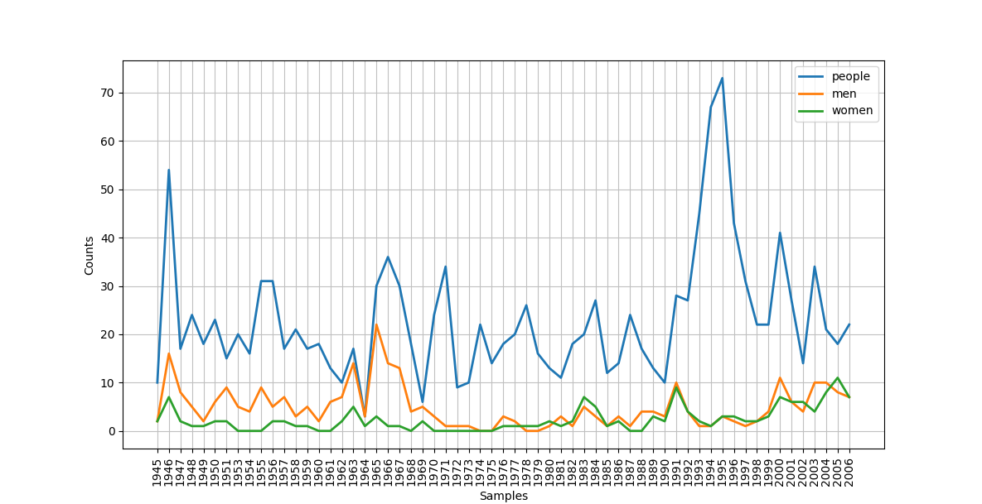

Shortened Tabulated version:

1945 1950 1955 1960 1965 1970 1975 1980 1985 1990 1995 2000 2005

men 2 6 9 2 22 3 0 1 1 3 3 11 8

women 2 2 0 0 3 0 0 2 1 2 3 7 11

people 10 23 31 18 30 24 14 13 12 10 73 41 18

**Chapter 2 : #5**

For noun "tree":

[]

[Synset('burl.n.02'), Synset('crown.n.07'), Synset('limb.n.02'), Synset('stump.n.01'), Synset('trunk.n.01')]

[Synset('heartwood.n.01'), Synset('sapwood.n.01')]

[Synset('forest.n.01')]

[]

[]

For noun "person":

[]

[Synset('human_body.n.01'), Synset('personality.n.01')]

[]

[Synset('people.n.01')]

[]

[]

For noun "dog":

[]

[Synset('flag.n.07')]

[]

[Synset('canis.n.01'), Synset('pack.n.06')]

[]

[]

**Chapter 2 : #7**

Usage of however in Emma

Displaying 25 of 131 matches:

her many enjoyments . The danger , however , was at present so unperceived , t

ion would offend . Miss Churchill , however , being of age , and with the full

n . From the expense of the child , however , he was soon relieved . The boy ha

-- and been very well brought up . However , I do not mean to set up my opinio

f and predict . It was not likely , however , that any body should have equalle

to be borne . We will not despair , however . Weston may grow cross from the wa

is so very handsome and agreeable . However , I do really think Mr . Martin a v

accepted after all . This letter , however , was written , and sealed , and se

e him ." " And if I did , ( which , however , I am far from allowing ) I should

slightingly . Waiving that point , however , and supposing her to be , as you

e was not so materially cast down , however , but that a little time and the re

ld inspire him ." The very next day however produced some proof of inspiration

and staid to look through herself ; however , she called me back presently , an

t turn up . His ostensible reason , however , was to ask whether Mr . Woodhouse

l and cross . This does not apply , however , to Miss Bates ; she is only too g

and sufferings of the poor family , however , were the first subject on meeting

ting for her . She gained on them , however , involuntarily : the child ' s pac

ould close it . It was not closed , however , it still remained ajar ; but by e

believes himself secure ." Still , however , though every thing had not been a

ght advance rapidly if they would , however ; they must advance somehow or othe

offence came not . The beginning , however , of every visit displayed none but

eed !-- and my memory is very bad . However , it was an exceeding good , pretty

first day . Emma ' s sense of right however had decided it ; and besides the co

le fatigued . I could have wished , however , as you know , that you had seen M

" Our little friend Harriet Smith , however , is just such another pretty kind

Usage of however in Leaves

Displaying 12 of 12 matches:

like One including and over all , ( However high the head of any else that head

. Allons ! we must not stop here , However sweet these laid - up stores , howe

ever sweet these laid - up stores , however convenient this dwelling we cannot

is dwelling we cannot remain here , However shelter ' d this port and however c

, However shelter ' d this port and however calm these waters we must not ancho

se waters we must not anchor here , However welcome the hospitality that surrou

and pass it , To conceive no time , however distant , but what you may reach it

ut it stretches and waits for you , however long but it stretches and waits for

, planets , All distances of place however wide , All distances of time , all

hou wouldst not really sell thyself however great the price , In that thou sure

im recesses , Acknowledging rapport however far remov ' d , ( As some old root

n to its divine source and origin , however distant , Latent the same in subjec

**Chapter 2 : #9**

Sense and Sensibility:

Average word length: 4.753785952421314

Average sentence length: 28.32086417283457

Lexical Diversity: 22.11088552241137

Emma:

Average word length: 4.609909212324673

Average sentence length: 24.822884416924666

Lexical Diversity: 26.201933551198255

Use of the word "arm" in both novels:

"Arm" in Sense and Sensibility

Displaying 3 of 3 matches:

er sister ' s chair , and putting one arm round her neck , and one cheek close

Steele , taking her familiarly by the arm --" for I wanted to see you of all th

and Marianne , leaning on Elinor ' s arm , was authorised to walk as long as s

"Arm" in Emma

Displaying 16 of 16 matches:

autiful we thought he looked ! He was arm - in - arm with Mr . Cole ." " This i

thought he looked ! He was arm - in - arm with Mr . Cole ." " This is an allian

u will be so kind as to give her your arm .-- Mr . Elton , and Miss Hawkins !--

could imagine she saw a touch of the arm at this speech , from his wife . " We

em walking up to the house together , arm in arm . She was wanting to see him a

ing up to the house together , arm in arm . She was wanting to see him again ,

ed the other ladies out of the room , arm in arm , with an appearance of good -

other ladies out of the room , arm in arm , with an appearance of good - will h

conservatory without having both his arm and his uncle ' s ! This , you know ,

ost kind . Upon my word , Jane on one arm , and me on the other !-- Stop , stop

urchill , with Harriet leaning on his arm -- actually Harriet !-- A moment suff

ervour as she seized and clung to his arm , with a sensibility amused and delig

ne of my little baskets hanging on my arm . Here ,-- probably this basket with

ne spot . Come , Jane , take my other arm ." Jane declined it , however , and t

ticular interest , till she found her arm drawn within his , and pressed agains

you will not allow yourself --." Her arm was pressed again , as he added , in

**Chapter 2 : #12**

Number of all entries: 133737

Number of distinct words: 123455

Fraction of words with more than one pronunciation: 0.07688223902136282

**Chapter 2 : #17**

50 most occuring words in Emma

['mr', 'emma', 'could', 'would', 'mrs', 'miss', 'must', 'harriet', 'much', 'said', 'one', 'weston', 'every', 'well', 'thing', 'knightley', 'elton', 'think', 'little', 'never', 'good', 'know', 'might', 'woodhouse', 'say', 'jane', 'quite', 'time', 'great', 'nothing', 'dear', 'fairfax', 'always', 'man', 'thought', 'soon', 'churchill', 'see', 'may', 'shall', 'without', 'first', 'frank', 'father', 'sure', 'indeed', 'like', 'made', 'body', 'ever']

50 most occuring words in Hamlet

['ham', 'lord', 'haue', 'king', 'thou', 'shall', 'come', 'let', 'hamlet', 'good', 'hor', 'thy', 'enter', 'oh', 'like', 'would', 'well', 'know', 'tis', 'selfe', 'loue', 'may', 'vs', 'th', 'sir', 'qu', 'laer', 'giue', 'thee', 'ile', 'must', 'hath', 'ophe', 'speake', 'make', 'vpon', 'say', 'doe', 'heere', 'father', 'pol', 'see', 'go', 'one', 'man', 'heauen', 'time', 'mine', 'much', 'thinke']

**Chapter 2 : #18**

50 most occuring bigrams in Emma

[('Miss', 'Woodhouse'), ('Frank', 'Churchill'), ('Miss', 'Fairfax'), ('I', 'shall'), ('every', 'thing'), ('Miss', 'Bates'), ('Jane', 'Fairfax'), ('I', 'think'), ('every', 'body'), ('I', 'hope'), ('I', 'could'), ('I', 'must'), ('young', 'man'), ('I', 'cannot'), ('great', 'deal'), ('I', 'would'), ('Emma', 'could'), ('said', 'Emma'), ('I', 'know'), ('Miss', 'Smith'), ('John', 'Knightley'), ('I', 'never'), ('I', 'dare'), ('dare', 'say'), ('Miss', 'Taylor'), ('I', 'assure'), ('I', 'believe'), ('But', 'I'), ('My', 'dear'), ('said', 'Mr'), ('I', 'thought'), ('I', 'suppose'), ('She', 'could'), ('I', 'wish'), ('dear', 'Emma'), ('Harriet', 'Smith'), ('Robert', 'Martin'), ('Maple', 'Grove'), ('It', 'would'), ('Colonel', 'Campbell'), ('cried', 'Emma'), ('She', 'would'), ('And', 'I'), ('young', 'woman'), ('young', 'lady'), ('body', 'else'), ('If', 'I'), ('She', 'must'), ('I', 'always'), ('good', 'deal')]

50 most occuring bigrams in Hamlet

[('I', 'haue'), ('Lord', 'Ham'), ('My', 'Lord'), ('I', 'know'), ('I', 'pray'), ('That', 'I'), ('I', 'shall'), ('Enter', 'King'), ('haue', 'seene'), ('I', 'must'), ('And', 'let'), ('I', 'would'), ('Lord', 'Hamlet'), ('Enter', 'Hamlet'), ('I', 'thinke'), ('st', 'thou'), ('good', 'Lord'), ('I', 'saw'), ('I', 'could'), ('I', 'cannot'), ('And', 'I'), ('thou', 'hast'), ('Enter', 'Polonius'), ('Lord', 'Polon'), ('Fathers', 'death'), ('If', 'thou'), ('I', 'see'), ('The', 'King'), ('I', 'doe'), ('Ile', 'haue'), ('mine', 'owne'), ('haue', 'heard'), ('To', 'giue'), ('Enter', 'Horatio'), ('let', 'vs'), ('thou', 'art'), ('haue', 'I'), ('What', 'would'), ('As', 'I'), ('You', 'must'), ('wilt', 'thou'), ('shall', 'I'), ('And', 'thus'), ('set', 'downe'), ('I', 'hope'), ('Hamlet', 'Ham'), ('thinke', 'I'), ('thy', 'selfe'), ('Father', 'lost'), ('Enter', 'Ghost')]

**Chapter 2 : #23**

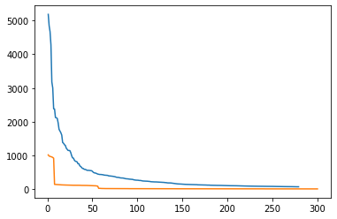

**Chapter 2 : #27**

Average polysemy for nouns: 1.2833560159282222

Average polysemy for verbs: 2.1866273523545225

Average polysemy for adjectives: 1.4104837960813446

Average polysemy for adverbs: 1.2532916759651864

**Chapter 3: #20**

The opening text from a book I enjoyed called Daisy Miller

'At the little town of Vevey, in Switzerland, there is a particularly\r\ncomfortable hotel. There are, indeed, many hotels, for the entertainment\r\nof tourists is the business of the place, which, as many travelers will\r\nremember, is seated upon the edge of a remarkably blue lake--a lake that\r\nit behooves every tourist to visit.'

**Chapter 3: #20**

'Home - BBC News Homepage Accessibility links Skip to content Accessibility Help BBC Account Notifications Home News Sport Weather iPlayer Sounds CBBC CBeebies Food Bitesize Arts Taster Local Three Menu Search Search the BBC Search the BBC BBC News News Navigation Sections Home Home selected Coronavirus Video World US & Canada UK Business Tech Science Stories Entertainment & Arts Health In Pictures Reality Check World News TV Newsbeat Long Reads More More sections Home Home selected Coronavirus Coronavirus Home Your Coronavirus Stories Video World World Home Africa Asia Australia Europe Latin America Middle East US & Canada UK UK Home England N. Ireland Scotland Wales Local News Business Business Home Market Data New Economy New Tech Economy Companies Entrepreneurship Technology of Business Economy CEO Secrets Global Car Industry Business of Sport Tech Science Stories Entertainment & Arts Health Health Home Coronavirus In Pictures Reality Check World News TV Newsbeat Long Reads BBC News'

**Chapter 6: #4**

Most Informative Features

contains(unimaginative) = True neg : pos = 7.6 : 1.0

contains(schumacher) = True neg : pos = 7.3 : 1.0

contains(suvari) = True neg : pos = 6.9 : 1.0

contains(mena) = True neg : pos = 6.9 : 1.0

contains(atrocious) = True neg : pos = 6.5 : 1.0

contains(singers) = True pos : neg = 6.4 : 1.0

contains(miscast) = True neg : pos = 6.1 : 1.0

contains(awful) = True neg : pos = 5.9 : 1.0

contains(unravel) = True pos : neg = 5.7 : 1.0

contains(turkey) = True neg : pos = 5.6 : 1.0

contains(bronson) = True neg : pos = 5.6 : 1.0

contains(underwood) = True neg : pos = 5.6 : 1.0

contains(canyon) = True neg : pos = 5.6 : 1.0

contains(everyday) = True pos : neg = 5.5 : 1.0

contains(ugh) = True neg : pos = 5.3 : 1.0

contains(justin) = True neg : pos = 5.3 : 1.0

contains(wasted) = True neg : pos = 5.2 : 1.0

contains(poorly) = True neg : pos = 5.2 : 1.0

contains(ridiculous) = True neg : pos = 5.1 : 1.0

contains(fluffy) = True pos : neg = 5.1 : 1.0

contains(sorrow) = True pos : neg = 5.1 : 1.0

contains(welles) = True neg : pos = 4.9 : 1.0

contains(surveillance) = True neg : pos = 4.9 : 1.0

contains(stretched) = True neg : pos = 4.9 : 1.0

contains(waste) = True neg : pos = 4.9 : 1.0

contains(temper) = True pos : neg = 4.6 : 1.0

contains(martian) = True neg : pos = 4.6 : 1.0

contains(sexist) = True neg : pos = 4.6 : 1.0

contains(kudos) = True pos : neg = 4.5 : 1.0

contains(sandler) = True neg : pos = 4.4 : 1.0