IEEE 118 Bus System

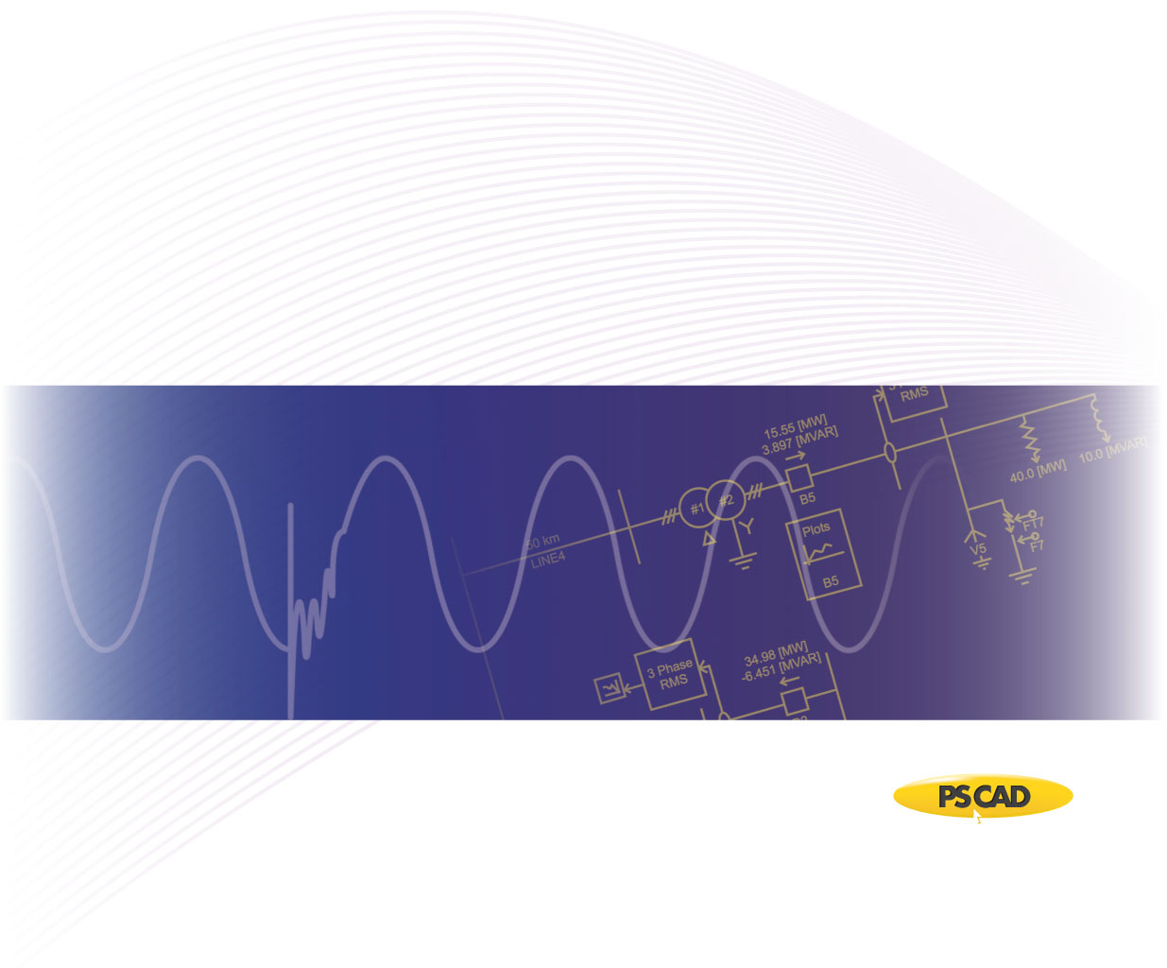

PSCAD

Author:

Date: December 30th, 2014

Revision: 0.00

Objective

IEEE bus systems are used by researchers to implement new ideas and concepts. This technical note describes the details of the IEEE 118-bus system [1]. The system consists of loads, capacitor banks, transmission lines, and generators. Figure 1 depicts a part of the PSCAD model of the IEEE 118-bus system.



Figure 1 – PSCAD Model of IEEE 118-bus system

Each machine (generator) is represented as a voltage source where its source impedance is set arbitarily as 1 Ohm. Table 1 summarizes the setting for each source, with a base of 100 [MVA] for per unitizing.

Table 1 - Terminal conditions of IEEE 118-bus system

|  |  |  |  |  |
| --- | --- | --- | --- | --- |
| **Bus** | **V [pu]** | **δ [deg]** | **P [pu]** | **Q [pu]** |
| 31 | 0.9989 | -24.69 | 0.30 | 0.1200 |
| 113 | 1.0206 | -21.32 | 1.00 | -0.3000 |
| 32 | 1.0121 | -23.46 | 1.00 | 0.3000 |
| 12 | 1.0249 | -25.37 | 3.00 | 1.2000 |
| 72 | 1.0200 | -8.060 | 0.30 | -0.0776 |
| 65 | 1.0400 | 0.000 | 5.47 | 0.3994 |
| 34 | 1.0188 | -16.52 | 0.30 | 0.1500 |
| 73 | 1.0321 | -2.630 | 0.30 | 0.1200 |
| 70 | 1.0177 | -2.880 | 0.80 | 0.3200 |
| 36 | 1.0226 | -16.10 | 1.00 | 0.3000 |
| 46 | 1.0200 | -1.770 | 1.00 | -0.0639 |
| 76 | 0.9962 | 1.200 | 1.00 | 0.3000 |
| 77 | 1.0084 | 3.550 | 1.00 | 0.3000 |
| 40 | 0.9980 | -14.83 | 0.30 | 0.1500 |
| 80 | 1.0200 | 4.620 | 3.00 | 0.2613 |
| 92 | 1.0300 | 21.55 | 3.00 | -0.3155 |
| 110 | 1.0270 | 24.08 | 0.50 | 0.2300 |
| 100 | 1.0300 | 18.78 | 3.00 | 0.6672 |
| 54 | 1.0300 | -4.150 | 2.50 | 0.7249 |
| 112 | 1.0400 | 26.74 | 1.00 | 0.0360 |
| 105 | 1.0172 | 20.41 | 1.00 | 0.2300 |
| 107 | 1.0196 | 19.25 | 0.20 | 0.1500 |

Transmission lines are modelled using the Bergeron model. Table 2 summarizes part of the transmission line parameters of the IEEE 118-bus system.

Table 2 - Transmission line characteristics of IEEE 118-bus system (for complete list, see [1])

|  |  |  |  |  |
| --- | --- | --- | --- | --- |
| **Line** | | **R [pu/m]** | **X [pu/m]** | **B [pu/m]** |
| **From Bus** | **To Bus** |
| 1 | 2 | 0.03030 | 0.09990 | 0.02540 |
| 1 | 3 | 0.01290 | 0.04240 | 0.01082 |
| 2 | 12 | 0.01870 | 0.06160 | 0.01572 |
| 3 | 12 | 0.04840 | 0.16000 | 0.04060 |
| 3 | 5 | 0.02410 | 0.10800 | 0.02840 |
| 4 | 11 | 0.02090 | 0.06880 | 0.01748 |
| 4 | 5 | 0.00176 | 0.00798 | 0.00210 |
| 5 | 6 | 0.01190 | 0.05400 | 0.01426 |
| 5 | 11 | 0.02030 | 0.06820 | 0.01738 |
| 6 | 7 | 0.00459 | 0.02080 | 0.00550 |
| 7 | 12 | 0.00862 | 0.03400 | 0.00874 |
| 8 | 30 | 0.00431 | 0.05040 | 0.51400 |
| 31 | 17 | 0.04740 | 0.15630 | 0.03990 |
| 31 | 32 | 0.02980 | 0.09850 | 0.02510 |
| 31 | 29 | 0.01080 | 0.03310 | 0.00830 |
| 29 | 28 | 0.02370 | 0.09430 | 0.02380 |
| 28 | 27 | 0.01913 | 0.08550 | 0.02160 |
| 27 | 32 | 0.02290 | 0.07550 | 0.01926 |
| 27 | 115 | 0.01640 | 0.07410 | 0.01972 |
| 27 | 25 | 0.03180 | 0.16300 | 0.17640 |
| 115 | 114 | 0.00230 | 0.01040 | 0.00276 |
| 114 | 32 | 0.01350 | 0.06120 | 0.01628 |
| 32 | 113 | 0.06150 | 0.20300 | 0.05180 |
| 23 | 24 | 0.01350 | 0.04920 | 0.04980 |
| 23 | 22 | 0.03420 | 0.15900 | 0.04040 |
| 23 | 25 | 0.01560 | 0.08000 | 0.08640 |
| 12 | 14 | 0.02150 | 0.07070 | 0.01816 |
| 14 | 15 | 0.05950 | 0.19500 | 0.05020 |
| 12 | 16 | 0.02120 | 0.08340 | 0.02140 |
| 12 | 117 | 0.03290 | 0.14000 | 0.03580 |
| 15 | 17 | 0.01320 | 0.04370 | 0.04440 |
| 17 | 18 | 0.01230 | 0.05050 | 0.01298 |

Loads are modelled as a constant PQ load and part of the load parameters are shown in Table 3.

Table 3 - Load characteristics of IEEE 118-bus system (for complete list, see [1])

|  |  |  |
| --- | --- | --- |
| **Bus** | **P [pu]** | **Q [pu]** |
| 1 | 0.5414 | 0.0866 |
| 3 | 0.4140 | 0.1062 |
| 2 | 0.2123 | 0.0955 |
| 117 | 0.2123 | 0.0849 |
| 12 | 0.4989 | 0.1062 |
| 11 | 0.7431 | 0.2442 |
| 16 | 0.2654 | 0.1062 |
| 18 | 0.6369 | 0.3609 |
| 20 | 0.1911 | 0.0318 |
| 21 | 0.1486 | 0.0849 |
| 22 | 0.1062 | 0.0531 |
| 23 | 0.0743 | 0.0318 |
| 70 | 0.6600 | 0.2000 |
| 74 | 0.6800 | 0.2700 |
| 75 | 0.4700 | 0.1100 |
| 118 | 0.3300 | 0.1500 |
| 76 | 0.6800 | 0.3600 |
| 78 | 0.7100 | 0.2600 |
| 79 | 0.3900 | 0.3200 |

Validation

The PSCAD model was validated against the PSS/E power flow values from [1]. Table 4 depicts part of the line and source power flow comparison.

Table 4 - Source and line power comparison of IEEE 118-bus system

|  |  |  |  |  |  |
| --- | --- | --- | --- | --- | --- |
| **Bus** | | **PSS/E** | | **PSCAD** | |
| **P [pu]** | **Q [pu]** | **P [pu]** | **Q [pu]** |
| 31 | | 0.30 | 0.1200 | 0.3004 | 0.1201 |
| 113 | | 1.00 | -0.3000 | 1.0000 | -0.2990 |
| 32 | | 1.00 | 0.3000 | 1.0010 | 0.3000 |
| 12 | | 3.00 | 1.2000 | 3.0010 | 1.2010 |
| 72 | | 0.30 | -0.0776 | 0.3001 | -0.0773 |
| 65 | | 5.47 | 0.3994 | 5.4680 | 0.3973 |
| 34 | | 0.30 | 0.1500 | 0.3000 | 0.1500 |
| 73 | | 0.30 | 0.1200 | 0.3000 | 0.1200 |
| 70 | | 0.80 | 0.3200 | 0.8003 | 0.3198 |
| 36 | | 1.00 | 0.3000 | 1.0000 | 0.2999 |
| **From Bus** | **To Bus** |  | | | |
| 2 | 1 | 0.291 | 0.052 | 0.2910 | 0.0520 |
| 3 | 1 | 0.250 | 0.034 | 0.2500 | 0.0340 |
| 12 | 2 | 0.506 | 0.131 | 0.5060 | 0.1310 |
| 12 | 3 | 0.310 | 0.083 | 0.3102 | 0.0826 |
| 5 | 3 | 0.355 | 0.050 | 0.3547 | 0.0498 |
| 4 | 11 | 0.029 | -0.032 | 0.0292 | -0.0320 |
| 5 | 4 | 0.348 | 0.096 | 0.3478 | 0.0955 |
| 5 | 6 | 0.237 | 0.022 | 0.2372 | 0.0218 |
| 11 | 5 | 0.071 | 0.024 | 0.0705 | 0.0239 |
| 7 | 6 | 0.315 | 0.200 | 0.3156 | 0.2003 |
| 12 | 7 | 0.518 | 0.219 | 0.5179 | 0.2187 |
| 30 | 8 | 1.014 | 0.127 | 1.0140 | 0.1271 |
| 17 | 30 | 0.237 | 0.088 | 0.2367 | 0.0876 |
| 32 | 31 | 0.239 | 0.072 | 0.2386 | 0.0719 |
| 31 | 29 | 0.319 | -0.007 | 0.3191 | -0.0070 |
| 29 | 28 | 0.063 | -0.045 | 0.0631 | -0.0447 |
| 27 | 28 | 0.118 | 0.096 | 0.1176 | 0.0958 |
| 27 | 32 | -0.395 | 0.046 | -0.3952 | 0.0459 |
| 27 | 115 | -0.059 | 0.043 | -0.0595 | 0.0430 |
| 25 | 27 | 0.322 | 0.151 | 0.3217 | 0.1506 |
| 114 | 115 | 0.293 | 0.012 | 0.2932 | 0.0121 |
| 32 | 114 | 0.378 | 0.042 | 0.3783 | 0.0420 |
| 113 | 32 | 0.185 | 0.009 | 0.1850 | 0.0092 |
| 23 | 24 | -1.301 | 0.289 | -1.3010 | 0.2885 |
| 23 | 22 | 0.328 | 0.062 | 0.3284 | 0.0623 |
| 23 | 25 | 0.431 | -0.255 | 0.4312 | -0.2547 |
| 12 | 14 | 0.073 | 0.091 | 0.0729 | 0.0907 |
| 14 | 15 | -0.076 | 0.098 | -0.0761 | 0.0978 |
| 12 | 16 | 0.019 | 0.097 | 0.0194 | 0.0971 |
| 12 | 117 | 0.214 | 0.055 | 0.2140 | 0.0547 |
| 17 | 15 | 0.704 | 0.347 | 0.7037 | 0.3471 |
| 17 | 18 | 0.569 | 0.403 | 0.5695 | 0.4031 |

PSCAD Case Set-up Instructions

Dependencies

This example is compatible with PSCAD v4.5.3 and beyond.

The files required to run the tutorial are as follows:

* New_IEEE_118_CT.pscx

Future updates to the system model

* Replace the voltage sources with detailed machine models for dynamic analysis.
* Update short circuit levels of each source to represent specific system strengths.

Technical References

[1] [Online]. Available FTP: <http://psdyn.ece.wisc.edu/IEEE_benchmarks>

[2] <http://sas.ieee.ca/pesias/seminar_slides/IEEE_PES-IAS_Chapter_24_01_13.pdf>

Appendix A

The line resistances and reactances are provided in [1] for each line segment of the test system. The following table lists the approximate line lengths of part of the segments, based on typical line data (as listed in Table A-2).

Table A-1- Approximate line lengths based on typical line reactance values as shown in Table A-2

|  |  |  |  |
| --- | --- | --- | --- |
| **From Bus** | **To Bus** | **Total Reactance (Ω)** | **Approximate length of the line based on typical line reactance values (km)** |
| 1 | 2 | 19.0249 | 38.0499 |
| 1 | 3 | 8.07465 | 16.1493 |
| 2 | 12 | 11.7311 | 23.4622 |
| 3 | 12 | 30.4704 | 60.9408 |
| 3 | 5 | 20.5675 | 41.1350 |
| 4 | 11 | 13.1023 | 26.2045 |
| 4 | 5 | 1.51971 | 3.03942 |
| 5 | 6 | 10.2838 | 20.5675 |
| 5 | 11 | 12.9880 | 25.9760 |
| 6 | 7 | 3.96115 | 7.92230 |
| 7 | 12 | 6.47496 | 12.9499 |
| 8 | 30 | 59.9886 | 199.962 |
| 31 | 17 | 29.7658 | 59.5315 |
| 31 | 32 | 18.7583 | 37.5166 |
| 31 | 29 | 6.30356 | 12.6071 |
| 29 | 28 | 17.9585 | 35.9169 |
| 28 | 27 | 16.2826 | 32.5652 |
| 27 | 32 | 14.3782 | 28.7564 |
| 27 | 115 | 14.1116 | 28.2232 |
| 27 | 25 | 31.0417 | 62.0834 |
| 115 | 114 | 1.98058 | 3.96115 |
| 114 | 32 | 11.6549 | 23.3099 |
| 32 | 113 | 38.6593 | 77.3186 |
| 23 | 24 | 9.3696 | 18.7393 |
| 23 | 22 | 30.2799 | 60.5599 |
| 23 | 25 | 15.2352 | 30.4704 |
| 12 | 14 | 13.4641 | 26.9282 |
| 14 | 15 | 37.1358 | 74.2716 |
| 12 | 16 | 15.8827 | 31.7654 |
| 12 | 117 | 26.6616 | 53.3232 |
| 15 | 17 | 8.32223 | 16.6444 |
| 17 | 18 | 9.61722 | 19.2344 |

Table A-2- Typical line reactance values

|  |  |  |
| --- | --- | --- |
| **Voltage (kV)** | **R(Ω/km)** | **X(Ω/km)** |
| 72 | 0.41 | 0.5 |
| 138 | 0.14 | 0.5 |
| 230 (single) | 0.09 | 0.5 |
| 230 (bundled) | 0.04 | 0.4 |
| 345 (bundled) | 0.03 | 0.3 |
| 500 (bundled) | 0.02 | 0.3 |