IEEE 14 Bus System

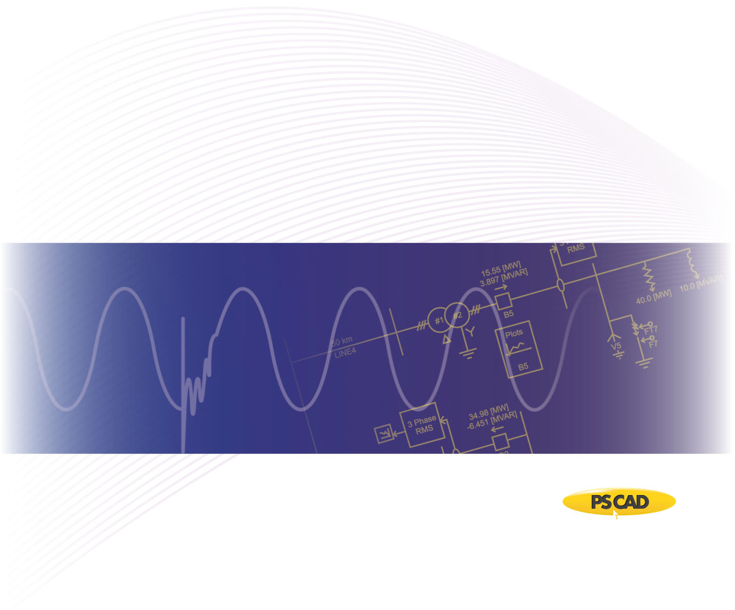

PSCAD

Author:

Date: December 30th, 2014

Revision: 0.00

Objective

IEEE bus systems are used by researchers to implement new ideas and concepts. This Technical Note describes the details of the IEEE 14-bus system [1]. The system consists of loads, capacitor banks, transmission lines, and generators as shown in Figure 1.



Figure 1 - PSCAD Model of the IEEE 14-bus system

Each machine (generator) is represented as a voltage source where its source impedance is set arbitrarily as 10 Ohms. Table 1 summarizes the characteristics of each source, with a base of 100 [MVA] for per unitizing.

Table 1 - Teminal conditions of IEEE 14-bus system

|  |  |  |  |  |
| --- | --- | --- | --- | --- |
| **Bus** | **V kV]** | **δ [deg]** | **P [pu]** | **Q [pu]** |
| 1 | 146.28 | 0.0000 | 2.3239 | -0.1655 |
| 2 | 144.21 | -4.9826 | 0.4000 | 0.4356 |
| 3 | 139.38 | -12.7250 | 0.0000 | 0.2508 |
| 6 | 147.66 | -14.2209 | 0.0000 | 0.1273 |
| 8 | 150.42 | -13.3596 | 0.0000 | 0.1762 |

Transmission lines are modelled using the Bergeron model. Table 2 summarizes the transmission line parameters.

Table 2 - Transmission line characteristics of IEEE 14-bus system

|  |  |  |  |  |
| --- | --- | --- | --- | --- |
| **Line** | | **R [pu/m]** | **X [pu/m]** | **B [pu/m]** |
| **From Bus** | **To Bus** |
| 1 | 2 | 1.94E-07 | 5.92E-07 | 5.28E-07 |
| 1 | 5 | 5.40E-07 | 2.23E-06 | 4.92E-07 |
| 2 | 3 | 4.70E-07 | 1.98E-06 | 4.38E-07 |
| 2 | 4 | 5.81E-07 | 1.76E-06 | 3.40E-07 |
| 2 | 5 | 5.70E-07 | 1.74E-06 | 3.46E-07 |
| 3 | 4 | 6.70E-07 | 1.71E-06 | 1.28E-07 |
| 4 | 5 | 1.34E-07 | 4.21E-07 | 1.00E-09 |
| 6 | 11 | 9.50E-07 | 1.99E-06 | 1.00E-09 |
| 6 | 12 | 1.23E-06 | 2.56E-06 | 1.00E-09 |
| 6 | 13 | 6.62E-07 | 1.30E-06 | 1.00E-09 |
| 7 | 8 | 1.00E-09 | 1.76E-06 | 1.00E-09 |
| 7 | 9 | 1.00E-09 | 1.10E-06 | 1.00E-09 |
| 9 | 10 | 3.18E-07 | 8.45E-07 | 1.00E-09 |
| 9 | 14 | 1.27E-06 | 2.70E-06 | 1.00E-09 |
| 10 | 11 | 8.21E-07 | 1.92E-06 | 1.00E-09 |
| 12 | 13 | 2.21E-06 | 2.00E-06 | 1.00E-09 |
| 13 | 14 | 1.71E-06 | 3.48E-06 | 1.00E-09 |

Loads are modelled as a constant PQ load with parameters as shown in Table 3.

Table 3 - Load characteristics of IEEE 14-bus system

|  |  |  |
| --- | --- | --- |
| **Bus** | **P [pu]** | **Q [pu]** |
| 2 | 0.217 | 0.127 |
| 3 | 0.942 | 0.190 |
| 4 | 0.478 | -0.039 |
| 5 | 0.076 | 0.016 |
| 6 | 0.112 | 0.075 |
| 9 | 0.295 | 0.166 |
| 10 | 0.090 | 0.058 |
| 11 | 0.035 | 0.018 |
| 12 | 0.061 | 0.016 |
| 13 | 0.135 | 0.058 |
| 14 | 0.149 | 0.050 |

Validation

The PSCAD model was validated against the PSS/E power flow values from [1]. Table 4 depicts the line and source power flow comparison.

Table 4 - Source and line power comparison of IEEE 14-bus system

|  |  |  |  |  |  |
| --- | --- | --- | --- | --- | --- |
| **Bus** | | **PSS/E** | | **PSCAD** | |
| **P [pu]** | **Q [pu]** | **P [pu]** | **Q [pu]** |
| 1 | | 2.324 | -0.165 | 2.3230 | -0.1548 |
| 2 | | 0.400 | 0.436 | 0.3995 | 0.4493 |
| 3 | | 0.000 | 0.251 | 0.0007 | 0.2613 |
| 6 | | 0.000 | 0.127 | 0.0020 | 0.1498 |
| 8 | | 0.000 | 0.176 | -0.0011 | 0.1896 |
| **From Bus** | **To Bus** |  | | | |
| 1 | 2 | 1.569 | -0.204 | 1.5690 | -0.2005 |
| 1 | 5 | 0.755 | 0.039 | 0.7543 | 0.0450 |
| 2 | 3 | 0.709 | -0.016 | 0.7096 | -0.0164 |
| 2 | 4 | 0.561 | -0.030 | 0.5606 | -0.0209 |
| 2 | 5 | 0.406 | 0.012 | 0.4043 | 0.0165 |
| 3 | 4 | 0.237 | -0.048 | 0.2354 | -0.0540 |
| 4 | 5 | 0.612 | -0.158 | 0.6130 | -0.1750 |
| 6 | 11 | 0.074 | 0.034 | 0.0747 | 0.0384 |
| 6 | 12 | 0.078 | 0.025 | 0.0781 | 0.0253 |
| 6 | 13 | 0.177 | 0.072 | 0.1782 | 0.0740 |
| 7 | 8 | 0.000 | 0.176 | 0.0011 | 0.1844 |
| 7 | 9 | 0.281 | 0.050 | 0.2793 | -0.0539 |
| 9 | 10 | 0.052 | 0.042 | 0.0511 | 0.0380 |
| 9 | 14 | 0.093 | 0.034 | 0.0878 | 0.0217 |
| 10 | 11 | 0.038 | 0.016 | 0.0390 | 0.0200 |
| 12 | 13 | 0.016 | 0.008 | 0.0166 | 0.0080 |
| 13 | 14 | 0.056 | 0.017 | 0.0568 | 0.0188 |

Set-up Instructions

Dependencies

This example is compatible with PSCAD v4.5.3 and beyond.

The files required to run the tutorial are as follows:

* New_IEEE_14_CT.pscx

Future updates to the system model

* Replace the voltage sources with detailed machine models for dynamic analysis.
* Update short circuit levels of each source to represent specific system strengths.

Technical References

[1] Illinois Center for a Smarter Electric Grid. (2013). [Online]. Available FTP: <http://publish.illinois.edu/smartergrid/>

[2] <http://sas.ieee.ca/pesias/seminar_slides/IEEE_PES-IAS_Chapter_24_01_13.pdf>

Appendix 1

The line resistances and reactances are provided in [1] for each line segment of the test system. The following table lists the approximate line length of each segment, based on typical line data (as listed in Table A-2).

Table A-1- Approximate line lengths based on typical line reactance values as shown in Table A-2

|  |  |  |  |
| --- | --- | --- | --- |
| **From Bus** | **To**  **Bus** | **Total Reactance (Ω)** | **Approximate length of the line based on typical line reactance values (km)** |
| 1 | 2 | 1.13E+01 | 2.25E+01 |
| 1 | 5 | 4.25E+01 | 8.49E+01 |
| 2 | 3 | 3.77E+01 | 7.54E+01 |
| 2 | 4 | 3.35E+01 | 6.70E+01 |
| 2 | 5 | 3.31E+01 | 6.63E+01 |
| 3 | 4 | 3.26E+01 | 6.51E+01 |
| 4 | 5 | 8.02E+00 | 1.60E+01 |
| 6 | 11 | 3.79E+01 | 7.58E+01 |
| 6 | 12 | 4.88E+01 | 9.75E+01 |
| 6 | 13 | 2.48E+01 | 4.95E+01 |
| 7 | 8 | 3.35E+01 | 6.70E+01 |
| 7 | 9 | 2.09E+01 | 4.19E+01 |
| 9 | 10 | 1.61E+01 | 3.22E+01 |
| 9 | 14 | 5.14E+01 | 1.03E+02 |
| 10 | 11 | 3.66E+01 | 7.31E+01 |
| 12 | 13 | 3.81E+01 | 7.62E+01 |
| 13 | 14 | 6.63E+01 | 1.33E+02 |

Table A-2- Typical line reactance values

|  |  |  |
| --- | --- | --- |
| **Voltage (kV)** | **R(Ω/km)** | **X(Ω/km)** |
| 72 | 0.41 | 0.5 |
| 138 | 0.14 | 0.5 |
| 230 (single) | 0.09 | 0.5 |
| 230 (bundled) | 0.04 | 0.4 |
| 345 (bundled) | 0.03 | 0.3 |
| 500 (bundled) | 0.02 | 0.3 |