IEEE 30 Bus System

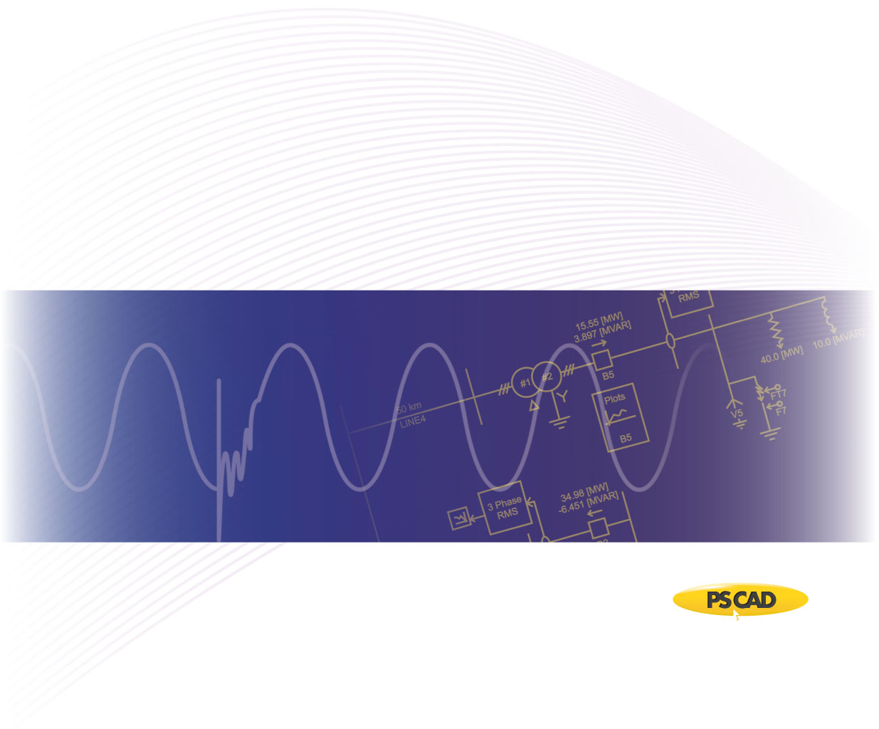

PSCAD

Author:

Date: December 30th, 2014

Revision: 0.00

Objective

IEEE bus systems are used by researchers to implement new ideas and concepts. This technical note describes the details of the IEEE 30-bus system [1]. The system consists of loads, capacitor banks, transmission lines, and generators. Figure 1 depicts a part of the PSCAD model of the IEEE 30-bus system.



Figure 1 - PSCAD Model of IEEE 30-bus system

Each machine (generator) is represented as a voltage source where its source impedance is set arbitrarily as 10 Ohms. Table 1 summarizes the characteristics of each source, with a base of 100 [MVA] for per unitizing.

Table 1 - Terminal Conditions of IEEE 30-bus system

|  |  |  |  |  |
| --- | --- | --- | --- | --- |
| **Bus** | **V [kV]** | **δ [deg]** | **P [pu]** | **Q [pu]** |
| 1 | 139.9200 | 98.4316 | 2.6095 | -0.1679 |
| 2 | 137.6932 | 93.0798 | 0.4000 | 0.5000 |
| 5 | 133.4520 | 84.2658 | 0.0000 | 0.3685 |
| 8 | 133.3200 | 86.6183 | 0.0000 | 0.3714 |
| 11 | 35.7060 | 84.3227 | 0.0000 | 0.1617 |
| 13 | 35.3430 | 83.4883 | 0.0000 | 0.1062 |

Transmission lines are modelled using the Bergeron model. Table 2 summarizes the transmission line parameters.

Table 2 - Transmission line characteristics of IEEE 30-bus system

|  |  |  |  |  |
| --- | --- | --- | --- | --- |
| **Line** | | **R [pu/m]** | **X [pu/m]** | **B [pu/m]** |
| **From Bus** | **To Bus** |
| 1 | 2 | 1.92E-07 | 5.75E-07 | 5.28E-07 |
| 1 | 3 | 4.52E-07 | 1.65E-06 | 4.08E-07 |
| 2 | 4 | 5.70E-07 | 1.74E-06 | 3.68E-07 |
| 2 | 5 | 4.72E-07 | 1.98E-06 | 4.18E-07 |
| 2 | 6 | 5.81E-07 | 1.76E-06 | 3.74E-07 |
| 3 | 4 | 1.32E-07 | 3.79E-07 | 8.40E-08 |
| 4 | 6 | 1.19E-07 | 4.14E-07 | 9.00E-08 |
| 5 | 7 | 4.60E-07 | 1.16E-06 | 2.04E-07 |
| 6 | 7 | 2.67E-07 | 8.20E-07 | 1.70E-07 |
| 6 | 8 | 1.20E-07 | 4.20E-07 | 9.00E-08 |
| 6 | 28 | 1.69E-07 | 5.99E-07 | 1.30E-07 |
| 8 | 28 | 6.36E-07 | 2.00E-06 | 4.28E-07 |
| 9 | 10 | 1.00E-09 | 1.10E-06 | 1.00E-09 |
| 9 | 11 | 1.00E-09 | 2.08E-06 | 1.00E-09 |
| 10 | 17 | 3.24E-07 | 8.45E-07 | 1.00E-09 |
| 10 | 20 | 9.36E-07 | 2.09E-06 | 1.00E-09 |
| 10 | 21 | 3.48E-07 | 7.49E-07 | 1.00E-09 |
| 10 | 22 | 7.27E-07 | 1.50E-06 | 1.00E-09 |
| 12 | 13 | 1.00E-09 | 1.40E-06 | 1.00E-09 |
| 12 | 14 | 1.23E-06 | 2.56E-06 | 1.00E-09 |
| 12 | 15 | 6.62E-07 | 1.30E-06 | 1.00E-09 |
| 12 | 16 | 9.45E-07 | 1.99E-06 | 1.00E-09 |
| 14 | 15 | 2.21E-06 | 2.00E-06 | 1.00E-09 |
| 15 | 18 | 1.07E-06 | 2.19E-06 | 1.00E-09 |
| 15 | 23 | 1.00E-06 | 2.02E-06 | 1.00E-09 |
| 16 | 17 | 5.24E-07 | 1.92E-06 | 1.00E-09 |
| 18 | 19 | 6.39E-07 | 1.29E-06 | 1.00E-09 |
| 19 | 20 | 3.40E-07 | 6.80E-07 | 1.00E-09 |
| 21 | 22 | 1.16E-07 | 2.36E-07 | 1.00E-09 |
| 22 | 24 | 1.15E-06 | 1.79E-06 | 1.00E-09 |
| 23 | 24 | 1.32E-06 | 2.70E-06 | 1.00E-09 |
| 24 | 25 | 1.89E-06 | 3.29E-06 | 1.00E-09 |
| 25 | 26 | 2.54E-06 | 3.80E-06 | 1.00E-09 |
| 25 | 27 | 1.09E-06 | 2.09E-06 | 1.00E-09 |
| 27 | 29 | 2.20E-06 | 4.15E-06 | 1.00E-09 |
| 27 | 30 | 3.20E-06 | 6.03E-06 | 1.00E-09 |
| 29 | 30 | 2.40E-06 | 4.53E-06 | 1.00E-09 |

Loads are modelled as a constant PQ load with parameters as shown in Table 3.

Table 3 - Load characteristics of IEEE 30-bus system

|  |  |  |
| --- | --- | --- |
| **Bus** | **P [pu]** | **Q [pu]** |
| 2 | 0.217 | 0.127 |
| 3 | 0.024 | 0.012 |
| 4 | 0.076 | 0.016 |
| 5 | 0.942 | 0.190 |
| 7 | 0.228 | 0.109 |
| 8 | 0.300 | 0.300 |
| 10 | 0.058 | 0.020 |
| 12 | 0.112 | 0.075 |
| 14 | 0.062 | 0.016 |
| 15 | 0.082 | 0.025 |
| 16 | 0.035 | 0.018 |
| 17 | 0.090 | 0.058 |
| 18 | 0.032 | 0.009 |
| 19 | 0.095 | 0.034 |
| 20 | 0.022 | 0.007 |
| 21 | 0.175 | 0.112 |
| 23 | 0.032 | 0.016 |
| 24 | 0.087 | 0.067 |
| 26 | 0.035 | 0.023 |
| 29 | 0.024 | 0.009 |
| 30 | 0.106 | 0.019 |

Validation

The PSCAD model was validated against the PSS/E power flow values from [1]. Table 4 depicts line and source power flow comparison.

Table 4 - Source and line power comparison of IEEE 30-bus system

|  |  |  |  |  |  |
| --- | --- | --- | --- | --- | --- |
| **Bus** | | **PSS/E** | | **PSCAD** | |
| **P [pu]** | **Q [pu]** | **P [pu]** | **Q [pu]** |
| 1 | | 2.609 | -0.168 | 2.6070 | -0.1530 |
| 2 | | 0.400 | 0.500 | 0.3992 | 0.5167 |
| 5 | | 0.000 | 0.369 | 0.0025 | 0.3868 |
| 8 | | 0.000 | 0.371 | -0.0000 | 0.4047 |
| 11 | | 0.000 | 0.162 | 0.0004 | 0.1662 |
| 13 | | 0.000 | 0.106 | 0.0009 | 0.1111 |
| **From Bus** | **To Bus** |  | | | |
| 1 | 2 | 1.732 | -0.2130 | 1.7320 | -0.2098 |
| 1 | 3 | 0.846 | -0.0240 | 0.8442 | -0.0128 |
| 2 | 4 | 0.426 | 0.0470 | 0.4253 | 0.0589 |
| 2 | 5 | 0.824 | 0.0180 | 0.8239 | 0.0142 |
| 2 | 6 | 0.603 | 0.0050 | 0.6026 | 0.0169 |
| 3 | 4 | 0.813 | -0.0360 | 0.8116 | -0.0408 |
| 4 | 6 | 0.715 | -0.1760 | 0.7128 | -0.1745 |
| 5 | 7 | 0.148 | -0.1330 | 0.1469 | -0.1465 |
| 6 | 7 | 0.377 | -0.0300 | 0.3749 | -0.0375 |
| 6 | 8 | 0.296 | -0.0810 | 0.2947 | -0.0990 |
| 6 | 28 | 0.186 | 0.0110 | 0.1861 | 0.0112 |
| 8 | 28 | 0.005 | -0.0040 | 0.0052 | -0.0045 |
| 9 | 10 | 0.277 | 0.0590 | 0.2776 | 0.0567 |
| 9 | 11 | 0.000 | 0.1620 | 0.0004 | 0.1662 |
| 10 | 17 | 0.053 | 0.0440 | 0.0531 | 0.0428 |
| 10 | 20 | 0.090 | 0.0370 | 0.0900 | 0.0362 |
| 10 | 21 | 0.157 | 0.0980 | 0.1574 | 0.0980 |
| 10 | 22 | 0.076 | 0.0450 | 0.0754 | 0.0450 |
| 12 | 13 | 0.000 | 0.1060 | 0.0009 | 0.1111 |
| 12 | 14 | 0.078 | 0.0220 | 0.0779 | 0.0227 |
| 12 | 15 | 0.177 | 0.0640 | 0.1771 | 0.0648 |
| 12 | 16 | 0.072 | 0.0340 | 0.0721 | 0.0335 |
| 14 | 15 | 0.016 | 0.0060 | 0.0159 | 0.0067 |
| 15 | 18 | 0.060 | 0.0160 | 0.0590 | 0.0157 |
| 15 | 23 | 0.050 | 0.0290 | 0.0503 | 0.0296 |
| 16 | 17 | 0.037 | 0.0140 | 0.0370 | 0.0154 |
| 18 | 19 | 0.028 | 0.0060 | 0.0279 | 0.0067 |
| 19 | 20 | 0.067 | 0.0280 | 0.0671 | 0.0273 |
| 21 | 22 | 0.018 | 0.0140 | 0.0176 | 0.0138 |
| 22 | 24 | 0.057 | 0.0310 | 0.0573 | 0.0306 |
| 23 | 24 | 0.018 | 0.0120 | 0.0183 | 0.0136 |
| 24 | 25 | 0.012 | -0.0200 | 0.0116 | -0.0214 |
| 25 | 26 | 0.035 | 0.0230 | 0.0350 | 0.0230 |
| 25 | 27 | 0.048 | 0.0040 | 0.0473 | 0.0025 |
| 27 | 29 | 0.061 | 0.0150 | 0.0610 | 0.0150 |
| 27 | 30 | 0.071 | 0.0170 | 0.0709 | 0.0175 |
| 29 | 30 | 0.037 | 0.0050 | 0.0367 | 0.0054 |

Set-up Instructions

Dependencies

This example is compatible with PSCAD v4.5.3 and beyond.

The files required to run the tutorial are as follows:

* New_IEEE_30_CT.pscx

Future updates to the system model

* Replace the voltage sources with detailed machine models for dynamic analysis.
* Update short circuit levels of each source to represent specific system strengths.

Technical References

[1] Illinois Center for a Smarter Electric Grid. (2013). [Online]. Available FTP: <http://publish.illinois.edu/smartergrid/>

[2] <http://sas.ieee.ca/pesias/seminar_slides/IEEE_PES-IAS_Chapter_24_01_13.pdf>

Appendix 1

The line resistances and reactances are provided in [1] for each line segment of the test system. The following table lists the approximate line length of each segment, based on typical line data (as listed in Table A-2).

Table A-1- Approximate line lengths based on typical line reactance values as shown in Table A-2

|  |  |  |  |
| --- | --- | --- | --- |
| **From Bus** | **To Bus** | **Total Reactance (Ω)** | **Approximate length of the line based on typical line reactance values (km)** |
| 1 | 2 | 10.0188 | 2.00E+01 |
| 1 | 3 | 28.7496 | 5.75E+01 |
| 2 | 4 | 30.3177 | 6.06E+01 |
| 2 | 5 | 34.4995 | 6.90E+01 |
| 2 | 6 | 30.6662 | 6.13E+01 |
| 3 | 4 | 6.6037 | 1.32E+01 |
| 4 | 6 | 7.2135 | 1.44E+01 |
| 5 | 7 | 20.2118 | 4.04E+01 |
| 6 | 7 | 14.2877 | 2.86E+01 |
| 6 | 8 | 7.3181 | 1.46E+01 |
| 6 | 28 | 10.4369 | 2.09E+01 |
| 8 | 28 | 34.8480 | 6.97E+01 |
| 9 | 10 | 19.1664 | 3.83E+01 |
| 9 | 11 | 36.2419 | 7.25E+01 |
| 10 | 17 | 14.7233 | 2.94E+01 |
| 10 | 20 | 36.4162 | 7.28E+01 |
| 10 | 21 | 13.0506 | 2.61E+01 |
| 10 | 22 | 26.1360 | 5.23E+01 |
| 12 | 13 | 24.3936 | 4.88E+01 |
| 12 | 14 | 44.6054 | 8.92E+01 |
| 12 | 15 | 22.6512 | 4.53E+01 |
| 12 | 16 | 34.6738 | 6.93E+01 |
| 14 | 15 | 34.8480 | 6.97E+01 |
| 15 | 18 | 38.1586 | 7.63E+01 |
| 15 | 23 | 35.1965 | 7.04E+01 |
| 16 | 17 | 33.4541 | 6.69E+01 |
| 18 | 19 | 22.4769 | 4.50E+01 |
| 19 | 20 | 11.8483 | 2.37E+01 |
| 21 | 22 | 4.1121 | 8.22E+00 |
| 22 | 24 | 31.1889 | 6.24E+01 |
| 23 | 24 | 47.0448 | 9.41E+01 |
| 24 | 25 | 57.3249 | 1.15E+02 |
| 25 | 26 | 66.2112 | 1.32E+02 |
| 25 | 27 | 36.4162 | 7.28E+01 |
| 27 | 29 | 72.3096 | 1.45E+02 |
| 27 | 30 | 105.0667 | 2.10E+02 |
| 29 | 30 | 78.9307 | 1.58E+02 |

Table A-2- Typical line reactance values

|  |  |  |
| --- | --- | --- |
| **Voltage (kV)** | **R(Ω/km)** | **X(Ω/km)** |
| 72 | 0.41 | 0.5 |
| 138 | 0.14 | 0.5 |
| 230 (single) | 0.09 | 0.5 |
| 230 (bundled) | 0.04 | 0.4 |
| 345 (bundled) | 0.03 | 0.3 |
| 500 (bundled) | 0.02 | 0.3 |