IEEE 39 Bus System

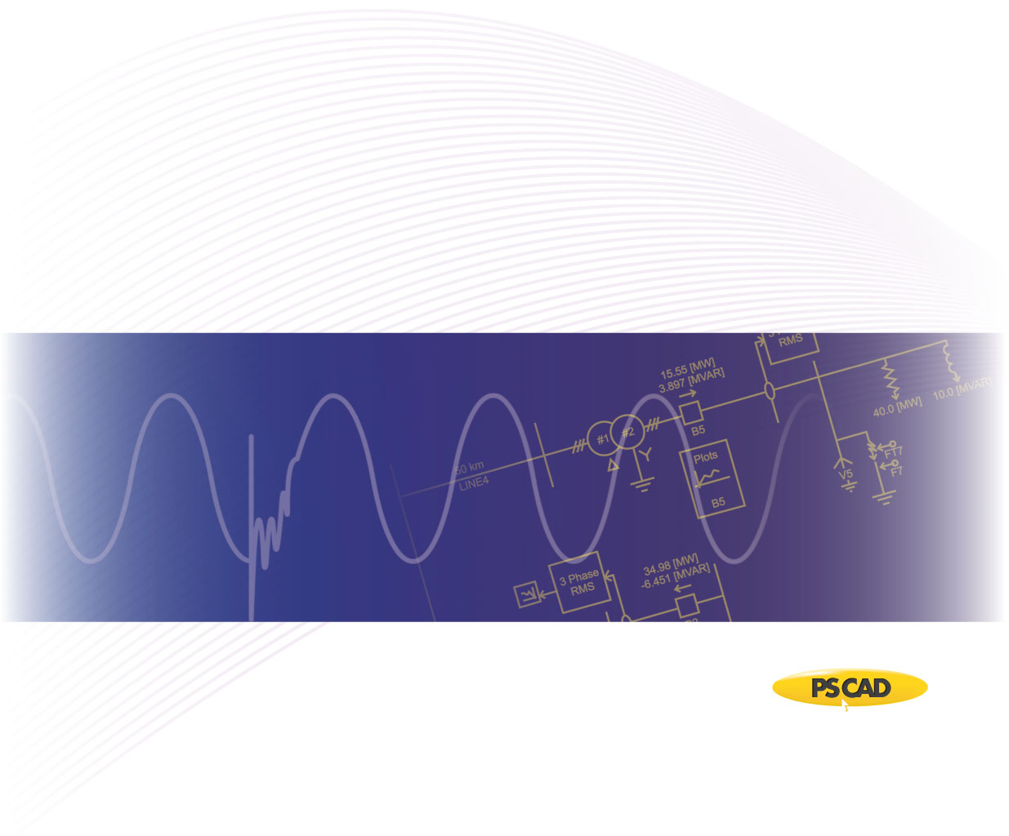

PSCAD

Author:

Date: December 30th, 2014

Revision: 0.00

Objective

IEEE bus systems are used by researchers to implement new ideas and concepts. This technical note describes the details of the IEEE 39-bus system [1]. The system consists of loads, capacitor banks, transmission lines, and generators. Figure 1 depicts part of the PSCAD model of IEEE 39-bus system.



Figure 1 – PSCAD Model of IEEE 39-bus system

Each machine (generator) is represented as a voltage source where its source impedance is set arbitarily as 10 Ohms. Table 1 summarizes the setting for each source, with a base of 100 [MVA] for per unitizing.

Table 1 - Terminal conditions of IEEE 39-bus system

|  |  |  |  |  |
| --- | --- | --- | --- | --- |
| **Bus** | **V [kV]** | **δ [deg]** | **P [pu]** | **Q [pu]** |
| 31 | 225.860 | -1.590 | 5.713 | 3.639 |
| 30 | 240.925 | -3.730 | 2.500 | 0.832 |
| 32 | 226.113 | 1.790 | 6.500 | 0.015 |
| 33 | 229.356 | 2.870 | 6.320 | 0.697 |
| 34 | 232.829 | 1.460 | 5.080 | 1.488 |
| 35 | 241.339 | 4.780 | 6.500 | 1.670 |
| 36 | 244.605 | 7.460 | 5.600 | 0.754 |
| 37 | 236.394 | 2.050 | 5.400 | -0.353 |
| 38 | 236.095 | 7.300 | 8.300 | -0.005 |
| 39 | 236.900 | -10.06 | 10.00 | -0.365 |

Transmission lines are modelled using the Bergeron model. Table 2 summarizes the transmission line parameters.

Table 2 - Transmission line characteristics of IEEE 39-bus system

|  |  |  |  |  |
| --- | --- | --- | --- | --- |
| **Line** | | **R [pu/m]** | **X [pu/m]** | **B [pu/m]** |
| **From Bus** | **To Bus** |
| 1 | 2 | 0.0035 | 0.0411 | 0.6987 |
| 1 | 39 | 0.0010 | 0.025 | 0.7500 |
| 2 | 3 | 0.0013 | 0.0151 | 0.2572 |
| 2 | 25 | 0.0070 | 0.0086 | 0.1460 |
| 3 | 4 | 0.0013 | 0.0213 | 0.2214 |
| 3 | 18 | 0.0011 | 0.0133 | 0.2138 |
| 4 | 5 | 0.0008 | 0.0128 | 0.1342 |
| 4 | 14 | 0.0008 | 0.0129 | 0.1382 |
| 5 | 6 | 0.0002 | 0.0026 | 0.0434 |
| 5 | 8 | 0.0008 | 0.0112 | 0.1476 |
| 6 | 7 | 0.0006 | 0.0092 | 0.1130 |
| 6 | 11 | 0.0007 | 0.0082 | 0.1389 |
| 7 | 8 | 0.0004 | 0.0046 | 0.0780 |
| 8 | 9 | 0.0023 | 0.0363 | 0.3804 |
| 9 | 39 | 0.0010 | 0.0250 | 1.2000 |
| 10 | 11 | 0.0004 | 0.0043 | 0.0729 |
| 10 | 13 | 0.0004 | 0.0043 | 0.0729 |
| 13 | 14 | 0.0009 | 0.0101 | 0.1723 |
| 14 | 15 | 0.0018 | 0.0217 | 0.3660 |
| 15 | 16 | 0.0009 | 0.0094 | 0.1710 |
| 16 | 17 | 0.0007 | 0.0089 | 0.1342 |
| 16 | 19 | 0.0016 | 0.0195 | 0.3040 |
| 16 | 21 | 0.0008 | 0.0135 | 0.2548 |
| 16 | 24 | 0.0003 | 0.0059 | 0.0680 |
| 17 | 18 | 0.0007 | 0.0082 | 0.1319 |
| 17 | 27 | 0.0013 | 0.0173 | 0.3216 |
| 21 | 22 | 0.0008 | 0.0140 | 0.2565 |
| 22 | 23 | 0.0006 | 0.0096 | 0.1846 |
| 23 | 24 | 0.0022 | 0.0350 | 0.3610 |
| 25 | 26 | 0.0032 | 0.0323 | 0.5130 |
| 26 | 27 | 0.0014 | 0.0147 | 0.2396 |
| 26 | 28 | 0.0043 | 0.0474 | 0.7802 |
| 26 | 29 | 0.0057 | 0.0625 | 1.0290 |
| 28 | 29 | 0.0014 | 0.0151 | 0.0249 |

Loads are modelled as a constant PQ load with parameters as shown in Table 3.

Table 3 - Load characteristics of IEEE 39-bus system

|  |  |  |
| --- | --- | --- |
| **Bus** | **P [pu]** | **Q [pu]** |
| 3 | 3.220 | 0.024 |
| 4 | 5.000 | 1.840 |
| 7 | 2.338 | 0.840 |
| 8 | 5.220 | 1.760 |
| 12 | 0.075 | 0.880 |
| 15 | 3.200 | 1.530 |
| 16 | 3.294 | 0.323 |
| 18 | 1.580 | 0.300 |
| 20 | 6.800 | 1.030 |
| 21 | 2.740 | 1.150 |
| 23 | 2.475 | 0.846 |
| 24 | 3.086 | -0.922 |
| 25 | 2.240 | 0.472 |
| 26 | 1.390 | 0.170 |
| 27 | 2.810 | 0.755 |
| 28 | 2.060 | 0.276 |
| 29 | 2.835 | 0.269 |
| 31 | 0.092 | 0.046 |
| 39 | 11.04 | 2.500 |

Validation

The PSCAD model was validated against the PSS/E power flow values from [1]. Table 4 depicts the line and source power flow comparison.

Table 4 - Source and line power comparison of IEEE 39-bus system

|  |  |  |  |  |  |
| --- | --- | --- | --- | --- | --- |
| **Bus** | | **PSS/E** | | **PSCAD** | |
| **P [pu]** | **Q [pu]** | **P [pu]** | **Q [pu]** |
| 30 | | 2.500 | 0.832 | 2.483 | 0.808 |
| 31 | | 5.713 | 3.639 | 5.702 | 3.645 |
| 32 | | 6.500 | 0.015 | 6.489 | 0.020 |
| 33 | | 6.320 | 0.697 | 6.303 | 0.767 |
| 34 | | 5.080 | 1.488 | 5.047 | 1.522 |
| 35 | | 6.500 | 1.670 | 6.497 | 1.642 |
| 36 | | 5.600 | 0.754 | 5.590 | 0.792 |
| 37 | | 5.400 | 0.353 | 5.397 | 0.312 |
| 38 | | 8.300 | 0.005 | 8.293 | 0.059 |
| 39 | | 10.00 | 0.365 | 9.988 | 0.381 |
| **From Bus** | **To Bus** |  | | | |
| 1 | 2 | 1.164 | 0.470 | 1.175 | 0.483 |
| 1 | 39 | 1.162 | 0.470 | 1.176 | 0.483 |
| 2 | 3 | 3.647 | -0.135 | 3.651 | -0.136 |
| 2 | 25 | 2.357 | -1.111 | 2.349 | -1.057 |
| 3 | 4 | 0.752 | -0.295 | 0.766 | -0.267 |
| 3 | 18 | 0.341 | -0.245 | 0.350 | -0.216 |
| 4 | 5 | 1.635 | 1.042 | 1.625 | -1.015 |
| 4 | 14 | 2.613 | -0.375 | 2.612 | -0.377 |
| 5 | 6 | 4.828 | -0.088 | 4.821 | -0.114 |
| 5 | 8 | 3.181 | 1.173 | 3.192 | 1.175 |
| 6 | 7 | 4.257 | 1.230 | 4.257 | 1.225 |
| 6 | 11 | 3.479 | -1.573 | 3.478 | -1.589 |
| 7 | 8 | 1.918 | 0.389 | 1.919 | 0.386 |
| 8 | 9 | 0.121 | 0.072 | 0.119 | 0.074 |
| 9 | 39 | 0.121 | 0.351 | 0.119 | 0.349 |
| 10 | 11 | 3.498 | 1.139 | 3.501 | 1.133 |
| 10 | 13 | 2.994 | 0.280 | 2.989 | 0.263 |
| 13 | 14 | 2.922 | -0.051 | 2.916 | -0.092 |
| 14 | 15 | 0.303 | 0.513 | 0.292 | -0.475 |
| 15 | 16 | 2.904 | 0.626 | 2.909 | 0.661 |
| 16 | 17 | 2.038 | -0.483 | 2.028 | -0.493 |
| 16 | 19 | 4.545 | 0.043 | 4.517 | 0.066 |
| 16 | 21 | 3.297 | -0.511 | 3.295 | -0.529 |
| 16 | 24 | 0.427 | 0.736 | 0.430 | 0.729 |
| 17 | 18 | 1.921 | -0.298 | 1.933 | 0.271 |
| 17 | 27 | 0.115 | -0.186 | 0.094 | -0.134 |
| 21 | 22 | 6.046 | 0.688 | 6.070 | 0.666 |
| 22 | 23 | 0.427 | 0.397 | 0.439 | 0.345 |
| 23 | 24 | 3.513 | 0.258 | 3.517 | 0.265 |
| 25 | 26 | 0.784 | -0.244 | 0.765 | -0.279 |
| 26 | 27 | 2.704 | 0.585 | 2.716 | 0.452 |
| 26 | 28 | 1.415 | -0.672 | 1.430 | -0.648 |
| 26 | 29 | 1.922 | -0.788 | 1.951 | -0.768 |
| 28 | 29 | 3.491 | -0.396 | 3.490 | -0.372 |

PSCAD Case Set-up Instructions

Dependencies

This example is compatible with PSCAD v4.5.3 and beyond.

The files required to run the tutorial are as follows:

* New_IEEE_39_CT.pscx

Future updates to the system model

* Replace the voltage sources with detailed machine models for dynamic analysis.
* Update short circuit levels of each source to represent specific system strengths.

Technical References

[1] [Online]. Available FTP: <http://psdyn.ece.wisc.edu/IEEE_benchmarks>

[2] <http://sas.ieee.ca/pesias/seminar_slides/IEEE_PES-IAS_Chapter_24_01_13.pdf>

Appendix 1

The line resistances and reactances are provided in [1] for each line segment of the test system. The following table lists the approximate line length of each segment, based on typical line data (as listed in Table A-2).

Table A-1- Approximate line lengths based on typical line reactance values as shown in Table A-2

|  |  |  |  |
| --- | --- | --- | --- |
| **From Bus** | **To Bus** | **Total Reactance (Ω)** | **Approximate length of the line based on typical line reactance values (km)** |
| 1 | 2 | 21.7419 | 43.4838 |
| 1 | 39 | 13.2250 | 26.4500 |
| 2 | 3 | 7.9879 | 15.9758 |
| 2 | 25 | 4.5494 | 9.0988 |
| 3 | 4 | 11.2677 | 22.5354 |
| 3 | 18 | 7.0357 | 14.0714 |
| 4 | 5 | 6.7712 | 13.5424 |
| 4 | 14 | 6.8241 | 13.6482 |
| 5 | 6 | 1.3754 | 2.7508 |
| 5 | 8 | 5.9248 | 11.8496 |
| 6 | 7 | 4.8668 | 9.7336 |
| 6 | 11 | 4.3378 | 8.6756 |
| 7 | 8 | 2.4334 | 4.8668 |
| 8 | 9 | 19.2027 | 38.4054 |
| 9 | 39 | 13.225 | 26.4500 |
| 10 | 11 | 2.2747 | 4.5494 |
| 10 | 13 | 2.2747 | 4.5494 |
| 13 | 14 | 5.3429 | 10.6858 |
| 14 | 15 | 11.4793 | 22.9586 |
| 15 | 16 | 4.9726 | 9.9452 |
| 16 | 17 | 4.7081 | 9.4162 |
| 16 | 19 | 10.3155 | 20.6310 |
| 16 | 21 | 7.1415 | 14.2830 |
| 16 | 24 | 3.1211 | 6.2422 |
| 17 | 18 | 4.3378 | 8.6756 |
| 17 | 27 | 9.1517 | 18.3034 |
| 21 | 22 | 7.4060 | 14.8120 |
| 22 | 23 | 5.0784 | 10.1568 |
| 23 | 24 | 18.5150 | 37.0300 |
| 25 | 26 | 17.0867 | 34.1734 |
| 26 | 27 | 7.7763 | 15.5526 |
| 26 | 28 | 25.0746 | 50.1492 |
| 26 | 29 | 33.0625 | 66.1250 |
| 28 | 29 | 7.9879 | 15.9758 |

Table A-2- Typical line reactance values

|  |  |  |
| --- | --- | --- |
| **Voltage (kV)** | **R(Ω/km)** | **X(Ω/km)** |
| 72 | 0.41 | 0.5 |
| 138 | 0.14 | 0.5 |
| 230 (single) | 0.09 | 0.5 |
| 230 (bundled) | 0.04 | 0.4 |
| 345 (bundled) | 0.03 | 0.3 |
| 500 (bundled) | 0.02 | 0.3 |