IEEE 09 Bus System

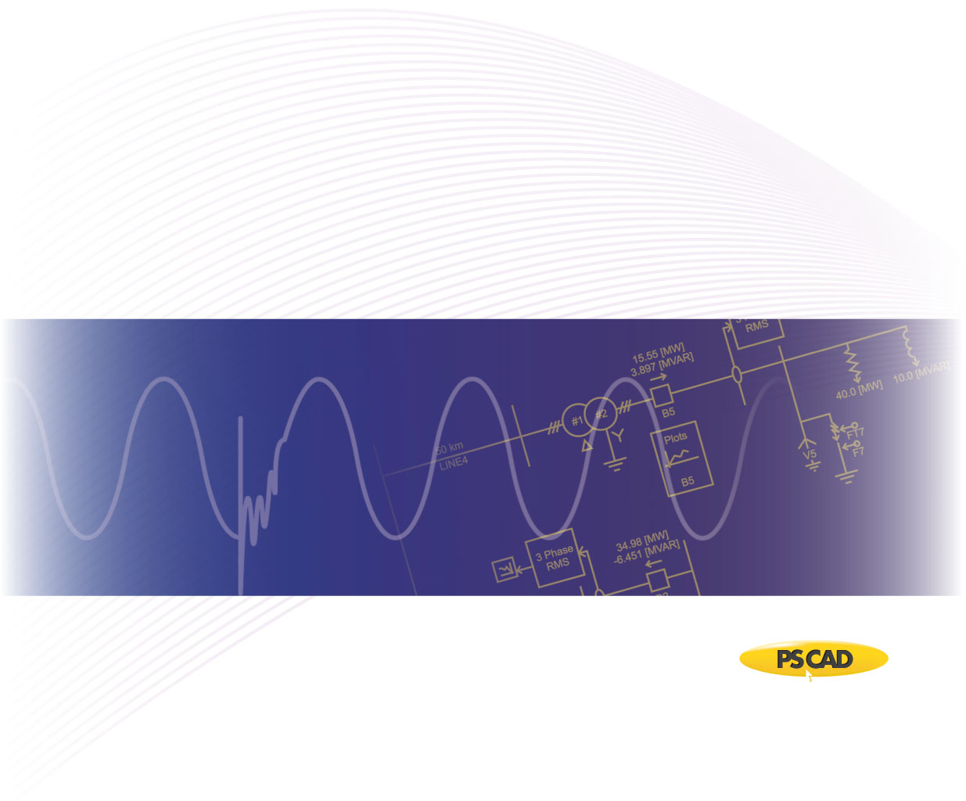

PSCAD

Author:

Date: December 30th, 2014

Revision: 0.00

Objective

IEEE bus systems are used by researchers to implement new ideas and concepts. This technical note describes the details of the IEEE 9-bus system [1]. The system consists of loads, transmission lines, and generators as shown in Figure 1.

#1

#2

P+jQ

RRL

Bus9

Bus5

slack bus

RRL

#1

#2

P+jQ

T6_9

T4_5

T4_6

P+jQ

T5_7

#1

#2

Bus7

T8_9

RRL

Bus8

T7_8

Bus6

Bus2

Bus3

Bus4

Bus1

Figure 1 - PSACD model of IEEE 9-bus system

Each machine (generator) is represented as a voltage source where its source impedance is set arbitarily as 1 Ohm. Table 1 summarizes the perunitized terminal conditions of each source, with 100 [MVA] base.

Table 1 - Terminal conditions of IEEE 9-bus system

|  |  |  |  |  |
| --- | --- | --- | --- | --- |
| **Bus** | **V [kV]** | **δ [deg]** | **P [pu]** | **Q [pu]** |
| 1 | 17.1600 | 0.0000 | 0.7163 | 0.2791 |
| 2 | 18.4500 | 9.3507 | 1.6300 | 0.0490 |
| 3 | 14.1450 | 5.1420 | 0.8500 | -0.1145 |

Transmission lines are modelled using the Bergeron model. Table 2 summarizes the transmission line parameters.

Table 2 - Transmission line characteristics of IEEE 9-bus system

|  |  |  |  |  |
| --- | --- | --- | --- | --- |
| **Line** | | **R [pu/m]** | **X [pu/m]** | **B [pu/m]** |
| **From Bus** | **To Bus** |
| 4 | 5 | 0.0100 | 0.0680 | 0.1760 |
| 4 | 6 | 0.0170 | 0.0920 | 0.1580 |
| 5 | 7 | 0.0320 | 0.1610 | 0.3060 |
| 6 | 9 | 0.0390 | 0.1738 | 0.3580 |
| 7 | 8 | 0.0085 | 0.0576 | 0.1490 |
| 8 | 9 | 0.0119 | 0.1008 | 0.2090 |

Loads are modelled as a constant PQ load with parameters as shown in Table 3.

Table 3 - Load characteristics of IEEE 9-bus system

|  |  |  |
| --- | --- | --- |
| **Bus** | **P [pu]** | **Q [pu]** |
| 5 | 1.25 | 0.50 |
| 6 | 0.90 | 0.30 |
| 8 | 1.00 | 0.35 |

Validation

The PSCAD model was validated against the PSS/E power flow values from [1]. Table 4 depicts the line and source power flow comparison.

Table 4 - Source and line power flow comparison of IEEE 9-bus system

|  |  |  |  |  |  |
| --- | --- | --- | --- | --- | --- |
| **Bus** | | **PSS/E** | | **PSCAD** | |
| **P [pu]** | **Q [pu]** | **P [pu]** | **Q [pu]** |
| 1 | | 0.716 | 0.279 | 0.7152 | 0.2761 |
| 2 | | 1.630 | 0.049 | 1.6320 | 0.0454 |
| 3 | | 0.850 | -0.114 | 0.8512 | -0.1170 |
| **From Bus** | **To Bus** |  | | | |
| 4 | 5 | 0.433 | 0.235 | 0.4322 | 0.2334 |
| 4 | 6 | 0.283 | 0.013 | 0.2830 | 0.0115 |
| 5 | 7 | 0.842 | -0.104 | 0.8430 | -0.1041 |
| 6 | 9 | 0.633 | -0.178 | 0.6340 | -0.1810 |
| 7 | 8 | 0.788 | -0.008 | 0.7892 | -0.0089 |
| 8 | 9 | 0.217 | 0.023 | 0.2172 | 0.0229 |

Set-up Instructions

Dependencies

This example is compatible with PSCAD v4.5.3 and beyond.

The file required to run the tutorial is given below:

* New_IEEE_09_CT.pscx

Future updates to the system model

* Replace the voltage sources with detailed machine models for dynamic analysis.
* Update short circuit levels of each source to represent specific system strengths.

Technical References

[1] Illinois Center for a Smarter Electric Grid. (2013). [Online]. Available FTP: <http://publish.illinois.edu/smartergrid/>

[2] <http://sas.ieee.ca/pesias/seminar_slides/IEEE_PES-IAS_Chapter_24_01_13.pdf>

Appendix 1

The line resistances and reactances are provided in [1] for each line segment of the test system. The following table lists the approximate line length of each segment, based on typical line data (as listed in Table A-2).

Table A-1 Approximate line lengths based on typical line reactance values as shown in Table A-2

|  |  |  |  |
| --- | --- | --- | --- |
| **From Bus** | **To Bus** | **Total Reactance (Ω)** | **Approximate length of the line based on typical line reactance values (km)** |
| 4 | 5 | 2645 | 5290 |
| 4 | 6 | 3174 | 6348 |
| 5 | 7 | 3703 | 7406 |
| 6 | 9 | 4761 | 9522 |
| 7 | 8 | 4232 | 8464 |
| 8 | 9 | 4761 | 9522 |

Table A-2- Typical line reactance values

|  |  |  |
| --- | --- | --- |
| **Voltage (kV)** | **R(Ω/km)** | **X(Ω/km)** |
| 72 | 0.41 | 0.5 |
| 138 | 0.14 | 0.5 |
| 230 (single) | 0.09 | 0.5 |
| 230 (bundled) | 0.04 | 0.4 |
| 345 (bundled) | 0.03 | 0.3 |
| 500 (bundled) | 0.02 | 0.3 |