Happy Angels  
Website

Final List of Requirements

## Links

* Social Media Links
* App download links (Android and iOS)
* Privacy Policy
* Terms & Condition
* Google Maps (Optional)

## Contact

* Phone Number
* Email address (Institutional)
* Office Address
* Customer support No.(optional)

## Testimonial

* Photo (400x400px)
* Review in max 50 words
* Star Rating (1 to 5)
* Name and Designation

## Usage Data

* Active Installs
* Client Reviews

## Pricing & Comparison

* Price
* Categorised breakup of benefits for each subscription
* Segment Naming (Gold, Platinum. etc)

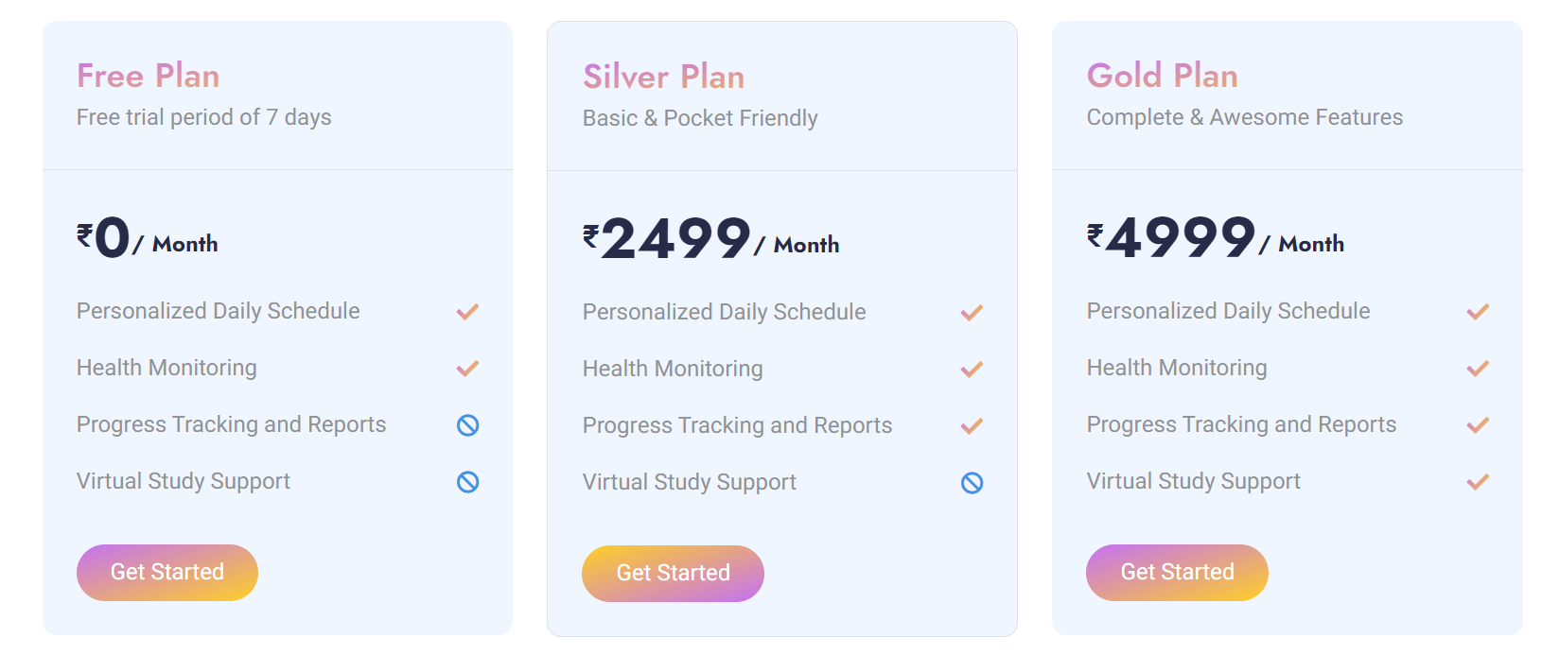

## Blog

* Content for Blog
* Thumbnail for each Blog
* Author name & publish date
* Categories for Blog

## Analytics

* Institutional G-mail account for Google Analytics (optional)
* Domain name registration

## SEO

* Meta description content.
* Meta tags.
* Google Core Web Vitals.