PROJECT REPORT ON

VULENRABILITY MANAGEMENT SYSTEM

SUBMITTED IN PARTIAL FULFILMENT

OF

THE REQUIREMENTS OF

THE AWARDS OF THE

PG-Diploma in Advanced Secure Software Development

Offered By
C-DAC Hyderabad
BY

SRIVALLI PAKALA (250850329026)
ANIL KADARI (250850329013)
TRISHA PONNANA (250850329036)
AKSHATA RAMGEER (250850329004)

Advanced Computing Training School
C-DAC
Hyderabad-501510
AUGUST 2025

Certificate

This is to certify that this is a bonafide record of a project entitled “Project Topic Name”. (Name & 12 digit Roll No of all members) has completed project work as part of Diploma in Advanced Secure Software Development (August 2025 Batch), a PG course offered by C-DAC Hyderabad. They have completed project work under the supervision of Ms Swati V. Their performance was good.

Name of Project guide
Ms. Swati V

Date :
Place : C-DAC, Hardware Park, HYDERABAD.

ACKNOWLEDGEMENT

The Vulnerability Management System project has presented an objective, a goal, a challenge of data security. This project marks the final hurdle that we tackle, of hopefully what would be one of the many challenges we have taken upon and am yet to take.
However, we could not have made it without the support and guidance from the following. Firstly I want to take this opportunity to have special thanks to our guide Ms Swati V. who helped us throughout this project by providing valuable guidance and advice as well as acquiring all components needed for this project to become a success.

(PG-DASSD AUGUST 2025)

SRIVALLI PAKALA (250850329026)
AKSHATA RAMGEER (250850329004)
TRISHA PONNANA (250850329036)
ANIL KADARI (250850329013)

TABLE OF CONTENTS

TOPIC ............................................................................................................................... PAGE
Abstract ................................................................................................................................ I
1. Introduction ......................................................................................................................2 1.1 Project Requirements ......................................................................................................2 1.2 Problem Statement ..........................................................................................................3 1.3 Software & Hardware Requirements ...............................................................................3 1.3.1 Hardware Specification .................................................................................................3 1.3.2 Software Specification .................................................................................................. 4 1.4 Coding and Testing .......................................................................................................... 4
2. Implementation ..................................................................................................................5 2.1 Frontend ............................................................................................................................5
2.1.1 Streamlit UI ....................................................................................................................5 2.1.2 Dynamic UI Rendering ...................................................................................................5 2.1.3 CSS and Styling .............................................................................................................5 2.1.4 Client-Side Logic ............................................................................................................5 2.2 Backend ............................................................................................................................6 2.2.1 Controller Logic ..............................................................................................................6 2.2.2 Python Classes and Modules .........................................................................................6 2.3 Data Persistence ...............................................................................................................7 2.4 Configuration .....................................................................................................................7
3. Function of Network Vulnerability Detection System ....................................................8
3.1 Three Main Functions of the System .................................................................................8
3.2 Important Definitions ..........................................................................................................8
4. Objectives ..........................................................................................................................10
5. ER Diagrams ......................................................................................................................11
5.1 State Diagram ...................................................................................................................11
5.2 Flow Chart .........................................................................................................................13
7. Revelation System (Vulnerability & Mitigation) …..........................................................15 7.1 Flow of Revelation Process ...............................................................................................15.
8. Literature Survey ...............................................................................................................16
8.1 List of Activities Done by User .............................................................................................16 8.2 Advantages ..........................................................................................................................17 8.3 Applications ..........................................................................................................................17 8.4 Future Scope ........................................................................................................................18 8.5 Conclusion ............................................................................................................................18
9. References ............................................................................................................................19

VULNERABILITY MANAGEMENT SYSTEM

Abstract :

In the modern cybersecurity landscape, threats extend far beyond physical access points. While physical device monitoring remains crucial, the ability to identify, assess, and mitigate vulnerabilities across a network is paramount. This project presents a comprehensive Network Vulnerability and Asset Detection System designed to automate the security auditing process. Unlike traditional systems that operate in silos, this unified platform integrates network discovery, port scanning, and advanced vulnerability assessment using the Open Vulnerability Assessment System (OpenVAS).
The system functionality is divided into three core phases: Discovery, Assessment, and Mitigation. Initially, the system scans the local network to identify active hosts and IP addresses. Subsequently, it utilizes Nmap for detailed asset interrogation and OpenVAS for deep-dive vulnerability scanning. A key differentiator of this project is its "Revelation and Mitigation" module, which not only generates detailed vulnerability reports but also provides actionable mitigation strategies. Administrators can apply fixes and immediately "Rescan" to verify security posture. This tool serves as a critical asset for network administrators, providing a streamlined, automated workflow for maintaining network hygiene and preventing exploitation.

- INTRODUCTION

The proliferation of connected devices in enterprise and home networks has created a massive attack surface for malicious actors. Administrators often struggle to maintain visibility over every device connected to their network, leading to "shadow IT" and unpatched vulnerabilities. This project introduces a robust software solution designed to bridge the gap between asset management and vulnerability remediation.
The system is built as a centralized dashboard that orchestrates complex security tools into a user-friendly interface. By integrating Dockerized security engines, the application allows users to discover devices on their subnet, fingerprint their operating systems, and identify open ports that could serve as entry points for attacks. Beyond simple detection, the system employs industry-standard scanning protocols to generate comprehensive vulnerability reports, categorizing risks by severity (High, Medium, Low). The ultimate goal is to empower users not just to see the problems, but to understand and fix them through a guided mitigation process.

1.1 Project Requirements The project aims to deliver a "One-Click" security assessment platform. The core requirements include:
- Automated Network Discovery: The ability to scan a given IP range and list all active devices.
- Deep Vulnerability Scanning: Integration with OpenVAS to check against a database of thousands of known CVEs (Common Vulnerabilities and Exposures).
- Reporting: Generation of human-readable reports summarizing security flaws.
- Mitigation Verification: A feature allowing users to view potential fixes and rescan the target to confirm resolution.

1.2 Problem Statement
- Lack of Visibility: Administrators often do not know exactly what devices are connected to their network at any given time.
- Complex Toolchains: Tools like Nmap and OpenVAS are powerful but command-line intensive and difficult for non-experts to configure.
- Static Reporting: Most scanners provide a PDF report but offer no workflow to verify if a patch was applied successfully.
- Manual Correlation: Users currently have to manually search for vulnerability solutions, which is time-consuming and error-prone.
1.3 Software & Hardware Requirements
1.3.1 Hardware Specification
- Processor: Intel Core i5 or higher (Virtualization support required for Docker).
- RAM: Minimum 8GB (16GB Recommended for running OpenVAS containers efficiently).
- Storage: 50GB SSD (Required for storing vulnerability feed data and scan reports).
- Network Adapter: Ethernet or Wi-Fi adapter with promiscuous mode support.
1.3.2 Software Specification
- Operating System: Linux (Ubuntu/Kali) or Windows 10/11 with WSL2.
- Containerization: Docker & Docker Compose (for managing OpenVAS services).
- Backend Framework: Python (Flask/Django) for logic processing and tool orchestration.
- Frontend Technologies: HTML5, CSS3, Bootstrap for the dashboard interface.
- Scanning Engines: Nmap (Network Mapper), OpenVAS (Greenbone Vulnerability Management).
- Database: SQLite/PostgreSQL for storing scan history and asset details.
1.4 Coding and Testing The application is developed using a modular coding approach. The backend, written in Python, handles the execution of shell commands for Nmap and API calls for the OpenVAS container. The frontend uses dynamic web templates to update scan status in real-time. Testing was conducted in two phases:
- Unit Testing: Verifying individual modules (e.g., ensuring the IP scanner correctly identifies a known device).
- Integration Testing: ensuring the "Mitigation" button correctly triggers the mitigation logic and that the "Rescan" function accurately updates the database with new results.

2.IMPLEMENTATION

The Vulnerability Management Dashboard utilizes a unified, single-script architecture where the entire application stack—Frontend, Backend, and Orchestration—is consolidated into a single Python file (final.py). This implementation leverages Streamlit to handle the user interface and application logic simultaneously, removing the need for complex server configurations or separate frontend/backend codebases. The system directly orchestrates external security engines (OpenVAS via Docker, Nmap) and remote management protocols (WinRM) from this central script.
2.1 Frontend (Streamlit UI) The user interface is generated dynamically by the Python script at runtime, ensuring seamless data flow between the scanner logic and the visual dashboard.
- 2.1.1 Declarative UI Components: Instead of writing HTML or JavaScript, the main() function declares UI components that render immediately. The st.sidebar context manager creates the "System Info" and "Docker Controls" panel, while the main content area is divided into interactive sections (e.g., "Step 1: Discover Network"). Interactive elements like st.button("SCAN NETWORK") trigger backend logic instantly without page reloads.
- 2.1.2 State Management (st.session_state): To maintain data continuity in a single-file script, the system uses st.session_state as a volatile memory store. Variables such as target_ip, vulnerable_ports, and mitigation_done are persisted here. This allows the application to remember scan results even as the user interacts with different buttons (e.g., moving from "Scan" to "Mitigate").
- 2.1.3 Custom Report Styling: While the dashboard uses standard components, the generated reports use custom CSS injected via the create_html_report() function. This function embeds a <style> block directly into the HTML output, defining visual classes like .critical (Red gradient) and .port (Monospace font) to create professional, readable vulnerability reports that are downloadable via the browser.
2.2 Backend (Script Logic) The backend logic is embedded within the same file, utilizing Python's robust standard library to interface with the operating system and network protocols.
- 2.2.1 Docker & OMP Orchestration: The system interfaces with the OpenVAS vulnerability scanner using a combination of Docker commands and the OpenVAS Management Protocol (OMP).
  - Docker Control: The subprocess module executes docker run to spin up the mikesplain/openvas container if it is not running.
  - OMP Execution: The run_omp_command() function wraps docker exec calls, sending XML-based commands (e.g., <create_target>) to the scanner's management service. This allows the script to programmatically create targets, start tasks, and retrieve scan progress.
- 2.2.2 Network & Nmap Integration: Network operations are handled by wrapping the Nmap binary.
  - Discovery: The discover_network_devices() function parses the output of nmap -sn, using Regular Expressions (re module) to extract IP addresses and MAC details.
  - Vulnerability Detection: The run_nmap_vuln_scan() function executes Nmap with the --script vulners flag, capturing the raw text output for display and parsing it to identify open ports.
- 2.2.3 Remote Mitigation (WinRM): The system utilizes the pywinrm library to actively mitigate vulnerabilities on Windows targets.
  - Connection: The test_winrm_connection() function verifies credentials using the NTLM transport protocol.
  - Remediation: The mitigate_vulnerabilities() function constructs PowerShell commands (e.g., netsh advfirewall...) and sends them to the target machine to block traffic on vulnerable ports immediately.
2.3 Data Persistence & Logic Flow The system uses a hybrid approach to data handling, prioritizing simplicity and portability.
- File-Based Reporting: Scan artifacts are saved directly to the local disk. Nmap outputs are stored as text files (vuln_report.txt), while OpenVAS reports are retrieved as XML, parsed, and converted into HTML reports (OpenVAS_Report.html). This ensures that audit trails are preserved even if the application is restarted.
- XML Parsing: The xml.etree.ElementTree module is critical for the "Revelation" phase. It parses the complex XML structure returned by OpenVAS to extract severity scores and CVE IDs, which are then used to populate the dashboard metrics (Critical/High/Medium/Low counts).
- Comparison Logic: The compare_reports() function reads the "Before" and "After" XML files, calculating the difference in vulnerability counts to quantitatively verify the success of mitigation actions.
2.4 Configuration Configuration is hardcoded into the script's preamble for simplicity and reliability.
- Constants: Critical parameters like OPENVAS_WEB_PORT (9392) and SCAN_CONFIG_ID (Full and Fast) are defined as global constants.
- Environment Awareness: The check_and_get_ip() function dynamically detects the host's network interface, ensuring the scanner binds to the correct subnet whether running on Wi-Fi or Ethernet.
- Credentials: WinRM credentials and OpenVAS login details are managed securely within the script's configuration block.

3. FUNCTION OF NETWORK VULNERABILITY DETECTION & REVELATION SYSTEM

3.1 Three Main Functions of the System The system operates on a cyclical security model comprising three core functions:
- Network Discovery (Data Collection): This module serves as the input phase. The system scans the local network interface (e.g., eth0 or wlan0) to build a live map of connected devices. It captures the IP address and status of every active host on the subnet using ARP and ICMP requests. This ensures that no "shadow" devices go unnoticed.
- Vulnerability Analysis (Revelation): Once a target is identified, the system performs deep interrogation. It combines Nmap scripts for rapid asset inventory (identifying OS, open ports, and services) with OpenVAS for comprehensive vulnerability testing. The data is analyzed against a database of thousands of known CVEs (Common Vulnerabilities and Exposures) to classify risks by severity (Critical, High, Medium, Low).
- Mitigation & Verification (Action): This function defines the system's reaction to threats. Instead of just reporting, the system allows for active defense. It uses WinRM (Windows Remote Management) to connect to vulnerable targets and apply firewall rules to block high-risk ports. A "Rescan" feature then validates that the mitigation was successful, closing the security loop.
3.2 Important Definitions
- Asset: Any computing device (Server, VM, PC) connected to the network that requires monitoring.
- Vulnerability: A flaw in software, firmware, or hardware that can be exploited by an attacker to gain unauthorized access.
- Mitigation: The process of reducing the severity of vulnerability, often by patching software or blocking access to the vulnerable service.
- CVE (Common Vulnerabilities and Exposures): A dictionary of common names (i.e., CVE Identifiers) for publicly known cybersecurity vulnerabilities.

4. OBJECTIVES

4.1 Project Objectives
- Automated Discovery: To eliminate the manual effort of tracking network devices by automatically scanning and listing all active IPs.
- Unified Dashboard: To integrate disparate tools (Nmap, OpenVAS, WinRM) into a single, user-friendly interface.
- Actionable Reporting: To move beyond static PDF reports by parsing XML data into interactive dashboards that highlight "Critical" threats immediately.
- Active Defense: To provide a mechanism (Mitigation Button) that doesn't just find problems but helps fix them by blocking vulnerable ports.
- Verification: To ensure security fixes work by offering a "Rescan" capability that compares "Before" and "After" states.

5. ER Diagram

5.1 What is E-R :
Database is absolutely an integral part of a software system. To fully utilize ER Diagram in database engineering guarantees you to produce high quality database design to use in database creation, management and maintenance. An ER model also provides a means for communication.

Since the Automated Vulnerability Management Dashboard operates as a procedural scanning tool rather than a data-heavy relational database system, the system design is best represented through a State Transition Diagram and a Process Flow Chart. These diagrams illustrate how the application moves through different operational phases and the sequential flow of data.

5.1 State Diagram
A State Diagram is used to represent the dynamic behavior of the system. It shows the different states the application can be in at any given moment and the events or user actions that cause a transition from one state to another.
In this system, the application progresses through distinct states based on user interaction with the Streamlit dashboard and the status of backend Docker containers.
The primary states are:
- Initialization State: The application starts, checks for Docker connectivity, and identifies the local subnet. The system is idle, waiting for user input.
- Discovery State: Triggered by the "SCAN NETWORK" button. The system is actively sweeping the subnet (ping sweep) to find live hosts.
- Scanning State: Triggered when a target is selected and "START SCAN" is clicked. In this state, Nmap and the OpenVAS Docker container are running actively. The UI shows progress bars.
- Reporting/Revelation State: The terminal state of scanning. The XML outputs are parsed, and vulnerabilities are revealed on the dashboard. The system waits for the user to review findings.
- Mitigation State: Triggered by the "BLOCK PORTS" button. The system establishes a WinRM session and is actively applying firewall rules to the target.
- Verification State: The final state after a "Rescan," where the system compares previous and current reports to confirm security fixes.

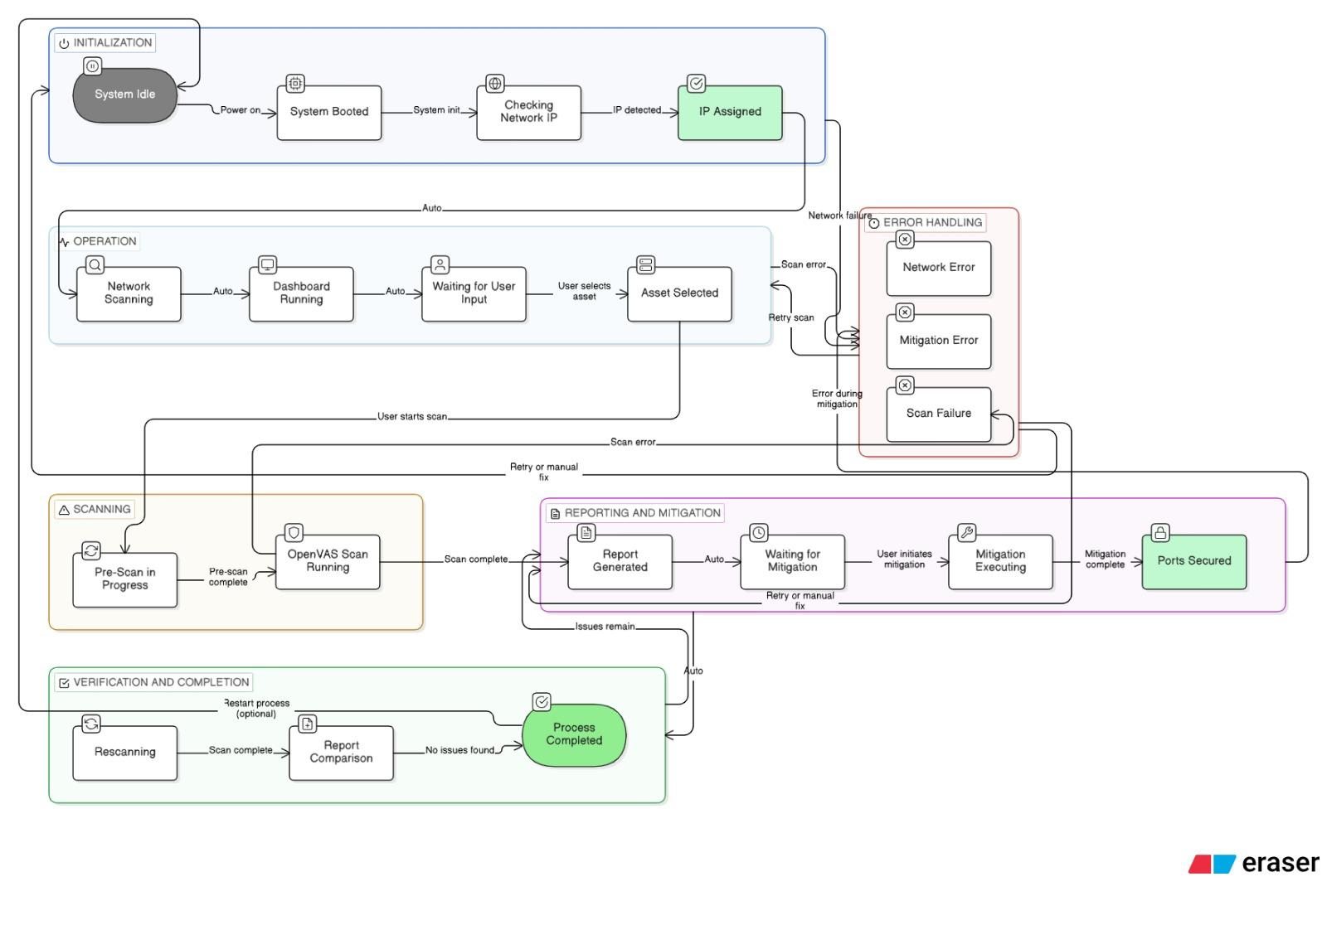

5.2 Flow Chart
The Flow Chart provides a graphical representation of the sequential workflow of the entire system, detailing the steps from initial launch to final mitigation verification. It maps directly to the user's journey through the dashboard steps.
The operational flow proceeds as follows:
- Start: The Python script launches, launching the Streamlit UI.
- Detect Network: The backend automatically determines the host IP and subnet range.
- User Action (Discover): The user clicks to scan the network. The system returns a list of potential targets.
- Select Target: The user inputs the desired IP address for auditing.
- Execute Scans: The system runs Nmap for asset inventory, followed by orchestrating the OpenVAS container for deep vulnerability analysis.
- Parse & Display Data: Complex XML scan reports are parsed and processed into human-readable metrics on the dashboard.
- Decision Point (Mitigate?): The user views critical vulnerabilities and decides whether to apply fixes.
  - If No: The process ends at the report view.
  - If Yes: The user clicks "Mitigate."
- Execute WinRM Action: The system connects remotely to the target and blocks vulnerable ports via Windows Firewall commands.
- Rescan & Compare: The system re-runs the scans to verify the ports are closed and displays a comparison report.
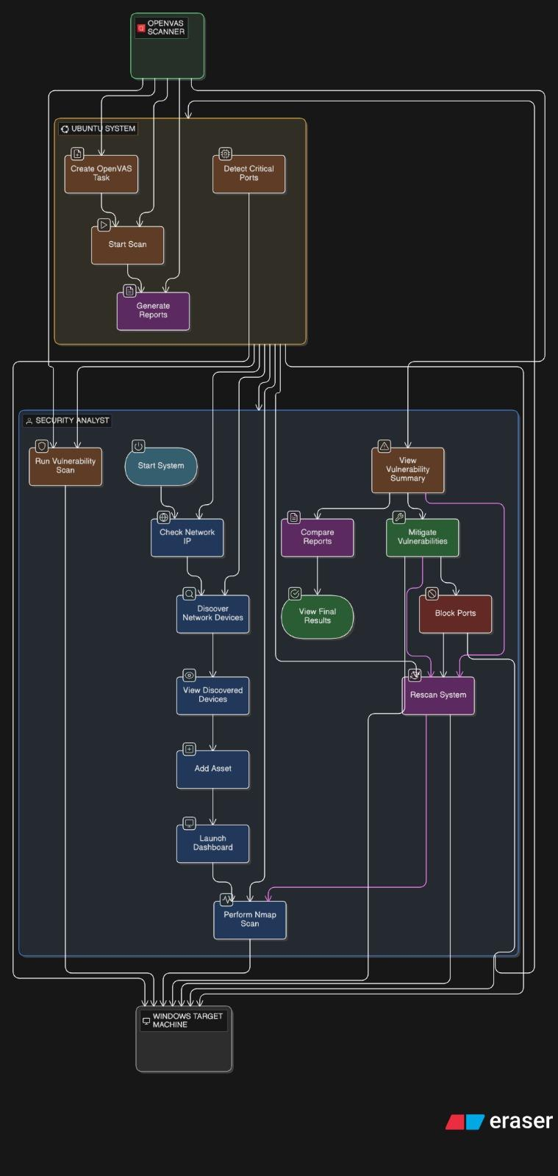
6. REVELATION SYSTEM

Flow of Revelation Process The "Revelation" phase involves Deep Scanning, Reporting, and Active Mitigation. This is handled by the OpenVAS integration and the WinRM module.
- Step 1: Containerized Scan execution The system communicates with the Dockerized OpenVAS engine using the OMP (OpenVAS Management Protocol).
  - create_target: Registers the IP in the OpenVAS database.
  - create_task: Links the Target to a Scan Config (Full & Fast).
  - start_task: Triggers the audit.
- Step 2: XML Parsing & Visualization Upon completion, the system retrieves the report in XML format. The parse_openvas_report function iterates through the XML tree to extract "High" and "Critical" severity items. These are rendered into the HTML Dashboard, categorizing threats by severity score (CVSS).
- Step 3: Active Mitigation (WinRM) This is the unique feature of the project. If a high-risk port (e.g., Port 445 SMB) is found:
  - The user clicks "BLOCK PORTS".
  - The script validates the winrm connection to the target.
  - It executes a remote PowerShell command: netsh advfirewall firewall add rule name="Block_Port_445" dir=in action=block...
  - This instantly hardens the target machine against network-based attacks.
- Step 4: Verification (The Loop) The "RESCAN & COMPARE" function closes the security loop. It re-runs the Nmap scan and compares the new open port list against the previous state, calculating a "Fixed" metric to prove that the mitigation was successful.

8. LITERATURE SURVEY

The domain of Network Security and Vulnerability Management has evolved significantly from manual port checking to automated, distributed scanning architectures.
- Gordon Lyon (Fyodor) [1]: In his seminal work on network discovery, Lyon established that accurate asset inventory is the foundational layer of any security strategy. His development of Nmap provided the industry with the standard for active TCP/IP fingerprinting, a technique we utilize in our "Discovery" module to identify operating systems and services.
- Greenbone Networks (OpenVAS) [2]: Research into the Open Vulnerability Assessment System (OpenVAS) highlights the importance of using a feed-based scanning engine. Unlike static scanners, OpenVAS utilizes a daily-updated feed of Network Vulnerability Tests (NVTs). Our project implements this by containerizing the OpenVAS engine, ensuring that the scanner always checks against the latest known CVEs (Common Vulnerabilities and Exposures).
- NIST Special Publication 800-115 [3]: The National Institute of Standards and Technology emphasizes that "Assessment" must be followed by "Mitigation." Traditional tools often stop at reporting. Our literature review indicates a gap in low-cost tools that integrate detection with active remediation. Our project addresses this by integrating WinRM (Windows Remote Management) directly into the dashboard, allowing for immediate port blocking upon detection.
8.1 List of activities done by user In our unified Automated Vulnerability Management Dashboard, the user workflow is streamlined into four distinct phases, replacing the disjointed command-line operations of the past:
- Discovery (Reconnaissance): The user initiates a subnet scan. The system uses ICMP and ARP protocols to map the "live" network surface, identifying IP addresses that require auditing.
- Assessment (Scanning): The user triggers a deep-dive scan. This orchestrates Docker containers to launch thousands of exploit tests against the target, parsing complex XML results into readable metrics.
- Remediation (Mitigation): Upon viewing the "Critical" vulnerability report, the user selects high-risk ports. The system executes remote PowerShell scripts to actively modify the Windows Firewall rules.
- Verification (Rescan): The final activity involves re-scanning the target to mathematically verify that the vulnerability count has decreased, providing a "Fixed" metric.
8.2 Advantages
The proposed system offers several distinct advantages over legacy manual methods:
- Unified Architecture: By consolidating Nmap, OpenVAS, and WinRM into a single Python/Streamlit script, we eliminate the need for administrators to switch between three different tools.
- Active Defense: Unlike passive scanners that only generate PDF reports, our system actively secures the network by blocking vulnerable ports with a single click.
- Visualization: Complex XML data is parsed into an interactive dashboard, allowing non-experts to immediately understand the severity of threats (Critical vs. Low).
- Portability: The use of Docker ensures that the scanning engine can be deployed on any Linux environment without complex dependency conflicts.
8.3 Application
- Small to Medium Enterprises (SMEs): For internal IT teams to perform weekly security audits without purchasing expensive enterprise licenses.
- Compliance Auditing: To generate timestamped HTML reports proving that devices were scanned and patched according to security standards.
- Educational Environments: As a learning platform for cybersecurity students to understand the lifecycle of a vulnerability—from detection to mitigation.
8.4 Future Scope
- Automated Patch Management: Currently, the system blocks ports. Future iterations could integrate with the Windows Update API to push software patches automatically.
- AI-Driven Risk Analysis: Integrating Machine Learning models to predict which vulnerabilities are most likely to be exploited based on current threat intelligence trends.
- Cloud Integration: Extending the scanning capabilities to audit cloud instances (AWS EC2, Azure VMs) via API keys rather than just local IP addresses.
8.5 Conclusion
The Automated Vulnerability Management Dashboard successfully bridges the gap between identification and action in network security. By automating the interaction between the powerful OpenVAS engine and the host operating system, the project achieves its primary objective: making advanced security auditing accessible and actionable.
The transition from a manual, CLI-heavy process to a GUI-based "One-Click" solution significantly reduces the time required to secure a network. Furthermore, the inclusion of the "Rescan & Compare" feature ensures that security is treated as a continuous loop rather than a one-time event. This tool stands as a robust proof-of-concept for modern, script-based security orchestration.

9. References

[1] G. Lyon, Nmap Network Scanning: The Official Nmap Project Guide to Network Discovery and Security Scanning. Insecure.com LLC, 2009.
[2] Greenbone Networks, "The Open Vulnerability Assessment System (OpenVAS) Architecture," Greenbone.net, 2024. [Online]. Available: https://www.greenbone.net/en/
[3] K. Scarfone, M. Souppaya, A. Cody, and A. Orebaugh, "Technical Guide to Information Security Testing and Assessment," NIST Special Publication 800-115, National Institute of Standards and Technology, Gaithersburg, MD, 2008.
[4] Streamlit Inc., "Streamlit Documentation: The fastest way to build and share data apps," 2024. [Online]. Available: https://docs.streamlit.io/
[5] Microsoft Corporation, "Windows Remote Management (WinRM) and WMI," Microsoft Learn, 2023. [Online]. Available: https://learn.microsoft.com/en-us/windows/win32/winrm/portal
[6] Docker Inc., "Docker Engine User Guide: Containerizing Security Applications," Docker Documentation, 2024. [Online]. Available: https://docs.docker.com/
[7] T. Richardson and C. Thies, Secure Coding in C and C++. Addison-Wesley Professional, 2013.
[8] G. Van Rossum and F. L. Drake, The Python Language Reference Manual. Network Theory Ltd., 2011.
[9] J. Postel, "Internet Control Message Protocol (ICMP)," RFC 792, Internet Engineering Task Force, 1981. (Reference for the Ping Sweep functionality implemented in the Discovery module).

