1. What are the benefits of using CSS?

There are number of benefits of using CSS; -

1. Faster page speed.
2. Easy formatting changes.
3. Excellent support in today’s browsers.
4. Better user expiries.
5. What are the disadvantages of CSS?

The disadvantages of CSS are-

1. After formatting changes, we have to check the compatibility.
2. Lacks of Security.
3. Might be cross -browser issues.
4. The multiple levels create confusion for non-developers and beginners.
5. What is the difference between CSS2 and CSS3?

CSS2 has compromised with single document, while CSS3 has its specifications divided into many individual modules.

1. Name a few CSS style components.

There are three type of css style component Selector, Attribute, Value of Property

1. What do you understand by CSS opacity?

The degree to which content behind an element is hidden, and the opposite of transparency.

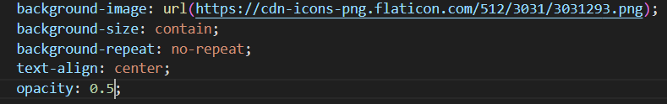

1. How can the background color of an element be changed?

By using the CSS background color property. Then add attribute to an html element like div, table etc.

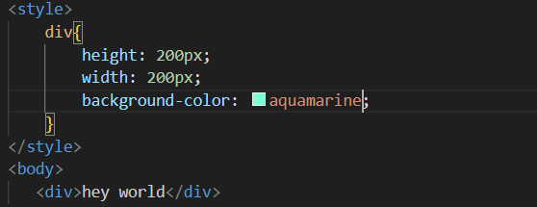

1. How can image repetition of the backup be controlled?

By using the Background-repeat property. That can help to control the image repetition of the image. It will also decide whether the background image will repeat or not.

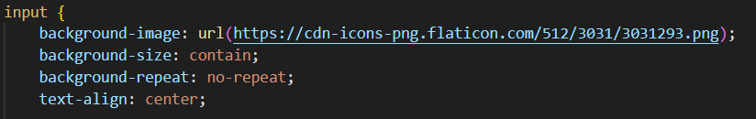

1. What is the use of the background-position property?

To sets the starting position of a background image. Background position to 50% 50% for example browser will align the middle of the image with middle of the container.

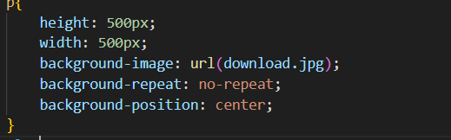

1. Which property controls the image scroll in the background?

The controls the image scroll is Background attachment Property.

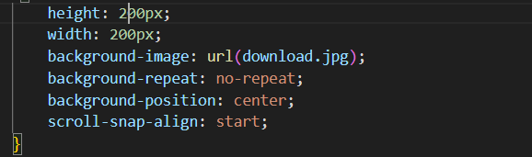

1. Why should background and color be used as separate properties?

Because it enhances the legibility of style sheets. The background property is a complex property in CSS, and if it is combined with color, the complexity will further increase.

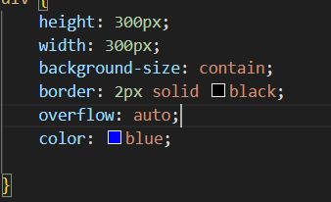 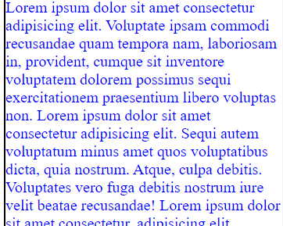

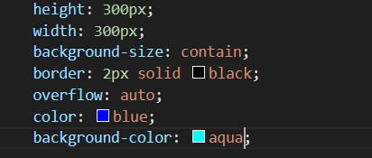

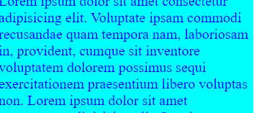

1. Why should background and color be used as separate properties?

the background element is total size of the element including padding and border

1. How to maintain the CSS specifications?

CSS specifications are maintained by the World Wide Web Consortium. a stylesheet language used to describe the presentation of a document written in HTML or XML

1. What are the ways to integrate CSS as a web page?

There are three ways -

* Inline - by using the style attribute inside HTML elements
* Internal - by using <style>elements in the <head> section
* External - by using a <link> element to link an external CSS file

1. What is embedded style sheets?

It allows you to define style for a particular HTML document as a whole in one place.

1. What are the external style sheets?

A separate CSS file that can be acceded by creating a link within the head section of the webpage.

1. What are the advantages and disadvantages of using external style sheets?

The advantage is that there is no restriction to the number of the webpages that can use the external style sheet.

The disadvantage is that the execution of the file may be deferred till the external style sheet is loaded.

1. What is the meaning of the CSS selector?

A pattern of elements and other terms that tell the browser which HTML elements should be selected to have the CSS property value inside the rule applied to them.

1. What are the media types allowed by CSS?

The media rule is used in media queries to apply different styles for different media types device. Media queria can be used to check many things such as width and height of the viewport

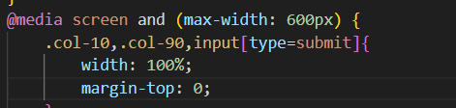

1. What is the rule set?

A table of instruction used to controlled interface to determine what data is allowable and how the data is handled between interconnected systems.