HIVE

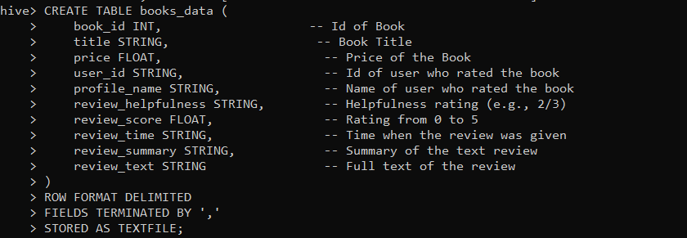

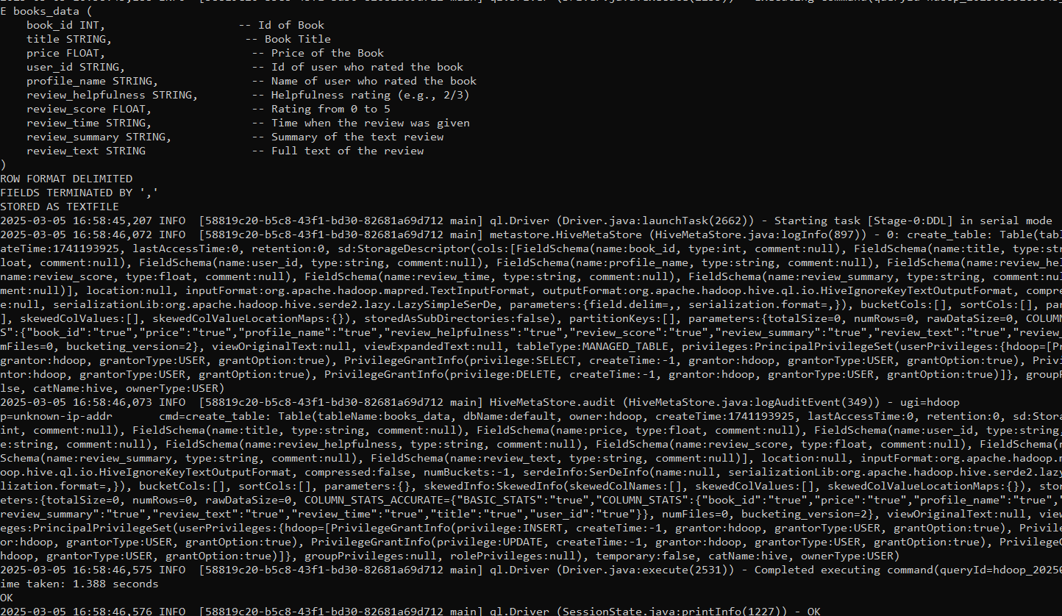



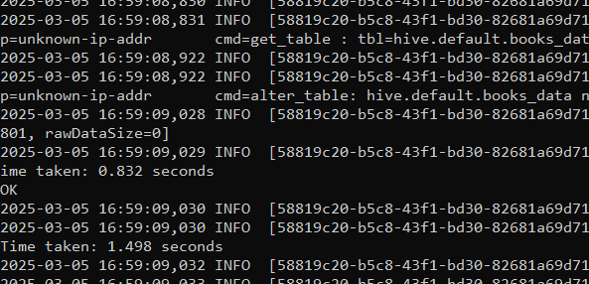



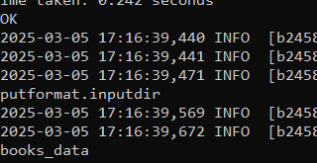

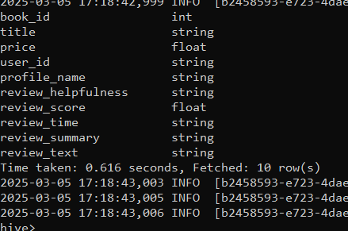

1)Give the 5 helpfulness



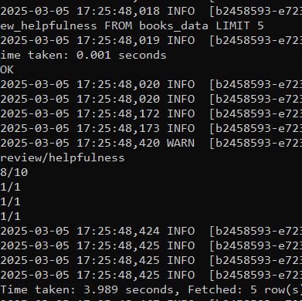

2) **Retrieve Books with High Ratings (Review Score ≥ 4.5)**

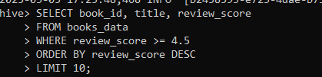

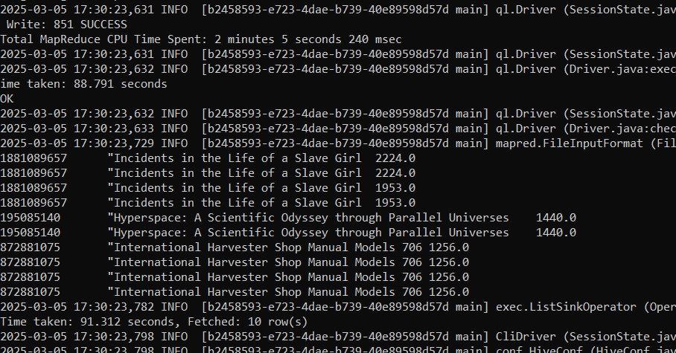

3) **Find the Most Active Reviewers (Users Who Wrote the Most Reviews)**

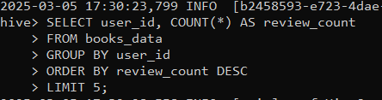

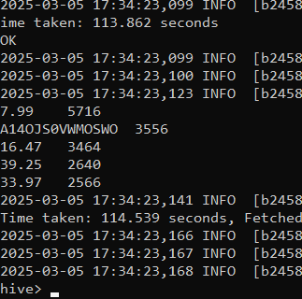

4) Average Price of Books with a High Review Score (≥ 4.0)

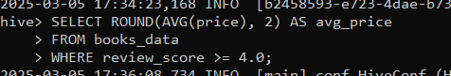

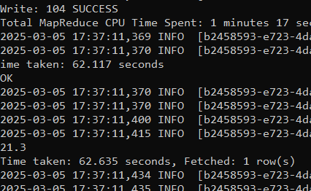

5) Find Books That Have Reviews Marked as "Most Helpful" (Helpfulness ≥ 90%)

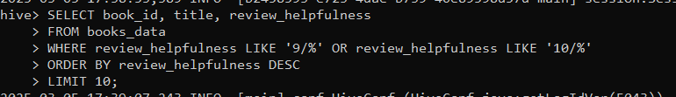

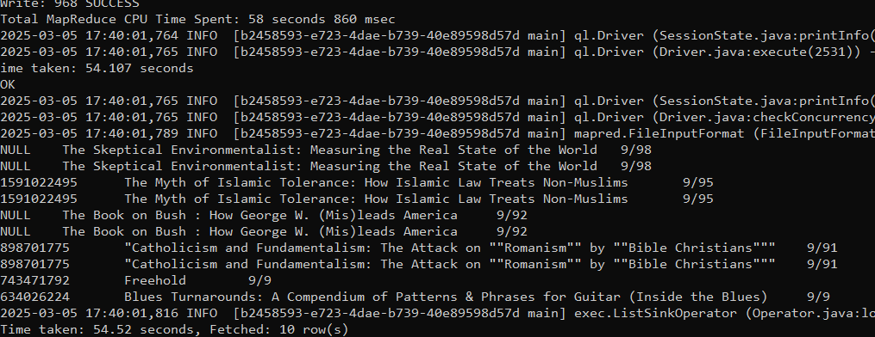

6) Find the Book That Received the Most Reviews in a Single Day

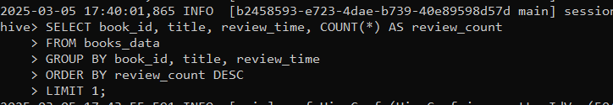

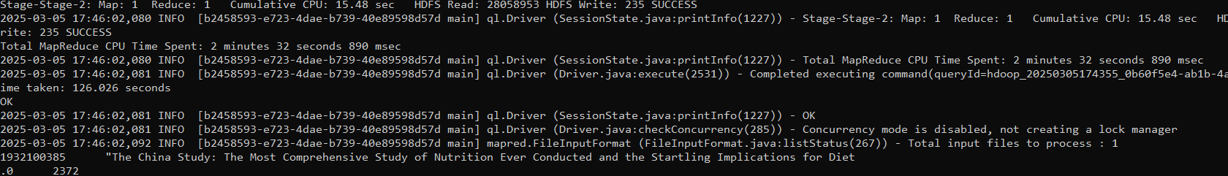

PIG

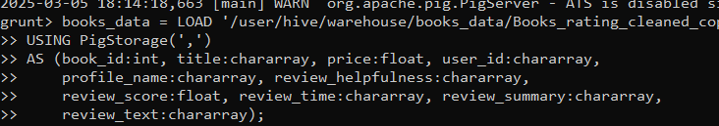

1) Find top 5 highest-rated books



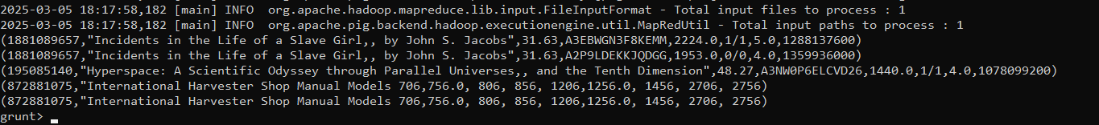

2) Count total number of reviews per book





3)Filter books with rating > 4.0



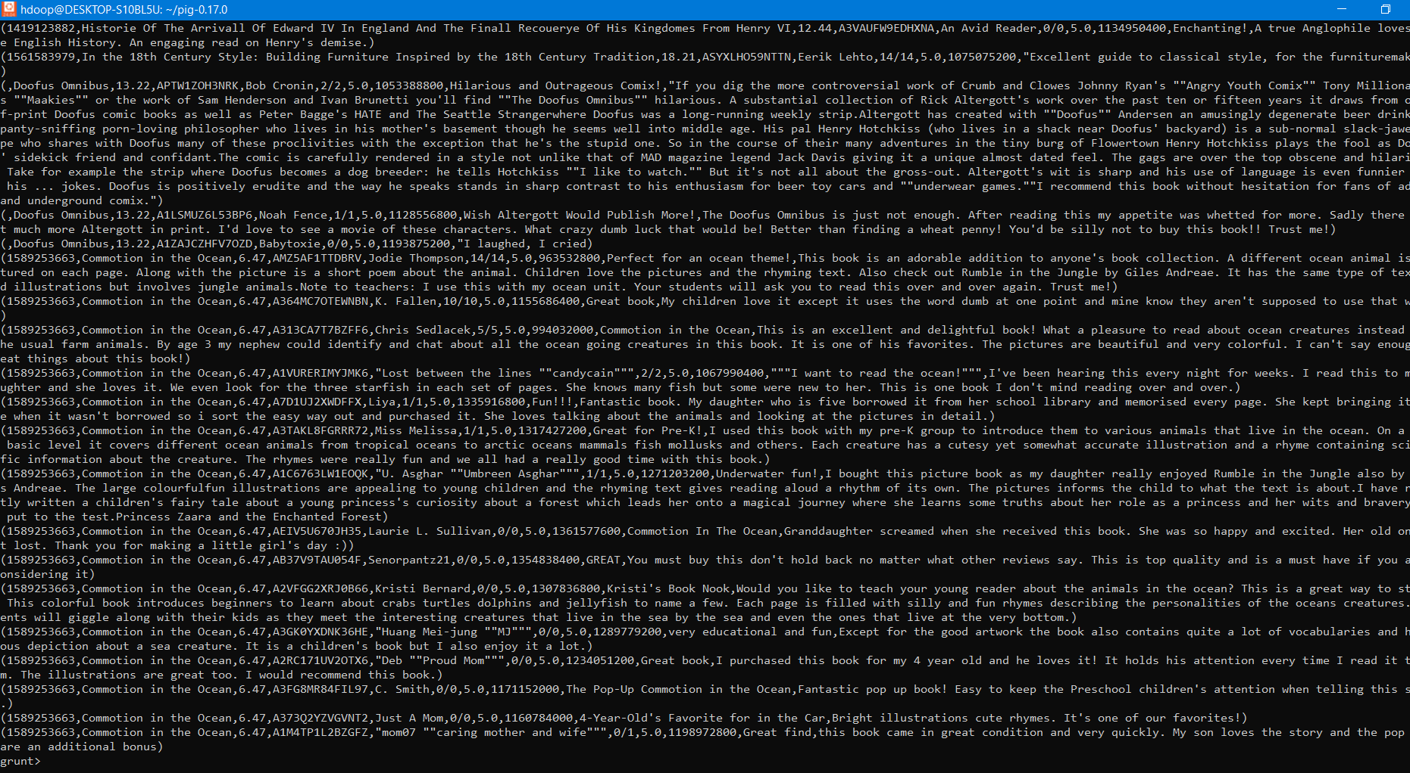

4) Get average rating per book



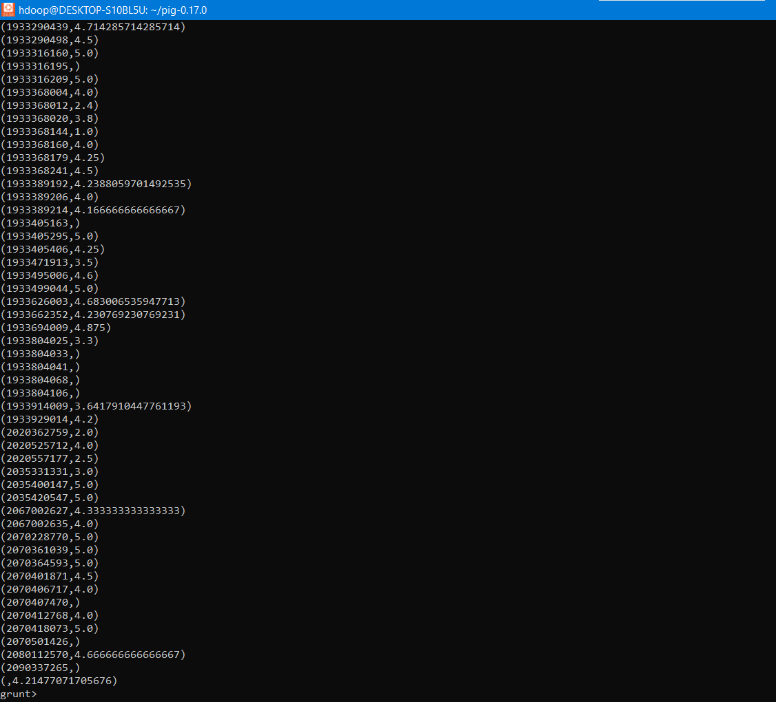

5) Find books with the most helpful reviews



