Problem statement :The retail industry generates massive volumes of transactional data every single day — customer purchases, product movements, order statuses, and revenue figures. However, most small and mid-sized retail businesses struggle to make sense of this data because it sits in disconnected spreadsheets with no structured way to query it.
We chose the Online Retail Sales Analysis Database because it solves a real-world business problem that every retail company faces:
- Inventory waste
- Revenue leakage
- Customer churn — no visibility into which customers have gone inactive
- Decision-making gaps Creating tables

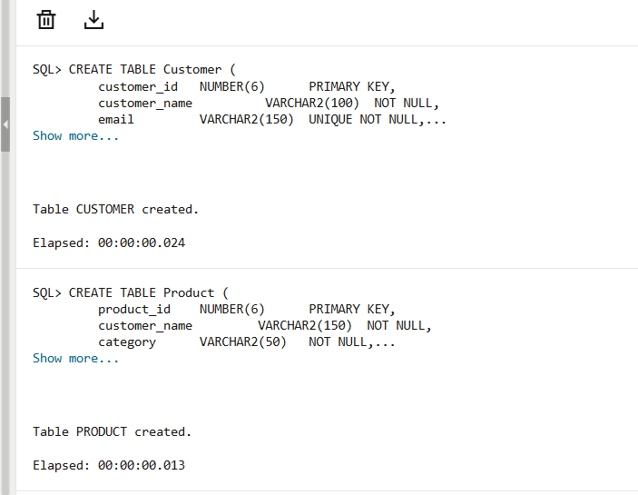
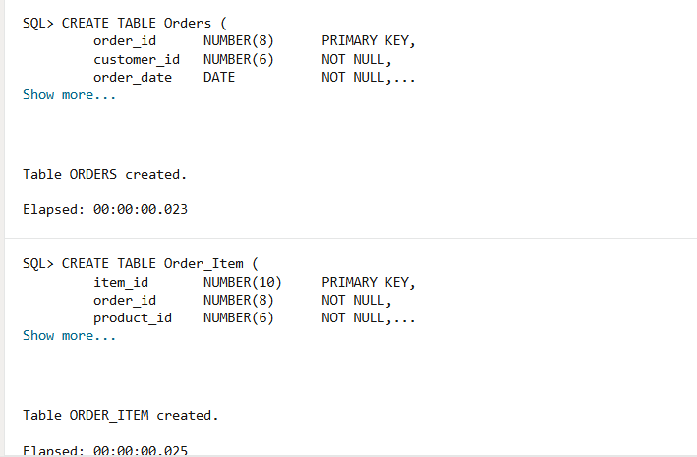
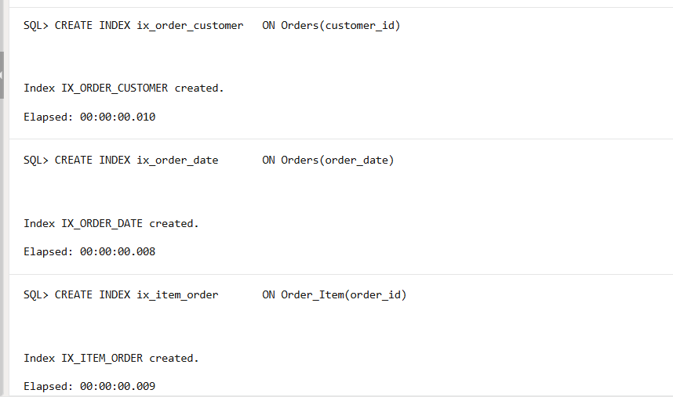
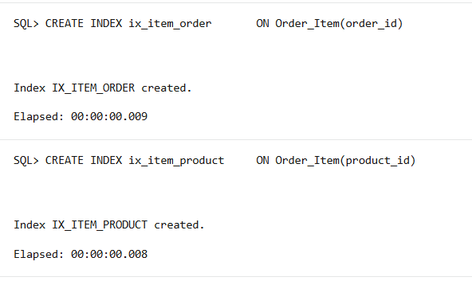

Inserting values
1)customer values
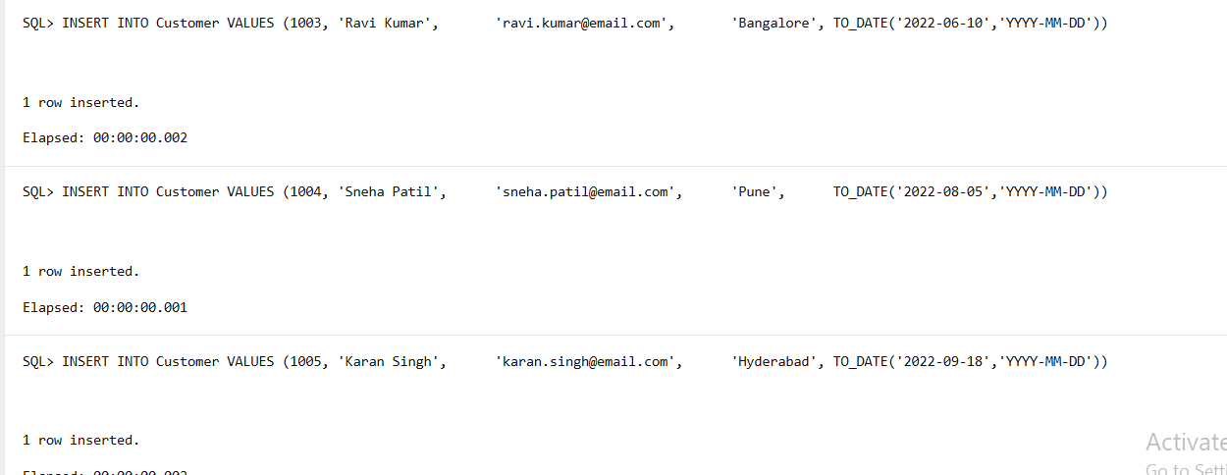

2)product values
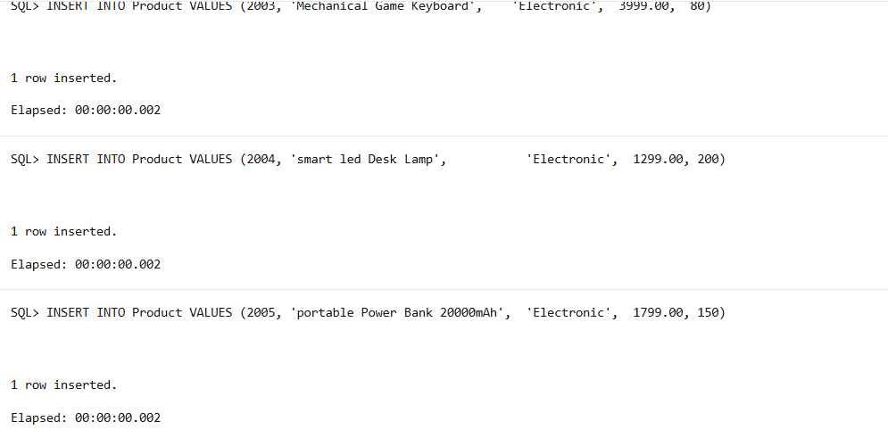
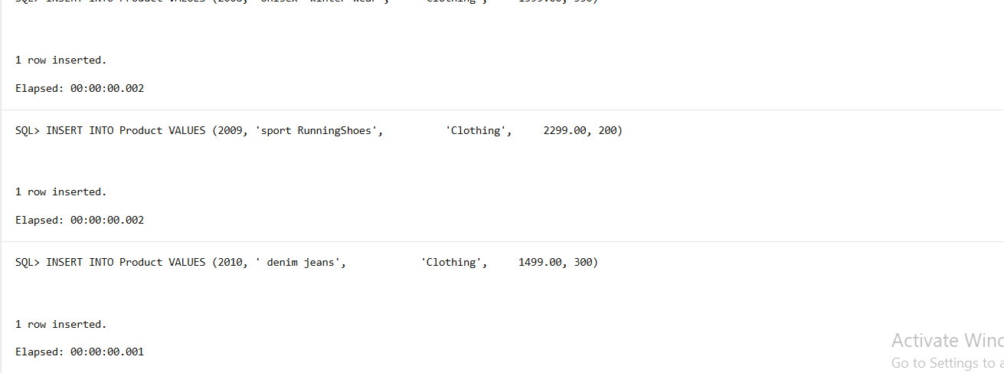
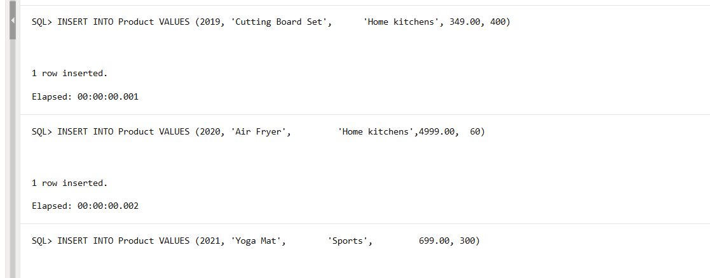
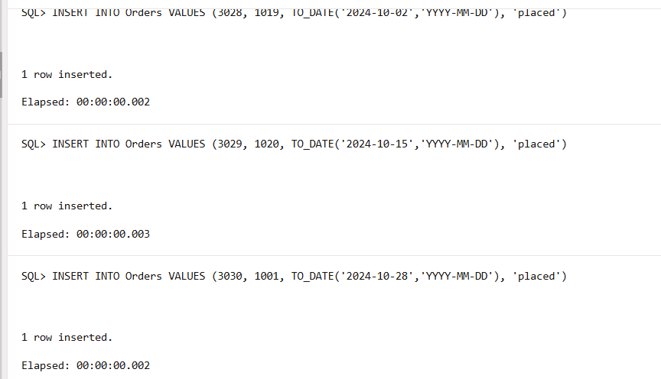

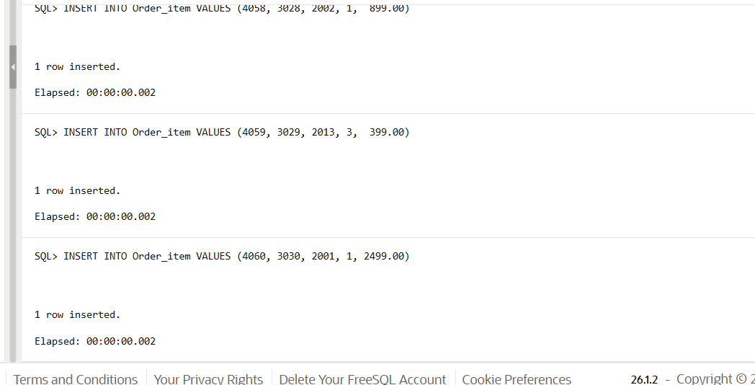

Commit
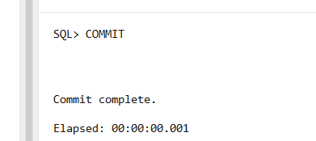

1) -- 1. Top 5 top products sold by total units
SELECT
p.product_id,
p.category,
SUM(oi.quantity) AS total_units_sold,
SUM(oi.quantity * oi.unitprice) AS total_revenue
FROM Product p
JOIN Order_Item oi ON p.product_id = oi.product_id
JOIN Orders o ON oi.order_id = o.order_id
WHERE o.status != 'cancelled'
GROUP BY p.product_id, p.category
ORDER BY total_units_sold DESC
FETCH FIRST 5 ROWS ONLY;
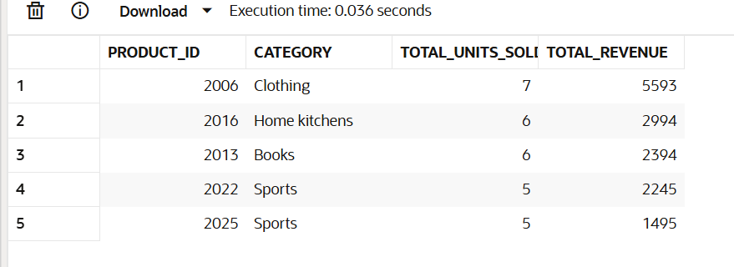

2) -- 2. 5top products by revenue generate
SELECT
p.product_id,

p.category,
SUM(oi.quantity * oi.unit_price) AS total_revenue,
RANK() OVER (ORDER BY SUM(oi.quantity * oi.unit_price) DESC) AS revenue_rank
FROM Product p
JOIN Order_Item oi ON p.product_id = oi.product_id
JOIN Orders o ON oi.order_id = o.order_id
WHERE o.status != 'CANCELLED'
GROUP BY p.product_id, p.category
ORDER BY total_revenue DESC
FETCH FIRST 5 ROWS ONLY;
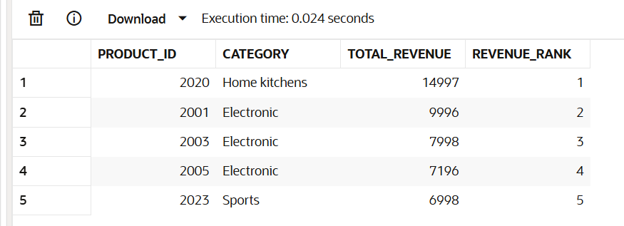

-- 3. 10 tops customer by life time spends
SELECT
c.customer_id,
c.name AS customer_name,
c.city,
COUNT(DISTINCT o.order_id) AS total_orders,
SUM(oi.quantity * oi.unitprice) AS lifetime_value,
DENSE_RANK() OVER (ORDER BY SUM(oi.quantity * oi.unitprice) DESC) AS value_rank
FROM Customer c
JOIN Orders o ON c.customer_id = o.customer_id
JOIN Order_Item oi ON o.order_id = oi.order_id
WHERE o.status != 'cancelled'
GROUP BY c.customer_id, c.name, c.city
ORDER BY lifetime_value DESC
FETCH FIRST 10 ROWS ONLY;
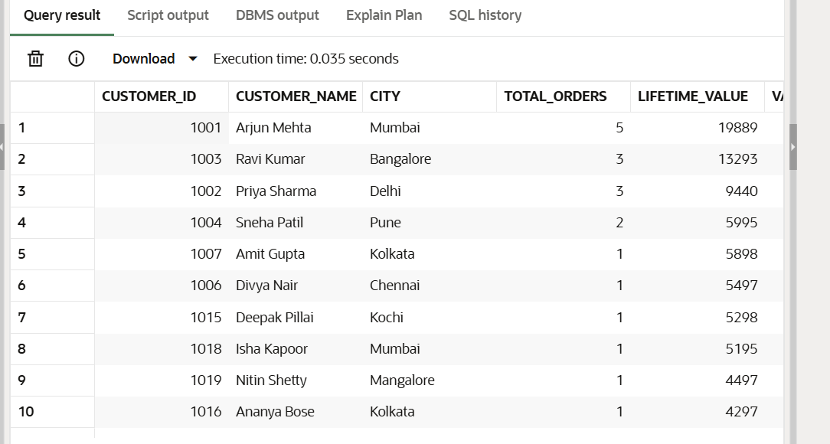

-- 4. segementation value od the customer(high/low)
SELECT
c.customer_id,
c.customer_name,
SUM(oi.quantity * oi.unitprice) AS lifetime_value,
CASE
WHEN SUM(oi.quantity * oi.unitprice) >= 10000 THEN 'high value'
WHEN SUM(oi.quantity * oi.unitprice) >= 5000 THEN 'mid value'
ELSE 'low value'
END AS customer_segment
FROM Customer c
JOIN Orders o ON c.customer_id = o.customer_id
JOIN Order_Item oi ON o.order_id = oi.order_id
WHERE o.status != 'cancelled'
GROUP BY c.customer_id, c.customer_name
ORDER BY lifetime_value DESC;
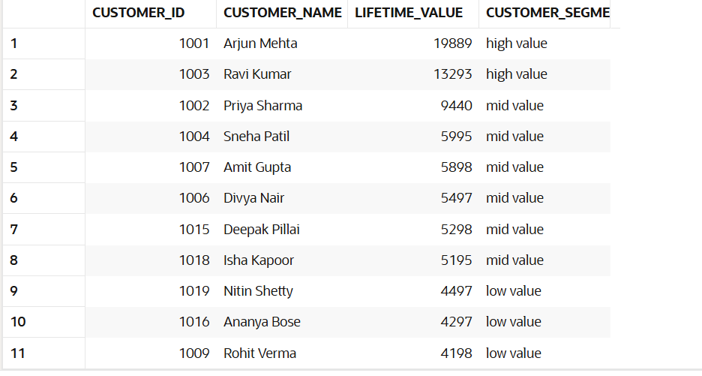

-- 5. month revenue across all the yeasrs
SELECT
TO_CHAR(o.order_date, 'YYYY-MM') AS year_month,
TO_CHAR(o.order_date, 'Mon YYYY') AS month_label,
COUNT(DISTINCT o.order_id) AS total_orders,
SUM(oi.quantity * oi.unitprice) AS monthly_revenue,
ROUND(AVG(oi.quantity * oi.unitprice), 2) AS avg_order_value
FROM Orders o
JOIN Order_Item oi ON o.order_id = oi.order_id
WHERE o.status != 'cancelled'
GROUP BY TO_CHAR(o.order_date, 'YYYY-MM'), TO_CHAR(o.order_date, 'Mon YYYY')
ORDER BY year_month;
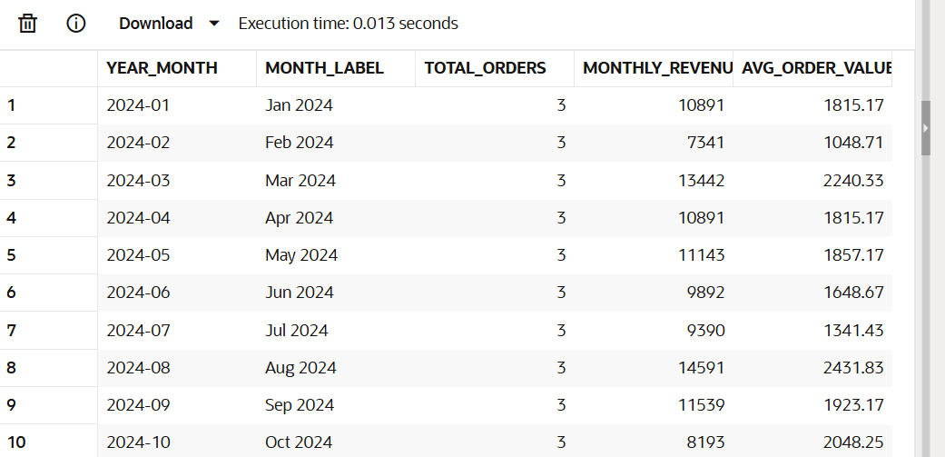
-- 6. renevie growth month over month
SELECT
year_month,
monthly_revenue,
LAG(monthly_revenue) OVER (ORDER BY year_month) AS prev_month_revenue,
ROUND(
(monthly_revenue - LAG(monthly_revenue) OVER (ORDER BY year_month))
/ NULLIF(LAG(monthly_revenue) OVER (ORDER BY year_month), 0) * 100,
2) AS growth_pct
FROM (
SELECT
TO_CHAR(o.order_date, 'YYYY-MM') AS year_month,
SUM(oi.quantity * oi.unitprice) AS monthly_revenue
FROM Orders o
JOIN Order_Item oi ON o.order_id = oi.order_id
WHERE o.status != 'cancelled'
GROUP BY TO_CHAR(o.order_date, 'YYYY-MM')
)
ORDER BY year_month;

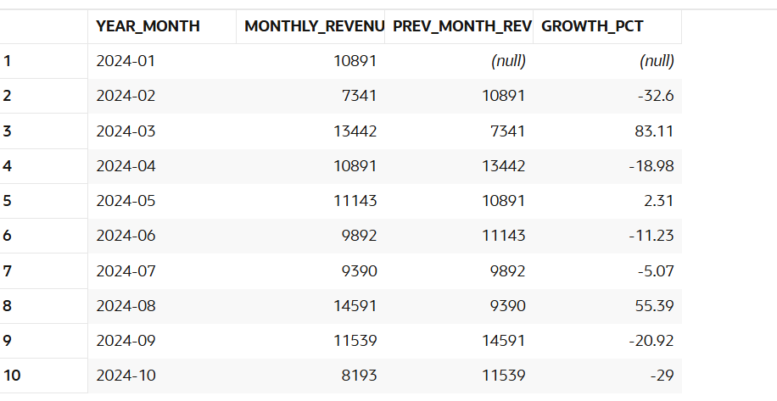

-- 6.volume and revenue per category
SELECT
p.category,
COUNT(DISTINCT oi.item_id) AS line_items_sold,
SUM(oi.quantity) AS total_units,
SUM(oi.quantity * oi.unitprice) AS total_revenue,
ROUND(
SUM(oi.quantity * oi.unitprice)
/ SUM(SUM(oi.quantity * oi.unitprice)) OVER () * 100,
2) AS revenue_share_pct
FROM Product p
JOIN Order_Item oi ON p.product_id = oi.product_id
JOIN Orders o ON oi.order_id = o.order_id
WHERE o.status != 'cancelled'
GROUP BY p.category
ORDER BY total_revenue DESC;
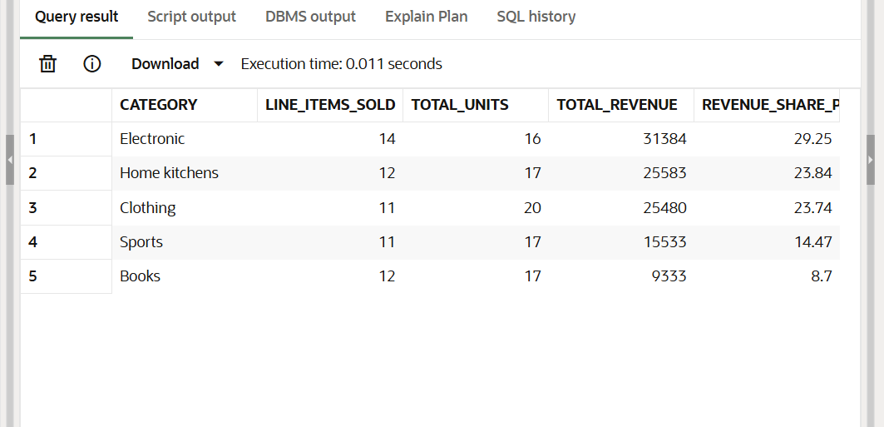
-- 7. bestest product with under each caegory
SELECT *
FROM (
SELECT
p.category,

SUM(oi.quantity * oi.unitprice) AS category_revenue,
RANK() OVER (
PARTITION BY p.category
ORDER BY SUM(oi.quantity * oi.unitprice) DESC
) AS rank_in_category
FROM Product p
JOIN Order_Item oi ON p.product_id = oi.product_id
JOIN Orders o ON oi.order_id = o.order_id
WHERE o.status != 'cancelled'
GROUP BY p.category
)
WHERE rank_in_category = 1
ORDER BY category_revenue DESC;
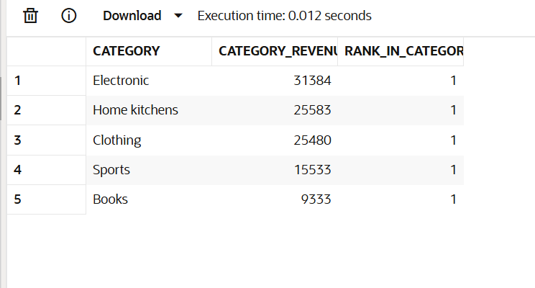

-- 8. cusomerts who have ever placed an order
SELECT
c.customer_id,
c.customer_name,
c.city,
c.signupdate,
'Never Ordered' AS status
FROM Customer c
WHERE c.customer_id NOT IN (
SELECT DISTINCT customer_id FROM Orders
);

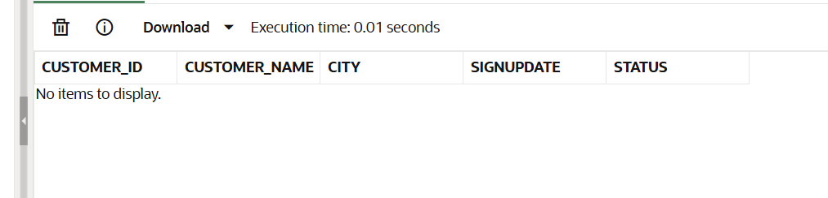

--9. customers who have not placed order for past 180 days
SELECT
c.customer_id,
c.customer_name,
c.city,
MAX(o.order_date) AS last_order_date,
ROUND(SYSDATE - MAX(o.order_date)) AS days_since_last_order
FROM Customer c
JOIN Orders o ON c.customer_id = o.customer_id
GROUP BY c.customer_id, c.customer_name, c.city
HAVING MAX(o.order_date) < SYSDATE - 180
ORDER BY days_since_last_order DESC;

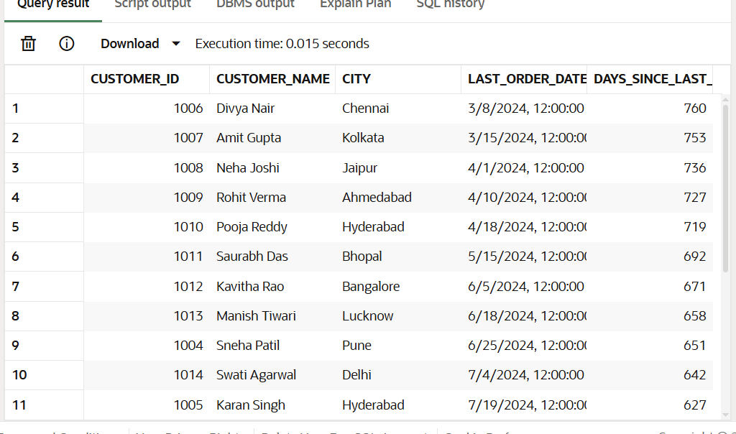

View and stored procedures
-- views 1: full orders summary with customers and revenue detail
CREATE OR REPLACE VIEW vw_order_summary AS
SELECT
o.order_id,
o.order_date,
o.status,
c.customer_id,
c.customer_name AS customer_name,
c.city,
COUNT(oi.item_id) AS total_line_items,
SUM(oi.quantity) AS total_qty,
SUM(oi.quantity * oi.unitprice) AS order_total
FROM Orders o
JOIN Customer c ON o.customer_id = c.customer_id
JOIN Order_Item oi ON o.order_id = oi.order_id
GROUP BY o.order_id, o.order_date, o.status, c.customer_id, c.customer_name, c.city;

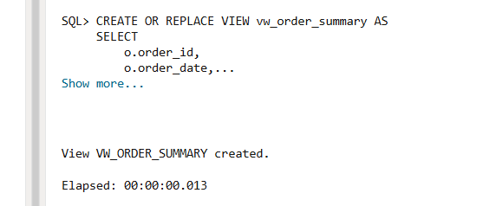

-- view2: Customer 360 view
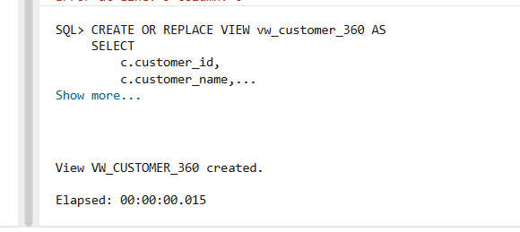

-- PROCEDURE 2: Customer order history lookup
CREATE OR REPLACE PROCEDURE sp_customer_history (
p_customer_id IN Customer.customer_id%TYPE
) IS
v_name Customer.name%TYPE;
v_city Customer.city%TYPE;

CURSOR c_orders IS
SELECT o.order_id, o.order_date, o.status,
SUM(oi.quantity * oi.unitprice) AS order_total
FROM Orders o
JOIN Order_Item oi ON o.order_id = oi.order_id
WHERE o.customer_id = p_customer_id
GROUP BY o.order_id, o.order_date, o.status
ORDER BY o.order_date DESC;
BEGIN
SELECT customer_name, city INTO v_name, v_city
FROM Customer
WHERE customer_id = p_customer_id;

DBMS_OUTPUT.PUT_LINE('Customer: ' || v_name || ' (' || v_city || ')');
DBMS_OUTPUT.PUT_LINE('--------------------------------------------------');

FOR r IN c_orders LOOP
DBMS_OUTPUT.PUT_LINE(
'Order#' || r.order_id ||
' Date: ' || TO_CHAR(r.order_date, 'DD-Mon-YYYY') ||
' Status: ' || RPAD(r.status, 10) ||
' Total: Rs.' || TO_CHAR(r.order_total, '99,999.00')
);
END LOOP;

EXCEPTION
WHEN NO_DATA_FOUND THEN
DBMS_OUTPUT.PUT_LINE('Customer ID ' || p_customer_id || ' not found.');
END sp_customer_history;
/
