2. Digital Signature + QR Code
🔑 Core Idea (PKI System)
- PKI (Public Key Infrastructure) means each institution has:
  - Private key → kept secret by the institution (used for signing).
  - Public key → shared openly (used for verification).
Anything signed by the private key can only be verified with the matching public key.
This ensures that only the issuing institution could have created the signature.

🛠 Process Flow
1. Institution issues a certificate
- The certificate (PDF or JSON record) is taken.
- A hash of the file is created using SHA256. Example:
- 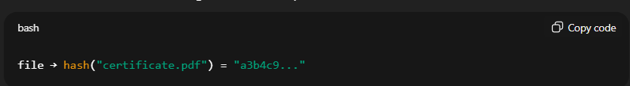
- This hash is then signed using the institution’s private key.
  - Think of this like a digital stamp unique to that institution.
Now we have:
- Certificate file
- Signature (signed hash)

2. Generate QR Code
- A QR code is generated which encodes:
  - Document ID (unique identifier)
  - File hash (shortened)
  - Signature
Example (inside QR):
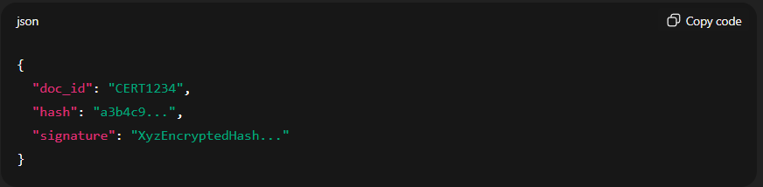
So the QR acts like a portable authenticity token.

3. Verification (Recruiter / University scans QR)
- When someone scans the QR, the system fetches the stored certificate details.
- Steps:
  - Extract the hash and signature from the QR.
  - Use the institution’s public key to verify the signature.
  - Recompute the hash of the actual certificate file.
  - Compare both hashes:
    - If they match → ✅ Certificate is genuine.
    - If not → ❌ It’s been tampered with.

⚙️ Tools & Implementation
🔹 For Digital Signature
- PyCryptodome (Python library for cryptography).
  - Generate keys (RSA 2048).
  - Sign file hash with private key.
  - Verify using public key.
🔹 For QR Code
- Python qrcode library.
  - Simple to generate QR containing JSON data.
  - Can later be scanned and decoded by frontend/mobile app.
🔹 For PKI Infrastructure
- OpenSSL → Generate keys (public/private).
- Store public keys of institutions in your backend DB (so anyone can use them for verification).

✅ Benefits
- Certificates can’t be forged — even if someone edits the PDF, the signature will fail.
- Verification is instant (just scan QR).
- Works offline too (QR already carries necessary data).

