| Which directory can you store system user default files used for creating user directories? | /etc/skel |
| --- | --- |
| What file specifies the order in which to use specified name services? | /etc/nsswitch.conf |
| Free Software Foundation | FSF |
| Format for mounting CD-ROM | * + Mount -t iso9660 /dev/cdrom /mnt/cdrom   + Mount /dev/cdrom   + Mount /mnt/cdrom |
| Linux file systems | mkfs |
| Number of lines count | wc -l |
| Display characteristics of a process | ps |
| Vi editor to replace text from cursor to right. | R |
| Backup over typing error in vi | # |
| What sign is used to erase or kill an entire line you have typed and start when you are on a new line (but not display a new prompt)? | @ |
| Save in vi still be in editing mode | :w |
| Command used to move back to the beginning of the word in vi | b |
| What command is used with the vi editor to search a pattern in the forward direction? | / |
| What command is used to add printing jobs to the queue? | lpr |
| What command is used to remove jobs from the queue? | lprm |
| Protocol allowed the user to retrieve mail from mail server to mail reader. | POP3 |
| Server used with the BIND package | named |
| Squid port by default | 3128 |
| Main Apache configuration file. | /etc/httpd/conf/httpd.conf |
| Command is used to access an SMB(Server Message Block-n/w file sharing protocol) share on a Linux system | smbclient |

| command is used to see the services running in the NFS server? | rpcinfo |
| --- | --- |
| tcp_wrappers file can you specify to allow all connections from all hosts? | /etc/hosts.allow |
| command is used with vi editor to append text at end of line | A |
| Copy directory structures in and out | cpio |
| OSI dialogue control and token management. | Session layer |
| Which of the following NIS clients, finds and stores information about an NIS domain and server? | ypbind |
| What command is used to save the standard output in a file, as well as display it on the terminal? | tee |
| What script is run for setting bash global defaults for all users? | /etc/profile |
| In what file can you specify which users are not allowed to access a system via FTP? | /etc/ftpusers |
| Which program is used to schedule particular jobs or programs at particular times on the system? | cron |
| Which command can force all buffers to disk? | sync |
| How many extended partitions can exist on one drive? | 1 |
| For you to create a swap partition by using fdisk, what must the partition's system ID type be? | 82 |
| What file contains the list of port numbers (and associated names) monitored by inetd? | /etc/services |
| The location of some system configuration and system administrator executable files, is: | /sbin |
| What command is used to count the number of files in the current directory by using pipes? | ls | wc -l |
| LILO -linux loader,Linux bootloader | Is a tool used to boot on x86 h/w |
| How can you rebuild the RPM file to include the new patches? | -- recompile |
| Command used to set user and group quotas. | /sbin/edquota |
| Which file is used to configure which filesystems are mounted? | /etc/fstab |
| Subdirectory contains the device files | /dev |
| Subdirectory contains the system boot scripts | /etc |
| Tool used to check and repair Linux file systems | fsck |
| Tool used for partition hard drive | fdisk |
| System and mail logs found in redhat linux | /var/log |
| What package group will you select during the custom configuration to enable the machine to communicate with Windows clients? | SMB(Samba) Connectivity |
|  |  |
| Main Apache configuration file | httpd.conf |
| Print a file | lp |
| File transfer with minimal capability and minimal overhead. | TFTP |
| Setup firewall on a Linux system | ipchains |
| Automatically install Red Hat Linux on identical hardware | mkkickstart |
| Command used in Vi editor to move the cursor to the left | 00 |
| Command used to add routes to a Linux router | **ip route add** |
| To build a modularized kernel, the kernel-headers and kernel-source packages must first be installed. Where will you find the kernel-headers and kernel-source? | /usr/src/linux |
| After you have compiled your kernel, what do you have to edit to boot your new kernel image? | /etc/lilo.conf |
| To create an installation boot floppy disk from Linux (or another Unix) machine, what command would you use? | dd |
| What are the appropriate Hex codes for setting Linux swap and Linux native partition types in fdisk? | 82 and 83 |
| Format of partition tables Linux use | DOS |
| Which of the following NIS clients returns the name of the NIS server used by the NIS client? | ypwhich |
| Which of the following is not a valid run-level | 8 |
| initrd is a file | Contains root-file system and drivers required to be preloaded during bootup |
| Which is loaded into memory when the system is booted? | KERNEL |
| The process of starting up a computer is known as | Boot Strapping |
| The shell used for Single user mode shell is | sh |
| Which daemon manages the physical memory by moving process from physical memory to swap space when more physical memory is needed. | Swap daemon |
| At the end of kernel bootstrap, which process is started? | /etc/init |
| The process id of init process is: | 1 |
| Which file is read by init to get the default runlevel | /etc/inittab |
| If a program executing in background attempts to read from STDIN | It’s execution is suspended |
| How to run a process in the background? | & |
| When a child process exits before the parent process exits, which of the following is true: | if the parent process does not handle SIGCHLD, the child process becomes a zombie |
| $ a.out &  $ bash  $ a.out &  If the user kills the bash process, then which of the following is true? | init process becomes parent of second a.out process |
| The signal sent to a process when the Ctrl-C key is pressed is | INT |
| we can change the priority of a running process using | renice |
| nohup is used to | continue the process after logout |
| . User’s Primary Group id is listed in which file, at the time of creation of the user (On a standard Unix system) | /etc/passwd |
| A user can change the default log-in shell using | chsh |
| Which of the following identifiers associated with a process decide its privilege level | euid |
| The /etc/passwd file contain | * User name. * Encrypted password. * User ID number (UID) * User's group ID number (GID) * Full name of the user (GECOS) * User home directory. * Login shell. |
| User id 0 is | The id of the root user |
| The login shell is | The shell program that runs when the user logs in |
| By default, a Linux user falls under which group? | same as userid (UPG) |
| $ echo "The process id is" $$$$ | The process id is <pid><pid> |
| While executing a command, the shell | Creates a child shell to execute it |
| Which variable contains current shell process id | $$ |
| Which command is used to debug a shell script program | set -x |
| For every successful login, which script will be executed? | /etc/profile |
| a file with execute permissions set, but with unknown file format is executed | The current shell will try to execute it |
| $ cd project/module1  $ pwd | /home/bhojas/project/module1 |
| cmd 2>&1 > abc will | Write standard output to abc & standard error to monitor |
| cmd > abc 2>&1 wil | Write standard output and standard error to abc |
| method for appending “foo” in /tmp/bar file? | echo foo >> /tmp/bar |
| Syntax to suppress the display of command error to monitor? | command 2> /dev/null |
| cat /etc/password > /dev/sda as superuser will | Write data to the physical device sda |
| The $ variables in a shell script context designates | PID of the shell running the script |
| display number of arguments specified in command line | $# |
| variable contains last background job process id | $! |
| ? Specifies | one character |
| * Specifies | zero or more character |
| Which of the following file set in the current directory are identified by the regular expression a?b* | aabb, axbc |
| Output of echo linux $0 | linux bash |
| display the list of the positional parameters? | $* |
| search for a blank line in a file? | $ grep “^$” file |
| Output of $ grep –c “^echo” abc | The count of lines which begin with the pattern echo in file abc |
| Which one is used to select only one copy of the repeated lines? | uniq -u |
| Indicate the right option to search for BOB, Bob, BOb or BoB? | grep ‘B[oO][bB]’ files |
| Indicate the right option to search for anything not a letter or number | grep ‘[^a-zA-Z0-9]’ |
| How do you remove duplicate lines from the file foo using uniq? | sort foo | uniq –u |
| who | cut –d ” ” -f1  what is the output if the who command displays like this  user1 tty 0 1234 | user1 |
| the command that can print lines of the first file matching with the second file? | comm |
| character to use to escape the meaning of special characters in search operations? | backslash (\) |
| When the return value of any function is not specified within the function, what function returns? | exit status of the last command executed |
| 1. #!/bin/bash 2. var[1]=san_1 3. var[2]=san_2 4. var[3]=san_3 5. echo ${var[*]} 6. exit 0 | All items of an array can be accessed by using ${[*]} or ${[@]}.  san_1 san_2 san_3 |
| 1. #!/bin/bash 2. san_var=hello 3. readonly san_var 4. san_var=hi 5. echo $san_var 6. exit 0 | hello |
| Which built-in command performs integer arithmetic in bash shell? | let |
| Which expression use the value of the enclosed arithmetic expression? | $(()) |
| If a and b are 2 variables then the meaning of a<<=b i | a = a << b |
| bitwise ‘exclusive or’ operator? | ^= |
| 1. #!/bin/bash 2. a=10; b=20 3. c=$((++a)) 4. let a=c+a 5. echo $a 6. exit 0 | 22 |
| fc stands for | both find & fix command |
| re-execute the previous command? | Ans→ !!  :’!cat’ will re-execute the last cat command, ‘!3’ will re-execute the third last command and ‘!$’ will execute the last argument of previous command. |
| Which command terminates a running process by name of the process? | killall |
| The command ‘compgen -c’ shows | full list of all commands |
| The command ‘disown -r’ | removes all running jobs |
| Which command can create an environment variable? | export |
| The command ‘enable -n ‘ | disables the specified built-in command |
| Which command concatenates the specified argument into a single command, then executes the command? | eval |
| The ‘logout’ built in command is used to | to exit the current shell |
| The command ‘umask -S’ | prints the current mask using symbolic notation |
| Which option of the kill command sends the given signal name to the specified process? | -s |
| Which command puts a script to sleep until a signal is received? | suspend |
| . Which option of the command ‘cd’ uses the actual filesystem path for cd.. and the value of pwd? | -P |
| Which command executes ‘command’ in place of the current process instead of creating a new process? | exec |
| Which command will delete all the blank lines in file old.txt? | sed ‘/^$/d’ old.txt |
| What is the meaning of $ sign in awk programming? | we are refering to a field or column in the current line |
| In awk program, the statement “print” with no items | is equivalent to “print $0” & prints the entire current record |
| The command “awk {print $1} san.txt” will | print the first field of every line in san.txt |
| What is the output of the command awk ‘BEGIN {printf “%c\n”,65}’ | A |
| . All numeric values are represented within awk in | double precision floating point |
| The comparison expression “x ~ y” will true if | the string x matches the regular expression denoted by y |
|  |  |
|  |  |
|  |  |
|  |  |
|  |  |
|  |  |
|  |  |
|  |  |
|  |  |

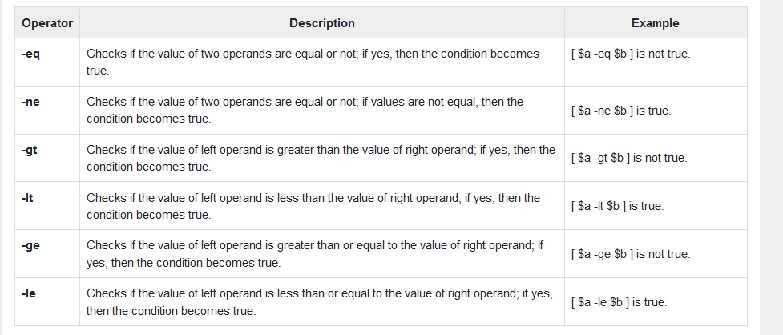

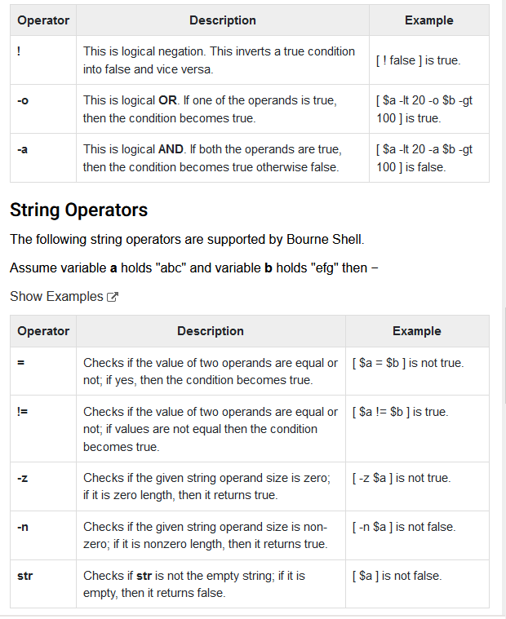

Perl variables have no type and no initialization. Both the strings and numbers can be as large as our machine permits.

substr function is also used to alter an existing string

$x= “abcdijklm”

substr($x,4,0)= “efgh” ; // stuff $x with efgh without replacing any charcaters

print “$x” ; //$x is now abcdefghijklm

\s - a whitespace character

\d - a digit

\w - a word character

We can specify filenames in the command line using perl.

perl -e ‘print while (<>)’ dept.lst // file opening implied

The command @x=(1. .10) will assign the first ten integer values to the array ‘a’.

Until loop in Perl is an entry-controlled loop with acts just opposite to while loop i.e., the code inside the loop will run if the condition inside it is false.

Perl is widely known as "[the duct-tape of the Interne](https://www.google.com/search?q=the%20duct-tape%20of%20the%20Internet)t”

| To test whether perl is in your PATH, use ____ | perl -e |
| --- | --- |
| ___ function is used for removing the last character from the line. | chop |
| When a string is used for numeral computations, perl converts it into ___ | number |
| If a variable is undefined, its value is __ | 0 |
| concatenation operators? | . (dot) |
| To repeat a string, perl uses ___ operator. | x operator  $ perl -e ‘print “*” x 10 ;’  ********** |
| function is used by perl for displaying the length of a string? | Length  $x= “Abdullah”;  print length($x); // prints 8 |
| ___ function returns the first occurrence of a character in a string | Index  $x= “Abdullah”;  print index($x,u); // prints 3 |
| For extracting a substring, ____ function is used. | substr |
| Which function is used by perl for reversing a string? | Reverse  $x= “abcd” ;  print reverse($x) ; / prints dcba |
| Which function is used for handling substitutions in perl? | tr and s |
| Which of the following is referred to as the default variable? | $_ |
| ___ operator is used for selecting the current line number. | $. |
| ___ is known as a range operator. | . . |
| The ___ prefix to an array name signifies the last index of the array. | $#,It is always one less than the size of the array |
| For deleting the elements from the left of the array ___ function is used. | shift |
| For deleting the elements from the right of the array ___ function is used. | Pop  **@list= (3. .5,9) ; // this is 3,4,5,9**  **pop(@list) // now it is 3,4,5** |
| To add elements to the left side of the array ____ function is used. | Unshift  @list= (5,9) ; // this is 5,9  unshift( @list,1. .3) ; // now it becomes 1,2,3,5,9 |
| To add elements to the right side of the array ____ function is used. | Push |
| Which function can combine the functionalities of push, pop, unshift and shift? | splice |

| for looping in a list, ____ is used. | foreach |
| --- | --- |
| perl is ____ of grep, tr, sed and awk. | superset |
| perl -e ‘print “UNIX” x 10 . “\n” ;’ | Display UNIX 10 times |
| my %fruit_color = (  apple => "red",  banana => "yellow",  ); | $fruit_color{"apple"};  #gives "red" |
| **What is the syntax to create multiline comments in Perl?** | =begin  =cut |
| **What is the correct syntax for defining a class in Perl?** | package class_name |
| **What is the correct syntax for creating a new object in Perl?** | my object_name = new class_name() |
| **Destructor's in Perl are _** | Used for cleanup of reference of objects |
| **What is method overwriting in Perl?** | Filling up method with extra written data |
| Run time polymorphism is implemented in Perl using method overwriting. | True |
| **Encapsulation is also known as?** | Data hiding |
| **Which statement is used to enable strict mode in Perl?** | use strict; |
| There is no boolean type in Perl. | true |
| 100 << 3 | 800 |
| **Scalar variables in Perl are _** | A Single unit of data |
| **Global scope variables can be used** | Inside any function or bloc |
| **Our' keyword is used to** | Create an alias to package |
| **What is a module in Perl?** | Collection of related subroutines and variables |
| **Which statement in Perl is used to import a module?** | use module_name |
| **Which escape sequence is used to print the hexadecimal of a number in Perl?** | %x |

| **What is a directory in Perl?** | A place to store values in the form of a list |
| --- | --- |
| **Which method in Perl is used to delete a directory?** | rmdir |
| **Arguments in Perl are passed as** | Array |
| **A built-in subroutine which is used inside the method is?** | Trait |
| **What are references in Perl?** | A way to access data with another variable |
| **The return() function in Perl is _** | eturn value at the end of subroutines |
| **List context of the returned value from a subroutine is extracted using** | @ |
| **What is recursion in Perl?** | Mechanism of a function calling itself again from its body |
| **Which of the following methods is used to display expressions in Perl?** | say() |
| **The print method in Perl return _** | boolean value |
| **STDIN in Perl stands for __** | STandarD INput |
| **foreach loop can iterate over** | List |
| **While in Perl is entry controlled?** | Yes |
| $a = **8**;  **until** ($a <= **7**){  **print** "Value of a = $a\n";  $a = $a - **1**;  } | Value of a = 8 |
| **What is a given-when statement in Perl?** | Multiway branch statement |
| **Is the Redo operator in Perl used?** | Jump the flow to the given label skipping the current block execution |
| **Which keyword is used to make the current iteration last?** | last |
| **Which of these is a type of the scalar in Perl?** | String |
| **The % sign in Perl is used to __** | Declare a hash |
| **Array in Perl created using?** | @ |

| **Which is a valid way to extract the size of an array in Perl?** | $size = scalar @array_name |
| --- | --- |
| **What is a hash in Perl?** | Set of key-value pair |
| %lang = ('Perl' => **4**, 'Python' => **2**, 'Javascript' => **5**);  @arr = values %lang;  **print** @arr | 425 |
| **Operations of Perl hashes are** | Accessing value,Updating value,Iteration |
| **The $ in Perl is used to create _** | Scalar |
| **Which of these types of string are interpolated?** | Double quoted |
| **The 'It' operator of string is used to _** | Check if the string to its left is stringwise less than string to its left |
| Which of the following statements causes the loop to skip the remainder of its body and immediately retest its condition prior to reiterating? | next |
| The default path to perl in Unix is | /usr/bin/perl |
| Which of the following method remove the elements of @ARRAY designated by OFFSET and LENGTH, and replaces them with LIST, if specified? | splice @ARRAY, OFFSET [ , LENGTH [ , LIST ] ] |
| To verify if the variable $str contains the word “test” you would use | if ($str = ~/test/) |
| What is the facility that allows nesting one select statement into another? | subquerying |
|  |  |
|  |  |
|  |  |
|  |  |
|  |  |
|  |  |
|  |  |
|  |  |