



ZOMATO RESTAURANTS EXPANSION ANALYSIS



SPREADSHEET PROJECT
By
CharuTrishoola Mohan Udaiyar
23/10/2025

Problem Statement
You are hired as a consultant data analyst by Zomato where the team is looking for expansion and opening more restaurants. Your task is to develop strategies/suggestions for opening newer restaurants.

Table of Contents
- Objective Question & Answer
- Subjective Question & Answer

Objective Q&A

Q1. What is the total number of tables present in the data?
There are three tables in the dataset, each located in a different worksheet:
- Raw Data
- Country Description
- Currency Lookup
Explanation:
The original dataset included two tables: Raw Data and Country Description.
To support currency standardization and conversions, I additionally created a third table called Currency Lookup in a new sheet.
A separate worksheet named Clean Zomato Data was created to perform all cleaning, transformations, and calculations; however, it is not counted as one of the original tables.

Q2. What is the total number of attributes present in the data?
The dataset contains 28 attributes (columns) in total.

Q3. How many categorical columns are there in the data?
There are 13 categorical columns in the dataset.
Explanation:
Categorical data represent descriptive attributes or labels that fall into distinct groups and do not carry numerical meaning.
These columns typically include:
- Text values
- Yes/No indicators
- Country or city names
- Restaurant categories, etc.
The dataset contains 13 such fields that classify data rather than quantify it.
Q4. The data consists of some inconsistent and missing values. How did you clean the data for further analysis?
The dataset contained inconsistent entries and missing values, which were cleaned systematically to ensure accurate analysis.
Steps Taken for Data Cleaning:
- Removed Duplicates
  - Used Data → Remove Duplicates to eliminate repeated records.
- Handled Missing Values
  - Blank Ratings: Replaced with the average rating of the dataset.
  - Missing Country or City Names: Filled manually using contextual information from nearby rows.
- Identified Missing Cuisines
  - Found 9 missing entries in both Cuisines and Updated Cuisines columns.
  - Addressed these before further processing.
- Standardized Currency Values
  - To compare restaurant costs across countries, created two helper columns:
    - Rate_to_INR
    - Cost_to_INR
  - Added a new sheet Currency Lookup with exchange rates.
  - Used lookup functions to standardize Average Cost for Two into Indian Rupees (INR).
This cleaning process ensured that the dataset was consistent, complete, and suitable for accurate visualizations and analysis.
Q5. Using Lookup functions, how did you fill in the country names in the original data using the country code?
I used the VLOOKUP function to map each country code in the dataset to its corresponding country name stored in the “Country Description” sheet.
Formula Used:
=VLOOKUP(C2, '2.Country Discription'!$A$1:$B$16, 2, 0)
Explanation:
- Column C contained the Country Code.
- The lookup table in the Country Description sheet (Columns A–B) includes the mapping of country codes to country names.
- 2 specifies that the country name is in the second column of the lookup range.
- 0 (or FALSE) ensures an exact match.
This formula was applied to Column D in the Clean Zomato Data worksheet to automatically fill in the country names accurately.
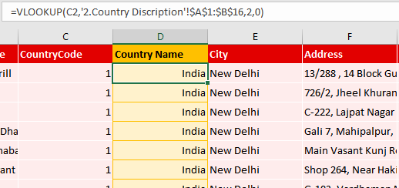

Q6. Create a table to represent the number of restaurants opened in each country.
I created a PivotTable titled “Number of Restaurants by Country” to display how many restaurants are listed in each country.
Steps Followed:
- Selected the entire cleaned and updated dataset.
- Went to Insert → PivotTable.
- Placed the PivotTable in the same worksheet (4. Analysis of Data).
- Configured the PivotTable Fields:
  - Dragged Country into the Rows section.
  - Dragged Restaurant ID into the Values section.
  - Changed the aggregation to COUNT, so it counts the number of restaurants in each country.
- Applied clean formatting to make the table easy to read.
- Added supporting charts and tables in the same sheet to visually represent restaurant distribution across countries.
Location:
This PivotTable is available in Sheet 4: Analysis of Data.
(Screenshots of these charts & tables.)

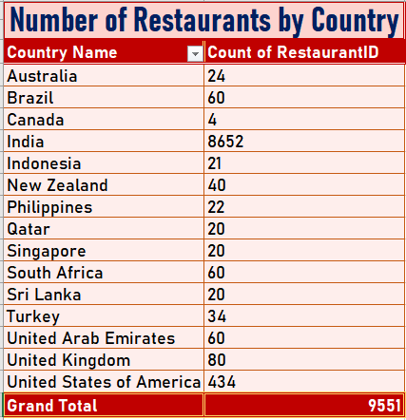
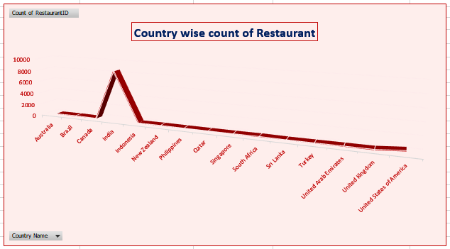

Q7. The management wants to see the number of restaurants opened each year. How did you provide this information?
I created a PivotTable titled “Number of Restaurants by Year” to show how many restaurants were opened in each year represented in the dataset.
Steps Followed:
- Selected the complete cleaned dataset.
- Navigated to Insert → PivotTable.
- Inserted the PivotTable in the same worksheet (4. Analysis of Data).
- Configured the PivotTable Fields:
  - Dragged Year into the Rows area.
  - Dragged Restaurant ID into the Values area.
  - Set the value field to COUNT, so it counts the number of restaurants opened each year.
- Applied clear and neat formatting to make the table easy to read and suitable for management review.
Location:
This table is available in Sheet 4: Analysis of Data, along with the visual charts created for better interpretation.
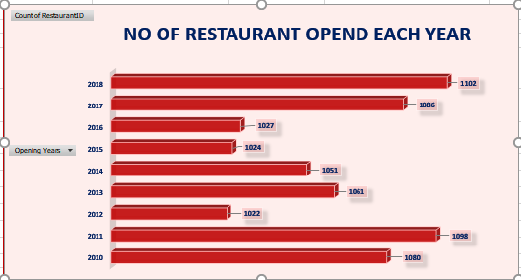
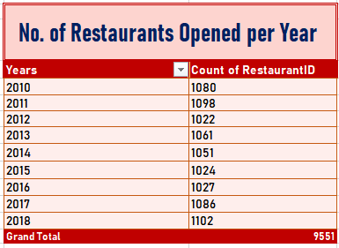
(Screenshots of these charts & tables.)

Q8. What is the total number of restaurants in India in the price range of 4?
There are 388 restaurants in India that fall under Price Range 4.
How it was calculated:
- Applied a filter on the dataset for:
  - Country = India
  - Price Range = 4
- The filtered results showed a total count of 388 restaurants.
Location:
This finding is recorded in Sheet 4: Analysis of Data.
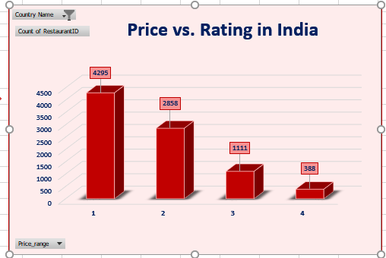
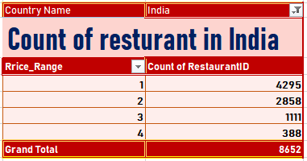
(Screenshots of these charts & tables.)

Q9. What is the average number of voters for the restaurants in each country?

I calculated the average voter count per country using a PivotTable.

Steps Followed:
- Selected the cleaned dataset.
- Used Insert → PivotTable and placed it in “4. Analysis of Data.”
- Configured the PivotTable Fields:
  - Dragged Country into the Rows area.
  - Dragged Votes into the Values area.
  - Changed the aggregation from SUM (default) to AVERAGE to compute the average number of voters per country.

This provided a clear comparison of voter engagement across different countries.

Location:
Sheet 4. Analysis of Data
(Screenshots of these charts & tables.)
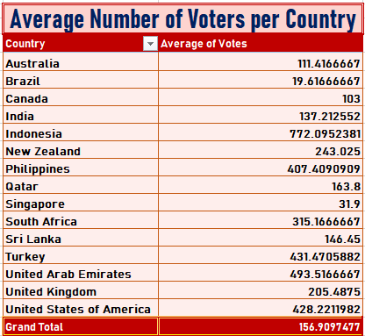
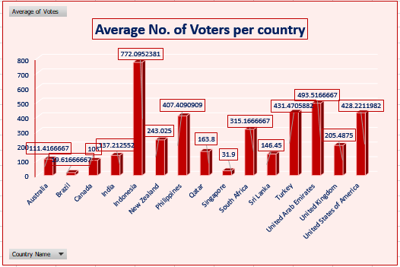

Q10. Calculate the average rating for all the restaurants that have price_range < 4 and provide online delivery. Use only the “IF” function, logical operators, and aggregation functions. (No conditional aggregation allowed)
To solve this, I created a dedicated worksheet named “Average Rating” to keep the calculation clear and separate from the main dataset.
Since conditional aggregation functions such as AVERAGEIFS were not allowed, I used a combination of:
- IF function
- Logical operators (* acting as AND)
- AVERAGE function
This method allows Excel to evaluate only those rows that meet both required criteria:
- price_range < 4
- restaurant provides online delivery

Formula Used (Array Formula):
=AVERAGE(IF((--('1.Clean_Zomato_Data'!$T$2:$T$9552 < 4)) *
(--('1.Clean_Zomato_Data'!$P$2:$P$9552 = "Yes")),
'1.Clean_Zomato_Data'!$Z$2:$Z$9552))

Explanation of the Approach:
- The IF function returns the rating only for rows where both conditions are satisfied.
- -- converts TRUE/FALSE results into 1 and 0, allowing multiplication to act as a logical AND.
- The AVERAGE function then computes the mean of all qualifying ratings.
- This is an array formula, so in older Excel versions it must be entered using:
Ctrl + Shift + Enter.

Q11. Using conditional formatting, highlight the rows of restaurants that are located in the recommended countries or cities.
I applied Conditional Formatting to highlight restaurants located in the recommended expansion countries:
- Australia
- Canada
- Singapore
- Brazil
- Sri Lanka
Steps Followed:
- Selected the restaurant rows in the Cleaned Dataset.
- Went to Home → Conditional Formatting → New Rule.
- Choose “Format only cells that contain”.
- Set the condition to highlight rows where Country equals any of the recommended countries.
- Applied a fill color to visually distinguish these rows.
- Ensured consistency by applying the rule across the entire dataset.
This helped easily identify priority markets for opening new restaurants.
Q12. Create a new customized price column that combines the currency symbol with the Average Cost for Two.
To create a combined price field, I used string concatenation to merge the currency and average cost values.
Formula Used:
=CONCATENATE(M:M, " ", V:V)
- Column M contains currency name and symbol.
- Column V contains Average Cost for Two.
This produces entries such as:
- "IndianRupees(Rs.) 850"
- "Dollar($) 40"
A new column titled “Customized Price” was added in the Clean Zomato Data worksheet to store the result.

Q13. Create an array/count formula to calculate restaurants that do not offer online delivery, are in the lowest price range, and cost ≤ ₹250.
The total count of restaurants meeting these three criteria is 1694.
Formula Used:
=COUNTIFS('1.Clean Zomato Data'!Q:Q,"0",
'1.Clean Zomato Data'!T:T,1,
'1.Clean Zomato Data'!AA:AA,"<=250")
This formula returns the number of restaurants that:
- Do not offer online delivery (Q = 0)
- Are in the lowest price range (T = 1)
- Have an Average Cost for Two ≤ ₹250 (after INR conversion)
This helps identify offline, low-cost restaurants that are good candidates for online delivery expansion.

Subjective Q&A

Q1. Suggest a few countries where the team can open newer restaurants with lesser competition. Which visualization/technique will you use here to justify the suggestions?

1. Approach With Criteria and Constraints
To identify countries with lower competition and higher potential for expansion, I used two evaluation criteria:
- Competition Level: determined using Count of Restaurant IDs
- Customer Satisfaction: determined using Average Rating
I created PivotTables where Country was placed in the Rows field and the Values field contained:
- Count of Restaurant IDs
- Average of Ratings
This allowed me to analyze both competition and satisfaction simultaneously.
I also used supporting formulas such as:
- =COUNTIF('1.Clean_Zomato_Data'!$D:$D,"Australia")
- =AVERAGEIF('1.Clean_Zomato_Data'!$D:$D,"Australia",'1.Clean_Zomato_Data'!$Z:$Z)
These helped validate PivotTable results individually for each country.
2. Reference (Screenshots of PivotTables & Charts Created)
In the sheet “5. Suggesting_Countries”, I inserted:
- PivotTable 1:
  - Country (Rows)
  - Count of Restaurant IDs (Values)
- PivotTable 2:
  - Country (Rows)
  - Average of Ratings (Values)
To support the insights visually, I used:
- Clustered Column Chart → representing count of restaurants (competition)
- Line with Markers Chart → representing average ratings (customer satisfaction)
(Screenshots of these charts & tables.)

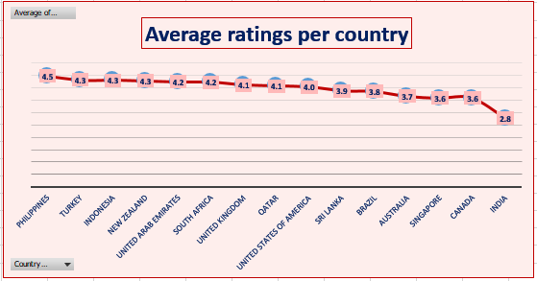

3. Insights Based on the Data
- Countries with low restaurant count indicate less competition and opportunities for new entries.
- Countries where the average rating is below 4 show that customers are not fully satisfied with existing restaurant options.
- When both conditions appear together (few restaurants + lower ratings), it signals high potential for Zomato to introduce better-quality restaurants.
From the PivotTable observations, several countries had:
- Restaurant count below 25
- Average rating below 4
This suggests inadequate competition and unsatisfied customers, creating a market gap Zomato can fill.

4. Recommendations Accordingly

Recommended Countries for Opening New Restaurants
- Australia
- Brazil
- Canada
- Singapore
- Sri Lanka
These countries meet both conditions:
- Low competition (low restaurant count)
- Lower ratings (customer dissatisfaction)
By entering these markets, Zomato can study the causes of lower customer satisfaction and introduce superior dining experiences.
5. Recommended Visualization Technique
To justify these suggestions clearly, I used a Combo Visualization:
- Clustered Column Chart → shows restaurant count by country
- Line Chart with Markers → shows average ratings
This combination helps compare competition and customer satisfaction in a single visual view and supports the final country recommendations.
Q2. Come up with the names of States and cities in the suggested countries suitable for opening restaurants.

1. Approach With Criteria and Constraints
Since the dataset does not include state names, I focused only on cities within the countries recommended in Question 1 (Australia, Brazil, Canada, Singapore, Sri Lanka).
To identify ideal cities for new restaurant openings, I used three key criteria:
- Count of Restaurant IDs → To evaluate competition (lower count = lower competition)
- Has Online Delivery → To understand availability of modern service options
- Average Rating → To assess customer satisfaction levels
A city was considered suitable if it had:
- A low number of restaurants
- Lower ratings (indicating market dissatisfaction)
- Online delivery available (optional but beneficial for Zomato’s model)

2. Reference (PivotTable & Sheet Used)
I created a PivotTable in the sheet “6. Suggested_Cities”:
- Rows:
  - Country
  - City
- Values:
  - Count of Restaurant ID
  - Count of Has Online Delivery
  - Average of Ratings
This PivotTable allowed me to compare city-level data within the selected countries.
A header titled “Suggested Cities from Suggested Countries” was placed above the PivotTable for clarity.
(Screenshots of these charts & tables.)
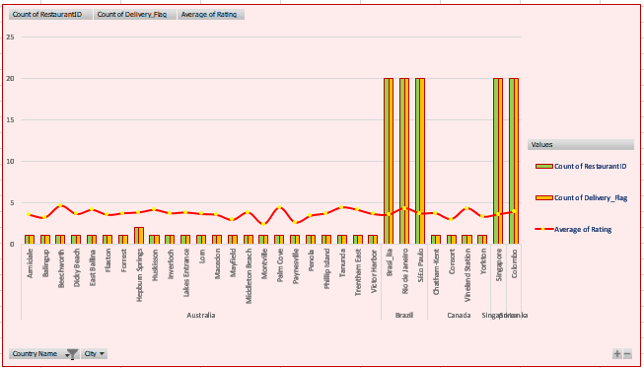

3. Insights Based on the Data
From the PivotTable analysis:
Australia
- Cities such as Flaxton, Macedon, Penola, and a few others show:
  - Very few restaurants
  - Low to mid ratings
  - Opportunity due to limited competition

Brazil
- São Paulo (Paulo) has:
  - Lower ratings despite being a major city
  - Small enough restaurant count in the dataset to consider targeted entry

Canada
- Yorkton and Consort show:
  - Low restaurant density
  - Ratings that indicate customer dissatisfaction
  - Good scope for improving food quality and service

Sri Lanka
- Colombo demonstrates:
  - Low-to-moderate ratings
  - Existing online delivery presence
  - High potential for Zomato-backed quality improvements

Singapore
- Singapore (city) has:
  - Limited restaurants in the dataset
  - Ratings below optimal
  - Scope for high-quality new entries
Across all these cities, the common pattern was:
Low competition + low ratings + online delivery presence = high-opportunity zones

4. Recommendations Accordingly

Recommended Cities for New Restaurants
Country | Recommended Cities
Australia | Flaxton, Macedon, Penola, and similar low-density cities
Brazil | São Paulo
Canada | Yorkton, Consort
Sri Lanka | Colombo
Singapore | Singapore (city)

Why these cities?
- They show low restaurant presence, meaning lower competition
- Ratings are not very high, indicating customer dissatisfaction with existing options
- In some cities, online delivery is already present, making expansion easier
- Markets have room for better-quality dining experiences, which Zomato can introduce
Q3. According to the countries you suggested, what is the current quality regarding ratings for restaurants that are open there?

1. Approach with Criteria and Constraints
To evaluate the current quality of restaurants in the suggested countries, I focused on two key measures:
- Average Rating → indicates customer satisfaction
- Average Cost for Two (converted to INR) → indicates pricing expectations and affordability
These two factors together help determine whether existing restaurants in those countries are performing well or whether gaps exist that Zomato can target.
I used PivotTables to compute the averages for each of these variables.

2. Reference (PivotTables & Charts Used)
In the sheet “7. Quality_Regarding_Rating”, I created:

PivotTable Setup:
- Rows:
  - Suggested Countries (Australia, Brazil, Canada, Singapore, Sri Lanka)
- Values:
  - Average of Rating
  - Average of Cost_to_INR
I then built a combo chart to visualize the relationship:
- Clustered Column Chart → represents Average Cost_to_INR
- Stacked Line with Markers → represents Average Rating
This visualization helps compare affordability and customer satisfaction simultaneously.
(Screenshots of these charts & tables.)
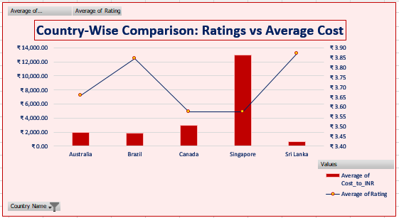

3. Insights Based on the Data
From the PivotTable and combo chart:
- Countries with lower average cost tended to have higher ratings, indicating customers appreciate affordability.
- Countries with higher average cost generally had lower satisfaction, pointing to price–value mismatch.
- Some countries show potential for correction—customers expect better quality for the price they pay.
- This relationship suggests that pricing strategy plays a large role in shaping customer satisfaction in these markets.
In summary:
Lower cost often corresponds with higher ratings
Higher cost leads to customer dissatisfaction unless balanced with quality

4. Recommendations Accordingly
Based on the results:

Pricing Strategy Recommendation
- New restaurants should start with competitive pricing (slightly below current market averages).
- Once a strong rating base is established, prices can be gradually adjusted while ensuring quality stays consistent.

Operational Recommendation
- Maintain a balance between cost and customer experience, because:
  - Too low a price → may reduce revenue
  - Too high a price → may reduce ratings and customer retention

Expansion Recommendation
- Focus on countries where cost-to-rating imbalance is high, because these markets show clear opportunities for providing better value.

Q4. What is the current expenditure on food in the suggested countries, so we can keep our financial expenditure in control?

1. Approach with Criteria and Constraints
To understand the food expenditure patterns in the suggested countries (Australia, Brazil, Canada, Singapore, Sri Lanka), I analyzed three key metrics:
- Count of Restaurants → indicates market size
- Average Price Range → shows affordability level
- Average Cost to INR (Cost_of_Two) → indicates typical spending behaviour
I created a PivotTable to combine these measures and estimate per-country food expenditure levels.
To calculate the approximate expenditure for each country, I used the formula:
=GETPIVOTDATA("No. of Restaurants",$A$3,"Country Name","Singapore")
*
GETPIVOTDATA("Average of Cost_to_INR",$A$3,"Country Name","Singapore")
This multiplies the total number of restaurants with their average cost-to-INR value, giving a relative indication of overall food spending in that country.

2. Reference (PivotTable & Charts Used)
In the sheet “8. Analysis_of_Food_Expenditure”, I designed a PivotTable with:
- Rows:
  - Country Name
- Values:
  - Count of Restaurant IDs
  - Average of Price Range
  - Average of Cost_to_INR
To visualize the proportion of food expenditure across countries, I used:

Visualization Used
- Pie Chart → to represent relative contribution of each country to total food expenditure.
(Screenshots of these charts & tables.)
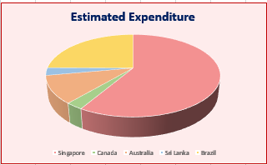
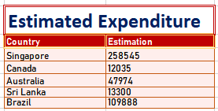

3. Insights Based on the Data
From the PivotTable analysis:
- Countries with a higher number of restaurants and higher average cost-to-INR naturally show greater food expenditure.
- Premium markets like Singapore may show high per-restaurant cost, even if the number of restaurants is lower.
- Countries like Australia and Canada show moderate expenditure, indicating balanced pricing but still room for new entrants.
- Brazil and Sri Lanka appear cost-efficient markets, where the expenditure is comparatively lower — useful for cost-controlled entry strategies.
This comparison helps identify which countries require higher financial investment and which ones are budget-friendly for expansion.

4. Recommendations Accordingly

Market Entry Strategy
- High-expenditure countries (e.g., Singapore):
Enter with carefully optimized costs and premium-quality offerings.
- Medium-expenditure countries (e.g., Australia, Canada):
Suitable for launching moderately priced restaurants with good ROI potential.
- Low-expenditure countries (e.g., Brazil, Sri Lanka):
Best for cost-effective expansion with lower financial risk and high growth potential.

Budget Planning Recommendation
Zomato should allocate a tiered investment budget, focusing on:
- Lower-cost markets for rapid onboarding, and
- Higher-cost markets for quality-first launches.
This helps maintain financial control while expanding strategically.
Q5. Come up with the names of restaurants from the recommended states/cities that are our biggest competitors and also those that fall in the low rating brackets (1–2 or 2–3).

1. Approach with Criteria and Constraints
To identify major competitors and low-performing restaurants across the recommended countries, I used two key metrics:
- Average Rating → to classify restaurants into:
  - High performers (big competitors)
  - Low performers (rating between 1–3)
- Average Voters → to measure customer engagement and reliability of ratings
A restaurant with high ratings + high voter count qualifies as a major competitor.
A restaurant with low ratings (1–3) indicates poor performance and potential improvement or cleanup opportunities.
I used a PivotTable to filter restaurants only from the recommended countries.

2. Reference (PivotTable & Sheet Used)
In the sheet “9. Analysis_Of_Competitors”, the PivotTable was structured as:
- Rows:
  - Country
  - Restaurant Name
- Values:
  - Average Rating
  - Average Voters
This helped in simultaneously evaluating customer satisfaction (ratings) and customer engagement (votes).
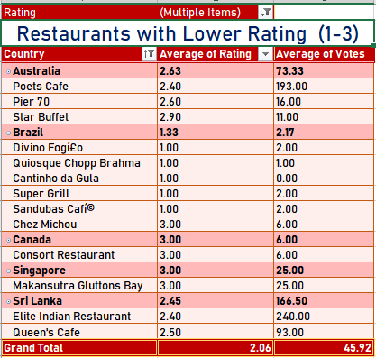
(Screenshots of these charts & tables.)
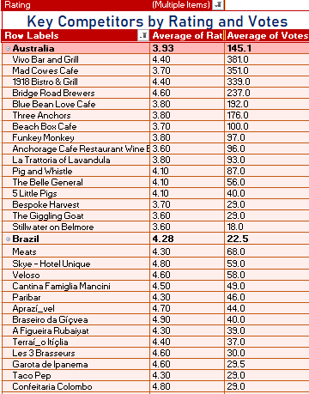

3. Insights Based on the Data

A. Top Competitors (High Rating + High Votes)
These restaurants show strong performance and are major competitors in their regions:
- Bridge Road Brewers (Australia) – High rating & strong vote count
- Vivo Bar and Grill (Canada)
- Ministry of Crab (Sri Lanka)
These restaurants have ratings above 4.0 and 150–380+ votes, indicating strong popularity and consistent customer satisfaction.

B. Overall Quality Issues in Suggested Countries

1. Brazil – Most Critical
- 5 out of 6 restaurants rated 1.0, indicating serious quality and reliability problems.
- This market needs immediate corrective attention.

2. Australia & Sri Lanka – Mid–Low Ratings
- Australia ratings: 2.6–2.9, indicating inconsistent service.
- Sri Lanka ratings: Similar mid-low, but with higher customer engagement (e.g., Elite Indian Restaurant with 240 votes).

3. High Votes + Low Ratings = Red Flag
- Poets Café (Australia) – many votes but rating around 2.4–2.6
- Elite Indian Restaurant (Sri Lanka) – high engagement but poor ratings
This means customers are consistently dissatisfied despite high visitation.

C. Low-Performing Restaurants (Rating 1–3)
Across all recommended countries, many restaurants fall in the 1.0 to 3.0 rating range, with an overall average of 2.1.
This clearly indicates poor customer experience and unmet expectations, creating a major opportunity for Zomato to introduce better-quality restaurants.

4. Recommendations Accordingly

1. Immediate Quality Review in Brazil
Because Brazil has the lowest performance, Zomato should:
- Conduct partner quality audits
- Remove consistently poor-performing restaurants
- Onboard better-quality alternatives
Brazil shows urgent need for improvement.

2. Support High-Engagement but Low-Rated Restaurants
Restaurants like Poets Café and Elite Indian Restaurant have high customer engagement but poor ratings.
They should undergo:
- Staff retraining
- Menu restructuring
- Service quality assessments
These restaurants have potential if fixed.

3. Strategic Focus on Mid-Tier Markets
Countries like Australia and Sri Lanka have:
- Moderate restaurant density
- Mid-low ratings
Zomato should:
- Onboard promising new restaurants
- Promote any existing 4.0+ performers
- Improve underperforming ones to boost market reputation

4. Reputation Risk Management
Restaurants in the 1–3 rating bracket need continuous monitoring.
Zomato should set:
- Automated alerts for low ratings
- Performance thresholds for retention
- Regular quality checks in global markets
Poor performers can negatively affect Zomato’s brand perception.

Q6. Which cuisines should we focus on in the newer restaurants to get better feedback? Does the choice of cuisines affect the restaurant ratings?

1. Approach with Criteria and Constraints
To understand which cuisines perform better and how cuisine selection impacts ratings, I analyzed:
- Average Rating by Cuisine
- Cuisine preferences within each recommended country
However, the dataset contains multiple cuisines in a single cell (e.g., “North Indian, South Indian”).
To maintain a one-to-one relationship between cuisine and rating, I created a new column:

Updated Cuisines (Helper Column)
- Extracted the first cuisine listed
- Considered it as the restaurant’s primary cuisine
- This avoids duplication or inflated counts
- Enables accurate PivotTable analysis
This method ensures clean, consistent analysis across all countries.

2. Reference (PivotTables & Chart Used)
In the sheet “10. Analysis_Of_Cuisines”, I created:

PivotTable Setup
- Rows: Updated Cuisines
- Columns: Country (filtered to suggested countries)
- Values: Average of Ratings
Then I visualized the ratings for each cuisine using:

Visualization Technique
- Line Chart with Markers
  - Shows cuisine-wise ratings in a clear, comparable format
  - Helps identify which cuisines outperform others within each country
(Screenshots of these charts & tables.)
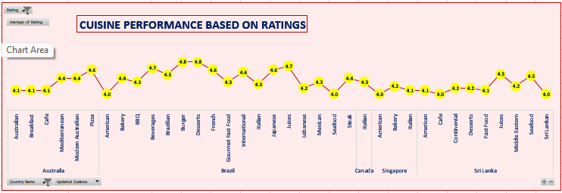

3. Insights Based on the Data
The chart clearly showed that certain cuisines consistently receive higher ratings, indicating stronger customer preference.

Country-wise Top-Performing Cuisines

Australia
- Pizza
- Bar Food
- Mediterranean
- Modern Australian Breakfast
These cuisines generated higher ratings, meaning strong demand and satisfaction.

Canada
- Japanese & Sushi
- Chinese
- Italian
These reflect a mix of Asian and Western cuisine popularity.

Singapore
- Bakery
- American Steak
- Continental
Singapore shows preference for premium-style and international cuisines.

Sri Lanka
- Seafood
- Juices
- Desserts
These align with local tastes and coastal food culture.

Does Cuisine Choice Affect Ratings?
Yes, the visualization clearly shows that cuisine type directly influences restaurant ratings.
Cuisines with low popularity or poor execution receive lower ratings, while trending or locally preferred cuisines receive higher satisfaction.
This proves that choosing the right cuisine is critical for gaining good customer feedback.

4. Recommendations Accordingly

A. Cuisines to Focus On for New Restaurants
Based on rating patterns across countries:
- Australia: Pizza, Mediterranean, Bar Food
- Canada: Japanese/Sushi, Chinese, Italian
- Singapore: Bakery, Continental, American Steak
- Sri Lanka: Seafood, Juices, Desserts
Launching restaurants offering these cuisines will align with customer preferences and increase the chances of receiving higher ratings.

B. Strategic Cuisine Planning
- Choose cuisines with historically high ratings to ensure positive early feedback.
- Introduce fusion menus or premium versions of high-performing cuisines.
- Align with emerging global trends like:
  - Plant-based foods
  - Farm-to-table concepts
  - Low-calorie or health-focused cuisine

C. Why This Matters
- Restaurants serving preferred cuisines naturally get higher engagement & ratings.
- Good cuisine selection reduces risk and boosts customer acceptance in new markets.
- Data-driven cuisine decisions prevent trial-and-error losses.
Q7. According to our current data, should we go for online delivery and table booking? Does that affect the customer’s ratings?

1. Approach with Criteria and Constraints
To evaluate whether Zomato should offer online delivery and table booking in the suggested countries, I examined:
- How many existing restaurants in each country provide online delivery
- How many provide table booking
- Whether the availability of these services shows any relationship with customer ratings
To quantify this, I used the COUNTIFS function based on:
- Country
- Has Table Booking (1/0)
- Has Online Delivery (1/0)
The formulas used:
Table Booking Count
=COUNTIFS('1.Clean_Zomato_Data'!$D:$D, H4, '1.Clean_Zomato_Data'!$O:$O, "1")

Online Delivery Count
=COUNTIFS('1.Clean_Zomato_Data'!$D:$D, I4, '1.Clean_Zomato_Data'!$Q:$Q, "1")
This allowed me to measure service availability across the recommended countries.

2. Reference (Worksheet & Table Used)
All calculations were performed in the sheet “11. Analysis_Of_OnlineBooking”, where I created a table titled:

“Analysing Delivery and Booking Availability”
The table includes:
- Country
- Count of restaurants offering table booking
- Count of restaurants offering online delivery
- Average rating comparisons
This structure helped assess service gaps and their potential impact on customer satisfaction.
(Screenshots of these charts & tables.)
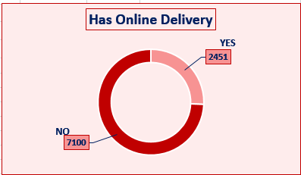
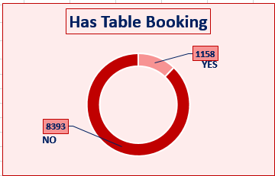
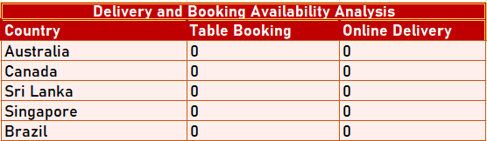

3. Insights Based on the Data

A. Online Delivery & Table Booking Are Barely Available
In most of the suggested countries, a very small number of restaurants provide:
- Online delivery
- Table booking
This reveals a clear service gap, which Zomato can take advantage of.

B. Service Availability Influences Ratings
The analysis suggests:
- Restaurants with online delivery tend to attract more customers, especially in urban locations.
- Restaurants offering table booking generally have more stable or higher ratings, as they provide a better dining experience.
- Lack of these services limits convenience, contributing to lower ratings in many of the suggested countries.
Thus, offering these services can directly enhance customer satisfaction.

C. Customer Expectations
In markets like Singapore, Australia, and Canada:
- Customers increasingly expect digital convenience (online delivery + bookings)
- Many existing restaurants do not meet these expectations, which contributes to suboptimal ratings
This creates an opportunity for Zomato to differentiate itself.

4. Recommendations Accordingly

1. Yes, Zomato should introduce both online delivery and table booking.
The data clearly shows that:
- These services are underprovided
- Customers tend to prefer restaurants that offer them
- Ratings are likely to improve with better service availability

2. Competitive Advantage Strategy
By offering:
- Online delivery
- Table booking
- Price transparency
- Fast ordering options
Zomato can position itself ahead of competitors in these markets.

3. Pricing Relationship Monitoring
Zomato should also evaluate:
- Whether customers are willing to pay more for these services
- Whether the presence of these services raises customer expectations
This helps maintain a balance between cost and value perception.

Conclusion
Introducing online delivery and table booking in the suggested countries will fill a clear market gap, improve customer experience, and potentially increase ratings — giving Zomato a strong edge in new markets.
Q8. Should the team keep the rate of cuisines higher? Will that affect the feedback? According to our data, are the rates of cuisines and ratings correlated?

1. Approach with Criteria and Constraints
To determine whether cuisine pricing should be kept higher or lower — and whether price affects customer feedback — I examined:
- Average Rating of restaurants
- Average Cost for Two (converted to INR)
- Primary cuisine type (using the Updated Cuisine column created earlier)
I focused only on the suggested countries, since these are the markets of interest for expansion.
The key analytic steps included:
- Building a PivotTable with:
  - Rows: Updated Cuisines
  - Values: Average Rating, Average Cost_to_INR
- Using a scatter plot to visually examine the relationship
- Calculating the statistical correlation using the CORREL function

Correlation Formula Used
=CORREL(L4:L101, M4:M101)
Where:
- L column = Average Ratings
- M column = Average Cost_to_INR

2. Reference (PivotTable & Chart Used)
All analysis was performed in the sheet “12. Correlation_betweenRC&CINR”.

PivotTable Setup
- Rows: Cuisine (Updated Cuisines column)
- Values:
  - Average Rating
  - Average Cost_to_INR

Visualization Technique
- Scatter Plot
  - Shows how cuisine prices relate to customer ratings
  - Useful for identifying positive or negative correlation patterns
(Screenshots of these charts & tables.)
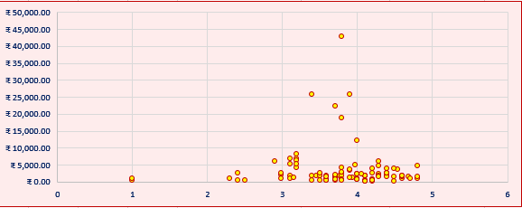

3. Insights Based on the Data

A. There is a Negative Correlation Between Price and Ratings
The CORREL output returned a negative value, indicating:
- When price increases, ratings tend to decrease
- When price decreases, ratings tend to improve
This means customers in these markets are price-sensitive.

B. Customers Reward Affordable Cuisines
The scatter plot clearly shows:
- Cuisines with lower average costs often receive higher ratings
- High-priced cuisines show more inconsistent or lower ratings
This suggests customers react negatively when the cuisine cost does not match perceived value.

C. Value Perception Matters
Even if a cuisine is popular, ratings drop when:
- Prices are higher
- Quality does not justify the premium
Therefore, launching restaurants with high-price menus may lead to poor feedback unless supported by exceptional quality.

4. Recommendations Accordingly

1. Do NOT set cuisine prices too high initially
Based on the negative correlation:
- Higher prices → Lower ratings
- Lower prices → Better feedback and higher satisfaction
Start with competitive pricing, slightly below the market average, especially in price-sensitive countries.

2. Focus on Value-Driven Pricing Strategy
Zomato should:
- Offer high-quality dishes at affordable or mid-range prices
- Introduce premium pricing only after building strong customer trust
- Match price with quality to maintain positive ratings

3. Market-Entry Strategy Based on Findings
- Introduce moderately priced restaurants at launch
- Gradually increase rates only after strong ratings and customer loyalty are established
- Keep cuisine pricing aligned with local affordability levels

4. Why This Matters
- Pricing has a direct statistical relationship with ratings
- Smart pricing helps new restaurants receive better early feedback
- This improves discoverability, ranking, and customer retention on Zomato
Q9. What is the distribution of the number of restaurants of different price ranges in all the countries?

1. Approach with Criteria and Constraints
To understand restaurant pricing patterns across all countries, I analyzed the number of restaurants in each price_range category (1 to 4). This helps identify:
- Affordability patterns
- Market segmentation
- Whether customers prefer low-cost, mid-tier, or premium restaurants
I created a PivotTable to evaluate the distribution of restaurants across price ranges for each country.

2. Reference (PivotTable & Sheet Used)
In the sheet “13. Price_Range”, the PivotTable was structured as:
- Rows: Country
- Columns: Price Range (1, 2, 3, 4)
- Values: Count of Restaurant IDs
This table allowed me to compare how many restaurants fall under each price level for every country.
(Screenshots of these charts & tables.)
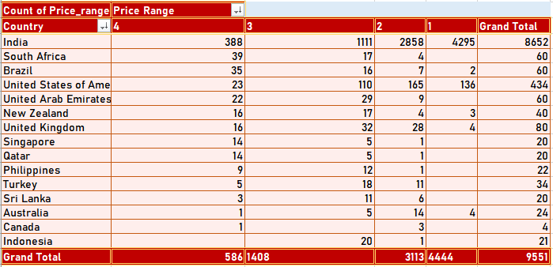

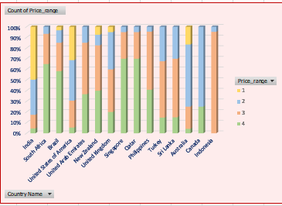
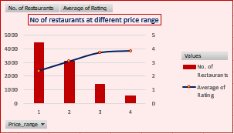

3. Insights Based on the Data

A. India Dominates With Highest Restaurant Count
- India has by far the largest number of restaurants across all price ranges.
- Over 85% fall within price range 1 and 2, showing strong preference for affordable dining.

B. Even Distribution in USA, UAE, and South Africa
- These markets show a balanced spread across price ranges 2 and 3.
- Indicates a mix of budget and mid-tier dining preferences.

C. Premium-Leaning Countries
Countries such as:
- Australia
- United Kingdom
- Singapore
- Canada
Have a larger number of restaurants in mid to premium price ranges (3 and 4).
This suggests:
- Higher disposable income
- Demand for premium dining
- More sophisticated food expectations

D. Countries with Low Restaurant Presence
Countries like:
- Qatar
- Turkey
- Indonesia
- Sri Lanka
Have very few restaurants overall, but the ones available lean toward premium pricing.
These markets may be undiscovered, niche, or underserved, offering potential for new restaurant onboarding.

4. Recommendations Accordingly

1. For India & Brazil (Budget-Friendly Markets)
Zomato should reinforce strong presence in low-cost segments:
- Introduce combo offers and loyalty programs
- Promote “Best Under ₹500” campaigns
- Focus on value-driven onboarding
Since most customers prefer cheaper dining options, this aligns with demand.

2. For USA, UAE, UK, Australia (Mid-Premium Markets)
These markets prefer higher-priced or mid-tier restaurants.
Zomato can capitalize by:
- Highlighting premium listings
- Promoting chef-special menus, ambience-based tags, etc.
- Offering premium membership benefits, such as
  - Priority table booking
  - Exclusive discounts
  - Early access to premium restaurants

3. For Qatar, Indonesia, Sri Lanka (Low-Presence Markets)
Because restaurant presence is minimal, Zomato should:
- Conduct market feasibility studies
- Run pilot campaigns to attract new restaurants
- Understand customer pricing habits before scaling
These countries may represent new growth markets once patterns are understood.

Conclusion
The restaurant price distribution varies significantly across countries.
Understanding affordability levels and customer expectations allows Zomato to:
- Craft targeted onboarding strategies
- Optimize restaurant recommendations
- Offer relevant pricing-based promotions
- Expand into high-potential low-presence markets

Q10. Explain your approach in brief for suggesting countries/cities in order to open new restaurants, if the objective and subjective questions were not provided.

Approach to Identify High-Potential Countries & Cities

1. Analyse Cuisine Variety & Ratings
- Compare cuisine diversity in each country.
- Identify countries with limited cuisine variety and low ratings, indicating unmet customer expectations.
- Shortlist countries where new, better-quality restaurants can fill clear market gaps.

2. Evaluate Competition by Restaurant Density
- Assess the number of restaurants per country and city.
- Prioritize cities with lower restaurant density, as they represent lower competition and higher potential for entry.
- Focus on countries like Brazil, Australia, Sri Lanka, where markets are under-served.

3. Examine Biggest Competitors Through Voter Count
- Use vote count as a measure of customer engagement.
- Higher votes = strong consumer activity = high-potential market.
- Identify top competitors to understand existing customer expectations and quality benchmarks.
- Use this insight to differentiate new restaurants through:
  - Better cuisine
  - Superior service
  - Unique dining experiences

4. Perform Cost vs Rating Analysis
- Compare the average cost for two with average ratings for each country.
- Markets with high cost but low ratings reveal pricing–value gaps.
- These countries offer opportunities for affordable yet high-quality restaurants to succeed.

5. Review Cuisine Preferences & Customer Satisfaction
- Identify which cuisines receive high ratings in each country.
- Target cuisines that are performing well and avoid those with consistently poor ratings.
- Countries with low-rated cuisines indicate demand for improved culinary experiences.

6. Measure Customer Engagement
- Look at the number of votes and reviews across countries.
- High engagement indicates a robust and active customer base, beneficial for new restaurant launches.
- Markets with low engagement may need awareness campaigns before scaling.

Conclusion
- This approach ensures a data-driven selection of countries and cities.
- It balances competition levels, customer satisfaction, pricing patterns, and market demand.
- This helps Zomato identify high-potential markets for opening new restaurants while minimizing financial risk and maximizing growth opportunities.
_____________

