**Layout of computer room:**

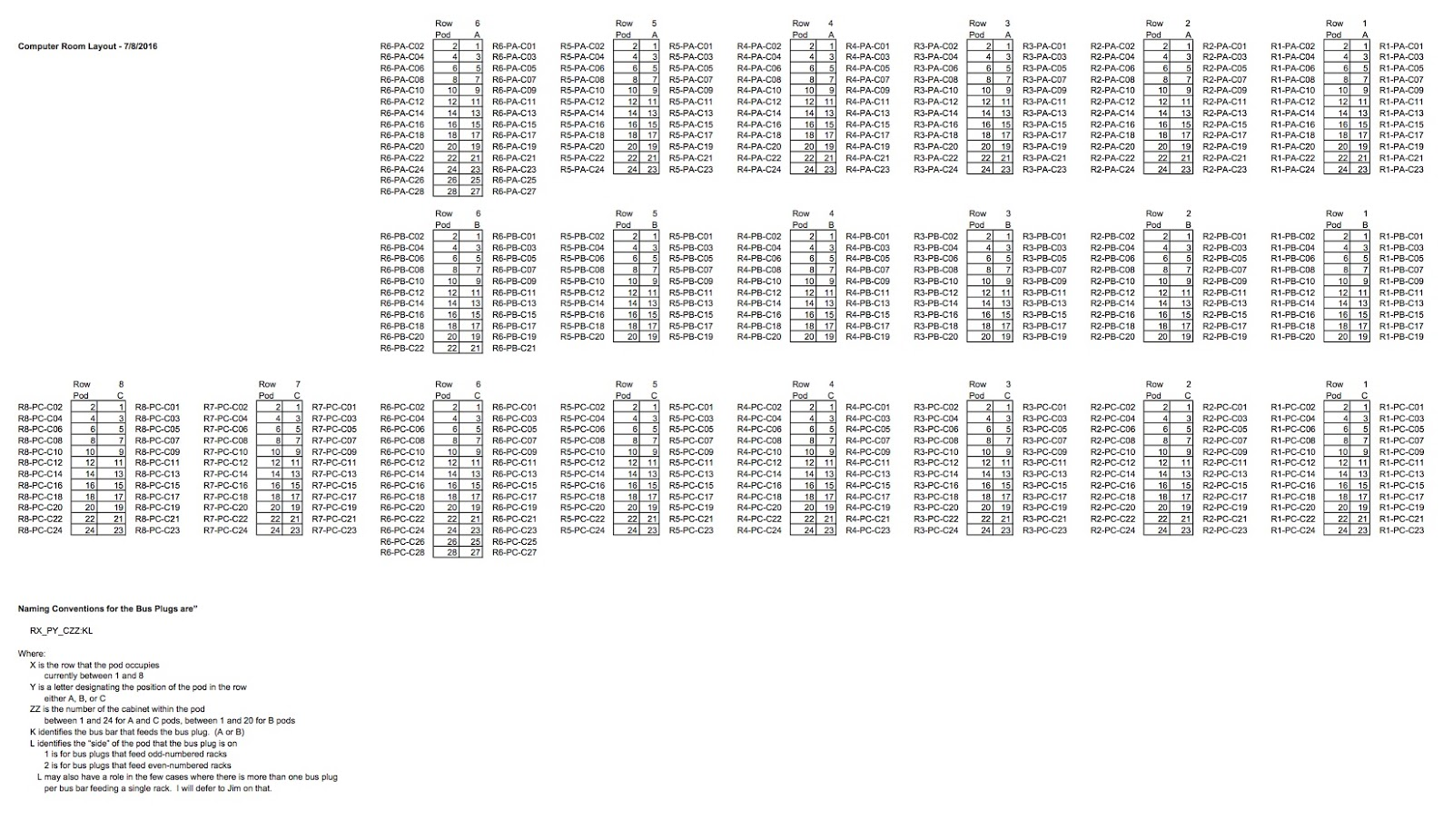

**Grafana visualizing collected data:** <http://129.10.5.134:3000>

**InfluxDB, time-series DB storing the data:** <http://129.10.5.134:8083>

**Dashboard: Electrical Busplug:** <http://129.10.5.134:3000/dashboard/db/electrical-busplug>

1. Voltage (V): Voltage of LN1,LN2 and LN3. Nominal voltage is around 230 V.

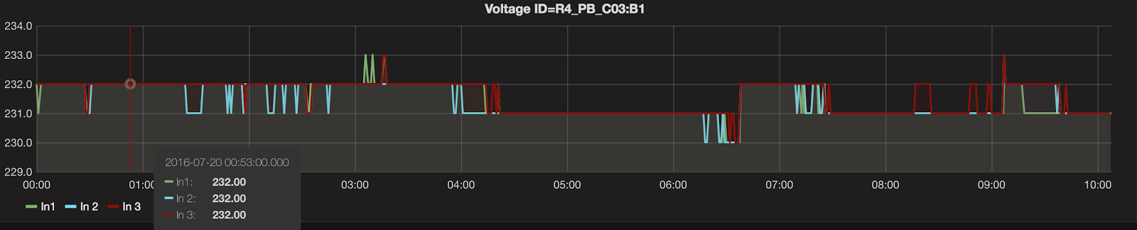

1. Current (A): the lowres and highres refers to low resolution and high resolution respectively (resolutions are 0.1 and 1 for high and low). I1, I2, I3 are the three different phases. Maximum current through a single bus plug is 24 Amps per phase

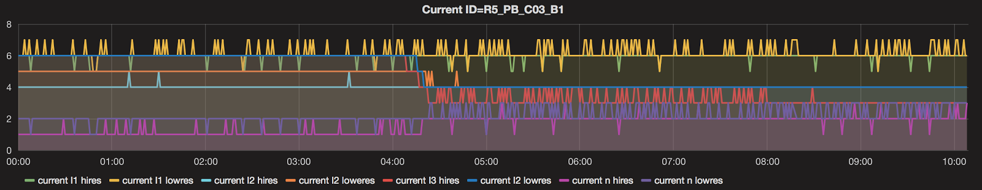

1. Power Factor: The Power Factor is the overall Power Factor. The Power Factor is a ratio value, and therefore has no units. Power Factor is 1.000 when the voltages and currents are in phase with each other, and 0.000 when they are at 90 degrees to each other. may be positive or negative depending on whether the load is inductive or capacitive.

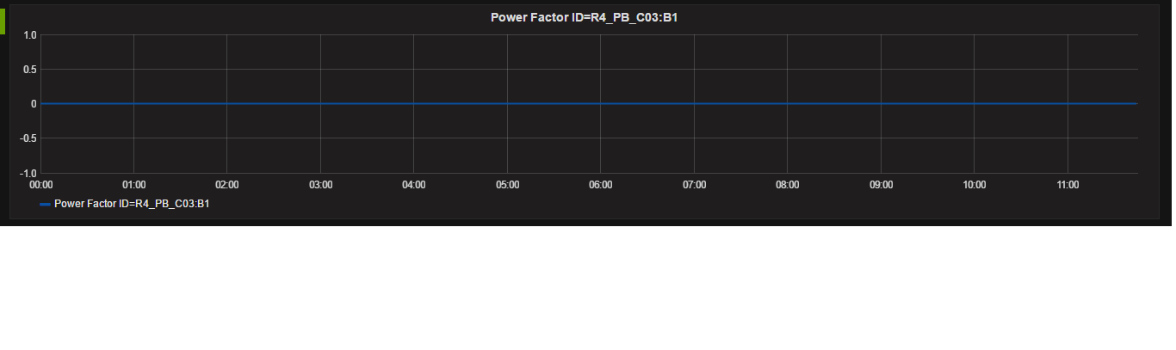

1. Frequency (Hz): Frequency of phase A. The MGHPCC power distribution system distributes three phase power. The phases are labeled "A", "B", and "C". Each phase feeds a subset of the outlets on the power distribution units in a rack. The frequency on all three phases has to be the same (unless something is wrong with the power grid). This might be why you are seeing a measurement for just one phase.

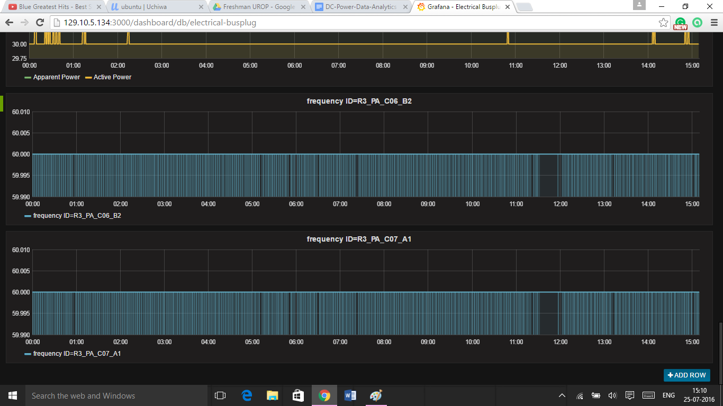

1. Metered active energy (Wh): measures energy used

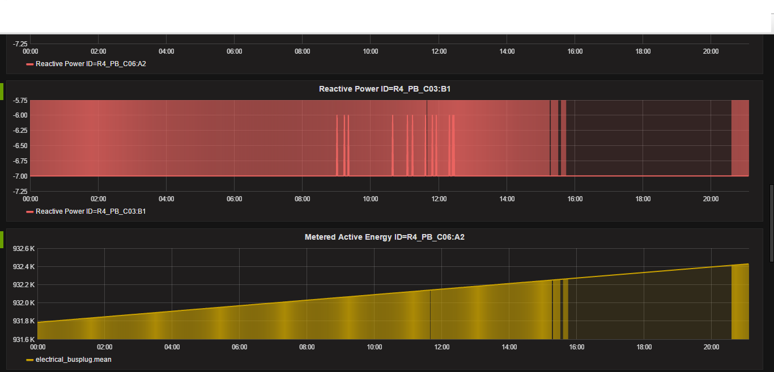

1. Reactive power (VAR): Definition: *P* = E(rms)*I(rms) where *P* is the power in watts, E(rms) is the rms voltage in volts, and I(rms) is the rms current in amperes. This value is recorded for each busplug.



1. Apparent power (VA): the power supplied to a circuit.
2. Active power (W): Def: Power drawn by the electrical resistance of a system doing useful work.

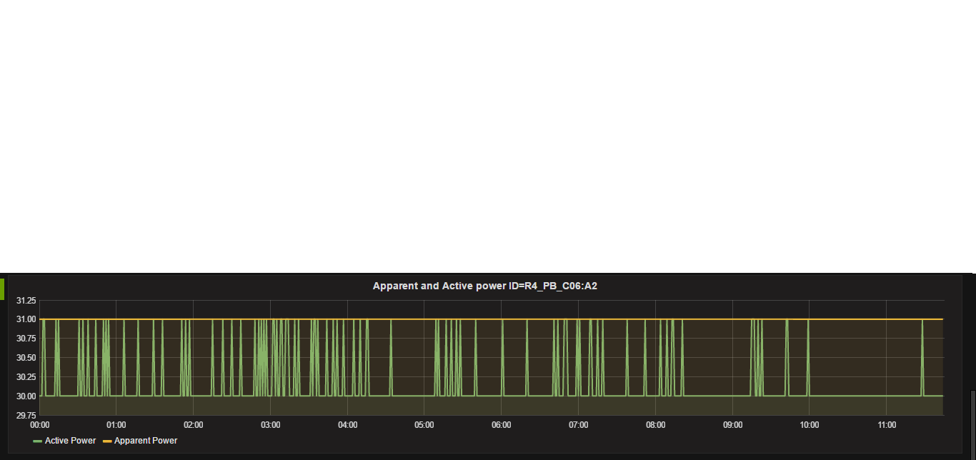

**Dashboard: mechanical IRC** (everything in this seems to be scaled by 10): <http://129.10.5.134:3000/dashboard/db/mechanical-irc>

1. Leaving fluid temperature (Fahrenheit): the temperature of the fluid as it leaves the IRCs.

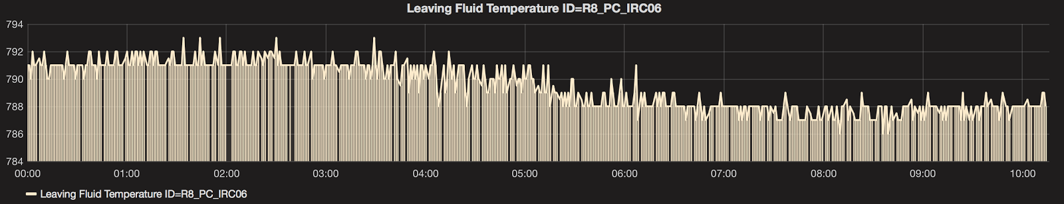

1. Entering fluid temperature (perhaps Fahrenheit): temperature of the fluid as it enters the IRCs.

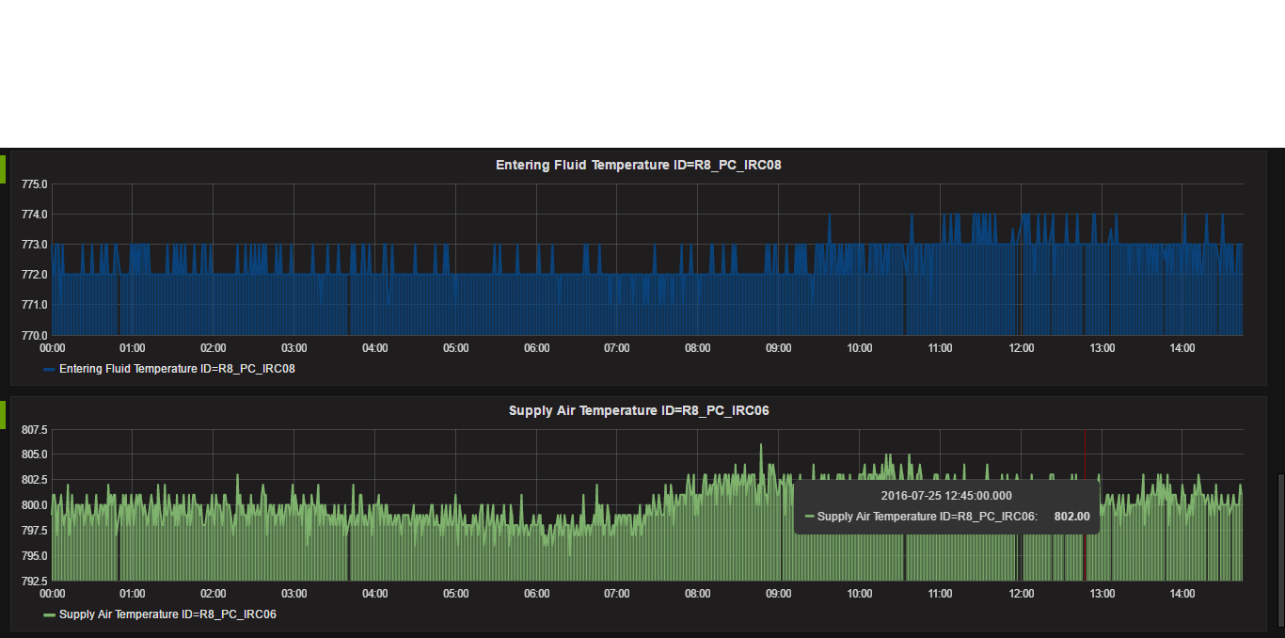

1. Rack inlet temperature (Fahrenheit): temperature of fluid coming into the inlets.

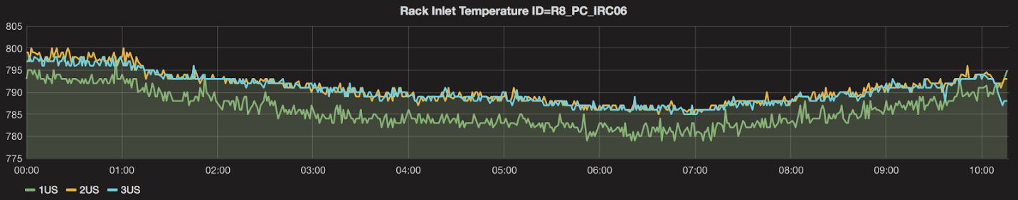

1. Return Air temperature (perhaps Fahrenheit): temperature of the air as it leaves the coolers.

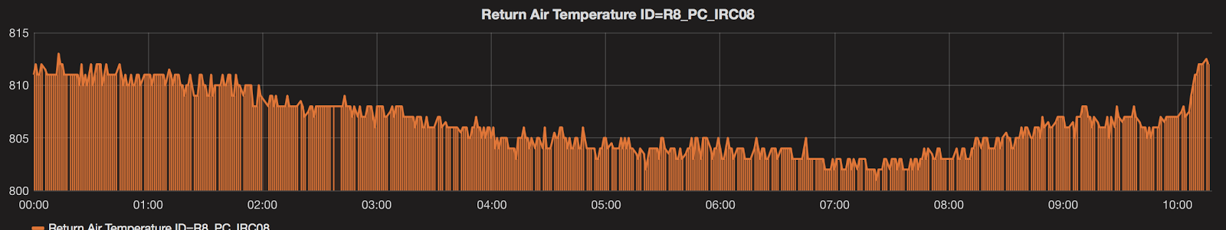

1. Supply air temperature (perhaps Fahrenheit): temperature of the air as it enters the coolers.



**Dashboard: Electrical meters**: <http://129.10.5.134:3000/dashboard/db/electrical-meters>

1. Watts: measures power of meter with the specefic ID

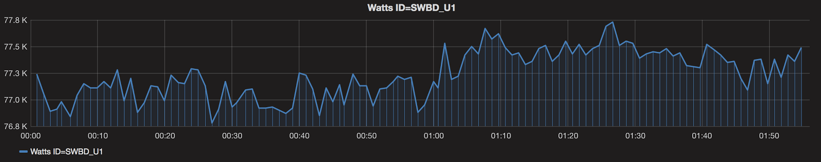

1. Watt hours: measures power of meter with the specefic ID

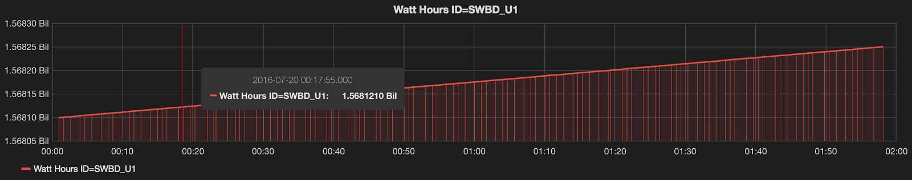

1. Apparent Power Factor:

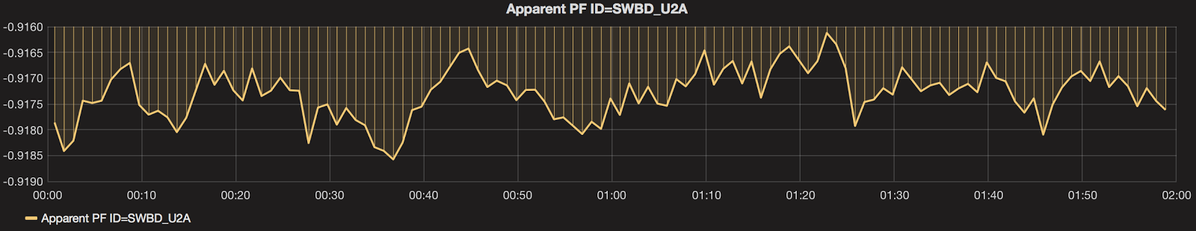

1. Displacement Power Factor:

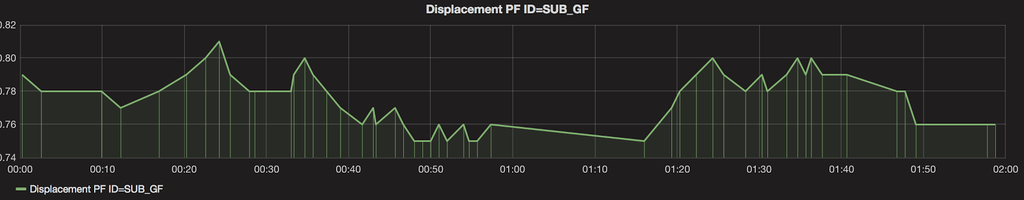

**Dashboard: mechanical cooling:** <http://129.10.5.134:3000/dashboard/db/mechanical-cooling>

1. Chiller (kWh):Refers to chillers 1,2 and 3 (CH1,2,3).

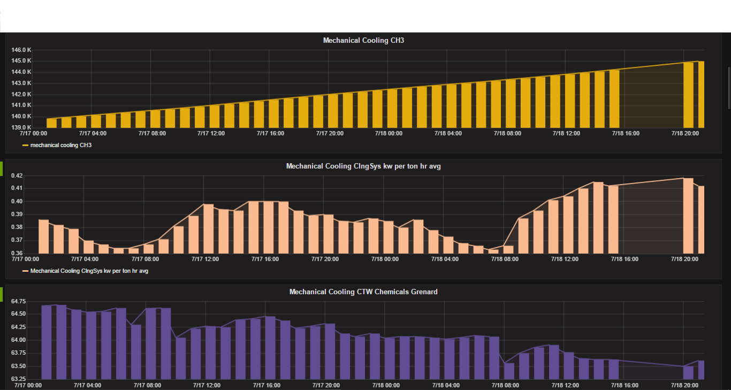

1. ClngSys per hour average (kW per ton): This is the number of kilowatts expended by the cooling plant to remove one ton of refrigeration. a ton of refrigeration is equivalent to 12,000 BTU/h or 3.5 kW. It's actual definition is the heat of fusion absorbed by melting 1 short ton (2,000 lb; 0.893 long tons; 0.907 t) of pure ice at 0 °C (32 °F) in 24 hours. This is a per hour average. don’t know what this stands for.

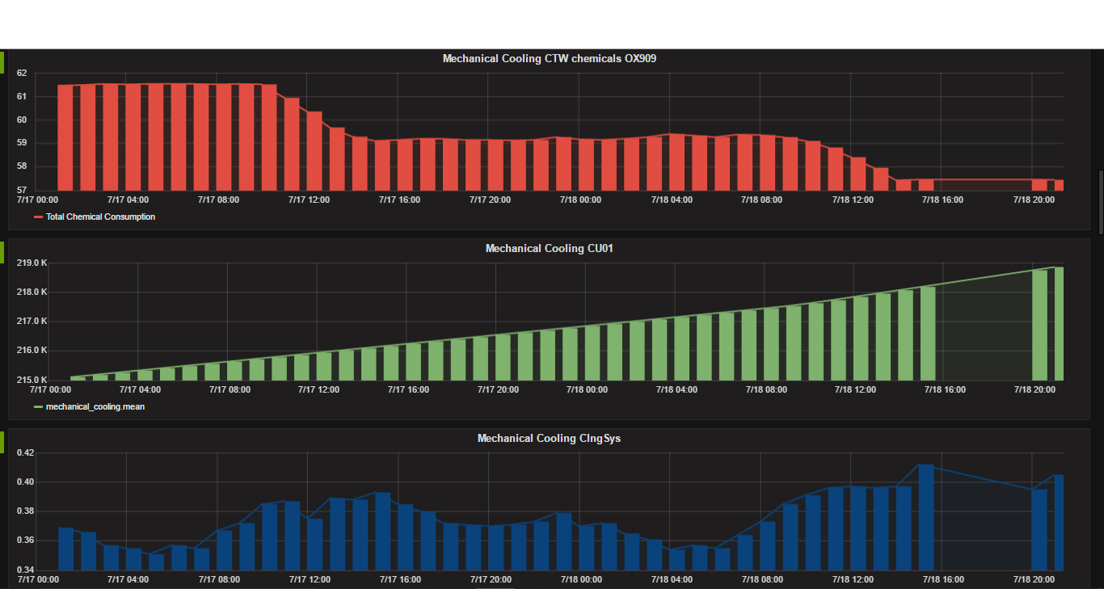

1. CTW Chemicals Grenard: CTW = Cooling Tower Water. don’t know what CTW stands for. This measures total chemical consumption (units unknown)



1. CTW chemicals OX909: also measures total chemical consumption. Units unknown



1. CU01 (kWh): don’t know what this stands for.



1. CT total: don’t know what CT stands for. Also don’t know what any any of the lines mean.

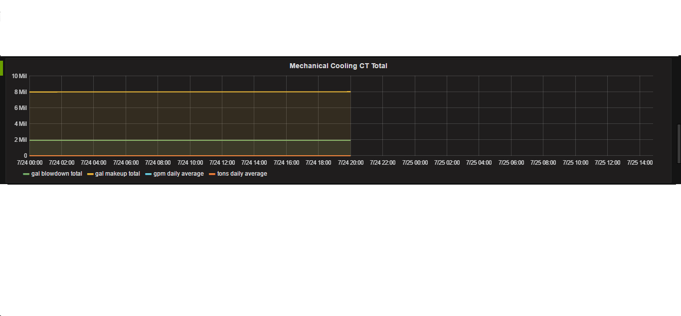

1. Airhandling unit: units unknown

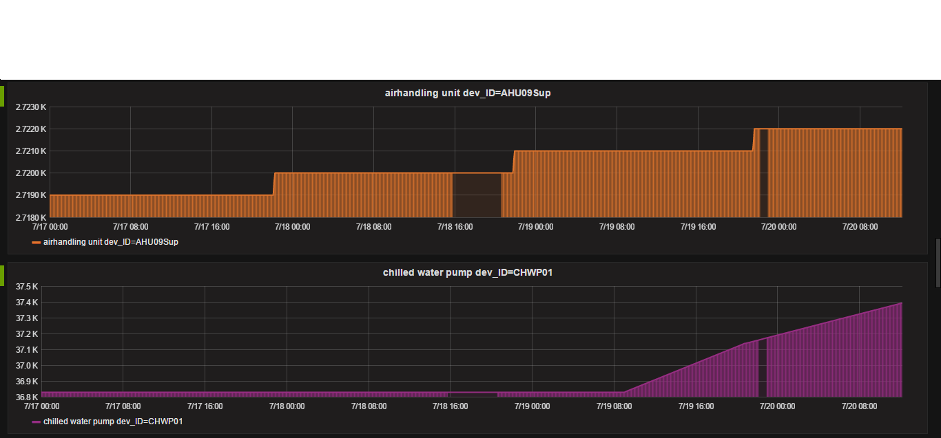

1. Chilled Water pump: units unknown

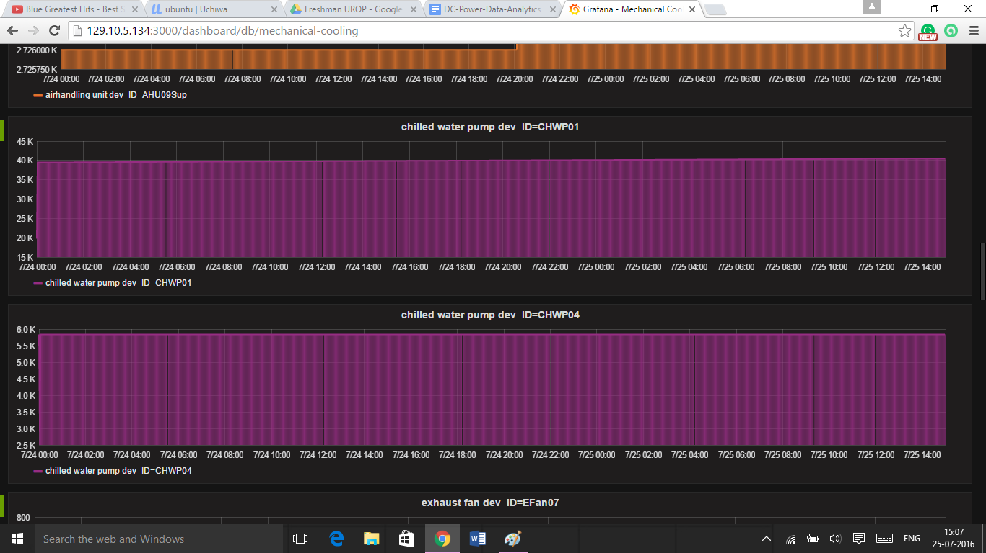

1. Hot water pump: units unknown

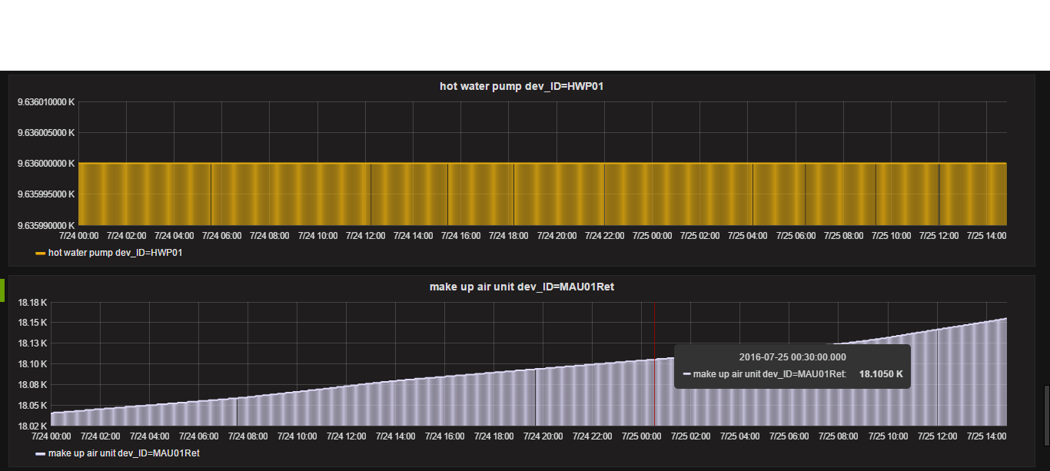

1. Exhaust fan: units unknown

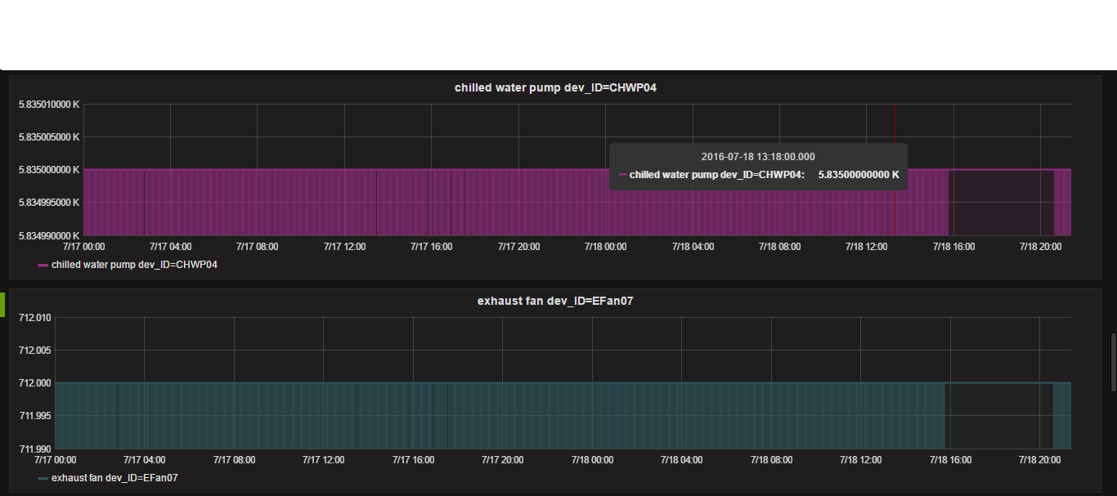

1. Make up air unit: units unknown



1. Cooling tower: units unknown

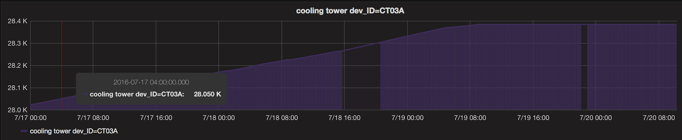

1. Cooling tower pump: units unknown

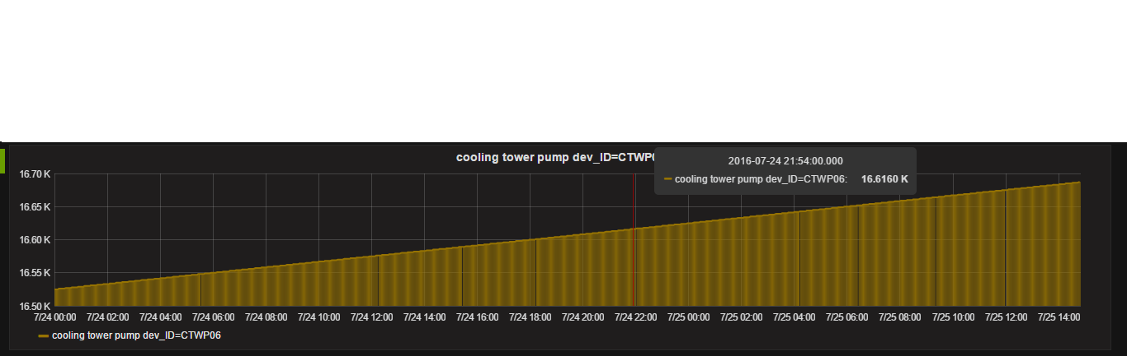

**Dashboard:Weather Station:** <http://129.10.5.134:3000/dashboard/db/weather-station>

1. Environmental Weatherstation (Fahrenheit): measures the wet bulb temperature. That is what determines how much energy it takes to cool the cooling tower water.

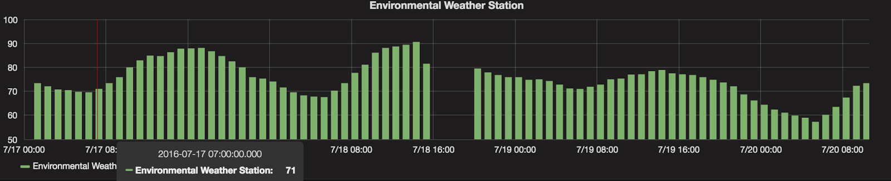

**Dashboard: Electrical Generator:** <http://129.10.5.134:3000/dashboard/db/electrical-generator>

1. GENC and GENF: there are two generators that supply backup power. GENF supplies power to Facility equipment (pumps, chillers, inrow coolers,etc). GENC supplies backup power to computing equipment. 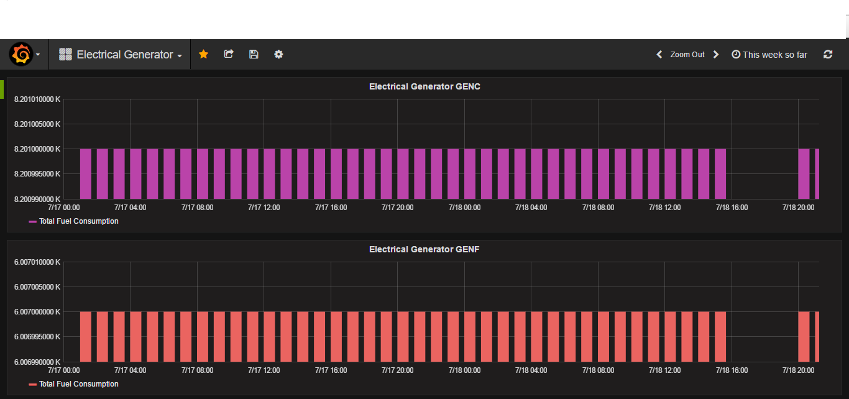

General questions:

1. What do the ID’s in electrical_meters mean?

John: the numeric ID is a hash, I believe. The ID in the JSON record identifies the location of the meter in the data center. It would be best, I think, to focus on the meters that matter, and not try to parse all of them.

Me: The ID’s actually refer to the different layers the meters are located at. For example, some meters are located right at the entrance of the datacenter. These have some ID’s that are different from, say, the meters that are located at each rack in the computing room.

1. Is data other than that from busplug (ex: mechanical IRC data) also scaled? This is because all of the temperatures in the IRC data are in the 700 ranges, so possibly there is a scale factor of 10.

Yes, IRC data is scaled by 10

1. Why is data from the cooling towers, chilling towers, exhaust fans, etc, so erratic?

cooling towers, chillers, and exhaust fans to not run all the time, so you should expect to see values go to zero often.

1. Why don’t we ever get any data from busplugs at Row 7 and 8 from pods A and B (the Redis database has no keys for those data metrics)

As noted in the computer room layout drawing, rows 7 and 8 only have C pods. There are no A or B pods.

Open questions:

1. For our purposes at PEAC lab, the granularity of the busplug and IRC data (1 minute) might be too large. Is there a way to get data every few seconds?
2. How do we connect the soft data coming from the servers to the power data coming from the busplugs and IRCs?
3. Is there a way to collect per pod data, per row data? InfluxDB doesn’t allow us to parse tag values? Connection of servers, and racks and pod data
4. Can we calculate PUE in real time?
5. How will we synchronize the data collected from the physical sensors to the soft data from the servers?