**Supplementary Material**

**Cortical surfaces mediate the relationship between polygenic scores for intelligence and general intelligence**

Tristram A. Lett1#*, Bob O. Vogel1#, Stephan Ripke1,2,3, Carolin Wackerhagen1, Susanne Erk1, Swapnil Awasthi1,3, Vassily Trubetskoy1,3, Eva J. Brandl1, Sebastian Mohnke1, Ilya M. Veer1, Markus M. Nöthen4,5, Marcella Rietschel6, Franziska Degenhardt4,5, Nina Romanczuk-Seiferth1, Stephanie H. Witt6, Tobias Banaschewski7, Arun L.W. Bokde8, Christian Büchel9, Erin B. Quinlan10, Sylvane Desrivières10, Herta Flor11,12, Vincent Frouin13, Hugh Garavan14, Penny Gowland15, Bernd Ittermann16, Jean-Luc Martinot17, Marie-Laure Paillère Martinot18, Frauke Nees7,11, Dimitri Papadopoulos Orfanos13, Tomáš Paus19, Luise Poustka20, Juliane H. Fröhner21, Michael N. Smolka21, Robert Whelan22, Gunter Schumann10 and the IMAGEN consortium, Heike Tost6, Andreas Meyer-Lindenberg6, Andreas Heinz1, Henrik Walter1*

# Shared first authorship

**\*** Corresponding authors:

Address: Division of Mind and Brain Research, Department of Psychiatry and Psychotherapy CCM, Charité - Universitätsmedizin Berlin; Charitéplatz 1, D-10117 Berlin, Germany.

Email: [tristram.lett@charite.de](mailto:tristram.lett@charite.de); [henrik.walter@charite.de](mailto:henrik.walter@charite.de)

Telephone: +49 30 450 517 141

**Running title**: Brain mediators of polygenic score for intelligence

**Keywords**: Intelligence, Genetics, Mediation, Cortical thickness, Surface area

1 Department of Psychiatry and Psychotherapy CCM, Charité - Universitätsmedizin Berlin, corporate member of Freie Universität Berlin, Humboldt-Universität zu Berlin, and Berlin Institute of Health, Berlin, Germany

2 Analytic and Translational Genetics Unit, Massachusetts General Hospital, Boston MA 02114, USA

3 Stanley Center for Psychiatric Research, Broad Institute of MIT and Harvard, Cambridge MA 02142, USA

4 Department of Genomics, Life & Brain Center, University of Bonn, Sigmund-Freud-Str. 25, 53127 Bonn, Germany

5 Institute of Human Genetics, University of Bonn, Sigmund-Freud-Str. 25, 53127 Bonn, Germany

6 Central Institute of Mental Health, University of Heidelberg, Square J5, 68159 Mannheim, Germany

7 Department of Child and Adolescent Psychiatry and Psychotherapy, Central Institute of Mental Health, University of Heidelberg, Square J5, 68159 Mannheim, Germany

8 Discipline of Psychiatry, School of Medicine and Trinity College Institute of Neuroscience, Trinity College Dublin

9 University Medical Centre Hamburg-Eppendorf, House W34, 3.OG, Martinistr. 52, 20246, Hamburg, Germany

10 Medical Research Council – Social, Genetic and Developmental Psychiatry Centre, Institute of Psychiatry, Psychology & Neuroscience, King’s College London, United Kingdom

11 Department of Cognitive and Clinical Neuroscience, Central Institute of Mental Health, Medical Faculty Mannheim, University of Heidelberg, Square J5, 68159 Mannheim, Germany

12 Department of Psychology, School of Social Sciences, University of Mannheim, 68131 Mannheim, Germany

13 NeuroSpin, CEA, Université Paris-Saclay, F-91191, Gif-sur-Yvette, France

14 Departments of Psychiatry and Psychology, University of Vermont, 05405 Burlington, Vermont, USA

15 Sir Peter Mansfield Imaging Centre School of Physics and Astronomy, University of Nottingham, University Park, Nottingham, United Kingdom

16 Physikalisch-Technische Bundesanstalt (PTB), Abbestr. 2 – 12, Berlin, Germany

17 Institut National de la Santé et de la Recherche Médicale, INSERM Unit 1000 “Neuroimaging & Psychiatry”, University Paris Sud, University Paris Descartes – Sorbonne Paris Cité; and Maison de Solenn, Paris, France

18 Institut National de la Santé et de la Recherche Médicale, INSERM Unit 1000 “Neuroimaging & Psychiatry”, University Paris Sud, University Paris Descartes; Sorbonne Université; and AP-HP, Department of Child and Adolescent Psychiatry, Pitié-Salpêtrière Hospital, Paris, France

19 Bloorview Research Institute, Holland Bloorview Kids Rehabilitation Hospital and Departments of Psychology and Psychiatry, University of Toronto, Toronto, Ontario, M6A 2E1, Canada

20 Department of Child and Adolescent Psychiatry and Psychotherapy, University Medical Centre Göttingen, von-Siebold-Str. 5, 37075, Göttingen, Germany

21 Department of Psychiatry and Neuroimaging Center, Technische Universität Dresden, Dresden, Germany

22 School of Psychology and Global Brain Health Institute, Trinity College Dublin, Ireland

**Intelligence measures**

Within IMAGEN, participants completed a battery of neuropsychological tests from the Wechsler Intelligence Scale for Children IV (WISC-IV) [(Wechsler 2003)](https://paperpile.com/c/KEEZio/Lx3SX). The following subtests were included in calculating *g*-factor. *Block design* measures the ability of spatial visualization, simultaneous processing, visual-motor coordination and dexterity. Individuals are given coloured blocks and must arrange them to display a printed image. *Similarities* measures abstract reasoning, verbal concept formation and logical thinking. Two related, yet different objects or concepts are presented and participants have to tell how they are alike or different. *Digit Span Forward* and *Digit Span Backward* measure short-term auditory memory and attention. Multiple digits are presented in random order by the examiner. Participants must then recite the digits by recalling them either in the same order (forward) or in reverse order (backward). *Vocabulary* measures verbal fluency, concept formation, word usage, and word knowledge. The examiner either presents a picture or a word is said aloud. Participants are asked to tell the name of the presented object or to define the word. *Matrix reasoning* measures non-verbal problem solving by presenting a matrix of abstract pictures to the participants, where one picture is missing. Participants have to choose the missing picture from multiple options.

In IntegraMooDS*,* subtests from the Hamburg-Wechsler Adult Intelligence Scale (HAWIE-R) [(Wechsler 2008)](https://paperpile.com/c/KEEZio/pegOn) and other neuropsychological tests were used. The following tests were included for calculating *g*-factor. *Digit Span Forward, Digit Span Backward* and *Matrix reasoning* are identical to the tests used in IMAGEN. *Digit Symbol* measures processing speed, working memory, attention and visuospatial processing. The test consists of a key with the numbers 1-9, each assigned to a unique symbol. Below the key, the numbers 1-9 are randomly listed and participants are asked to write the corresponding symbols, referring to the key, below the numbers in 120 seconds. *Verbal Fluency* as measured by the RWT (Regensburger Wortflüssigkeitstest)[(Aschenbrenner et al. 2000)](https://paperpile.com/c/KEEZio/LYilj), is a test in which participants have to generate as many words as possible, belonging to a category (e.g. fruits, vegetables) in either one or two minutes. *Verbal Intelligence* as measured by the MWT-B (Mehrfachwahl-Wortschatz-Intelligenztest)[(Lehrl 1999)](https://paperpile.com/c/KEEZio/Qud9h) is a German instrument measuring crystallized intelligence. The MWT-B consists of 37 multiple-choice items of which only one of five options actually reflects a German word, while the other four are pseudo words. The participants’ task is to circle the real words. *Verbal Learning and Memory* as measured by the VLMT (Verbaler Lern- und Merkfähigkeitstest)[(Helmstaedter et al. 2001)](https://paperpile.com/c/KEEZio/NXLWs) is a German instrument measuring different parameters of declarative verbal memory, learning performance, as well as long-term encoding, recall and recognition performance. *Trail Making Test A & B* [(Giovagnoli et al. 1996)](https://paperpile.com/c/KEEZio/IJEnE) is a test of visual attention and task switching. In version A, participants have to connect 25 randomly scattered numbers, in the correct order, starting with 1 and ending with 25, without lifting the pen from the paper. In version B, participants have to do the same task and additionally alternate between numbers and letters, (i.e. 1-A-2-B-3-C, etc.). The *D2 Concentration Test* [*(Brickenkamp et al. 1998)*](https://paperpile.com/c/KEEZio/yhKEo) measures selective and sustained attention, as well as visual scanning speed. Participants are required to cross out all letters “d” with two marks surrounding it, with similar surrounding distractor stimuli that do not differ substantially from the target stimulus.

**Genetics**

In IMAGEN, genotyping was performed using the Illumina Human610Quad chips (Illumina Inc., San Diego, California, USA). In IntegraMooDSgenotyping was performed at the Department of Genomics, Life & Brain Center, University of Bonn using the Illumina's Human610Quad, Human660W-Quad and Infinium PsychArray-24 BeadChips. The quality control parameters applied to subjects and SNPs were: SNP missingness < 0.05 (before sample removal); subject missingness < 0.02; autosomal heterozygosity deviation (| Fhet | < 0.2); SNP missingness < 0.02 (after sample removal); difference in SNP missingness between cases and controls < 0.02; and SNP Hardy-Weinberg equilibrium (P > 10−6 in controls or P > 10−10 in cases). Genotype imputation was performed using the pre-phasing/imputation stepwise approach implemented in EAGLE / MINIMAC3 (with variable chunk size of 132 genomic chunks and default parameters) [(Das et al. 2016; “Eagle v2.4.1 User Manual” 2018)](https://paperpile.com/c/KEEZio/CLdi4+cTmAa). The imputation reference set consisted of 54,330 phased haplotypes with 36,678,882 variants from the publically available HRC reference (<https://ega-archive.org/datasets/EGAD00001002729>). After linkage disequilibrium pruning (r2 > 0.02) and frequency filtering (MAF > 0.05), there were 64,081 autosomal SNPs across both datasets of European ancestry. This SNP set was used for robust relatedness testing and population structure analysis. Relatedness testing was done with PLINK; pairs of subjects with > 0.2 were identified and one member of each pair removed at random after preferentially retaining cases over controls. After quality control and imputation, 7,644,814 single-nucleotide polymorphisms (SNPs) remained in the IMAGEN sample and 8,843,142 SNPs remained in IntegraMooDS.

We used the standard PGC method for creating polygenic scores across 10 deciles [(Ripke et al. 2014)](https://paperpile.com/c/KEEZio/8Cwrf). We filtered out variants with an effect allele frequency < 2% and > 98% in the haplotype reference consortium. Variants with less than 80% minimum imputation quality score were excluded. Next, we performed linkage disequilibrium (LD) pruning and clumped the summary statistics, removing variants within 500 kb and R2 ≥ 0.1 with, another (more significant) marker. After clumping we had 310,534 LD-independent SNPs available for IMAGENand286,154 LD-independent SNPs for IntegraMooDS. For both samples, we calculated PSi by multiplying the beta estimate of each variant by the imputation probability for the effect allele for each individual. PSi ranged from S1 to S10 corresponding to p-value thresholds (PT) from the Savage et al. GWAS [(Savage et al. 2018)](https://paperpile.com/c/KEEZio/Oc1qE) of: PS1 (PT<5×10−8), PS2(PT<1×10−6), PS3 (PT<1×10−4), PS4 (PT<0.001), PS5 (PT<0.01), PS6 (PT<0.05), PS7 (PT<0.1), PS8 (PT<0.2), PS9 (PT<0.5), and PS10 (PT<=1.0).

Population stratification principal component estimation was performed with the same collection of autosomal SNPs (IMAGEN: Figure S3; IntegraMooDS: Figure S4). We tested the first four principal components for phenotype association (using logistic regression with study indicator variables included as covariates) and evaluated their impact on the genome-wide test statistics using λ. IMAGEN was separately imputed so was not included in the GWAS meta-analysis thus there was not relatedness testing between all three datasets.

**Image acquisition**

In IMAGEN, scans were acquired from 3-Tesla scanners from different manufacturers (Siemens, Munich, Germany; Philips, Best, The Netherlands; General Electrics, Chalfont St Giles, UK; Bruker, Ettlingen, Germany) at eight different sites (King’s College, London; Sir Peter Mansfield Imaging Centre of the University of Nottingham; Trinity College Institute of Neuroscience, Dublin; the Centre de Neuroimagerie de Recherche, Paris; Charité Universitätsmedizin Berlin; Universitätsklinikum Hamburg-Eppendorf; Zentralinstitut für seelische Gesundheit, Mannheim; and the Universitätsklinikum Carl Gustav Carus, Dresden). High-resolution anatomical MRIs were acquired, including a three-dimensional (T1-weighted) magnetization prepared gradient echo sequence (MPRAGE) based on the ADNI protocol (for further details see, [Schumann et al. 2010)](https://paperpile.com/c/KEEZio/SKZYM).

In IntegraMooDS, structural scans were acquired using T1-weighted three-dimensional magnetization prepared rapid gradient echo (MP-RAGE) sequence with an isotropic spatial resolution of 1 mm3 (repetition time (TR) = 1.57 s, echo time (TE) = 2.74 ms, flip angle = 15°). Quality control measurements were conducted at all three study sites (Berlin, Bonn, Mannheim) utilizing a multicenter quality assurance protocol [(Friedman and Glover 2006)](https://paperpile.com/c/KEEZio/QFUlv), which revealed stable signals over time and comparable quality between sites. Additionally, we included site as a covariate for all statistical analyses.

**Processing of structural images**

Cortical reconstruction was performed on all T1-weighted images using the Freesurfer image analysis suite (http://surfer.nmr.mgh.harvard.edu/). The technical details of these procedures are described in prior publications [(Fischl, Sereno, and Dale 1999; Fischl, Sereno, Tootell, et al. 1999; Fischl and Dale 2000; Fischl et al. 2001, 2004)](https://paperpile.com/c/KEEZio/9S7Nw+S1R9i+E7cDj+gTjTO+1K1fL). In brief, this process includes motion correction and averaging of multiple volumetric T1 weighted images, removal of non-brain tissue, automated Talairach transformation, segmentation of the subcortical white matter and deep gray matter volumetric structures, intensity normalization, tessellation of the gray matter white matter boundary, automated topology correction, and surface deformation. A number of deformable procedures were performed including surface inflation, registration to a spherical atlas which is based on individual cortical folding patterns to match cortical geometry across subjects, and creation of a variety of surface based data including maps of curvature and sulcal depth. Both intensity and continuity information from the entire three dimensional MR volume in segmentation and deformation procedures to produce representations of cortical thickness, calculated as the closest distance from the gray/white boundary to the gray/CSF boundary at each vertex on the tessellated surface [(Fischl and Dale 2000)](https://paperpile.com/c/KEEZio/9S7Nw). For our analyses, a template of all subjects is created using TFCE_mediation [(Lett et al. 2017)](https://paperpile.com/c/KEEZio/wwea3) employing standard Freesurfer methods. A list of subjects is submitted to create a template with an option for either cortical thickness or surface area. For each subject, surface data is then resampled to the ‘fsaverage’ using surface-based registration where the cortical manifold is inflated to a sphere and homologous neuroanatomical features are matched [(Fischl, Sereno, and Dale 1999; Fischl, Sereno, Tootell, et al. 1999)](https://paperpile.com/c/KEEZio/1K1fL+gTjTO). After registration, all subjects are merged into a single image separately for each hemisphere. The images are smoothed using full-width half maximum (FWHM) of 3mm.

**Cortex-wise mediation analysis**

TFCE_mediation performs cortex-wise mediation analysis with threshold-free cluster enhancement (TFCE). For a detailed description, please see the methods paper by [Lett et al. 2017](https://paperpile.com/c/KEEZio/wwea3). In summary, mediation models can be employed to identify the nature of the relationship between an independent variable and two dependent variables [(Baron and Kenny 1986)](https://paperpile.com/c/KEEZio/uNS4t). Mediation models assess the relationship between an independent variable and a dependent variable via a mediator (intermediate) variable. The effect of the independent variable on the dependent variable that is explained by a mediator variable is called the indirect effect. TFCE_mediation applies a mediation model at all vertices of a 4D image which then undergo TFCE and significance testing of the indirect effect is assessed via permutation testing. In this study, the mediation analysis was performed with polygenic scores for general intelligence served as the independent variable, cortex-wise images were the mediator variable, and *g*-factor performance scores were the dependent variable. In TFCE_mediation, two sets of regression are performed to assess the indirect effect using the Aroian variant of the Sobel equation [(Sobel 1982, 1986; Mackinnon et al. 1995)](https://paperpile.com/c/KEEZio/4W4QH+sZdOQ+xrr7R). Significant mediation is assessed using the maximum TFCE transformed z-value from 10,000 permutations. TFCE transformed Sobel z-values that were greater than 95% of the maximum TFCE transformed z-values are deemed significant (i.e., PFWE-corrected < 0.05).

As described in Lett et al. (2017), in TFCE_mediation, sets of regression analyses are performed to assess the indirect (mediation) effect using the Aroian variant of the Sobel equation [(Mackinnon et al. 1995; Sobel 1982; Sobel 1986)](https://paperpile.com/c/g4kU1k/I3Qa+6xd9+FULu):

For Path A, the independent variable (PSi) is regressed on the mediator variable (brain structure). For Path B, the mediator variable (brain structure) is regressed on the dependent variable (*g*-factor) including the independent variable (PSi) as a covariate. The unstandardized regression coefficients (betas: a and b) and the standard errors (Sa and Sb) are used to produce a z-value at each vertex of the cortical surface. The z-value then undergoes vertex-wise TFCE transformation, and significance is determined using permutation testing. For additional information please see our methods paper as well as recent publications using TFCE_mediation [(Lett et al. 2017; Vogel et al. 2018; Lett et al. 2018)](https://paperpile.com/c/g4kU1k/3n1S+YEX9+8et0). Moreover, the source code and further information are available on the website: <https://github.com/trislett/TFCE_mediation>.

**Online Vertex-wise Results**

The association of PSi ranging from S1 to S10 on vertex-wise measures of cortical thickness and surface area for different PFWER-corrected thresholds. PFWER-corrected < 0.05 represents the family-wise error rate corrected threshold, PFWER-corrected < 0.005 represents the family-wise error rate as well as Bonferroni corrected threshold for ten multiple comparisons (ten PSi thresholds). IMAGEN (N = 1,651) included sex, age, site and four population stratification principal components as covariates. IntegraMooDS (N = 742) included subgroup, sex, age, site, and four population stratification principal components as covariates.

Website: <https://github.com/bobvogel/g-factor-mediation>

**Figures and tables**

|  |  |  |  |  |  |  |  |  |
| --- | --- | --- | --- | --- | --- | --- | --- | --- |
| IntegraMooDS | CON | rel-MDD | rel-BPD | rel-SCZ | pat-MDD | pat-BPD | pat-SCZ | Total |
| Berlin | N = 121 | N = 29 | N = 21 | N = 24 | N = 37 | N = 32 | N = 28 | N = 292 |
| Bonn | N = 117 | N = 40 | N = 33 | N = 20 | N = 0 | N = 0 | N = 0 | N = 210 |
| Mannheim | N = 101 | N = 22 | N = 15 | N = 23 | N = 30 | N = 27 | N = 22 | N = 240 |
| Sex (m/f) | 165/174 | 61/30 | 41/28 | 41/26 | 23/44 | 27/33 | 34/16 | 401/341 |
| Age (M±SD) | 33.4±10.3 | 28.0±9.4 | 32.6±12.0 | 32.9±12.7 | 38.8±13.2 | 36.5±10.8 | 33.6±9.0 | 33.7±11.1 |
| GSI* (M±SD) | 0.17±0.17 | 0.23±0.23 | 0.20±0.22 | 0.28±0.35 | 0.94±0.58 | 0.97±0.53 | 0.68±0.48 | 0.34±0.41 |
| PST* (M±SD) | 12.6±11.0 | 15.7±12.3 | 14.0±12.5 | 17.3±16.3 | 45.5±17.6 | 35.7±18.1 | 37.6±21.1 | 20.1±18.1 |
| PSDI** (M±SD) | 1.12±0.36 | 1.12±0.28 | 1.13±0.31 | 1.31±0.54 | 1.73±0.37 | 1.5±0.48 | 1.52±0.39 | 1.3±0.44 |

**Table S1.** Demographic characteristics of the IntegraMooDS sample. * data not available for N=14, ** data not available for N=18. f, female; GSI, symptom checklist 90 global severity index; m, male; M, mean; PSDI, symptom checklist 90 positive symptom distress index; PST, symptom checklist 90 positive symptom total; pat-BPD, patients with bipolar disorder; pat-UPD, patients with unipolar depression; pat-SCZ, patients with schizophrenia; rel-BPD, relatives of patients with bipolar disorder; rel-UPD, relatives of patients with unipolar depression; rel-SCZ, relatives of patients with schizophrenia; SD, standard deviation.

|  |  |  |  |  |
| --- | --- | --- | --- | --- |
|  | pat-MDD | pat-BPD | pat-SCZ | Total |
| Unmedicated | 11 | 3 | 2 | 16 |
| SSRI | 19 | 16 | 6 | 41 |
| SMS | 1 | 2 | - | 3 |
| SNRI | 13 | 2 | 1 | 16 |
| NDRI | 4 | 4 | - | 8 |
| MAO-I | 1 | 1 | - | 2 |
| NaSSA | 8 | 1 | - | 9 |
| A-AD | 1 | 1 | 2 | 4 |
| TCA | 11 | - | - | 11 |
| FGA | - | 1 | 3 | 4 |
| SGA | 12 | 29 | 47 | 88 |
| Lithium | 2 | 22 | 1 | 25 |
| Anticonvulsants | 1 | 14 | 2 | 17 |
| Valproic acid | - | 8 | - | 8 |
| Benzodiazepines | 1 | 3 | - | 4 |
| L-Thyroxine | 3 | 9 | - | 12 |
| Antihistamines | 4 | 3 | - | 7 |

**Table S2.** Medication information for patient groups in IntegraMooDS. Number of individuals without medication information: pat-UPD = 7, pat-BPD = 2, pat-SCZ = 1. A-AD, atypical antidepressant; AC, anticonvulsants; FGA, first generation antipsychotic; MAO-I, monoamine oxidase inhibitor; NaSSA, noradrenergic and specific serotonergic antidepressant; NDRI, norepinephrine-dopamine reuptake inhibitor; pat-BPD, patients with bipolar disorder; pat-UPD, patients with unipolar depression; pat-SCZ, patients with schizophrenia; SGA, second generation antipsychotic; SMS, serotonin modulator and stimulator; SNRI, selective serotonin norepinephrine reuptake inhibitors; SSRI, selective serotonin reuptake inhibitor.

|  |  |  |  |  |
| --- | --- | --- | --- | --- |
|  | IMAGEN | | IntegraMooDS | |
| PC | Eigenvalues | % of variance | Eigenvalues | % of variance |
| 1 | 3.29 | 41.06 | 3.66 | 40.62 |
| 2 | 1.68 | 21.04 | 1.17 | 13.04 |
| 3 | 1.07 | 13.35 | 0.91 | 10.12 |

**Table S3** Eigenvalues and percentage of variance explained for the first three unrotated principal components from different cognitive batteries, separately for IMAGEN and IntegraMooDS.

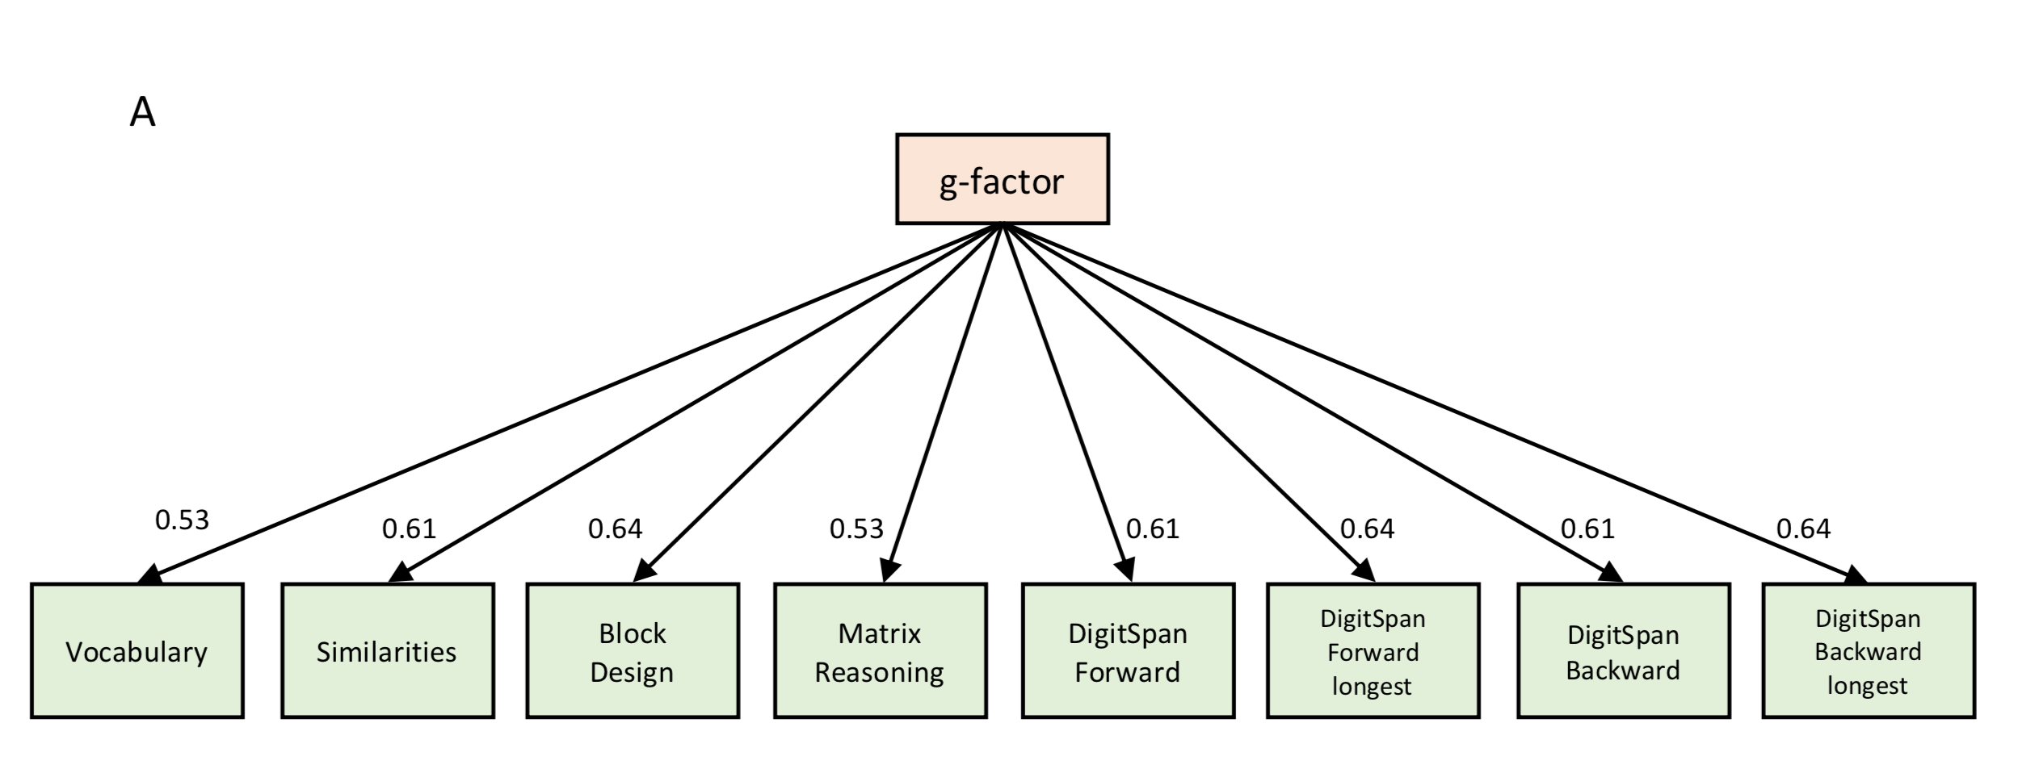

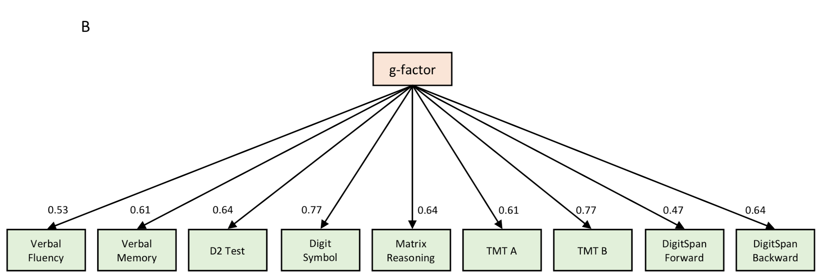

**Figure S1.** Factor loadings of individual neurocognitive tests on *g*-factor, separately for (**A**) IMAGEN and (**B**) IntegraMooDS. The *g*-factor explained 41.06 % of the variance across the different domains in IMAGEN and 41.72 % in IntegraMooDS.

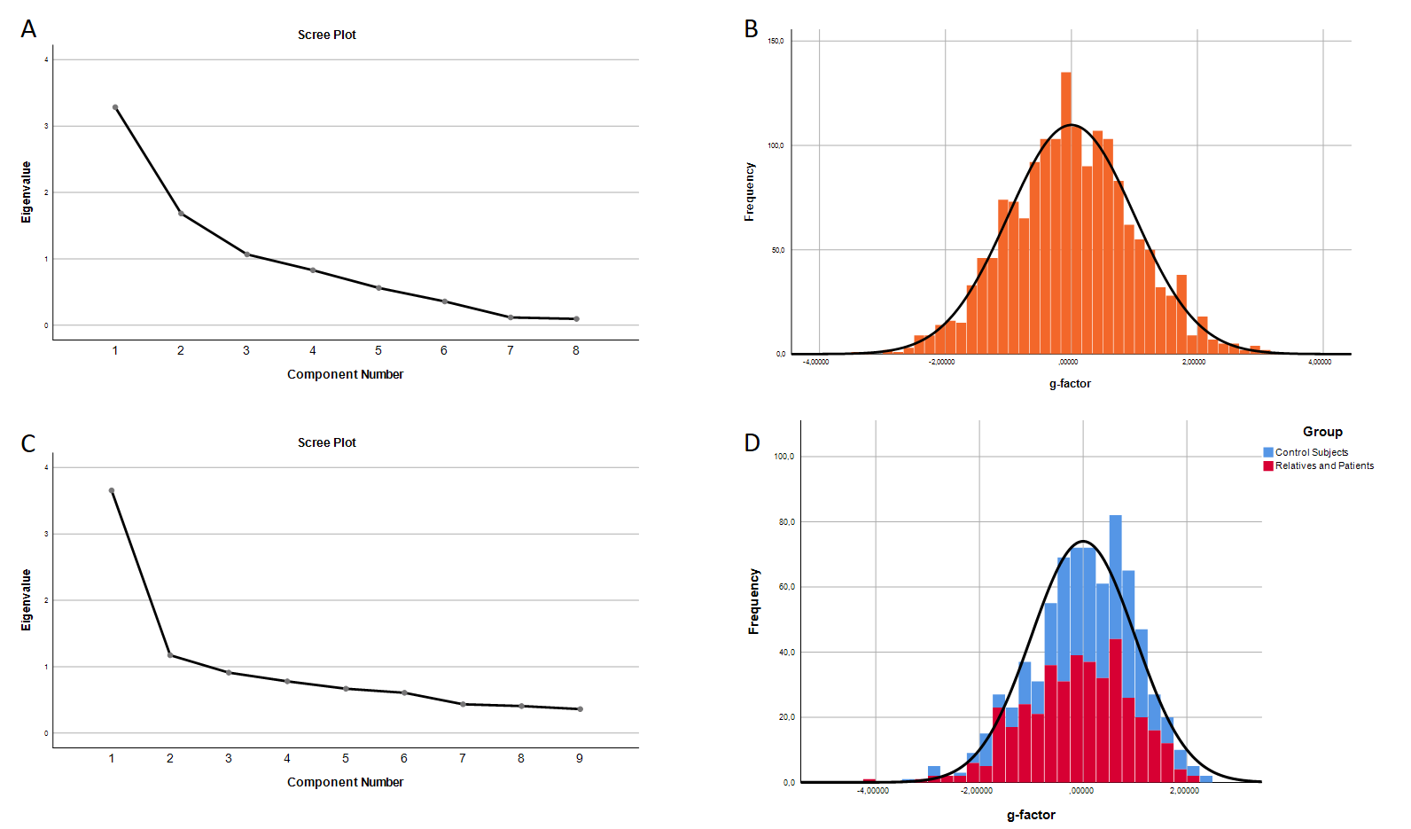

**Figure S2** Basic statistics for the principal component analysis. (A) Scree plot for eight principal components from different cognitive batteries in IMAGEN. (B) Histogram for the first unrotated principal component (*g*-factor) in IMAGEN. (C) Scree plot for nine principal components from different cognitive batteries in IntegraMooDS. (D) Histogram for the first unrotated principal component (*g*-factor) in IntegraMooDS, separately for control subjects (blue) as well as relatives and patients (red).

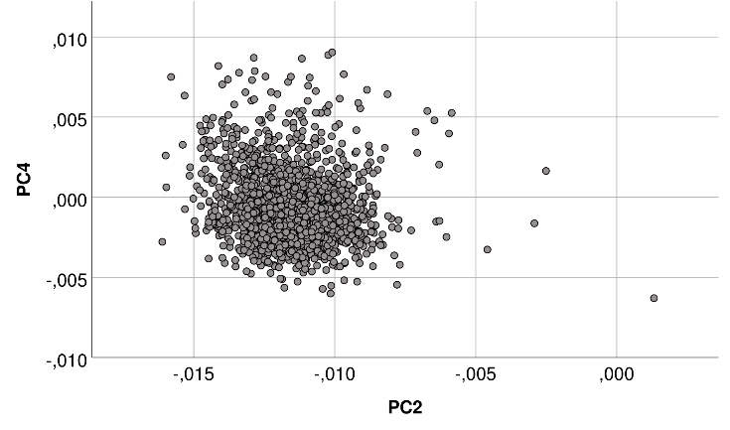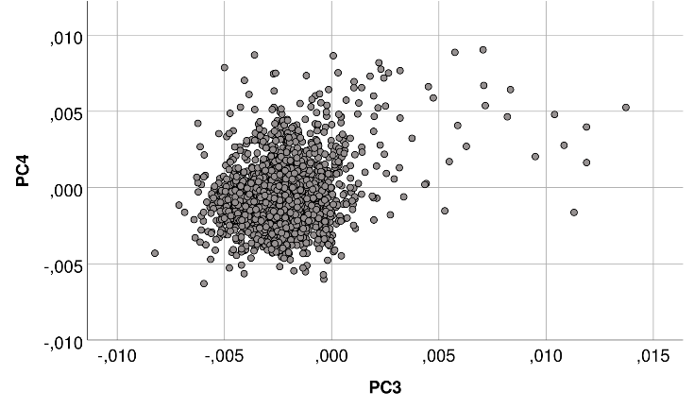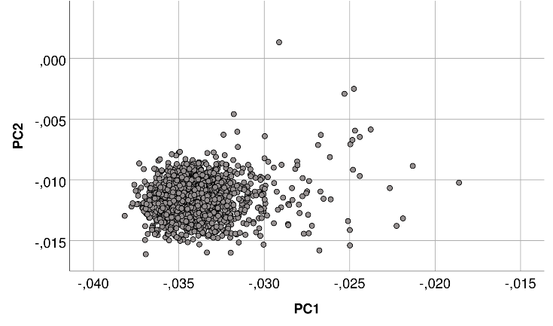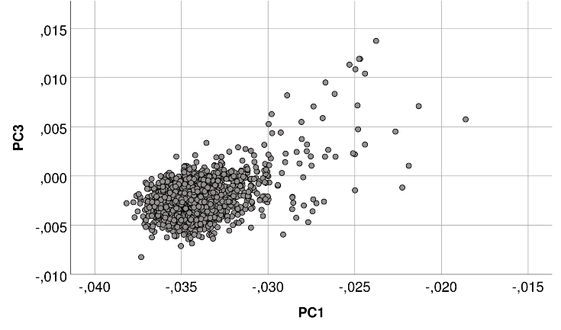

**Figure S3.** Scatterplots of first four population stratification principal components (PC1 - PC4) in IMAGEN (N=1,651). Population stratification principal component estimation was performed with 64,081 autosomal SNPs. Every dot represents one individual. The clustering of cases clearly indicates common genetic ancestry (all participants were self-report as European-Caucasian).

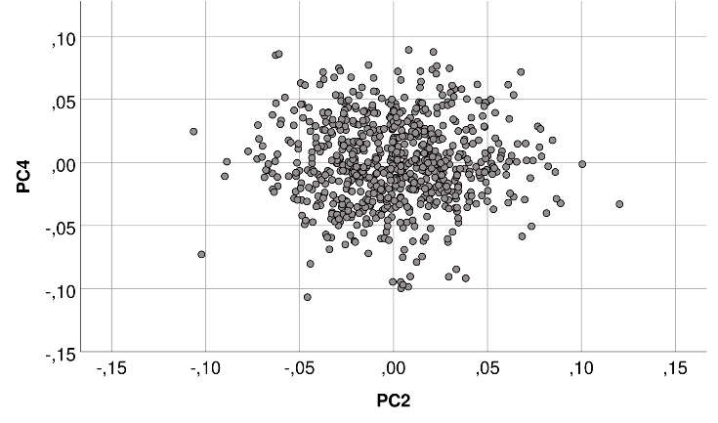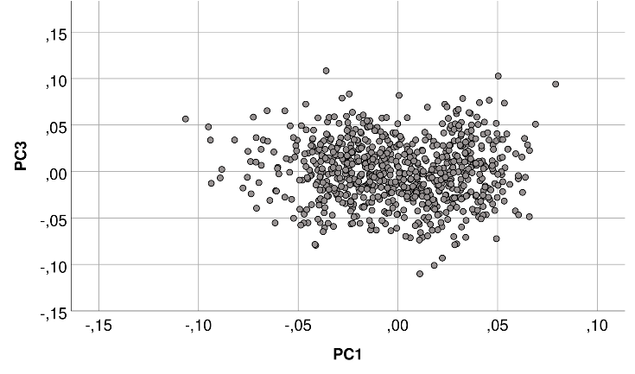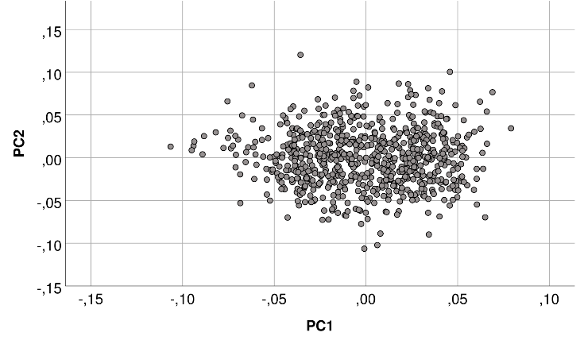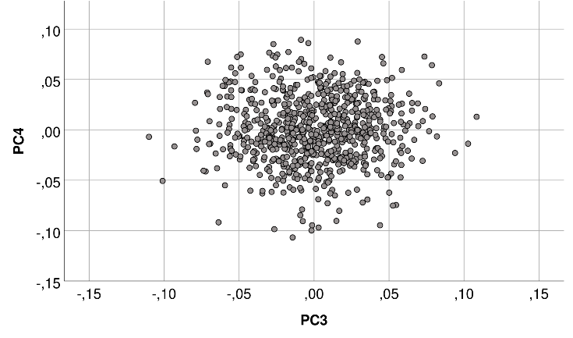

**Figure S4.** Scatterplots of first four population stratification principal components (PC1 - PC4) in IntegraMooDS (N=742). Population stratification principal component estimation was performed with 64,081 autosomal SNPs. Every dot represents one individual. The clustering of cases clearly indicates common genetic ancestry (all participants were self-report as European-Caucasian).

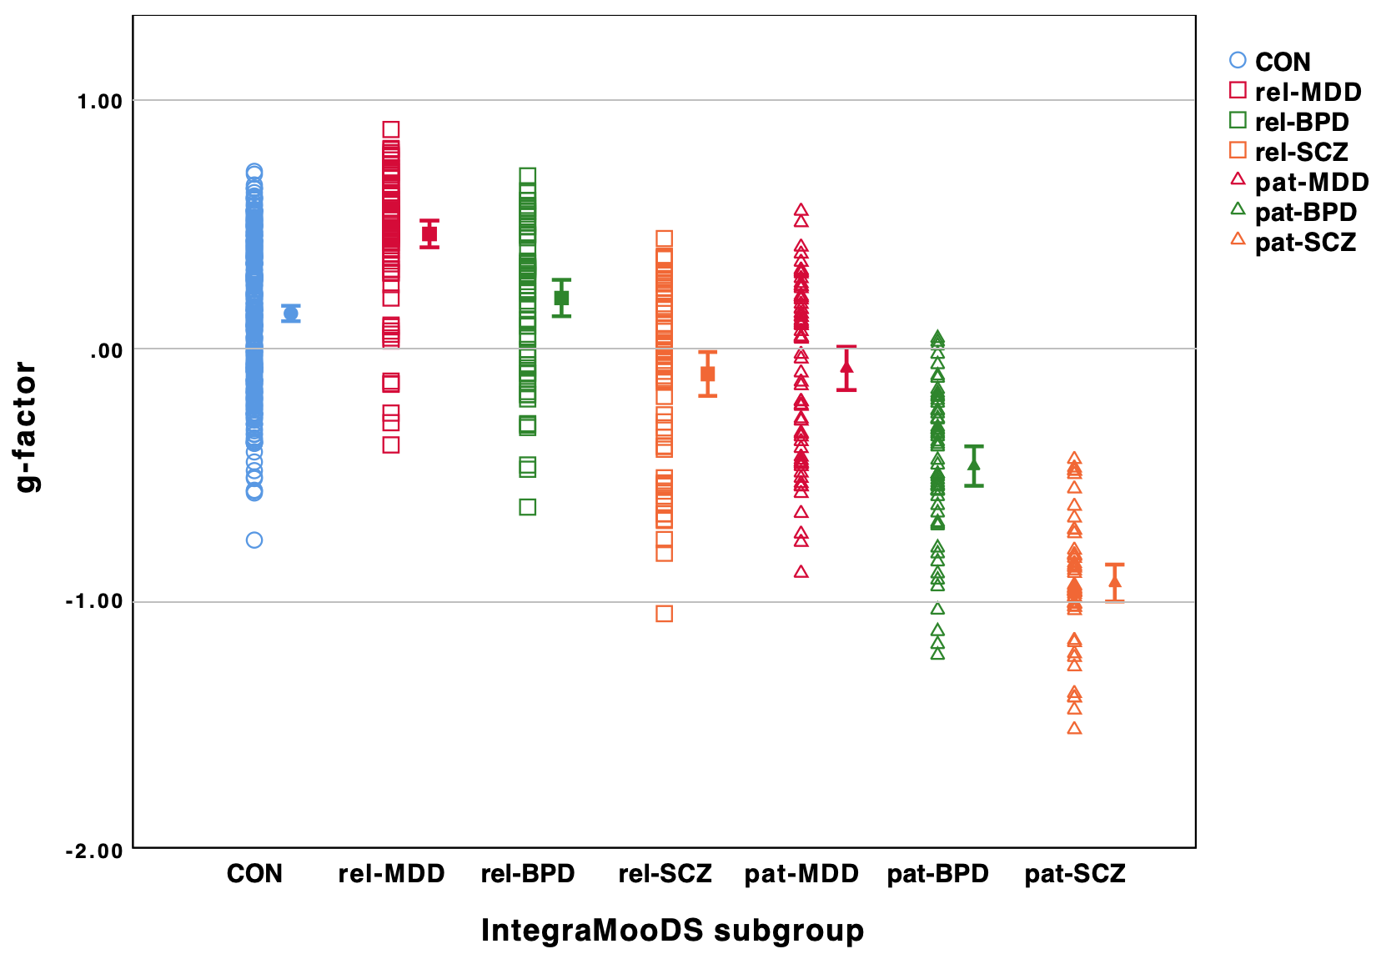

**Figure S5.**  In IntegraMooDS, *g*-factor was significantly different between subgroups after covarying for sex, age, site, and four population stratification principal components (F6,726= 9.34, P < 0.001). *g*-factor was significantly lower in schizophrenia relatives (rel-SCZ), patients with bipolar disorder (pat-BPD) and patients with schizophrenia (pat-SCZ) compared to healthy controls, with the greatest difference in pat-SCZ compared to control subjects. Hollow circles, squares and triangles represent each subject of healthy controls, relatives and patients respectively. Mean and 95% confidence interval are shown to the right of each group. For pairwise comparisons see Table S8.

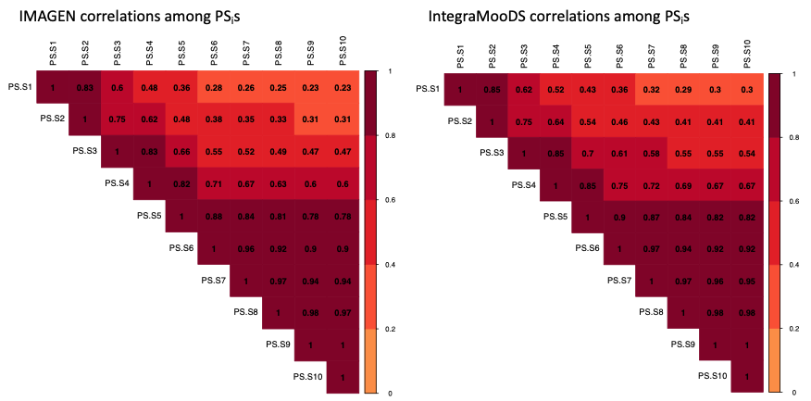

**Figure S6.** Full correlations between PS1 to PS10 in IMAGEN (left) and IntegraMooDS (right). All correlations were significant after correcting for ten multiple comparisons (all Pcorrected < 0.05). Medium to large correlation coefficients (r > 0.6) are observed between PS4 to PS10.

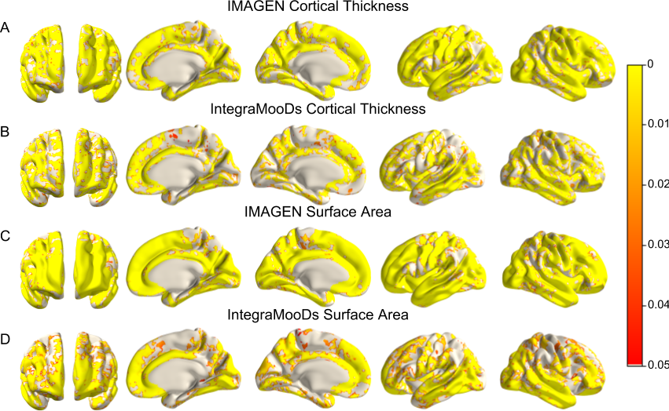

**Figure S7.** The association of *g*-factor with CT, as well as *g*-factor with SA throughout the cortex ranging from PFWE-corrected < 0.05 (red) to PFWE-corrected < 0.001 (yellow). Anatomical locations from left to right: rostral, left, superior, caudal, right, inferior. IMAGEN included sex, age, site and ethnicity as covariates. IntegraMooDS included subgroup, sex, age, site, and ethnicity as covariates. (**A**) The association of *g*-factor and CT in IMAGEN (N = 1651). (**B**) The association of *g*-factor and CT in IntegraMooDS (N=742). (**C**) The association of *g*-factor and SA in IMAGEN. (**D**) The association of *g*-factor and SA in IntegraMooDS. CT, cortical thickness; SA, surface area.

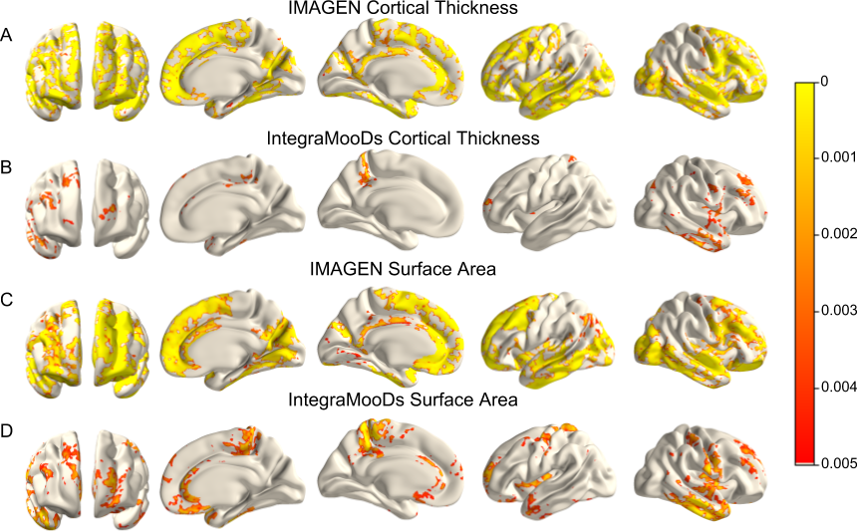

**Figure S8.** The association of PS4 with CT, as well as PS4 with SA in key areas associated with general intelligence differences ranging from PFWE-corrected < 0.005 (red) to PFWE-corrected < 0.001 (yellow). Anatomical locations from left to right: anterior, right inner, left inner, left outer, right outer. IMAGEN included sex, age, site and ethnicity as covariates. IntegraMooDS included subgroup, sex, age, site, and ethnicity as covariates. (**A**) The association of PS4 and CT in IMAGEN (N = 1651). (**B**) The association of PS4 and CT in IntegraMooDS (N=742). (**C**) The association of PS4 and SA in IMAGEN. (**D**) The association of PS4 and SA in IntegraMooDS. CT, cortical thickness; SA, surface area.

**References**

[Aschenbrenner S, Tucha O, Lange KW. 2000. RWT: Regensburger Wortflüssigkeits-Test. Hogrefe.](http://paperpile.com/b/KEEZio/LYilj)

[Baron RM, Kenny DA. 1986. The moderator--mediator variable distinction in social psychological research: Conceptual, strategic, and statistical considerations. J Pers Soc Psychol. 51:1173.](http://paperpile.com/b/KEEZio/uNS4t)

[Brickenkamp R, Zillmer E, Others. 1998. The d2 test of attention. Hogrefe & Huber Seattle, WA.](http://paperpile.com/b/KEEZio/yhKEo)

[Das S, Forer L, Schönherr S, Sidore C, Locke AE, Kwong A, Vrieze SI, Chew EY, Levy S, McGue M, Schlessinger D, Stambolian D, Loh P-R, Iacono WG, Swaroop A, Scott LJ, Cucca F, Kronenberg F, Boehnke M, Abecasis GR, Fuchsberger C. 2016. Next-generation genotype imputation service and methods. Nat Genet. 48:1284–1287.](http://paperpile.com/b/KEEZio/CLdi4)

[Eagle v2.4.1 User Manual [WWW Document]. 2018. . URL](http://paperpile.com/b/KEEZio/cTmAa) <https://data.broadinstitute.org/alkesgroup/Eagle/>

[Fischl B, Dale AM. 2000. Measuring the thickness of the human cerebral cortex from magnetic resonance images. Proc Natl Acad Sci U S A. 97:11050–11055.](http://paperpile.com/b/KEEZio/9S7Nw)

[Fischl B, Liu A, Dale AM. 2001. Automated manifold surgery: constructing geometrically accurate and topologically correct models of the human cerebral cortex. IEEE Trans Med Imaging. 20:70–80.](http://paperpile.com/b/KEEZio/S1R9i)

[Fischl B, Salat DH, van der Kouwe AJW, Makris N, Ségonne F, Quinn BT, Dale AM. 2004. Sequence-independent segmentation of magnetic resonance images. Neuroimage. 23 Suppl 1:S69–S84.](http://paperpile.com/b/KEEZio/E7cDj)

[Fischl B, Sereno MI, Dale AM. 1999. Cortical surface-based analysis. II: Inflation, flattening, and a surface-based coordinate system. Neuroimage. 9:195–207.](http://paperpile.com/b/KEEZio/gTjTO)

[Fischl B, Sereno MI, Tootell RBH, Dale AM. 1999. High-resolution intersubject averaging and a coordinate system for the cortical surface. Hum Brain Mapp. 8:272–284.](http://paperpile.com/b/KEEZio/1K1fL)

[Friedman L, Glover GH. 2006. Report on a multicenter fMRI quality assurance protocol. J Magn Reson Imaging. 23:827–839.](http://paperpile.com/b/KEEZio/QFUlv)

[Giovagnoli AR, Del Pesce M, Mascheroni S, Simoncelli M, Laiacona M, Capitani E. 1996. Trail making test: normative values from 287 normal adult controls. Ital J Neurol Sci. 17:305–309.](http://paperpile.com/b/KEEZio/IJEnE)

[Helmstaedter C, Lendt M, Lux S. 2001. Verbaler Lern- und Merkfähigkeitstest: VLMT ; Manual. Beltz-Test.](http://paperpile.com/b/KEEZio/NXLWs)

[Lehrl S. 1999. Mehrfachwahl-Wortschatz-Intelligenztest: MWT-B. Spitta.](http://paperpile.com/b/KEEZio/Qud9h)

[Lett TA, Waller L, Tost H, Veer IM, Nazeri A, Erk S, Brandl EJ, Charlet K, Beck A, Vollstädt-Klein S, Jorde A, Kiefer F, Heinz A, Meyer-Lindenberg A, Chakravarty MM, Walter H. 2017. Cortical surface-based threshold-free cluster enhancement and cortexwise mediation. Hum Brain Mapp. 38:2795–2807.](http://paperpile.com/b/KEEZio/wwea3)

[Mackinnon DP, Warsi G, Dwyer JH. 1995. A Simulation Study of Mediated Effect Measures. Multivariate Behav Res. 30:41.](http://paperpile.com/b/KEEZio/4W4QH)

[Ripke S, Neale BM, Corvin A, Walters JTR, Farh K-H, Holmans PA, Lee. 2014. Biological insights from 108 schizophrenia-associated genetic loci. Nature. 511:421.](http://paperpile.com/b/KEEZio/8Cwrf)

[Savage JE, Jansen PR, Stringer S, Watanabe K, Bryois J, de Leeuw CA. 2018. Genome-wide association meta-analysis in 269,867 individuals identifies new genetic and functional links to intelligence. Nat Genet. 50:912–919.](http://paperpile.com/b/KEEZio/Oc1qE)

[Schumann G, Loth E, Banaschewski T, Barbot A, Barker G, Büchel C, Conrod PJ, Dalley JW, Flor H, Gallinat J, Garavan H, Heinz A, Itterman B, Lathrop M, Mallik C, Mann K, Martinot J-L, Paus T, Poline J-B, Robbins TW, Rietschel M, Reed L, Smolka M, Spanagel R, Speiser C, Stephens DN, Ströhle A, Struve M, IMAGEN consortium. 2010. The IMAGEN study: reinforcement-related behaviour in normal brain function and psychopathology. Mol Psychiatry. 15:1128–1139.](http://paperpile.com/b/KEEZio/SKZYM)

[Sobel ME. 1982. Asymptotic Confidence Intervals for Indirect Effects in Structural Equation Models. Sociol Methodol. 13:290–312.](http://paperpile.com/b/KEEZio/sZdOQ)

[Sobel ME. 1986. Some New Results on Indirect Effects and Their Standard Errors in Covariance Structure Models. Sociol Methodol. 16:159–186.](http://paperpile.com/b/KEEZio/xrr7R)

[Wechsler D. 2003. Wechsler intelligence scale for children--Fourth Edition (WISC-IV). San Antonio, TX: The Psychological Corporation.](http://paperpile.com/b/KEEZio/Lx3SX)

[Wechsler D. 2008. WAIS-IV Administration and Scoring Manual. PsychCorp.](http://paperpile.com/b/KEEZio/pegOn)